248 CMR 10.00: UNIFORM STATE PLUMBING CODE

Section
10:01: Scope and Jurisdiction 10.02: Basic Principles
10.03: Definitions
10.04: Testing and Safety 10.05: General Regulations
10.06: Materials
10.07: Joints and Connections 10.08: Traps and Cleanouts
10.09: Interceptors, Separators, and Holding Tanks 10.10: Plumbing Fixtures
10.11: Hangers and Supports 10.12: Indirect Waste Piping
10.13: Piping and Treatment of Special Hazardous Wastes 10.14: Water Supply and the Water Distribution System 10.15: Sanitary Drainage System
10.16: Vents and Venting 10.17: Storm Drains
10.18: Hospital Fixtures
10.19: Plumbing in Manufactured/Mobile Homes, Construction, and Construction Temporary Use Trailers 10.20: Public and Semi-public Swimming Pools
10.21: Boiler Blow-off TankVacuum Powered Sanitary Drainage Systems 10.22: FiguresBoiler Discharge to the Building Drainage System
10.23: Vacuum Drainage Systems

  - : Scope and Jurisdiction

    - Scope. 248 CMR 10.00 governs the requirements for the installation, alteration, removal, replacement, repair, or construction of all plumbing.

    - Jurisdiction.
      - Nothing in 248 CMR 10.00 shall be construed as applying to:
        - refrigeration,
        - heating,
        - cooling,
        - ventilation or fire sprinkler systems beyond the point where a direct connection is made with the potable water distribution system.
      - Sanitary drains, storm water drains, hazardous waste drainage systems, dedicated systems, potable and non-potable water supply lines and other connections shall be subject to 248 CMR 10.00.

  - : Basic Principles

Founding of Principles. 248 CMR 10.00 is founded upon basic principles which hold that public health,
environmental sanitation, and safety can only be achieved through properly designed, acceptably installed, and adequately maintained plumbing systems.

    - Principle No. 1 -: All Occupied Premises Must Have Potable Water.: All habitable buildingsoccupied premises must be provided with a supply of potable water. Such a water supply shall not be connected withto unsafe or questionable water sources, nor shall it be subject to the hazards of backflow, backpressure, or back-siphonage.

    - Principle No. 2 -: Adequate Water Required.: Plumbing fixtures, devices, and appurtenances must be supplied with water in sufficientenough volume and at pressures adequate to enable them to function properly under normal conditions of use.

    - Principle No. 3 -: Hot Water Required.: Hot water must be supplied in all habitable buildingsoccupied premises for plumbing fixtures which utilize hot water for sanitary or hygienic purposes.

    - Principle No. 4 -: Water Conservation.: Plumbing must be designed and installed to meet the water
conservation requirements of 248 CMR 10.00this code while using the minimum quantity of water necessary to function properly under normal conditions of use.

    - Principle No. 5 -: Dangers of Explosion or Overheating.: Devices and appliances for heating and storing water must be so designed and installed as to guard against dangers from explosion or overheating.

    - Principle No. 6 -: Required Plumbing Fixtures.:
      - To meet the basic prerequisites of sanitation and personal hygiene each dwelling shall include the following:
        - At least one toilet;.
        - At least one lavatory;.
        - At least one kitchen style sink;.
        - At least one bathtub or shower compartment or shower unit;.
        - Laundry Facility Requirements.: A washing machine connection that consists of a piping arrangement that includes a cold-water supply, hot water supply, and a sufficient drain connection shall be provided in conformance with the following:

          - One and Two-Family Dwelling: At least one washing machine connection in a common area accessible to all units.
          - Multiple Dwellings.:
            - Non-elderly Housing In multiple dwellings, other than dormitories, that are not restricted to the elderly, at least one: One washing machine connection for every ten dwelling units or fraction thereof that do not have a washing machine in the unit. For laundry requirements in dormitories, see 10.10 (8) (a) 2. c.
            - Elderly Housing: In housing that is restricted to the elderly, at least one washing machine connection for every 20 dwelling units or faction thereof that do not have a washing machine in the unit.
            - The washing machine connection shall be located so that each occupant in a dwelling has access to a washing machine that may be affixed to the washing machine connection.
            - The washing machine connection shall be located so that each occupant in a dwelling has access to a washing machine that may be affixed to the washing machine connection.
      - All buildings and structures other than residential dwellings that are intended for occupancy shall be equipped with sufficient sanitary facilities as outlined in 248 CMR 10.00.
      - Plumbing fixtures must be constructed of durable, smooth, nonabsorbent, and corrosion resistant material and must be free of concealed fouling surfaces.

    - Principle No. 7 -: Protection of Drainage Systems.: The plumbing drainage system must be installed,
designed, arranged, constructed, and maintained to protect against fouling, deposit of solids, and stoppages. Additionally, adequate cleanouts must be incorporated to ensure the system may be readilycleaned.

    - Principle No. 8 -: Durable Materials and Good Workmanship.: The piping and other components of the
plumbing system must be manufactured of durable material, free from defective workmanship, and designed and constructed to provide satisfactory service for its reasonable expected life.

    - Principle No. 9 -: Need for Trapstraps in the Plumbing Drainage System.plumbing drainage system. Every fixture directly connected to the drainage system must be equipped with a liquid-seal trap. The drainage and associated vent system must be designed to provide adequate circulation of air in and throughout all piping. Trap seals shall be protected
from the dangers of siphonage, leakage, aspiration, momentum, oscillation, back pressure, evaporation, and capillary action under conditions of normal ordinary use.

    - Principle No. 10 -: Special Precautionsprecautions for Oilyoily and/or Flammable Liquid Wastes.flammable liquid wastes: Oily and/or flammable liquid wastes pose a public health and safety danger if not properly disposed of. Accordingly, all commercial buildings and garages which are used to store, or repair motor vehicles must have separators
installed to ensure that all oil, grease, and other flammable wastes are discharged before emptying into the building drainage system or other point of disposal.

    - Principle No. 11 -: Need for Ventingventing in the Plumbing System.plumbing system: Vent terminals shall extend to the outer air above the roof line and be installed to prohibit the possibility of vent obstruction and the return of sewage gases into the building.

    - Principle No. 12 -: Plumbing Systems must Be Tested.be tested: The plumbing system must be subjected to such tests as mandated by 248 CMR 10.00this code to effectively disclose all leaks and defects in the work or the materials.

    - Principle No. 13 -: Harmful Substances must Be Excludedbe excluded from the Plumbing System.: No substance that will cause or exacerbate clogs or stoppages in pipes, produce explosive mixtures, destroy the pipes or their joints
, or interfere unduly with the sewage disposal process shall enter the sanitary drainage system. Special waste water wastewater discharges containing such hazards must be collected and disposed of or treated prior to entering the sanitary drainage system.

    - Principle No. 14 -: Need for Indirect Waste Piping in the Plumbing Drainage System. Indirectindirect waste piping in the plumbing drainage system: Indirect waste piping shall be provided to prevent backflow of sewage or the contamination of food, water, ice, sterile goods, and other similar products. When the potential of a backflow of sewage event is possible, the fixture, device, or appliance shall be connected indirectly with the building sanitary or storm drainage system.

    - Principle No. 15 -: Light and Ventilation.: No toilets, urinals, bathtubs, or shower facilities shall be installed
into a new or renovated room, space, or compartment that does not incorporate proper illumination and mechanical exhaust to the exterior of the building. Principle No. 15 This principle does not apply to the removal and replacement of existing fixtures.

    - Principle No. 16: Need for Disposal of Sewage.: All habitable buildingsoccupied premises must be provided with a means of disposing of sewage. If toilets or other plumbing fixtures are to be installed in buildings where there is no
sewer within a reasonable distance, suitable provisions shall be made for disposing of the sewage in compliance with 248 CMR and 310 CMR 15.00: Septic Systems.: The State Environmental Code, Title 5: Standard Requirements for the Siting, Construction, Inspection, Upgrade and Expansion of On-site Sewage Treatment and Disposal Systems and for the Transport and Disposal of Septage.

    - Principal No. 17 -: Prevent Sewer Flooding.: Where a plumbing drainage system is subject to back-flowbackflow of sewage from the public sewer system suitable provision shall be incorporated to prevent the potential of overflow into the building.

    - Principle No. 18 -: Proper Maintenance.: Plumbing systems shall be maintained in a safe and serviceable condition from the standpoint of both mechanics and health.

    - Principle No. 19 -: Fixtures Shall Be Accessible.: All plumbing fixtures shall be installed in a manner with
respect to clearances for spacing and accessibility for their intended use, cleaning, maintenance, and cleansing. replacement.

    - Principle No. 20 -: Structural Integrity.: The performance of plumbing work shall not impact the structural
integrity of building components. See 780 CMR: The Massachusetts State Board of Building Regulations and StandardsCode for licensing and other requirements governing such issues.

    - Principle No. 21 -: Protect Ground and Surface Water.: All discharges to ground or surface water must meet all local, state, and federal water quality discharge standards.

    - Principle No. 22 -: Piping and Treatment of Hazardous Wastes.: All waste discharge materials that may become detrimental to the health and welfare of the general public, that enter the sanitary drainage system of any building, shall be carried within hazardous waste piping systems. The hazardous waste shall be collected and
disposed of or treated prior to entering the sanitary drainage system in accordance with the requirements of 248 CMR 10.00.

    - Principle No. 23 -: Need for Privacy.: In a room that accommodates more than one toilet, or that incorporates a urinal and a toilet, each toilet shall be enclosed, and each urinal shall be side shielded for privacy.

    - Principle No. 24 -: Drinking Fountain.Water Station: Drinking fountainsWater Stations shall be installed in safe, clean, and hazard-free areas. The installation of a drinking fountainwater station in a restroom that incorporates toilets or urinals is prohibited.

    - Principle No. 25: Structures or Trailers for Temporary Construction Trailers. Temporary construction trailersUse: Any trailer or other structure used for human shelter which is designed to be transportable, and which is not located on the same premises for more than 30 days in a calendar year are exempt from the material provisions of 248 CMR 10.06. The water and sewer connections shall be the same materials as supplied by
Exception: Trailers for construction projects may remain on the trailer manufacturerpremises for the duration of the project.

    - Principle No. 26 -: Materials and Design.: The materials, products, devices, methods, systems, design, and installation of any and all aspects of a plumbing systemssystem shall be in conformance with 248 CMR 3.00 through 10.00, including that all products used in any plumbing or gas fitting systems shall be Product-approved Accepted by the Board.

    - Principle 27: Emergency/Temporary Use: Failure to have sufficient plumbing fixtures, systems, and other appurtenances whose installation complies with 248 CMR 10.00: UNIFORM STATE PLUMBING CODE represents a significant danger to public health. Where a temporary use of a building or structure not complying with 248 CMR 10.00: UNIFORM STATE PLUMBING CODE is necessary due to an emergency or other hardship, said use shall only be considered safe and legal if approved by the Board and/or the Inspector acting pursuant to subsection 10.05(19).
  - : Definitions

For the purposepurposes of 248 CMR 10.00, the terms defined in 248 CMR 3.00: General Provisions Governing the Conduct of Plumbing and Gas Fitting Work Performed in the Commonwealth have the meanings as defined in 248 CMR
10.03. therein.
In addition, for the purposes of 248 CMR 10.00, the following terms shall have the meanings. No attempt is made to define ordinary words which are used in accordance with their established dictionary meaning
except where it is necessary to define their meaning as used in 248 CMR 10.00 to avoid misunderstanding. ABS: Acrylonitrile-Butadiene-Styrene
Accessible.: Having access thereto that may require the removal of an access panel, door, or similar obstruction.

Accessible (Readily): Direct access without the necessity of removing or moving any panel, door, lock or similar obstruction.

Air-Break (Drainage System): A piping arrangement wherein a drain from a fixture, appliance, or device discharges
discharge indirectly into a fixture, receptacle, or interceptor at a point below the flood level rim of the receptacle.

Air Gap (Drainage System): The unobstructed vertical distance through the free atmosphere between the
outlet of a waste pipe and the flood level rim of the receptacle into which the waste discharges. An air gap shall be at least twice the effective diameter of the drain served.

Air Gap (Water Distribution System): The unobstructed vertical distance through the free atmosphere
between the lowest opening from any pipe or faucet supplying water to a tank, plumbing fixture, or other device and the flood level rim of the related receptacle. An air gap shall be at least twice the effective opening of the potable water outlet.

Alkalinity.: The measure of its capacity to neutralize acids. The quality or state of being alkaline. Containing more alkali than normal. Having a pH factor of more than seven. The opposite of acidity.
Anti-siphon Vacuum Breaker - Non-pressure Type (Back-siphonage Preventer): A device or means to prevent back-siphonage. Not to be used under continuous pressure.

Anti-siphon Vacuum Breaker - Pressure Type (Back-siphonage Preventer): A device or means to prevent

back-siphonage. Designed to be used under continuous pressure.

Anti-siphon Valve.: A diaphragm type spring loaded device that prevents unwanted siphoning or over
pumping of a chemical into a potable supply of water. Such device is constructed so as to sit tight on increasing vacuum, and its positive pressure opening point shall is not be less than five P.S.I.GPSIG.

Area Drain.: A receptacle designed to collect surface or storm water from an open area.

Backflow.: The flow of water or other liquids, mixtures, or substances into the distributing pipes of a potable supply of water from any source or sources other than its intended source. Back-siphonage and back pressure are examples of backflows.

Backflow Connection.: Any arrangement whereby backflow can occur.

Backflow Preventor.: A device or means to prevent backflow.

Backflow Preventor (Reduced Pressure Zone Type): An assembly of differential valves and check valves including an automatically opened spillage port to the atmosphere.

Back-pressure.: Pressure created by mechanical means or other means, causing water, liquids or other substances to flow, or move, in a reverse or opposite direction than intended.

Back-pressure Valve.: A spring-loaded one-way check valve to prevent over pumping or unwanted siphoning of a chemical into a potable supply of water.

Back-siphonage.: The flowing back of used, contaminated, or polluted water from a plumbing fixture, vessel or other sources into a water supply pipe due to a negative pressure in such pipe.

Barometric Loop.: A vertical loop of pipe, rising to a height sufficient to prevent back-siphonage from occurring in the potable water supply pipe. (Approximately 35thirty-five feet, depending on the weight of the atmosphere.)

Bathroom (Residential).): A room equipped with a bathtub or shower stall, toilet, and a lavatory basin or any combination thereof.

Bathroom (Half-bath).): A room equipped with a toilet and a lavatory basin.

Battery of Fixtures.: Any group of two or more similar fixtures, that are adjacent, which discharge into a common horizontal waste or soil branch. See 10.03: Example 1

10.03: Example 1 - Battery of Fixtures
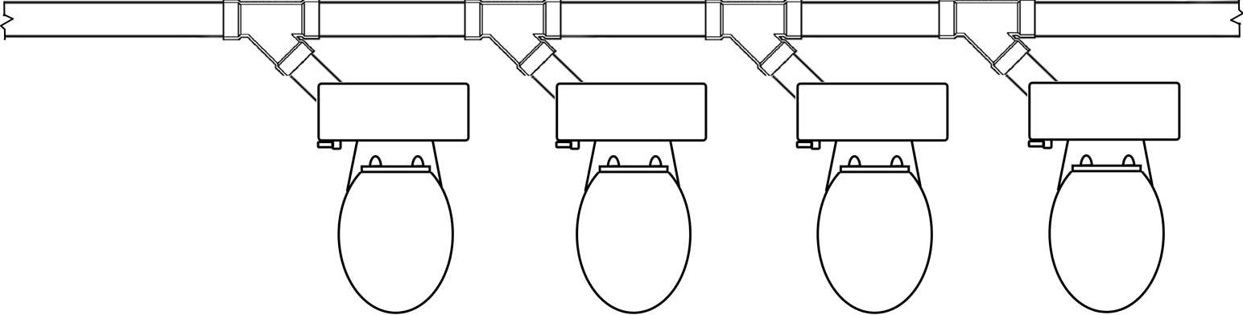

Battery Waste and& Vent System.: See 248 CMR 10.03: Combination Waste and& Vent System.

Black-water. Waste water Water: Wastewater containing fecal matter and other human waste that is flushed or discharged from toilets or urinals.

Boiler Blow-off.: An outlet on a boiler to permit emptying or discharge of sediment.

Boiler Blow-off Tank.: A vessel designed to receive the discharge from a boiler blow-off outlet, to cool the discharge to a temperature of 150EF150 degrees Fahrenheit or less, and permits the discharge to flow safely to the drainage system.

Branch.: Any part of a piping system other than a main, riser, or stack.

Branch Interval.: A distance along a soil or waste stack corresponding in general to a story height, but not
less than eight feet in vertical height, and wherein the horizontal branches from one floor or story of a building are would be connected to the stack. See 10.03: Example 2

10.03: Example 2 - Branch Intervals
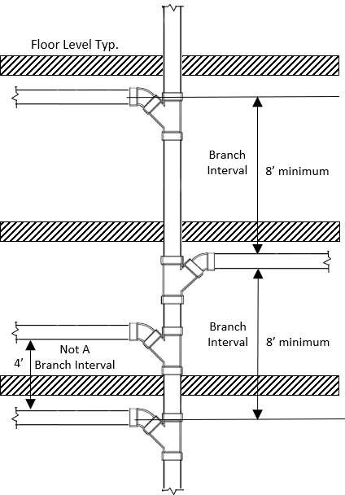
Branch Vent.: A vent connecting one or more individual vents with a vent stack or stack vent.

Building.: A structure used for the housing, shelter, enclosure, or support of persons, animals, or property.

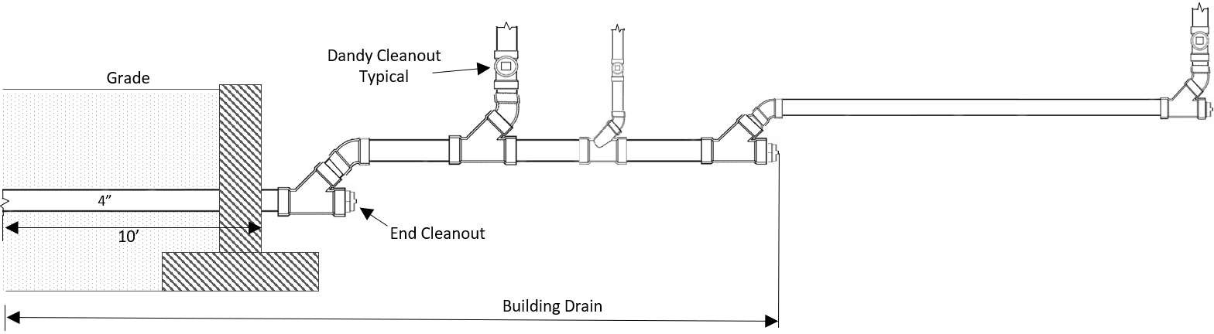
Building Drain.: The lowest horizontal piping ofin a drainage system that extendsreceiving discharge in fixture units from the base of the main stack to soil, waste and other drainage piping conveying that waste to a terminating pointbuilding sewer measured ten feet outside in developed length from the inside face of the inner surface of a building’s foundation wall, and is of sufficient size to receive. The ten-foot section defined as the discharge from branch drainsBuilding Drain shall be minimum four inch and/or stacks. sized in accordance with 248 CMR 10.15 (6) (b). See 10.03: Example 3

10.03: Example 3 - Building Drain

Building Drain - Sanitary.: A building drain which conveys the discharge of plumbing fixtures.

Building Drain - Storm.: A building drain which conveys storm water waste or other clear water drainage.

Building Sewer.: The pipe that begins ten feet outsideat the inner face of a building’s foundation wall end of the building drain and extends to a public sewer, septic tank, or other place of sewage disposal. See 10.03: Example 4

10.03: Example 4 - Building Sewer
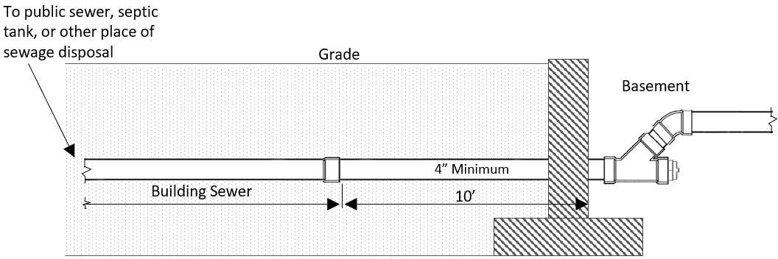

Building Sewer - Combined.: A building sewer that conveys both sewage and storm water or other drainage.

Building Sewer - Sanitary.: A building sewer that conveys the discharge of plumbing fixtures.

Building Sewer - Storm.: A building sewer that conveys storm water waste or other clear water drainage except that it does not convey sewage.

Building Subdrain.: The portion of a drainage system that cannot drain its discharge into a building sewer via the force of gravity.

Building Subdrain - Sanitary.: The portion of a drainage system that cannot drain its sewage discharge into a building sewer via the force of gravity.

Building Subdrain - Storm.: The portion of a drainage system that cannot drain its storm water waste, clear
water discharge or other subsurface clear water discharge excluding sewage, into a building storm sewer via the force of gravity.

Circuit Vent.: A branch vent that serves two or more floor-outlet fixtures that are battery wasted. Said vent
extends from the top of the horizontal soil and/or waste branch in front of the last fixture waste and connects to a vent stack adjacent to the upstream end of the horizontal branch. A circuit vent begins where a drain from the fixture connects to the battery waste horizontally and extends to a point where it runs vertically to the venting system providing free movement of air above the flow line of the horizontal drain.

Clear Water Waste: Wastewater discharge from air conditioning and refrigeration equipment, condensate from steam equipment, steam and water boiler blowdowns, sprinkler system discharge and other similar types of waste containing only clear water.

Combination Fixture.: A fixture that combines multiple compartments into one unit.

Combination Waste and Vent System.: A specially designed system of waste piping embodying the horizontal wet venting of one or more plumbing fixtures or floor drains by means of a common waste and vent pipe. In
such a system, the piping is adequately sized to provide free movement of air above the flow line of the drain. The complete system shall be compliant with 248 CMR 10.16 (1)(a).

Common Vent.: A vertical vent that serves two fixtures and connects in compliance with 248 CMR 10.16:
Table 1.

Conductor.: A pipe that is inside a building and that conveys storm water from the roof to a storm drain or combined building sewer/storm sewer. See 10.03: Example 5

10.03: Example 5 - Roof Drain Conductor
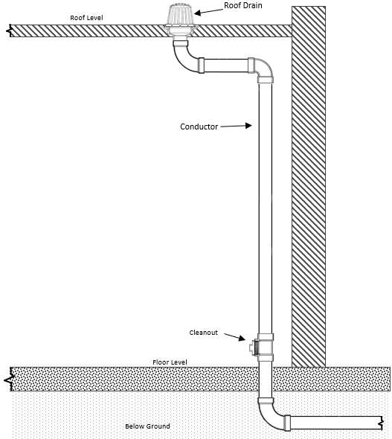

Core Facilities: A rest room consisting of at least one toilet and one lavatory which may be utilized by more than one business, classification, or category within that building or structure.

CPVC: Chlorinated Polyvinyl-Chloride

Continuous Vent.: A vertical vent that is a continuation of the vertical drain to which it connects.

Critical Level.: In the potable water supply piping, the minimum elevation that a backflow prevention device or anti-siphon vacuum breaker is installed, above the flood level rim of the fixture or receptacle it is to serve.

Cross Connection.: Any actual or potential physical connection or arrangement between a pipe containing potable water from a public water system and any non-potable water supply, piping arrangement, or
equipment, including, but not limited to waste pipe, soil pipe, sewer drain or other unapproved sources. (See 248 CMR 10.03: Back-flow and Back-siphonage.)

Dead End. A branch leading from a soil, waste, or vent pipe, building drain, or building sewer, and terminating at a developed length of two feet or more by means of a plug, cap or other closed fitting. on a potable water system which does not contain an accessible isolation valve located within 5’ of the main capped for possible future use.

Decontamination.: The reduction or removal of microbial or hazardous chemical contamination from surfaces, liquids, or spaces.
Dedicated Systems.: Specialized plumbing systems which are located within a property line, but not
necessarily within a Building, that are utilized for storing, treating, removing, or recycling water and waste products. Examples of dedicated systems include, but are not limited to:
- (1) Dedicated Acid Waste - Special Waste WaterWastewater Discharge Systems;.
- (2) Dedicated Gasoline, Oil and Sand Systems;.
- (3) Dedicated Grease Systems;.
- (4) Dedicated Water Recycling Systems;.
- (5) Dedicated Class V Well Systems.
Developed Length.: The length of a pipeline as measured along the center line of the pipe or fittings. Diameter. The nominal diameter as designated commercially.
Double Offset.: Two changes of direction that are or have been installed in succession or series in a continuous pipe.
Domestic Sewage.: The waterborne wastes derived from ordinary living processes.

Drain.: A horizontal pipe that carries waste waterwastewater or waterborne waste in a drainage system.
Drainage System.: Includes all the piping contained within a public or private premisespremise that conveys sewage, rain waterrainwater, or other liquid wastes to an appropriate point of disposal. It does not include the mains of a public
sewer system or private or public sewage treatment or disposal plant.
Drainage System, - Building Gravity.: A drainage system that drains via the force of gravity into a building sewer.

Drinking Fountain. Either: For the purposes of this code, Drinking Fountain shall be either Drinking Water Station, with - With Drain or Drinking Water Station, - Without Drain.

Drinking Water Station, with - With Drain.: A device equipped with a nozzle that when activated provides a stream of drinking water for either direct consumption or to allow filling of bottles. Said device is
connected to the water distribution system, may chill, and/or filter the water, and is connected to the sanitary drainage system.

Drinking Water Station, - Without Drain.: A device equipped with a nozzle that when activated provides a stream of drinking water for either direct consumption or to allow filling of bottles. Said device is connected to the water distribution system, may chill, and/or filter the water, and is not connected to the sanitary drainage system, though rough plumbing has been added to facilitate a future connection.
Dual Vent. (See 248 CMR 10.03: Common Vent)

Durham System.: Soil or waste systems where all piping is threaded pipe that uses recessed drainage fittings to correspond to the types of piping.
Dwelling - Single.: A room or group of rooms, forming a single habitable unit that is an independent building enclosed within its own exterior walls, roof, and foundation, with facilities which are used, or intended to be used, for
sleeping, living, cooking, and eating; and where both the sewer connection and water supply are within the building’s own premise and is separate from and completely independent of any other dwelling.
Dwelling - Multiple.: Three or more single dwellings that are not independent buildings, that sharesharing exterior walls, a roof, and a foundation and where a common sewer connection and water supply are contained within the premise.

Dwelling - Two Family.: Two single dwellings that are not independent buildings, that share a common
exterior wall, a roof, and a foundation and a where a common water supply and sewer connection are contained within its own premises.
DWV: Drain, Waste and Vent

Effective Opening.: The minimum cross-sectional area at the point of water supply discharge, measured or expressed in terms of:
- if the opening is circular as the diameter of a circle;, or
- if the opening is not circular, as the diameter of a circle having the equivalent cross-sectional area of the opening.

Existing Work. A plumbing system or any part thereof installed prior to March 11, 2005.

Fire Line. A system of pipes and equipment used exclusively to supply water for extinguishing fires.

Fixture (Plumbing Fixture): Installed receptacles, devices or appliances that are either supplied with water
and/or receive and/or discharge liquids, or liquid-borne wastes, or both, with or without discharge into the drainage system with which they may be directly or indirectly connect.
Fixture Branch.: A pipe connecting several fixtures.

Fixture Drain.: A drain connected to the trap of one fixture.

Fixture Supply.Connector: The water supply pipe that connects aflexible connector made of copper, copper alloy or stainless steel used to connect the fixture to either a branch water supply pipe or directlyshut-off valve to a main water supply pipethe individual fixture or appliance.
Fixture Unit. The rate of discharge : One cubic foot of water through a plumbing fixture wherein 7½ gallons per drained in a one and one quarter inch pipe over a period of one minute. One cubic foot of water is equal to one fixture unit7.5 gallons.
Flood Level Rim.: The edge of a receptacle from which water overflows. Flooded.: When the liquid in a fixture or receptacle rises to the flood level rim.
Flow Pressure (Residual Pressure): The pressure in a water supply pipe as measured at the faucet or water outlet when the faucet or water outlet is wide open and flowing.

Flush Valve. A device that is located at the bottom of a tank and that is used for flushing toilets and similar fixtures.

Flushometer Valve. A device used for flushing purposes that discharges a predetermined quantity of water into fixtures and where the device is closed by direct water pressure.
Genetics. The branch of biology that deals with heredity and variations of organisms.

Grade.: The fall (slope) of a line of pipe inwith reference to a horizontal plane. In drainage it is usually expressed as the fall in a fraction of an inch per foot length of pipe.

Gray-water.Graywater: Used water out-flowing from a clothes-washer, shower, bathtub, or bathroom sink and reused on the same site for below ground irrigation only. Gray-water is typicallynot treated..

GPM: Gallons Per Minute

Grease Interceptor. (Gravity): A passivelarge interceptor whose rated flow exceeds 50 gpm (189 L/m). (, (usually installed outside underground) because it requires an extended time for grease separation (30 minutes or more). The separation is simply due to the specific gravity difference between FOG (fats, oils, and grease) and water. See 248 CMR 10.03: Example 6

10.03: Example 6 - Gravity Type Grease Interceptor)
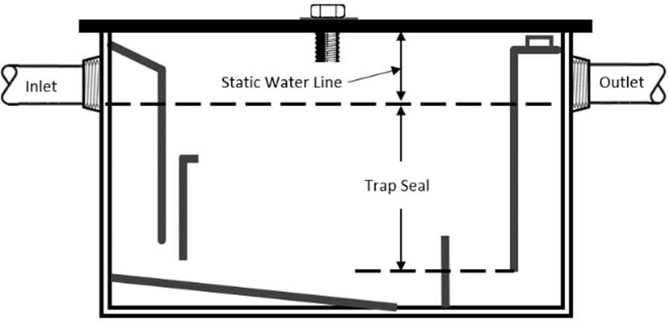

Grease Trap.Interceptor (Hydro-Mechanical): A passivesmaller interceptor whose rated, (normally installed inside a building) which is compact in size because grease separation occurs continuously due to several simultaneous actions; a
hydraulic flow is 50 gpm (189 L/m) or less. (See 248 CMR 10.03: Interceptor)action, air entrainment and the difference in specific gravity between water and FOG (fats, oils and grease).

Hangers. : (See 248 CMR 10.03: Supports)
Hazardous Waste. A waste, or combination of wastes, which because of its quantity, concentration, or physical, chemical or infectious characteristics may cause, or significantly contribute to an increase in mortality or an increase in serious irreversible, or incapacitating reversible illness or pose a substantial present or potential hazard to human health, safety, or welfare or to the environment when improperly treated, stored, transported, used or disposed of, or otherwise managed. See 310 CMR 30.00:

Hazardous Waste for possible exemptions and for “Mixed Waste”.

Horizontal Branch Drain. A drain branch pipe that extends laterally from a soil or waste stack or a building drain, that may or may not have vertical sections or branches, that receives the discharge from one or more fixture drains and that conducts the discharge to the soil or waste stack or to the building drain.

Horizontal Pipe. Any pipe or fitting that makes an angle of less than 45 degrees E in reference to a horizontal plane. See 10.03: Example 7

10.03: Example 7 - Horizontal Pipe
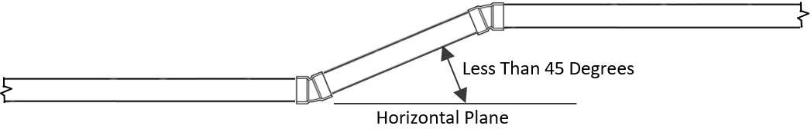

Hot Water: Water at a temperature of at least 120EF degrees Fahrenheit.

Individual Sewage Disposal System: A system for disposal or treatment of domestic sewage by means of a septic tank or sewage treatment plant wherein the system is designed for use apart from a public sewer and serves a single establishment or building where a public sewer is not available.

Indirect Waste Pipe. A waste pipe that does not connect directly with a drainage system, but discharges into a drainage system through an air break or air gap into a properly wasted and vented trap, fixture, receptacle or interceptor.

Individual Sewage Disposal System. A system for disposal or treatment of domestic sewage by means of a septic tank or sewage treatment plant wherein the system is designed for use apart from a public sewer and serves a single establishment or building where a public sewer is not available.

Individual Vent: A pipe installed to vent a fixture drain. It connects with the vent system above the fixture served or terminates at a point above the roof level.
Individual Water Supply: A water supply, other than a public water supply, that serves one or more buildings, dwellings, or structures.
Industrial Waste wWater: Water that has been contaminated with by-products of industrial manufacturing processes.
Industrial Wastes: Liquid wastes that result from the processes employed in industrial and commercial establishments.

Insanitary: Contrary to sanitary principles; injurious to health.
Interceptor: A device designed and installed to separate and retain for removal, by automatic or manual (passive) means, deleterious, hazardous, or undesirable matter from normal wastes and permits normal sewage or liquid wastes to discharge into the drainage system by gravity.
Installed: An altered, changed, or new installation.

Invert: The lowest point inside a pipe upon which water can flow. See 10.03: Example 8

10.03: Example 8 - Invert of a Pipe


Irrigation System: A system of water distribution piping used to wet or moisten the landscape.
Leaching Well or Pit: A pit or receptacle having porous walls that permits the contents to seep into the ground.

Leader: An exterior drainage pipe for conveying storm water from roof or gutter drains. and discharges to a storm water waste system. See 10.03: Example 9. See 10.03 definition of plumbing for jurisdiction.

10.03: Example 9 - Storm Water Leader
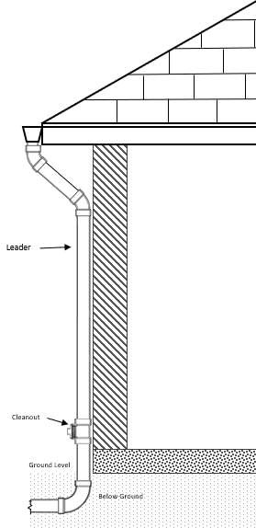
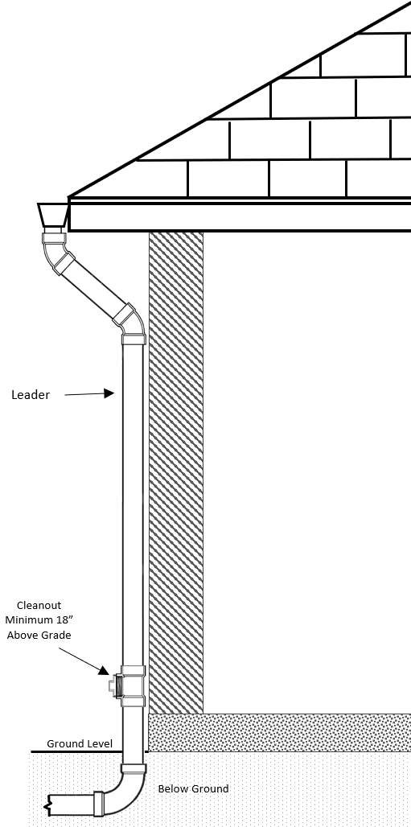

Liquid Waste: Discharge from any fixture, appliance, area, or appurtenance that does not contain human or animal waste matter suspended in a solution.

Licensee: The holder of a current journeyman or master plumbing license issued by the Board.

Load Factor: The percentage of the total connected fixture unit flow which is likely to occur at any point in
the drainage system. It varies with the type of occupancy, the total flow unit above this point being considered, and with the probability factor of simultaneous use.

Loop Vent: A branch vent that serves two or more floor-outlet fixtures that are battery wasted. The loop vent extends from the top of the horizontal soil and/or waste branch in front of the last fixture waste and connects to a vent stack or stack vent that is adjacent to the down-stream end of the horizontal branch. as required in
248 CMR 10.16. A loop vent begins where a drain from the fixture connects to the battery waste horizontally and extends to a point where it runs vertically to the venting system providing free movement of air above the flow line of the horizontal drain.

Main: The principal pipe artery to which branches may be connected.

Massachusetts Professional Engineer. A person who is licensed or otherwise authorized to practice in the engineering profession as defined by the statutory and regulatory requirements of the Commonwealth.

Materials: All piping, tubing, and fittings, drains and receptacles, interceptors and protectors, hangers and supports, covers and coverings, appliances and other devices and appurtenances used, or referred to, in the definitions of Plumbing, Plumbing Fixtures and Plumbing Systems.

Mezzanine. An intermediate or fractional level between a floor (orfloors) inabuilding whichisopentotheflowbelowprojectingand a ceiling that projects in the form of a balcony over the floor and wherein the aggregate floor area of the intermediate or fractional level is less than 33% of the area of the floor over which it is located.and is less than 33 percent of the area of the floor over which it is located. For the purposes of this code, a mezzanine shall not be considered a floor level where fixtures are required.

Non-potable Water: Water that does not meet the standards of potable water. Its bacteriological and chemical quality does not conform to the pertinent requirements of 310 CMR 22.00, Drinking Water.

Nuisance: Public nuisance as known in common law or in equity jurisprudence; what is dangerous to human life or detrimental to health; what building, structure or premise is not sufficiently ventilated, sewered, drained, cleaned, or lighted, in with reference to its intended or actual use; or what renders the air or human food or drink or water supply unwholesome.

Offset: A combination of elbows or bends which brings a pipe out of line with one section of piping but into a line parallel with another section of piping.

pH: The negative logarithm of the hydrogen-ion concentration used in expressing both acidity and alkalinity

on a scale whose values run from zero to 14fourteen, with a lower value of less than seven indicating increasing acidity and values greater than seven indicating increasing alkalinity. A value of seven would indicate a neutral pH condition.

Person: A natural person, his heirs, executors, administrators or assigns; a firm, partnership, corporation, institution, association or group, its or their successors or assigns, or a city, town, county, or other governmental unit, owning or renting, leasing, or controlling property, or carrying on an activity regulated by M.G.L. c. 142 or 248 CMR.

PEX: Cross-Linked Polyethylene

Plumbing: Plumbing includes the work and/or practice, materials and fixtures used in the installation, removal, maintenance, extension, and alteration of a plumbing system; of all piping, fixtures, fixed appliances and appurtenances in connection with any of the following: sanitary drainage or storm drainage facilities, hazardous wastes, the venting system and the public or private water-supply systems, within or adjacent to any building, structure, or conveyance; to their connection with any point of public disposal or other acceptable terminal within the property line. Plumbing This definition shall not include the following:

(a1) The installation of potable water pipes entering the property from outside the property line or a potable water source inside the property to either a metering device or control valve closest to the inside face of the outermost foundation wall of a building or structure. This exemption shall not apply to any potable water pipes on the outlet side of a metering device or control valve serving a plumbing fixture located outside of a building or structure:

(b2) The installation of exterior waste piping beginning after the first ten feet of developed length of pPiping falling outside of a Bbuilding’s foundation wall/exterior to the building structure which is used to carry building drainage to a public sewer, septic tank, or other place of wastewater disposal. The connection of such pipes to any fixtures (such as an exterior grease interceptor) or other drainage
systems are not included in this exemption. Storm drainage leader piping originating from an outside scupper which at no time enters a building or structure.

(c3) The installation of perimeter or sub-soil drains which do not discharge, communicate, or convey discharge to a storm or sanitary drainage system.

(e4) These exemptions shall be narrowly construed and shall not be considered to apply to Dedicated
Systems or any other piping systems not explicitly referenced in (1a) through to (3c), above. Additionally, these exemptions apply to pipes only, and should not be construed as creating exemptions for other fixtures, appliances, and appurtenances connected to said pipes.

Plumbing System: The water supply and distribution pipes; plumbing fixtures and traps; soil, waste, and vent pipes; building sanitary and storm drains including the respective connections, devices, and appurtenances of the drains that are connected a point of public disposal or another appropriate terminal within the property line.

Potable Water: Water that does not contain impurities in amounts enough to cause disease or harmful physiological effects. Its bacteriological and chemical quality shall conform to the pertinent requirements of
310 CMR Department of Environmental Protection or to the pertinent local Board of Health regulations 22.00, Drinking Water.

Private or Private Use: In the classification of plumbing fixtures, private shall apply to fixtures in residences, apartments, condominiums, dormitories, private office bathrooms and to private guest rooms in hotels and motels.

Private Sewer: A sewer, serving two or more buildings, privately owned, and not directly controlled by a public authority.

PSIG: Pounds Per Square Inch Gauge

Public or Public Use: In the classification of plumbing fixtures, public shall apply to every fixture not defined under Private or Private Use.

Public Sewer: A common sewer directly controlled by public authority.
Public Water Main: A water supply pipe for public use controlled by public authority.
Public Water System: A system for the provision to the public of water for human consumption, through pipes or other constructed conveyances if such system has at least 15 service connections or regularly serves an average of at least 25 individuals daily at least 60 days of the year. Public Water System includes any collection, treatment, storage, and distribution facilities under control of the operator of such a system and used primarily in connection with such system, and any collection or pretreatment storage facilities not under such control which are used primarily in connection with such system.

Purification Waste: A by-product of waste material generated by or from the fermentation process to produce a pure substance.

Purified Water: Water produced by distillation, deionization, reverse osmosis, or other methods so that it meets the requirements of purified water in the most recent edition of the United State Pharmacopoeia.

PVC: Polyvinyl-Chloride

Readily Accessible. Direct access without the necessity of removing or moving any panel, door, lock or similar obstruction.

Receptor: A properly trapped and vented fixture or device that receives the discharge from indirect waste pipes.

Recombinant Deoxyribonucleic Acid DNA Molecules: Viable organisms containing molecules made outside living cells by joining natural or synthetic DNA segments to DNA molecules that can replicate in a living cell, or DNA molecules that can result from the replication of those described above. Such use shall be in accordance with the NIH Guidelines for Research Involving Recombinant DNA Molecules, Federal Register Vol. 49, No. 227, November 23, 1984, P.462266.
Relief Vent: A vent that is designed to permit additional circulation of air between drainage and vent systems.

Return Offset: A double offset installed so that it returns the pipe to its original alignment.

Reverse Osmosis: A water treatment process that removes undesirable materials from water by using pressure
to force the water molecules through a semi-permeable membrane. This process is referred to as “reverse” osmosis. Pressure forces the water to flow in the reverse direction (from the concentrated solution to the dilute solution) to the flow direction (from the dilute to the concentrated) in the process of natural osmosis. Reverse osmosis removes ionized salts, colloids, and organic molecules down to a molecular weight of 100. This process is sometimes referred to as hyperfiltration.

Reverse Osmosis - (Water Treatment Unit): A device installed within a potable drinking water system that uses reverse osmosis as the primary technology for processing potable tap water into high quality drinking water. The reverse osmosis drinking water device is designed to separate water from undesirable dissolved and undissolved substances such as particulate matter, salts, metals, organic matter, and microorganisms.

Rim: An unobstructed open edge of a fixture.
Riser: A water supply pipe which extends vertically one full story or more to convey water to branches or to a group of fixtures.

Roof Drain: A drain receptor installed to receive water that collects on the surface of a roof and conveys the discharge water into a leader or a conductor.

Roughing-in: The installation of all parts of the plumbing system that can be completed prior to the installation of fixtures. This includes drainage piping, water supply piping, vent piping, the necessary fixture supports,
and any fixtures that are built into the building. Sand Trap: See 248 CMR 10.03: Interceptor.
Sanitary Sewer: A pipe that carries sewage but does not carry storm, surface, clear water, or ground water.

Seepage Well or Pit: A covered pit with open jointed lining. The septic tank effluent the pit receives may
seep or leach into the surrounding porous soil through the open jointed lining. Separator: See 248 CMR 10.03: Interceptor.
Septic Tank: A watertight receptacle to receive sewage from a building sewer or building drain which is designed and constructed to permit sufficient retention of wastewater to allow for the separation of scum and sludge and the partial digestion of organic matter before discharge of the liquid portion to a soil absorption system.
Sewage: Any liquid waste containing animal or vegetable matter in suspension or solution, and the waste may include liquids containing chemicals in solution.

Sewage Ejectors: A device for moving sewage by entraining it on a high velocity steam, air, or water jet.

Sewage Pump: A permanently installed mechanical device, except an ejector, for removing sewage or liquid
waste from a sump.

Side Vent. A vent that connects to a drain pipe via a fitting where the angle of the vent is less than 45E from the vertical.

Siphon Breaker: A siphon breaker is a valve device, or appurtenance, constructed and installed to prevent
back flow in the plumbing system or any portion thereof. (See 248 CMR 10.03: Back-flow and Back-siphonage)

Size of Pipe and Tubing. (See 248 CMR 10.03: Diameter) Slope. (See 248 CMR10.03: Grade)

Slope: (See Grade)

Soil Pipe: Any pipe that conveys the discharge of toilets, urinals or fixtures having similar functions to the building drain or building sewer. The discharge may be conveyed with or without the discharge from other fixtures.

Special Waste: A waste, or combination of wastes, which because of its quantity, concentration, or physical, chemical, or infectious characteristics may cause, or significantly contribute to an increase in mortality or an increase in serious irreversible, or incapacitating reversible illness or pose a substantial present or potential hazard to human health, safety, or welfare or to the environment when improperly treated, stored, transported, used, or disposed of, or otherwise managed. See 310 CMR 30.00 for possible exemptions and for “Mixed waste.”

Special Wastes, Piping or Treatment.: Wastes which require special treatment before entry into a normal plumbing system.

Special Waste Pipe.: Pipes which convey hazardous wastes.

Stack.: A general term for any vertical line of soil, waste, vent or inside conductor piping which extends beyond at least one branch interval in height.
Stack Group.: A term that is applied to the location of fixtures in relation to the stack so that by means of proper fittings vents may be reduced to a minimum.

Stack Vent.: The portion of a soil or waste stack that is six inches above the highest flood level rim of the highest fixture connected to the stack. The stack vent terminates in compliance with 248 CMR 10.16.
Stack Venting.: A method of venting a fixture or fixtures through a soil or waste stack.

Sterilization.: The act or process that is physical or chemical that results in the complete destruction of microorganisms.

Storm Drainage System.: A system that is used for conveying rain waterrainwater, surface water, condensate, cooling
water, sprinkler discharge or similar clear liquid wastes to the storm sewer or other place of disposal. The clear liquid waste conveyed excludes sewage or industrial waste.
Storm Sewer.: A sewer used for conveying rain waterrainwater, surface water, condensate, cooling water, or similar clear liquid wastes.
Subsoil Drain.: A drain that collects subsurface, ground or seepage water and conveys it to a place of disposal.
Sump.: A tank or pit that receives sewage or liquid waste, that is located below the normal grade of the gravity drainage system, and that must be emptied by mechanical means.
Sump Pump.: A mechanical device, except for an ejector or bucket, that removes clear liquid waste from a sump.
Supports - Hangers - Anchors.: Devices for supporting and securing pipe, fixtures, and equipment, to walls, ceilings, floors, or structural members.
Swimming Pool.: Any structure, basin, chamber, or tank containing an artificial body of water for swimming, diving, or recreational bathing and having a depth of two feet or more at any point.

Trap.: A fitting or device that provides a liquid seal that prevents the emission of sewer gases without materially effecting the flow of sewage or waste waterwastewater through it.
Trap Arm.: That portion of a fixture drain or waste drain between the trap and its vent.
Trap Primer.: A trap primer is a device or system of piping to maintain a water seal in a trap. Trap Seal.: The vertical distance between the crown weir and the top of the dip of the trap.
Treated Water.: Potable water that has passed through a system for the purpose of purification, aeration,
filtration, disinfection, softening, conditioning, fluoridation, stabilization, or corrosion correction and/or has had chemicals added which mayalter its physical, chemical or radiological quality.
Troughs.: An open conduit, drain, channel, trench, or gutter.
Unisex/Handicap/Gender-Neutral Toilet Room.: A room containing one toilet and one lavatory availableand a lockable door for use by anyone.
Vacuum.: Any pressure less than that exerted by the atmosphere.
Vacuum Breaker, Non-pressure Type (Atmospheric).): See 248 CMR 10.03: Anti-siphonSiphon Vacuum Breaker --- Non- pressure Type.
Vacuum Breaker, Pressure Type.: See 248 CMR 10.03: Anti-siphonSiphon Vacuum Breaker --- Pressure Type. Vacuum Relief Valve.: A device to prevent an excessive vacuum in a water storage tank or heater.
Vent - Automatic.: A mechanical device that opens as a resultbecause of negative pressure in the drainage system to prevent trap siphonage, and closes gas and water tightwatertight when the pressure in the drainage system is equal to or

greater than ambient pressure to prevent the entry of sewer gas into the building. Vent Pipe.: Part of a vent system.
Vent Stack.: A vertical vent pipe installed to provide circulation of air to and from the drainage system.

Vent System.: A pipe or pipes installed to provide a flow of air to or from the drainage system or to provide a circulation of air within such system to protect trap seals from siphonage and back pressure.

Vertical Pipe.: Any pipe or fitting which makes an angle of 45E45 degrees or less with the vertical plane.

Wall Hung Toilet.: A wall mounted toilet installed in such a way that no part of the toilet touches the floor.

Waste.: See 248 CMR 10.03: Liquid Waste.

Waste Pipe.: A pipe which conveys only waste.

Water Distribution Pipe.: A pipe within the building or on the premises that conveys water from the water service pipe to the point of usage.

Water Filter.: A device installed on a potable water system through which water flows for the reduction of turbidity, microorganisms, particulate matter, taste, color, odor, or other contaminants.

Water Main.: A pipe used to convey the public water supply.

Water of Questionable Safety.: Water in a plumbing system that passes through an isolated portion of the
water piping distribution system. The system is defined as beginning at the outlet of a back-flowbackflow preventing
device and ends at a point of final or actual connection with heating/cooling equipment or other fixtures, apparatus and appliances that require water for operation and process.

Water Outlet.: As used in connection with a water-distribution system, a discharge opening for water:
- to a fixture; or
- to atmospheric pressure (except into an open tank which is part of the water supply system); or
- to a boiler or heating system; or
- to any water operated device or equipment requiring water in a plumbing system.

Water Service Pipe.: The pipe from the municipal water main or private other source of water supply to the water distribution system of the building served.

Water Softener.: A device installed on a potable water system through which water flows for the reduction of hardness and other metals using the cation exchange process.

Water Supply System.: The water service pipe, the water distribution pipes, and the necessary connection pipes, fittings, control valves, and all appurtenances in or adjacent to a building or premises.

Water Treatment Device.: A device which means any instrument or product sold, rented, or leased, or offered for sale, rental or lease designed or claimed either to benefit potable water systems or to treat water intended for human consumption or use; including but not limited to, instruments or products using filtration, distillation, absorption, adsorption/ion exchange, reverse osmosis, or other treatment processes or
technologies such as magnetic or electro-magnetic field and catalytic conversion which is claimed to alter the radiological, chemical or physical properties of water.

Water Vending Machine. Any self-service device which, upon receipt of payment, dispenses purified or drinking water in bulk without the necessity of replenishing the device between each vending operation. The device is connected to a public or private system.

Wet Vent.: A waste pipe that also serves as a vent, on the same floor level.

Workmanship.: Work of such character that will fully secure the desired or needed results.

Yoke Vent (Relief Vent-foot).: A pipe connecting at a forty-five-degree angle upward from a soil or waste stack to a vent stack and designed for the purpose of preventing pressure changes in the stack.

  - : Testing and Safety

    - Surveyed: Prior to the commencement of work, all portions of existing systems that arewill be directly affected by proposed plumbing work shall be surveyed by the licensed plumber to insure that the existing work issystems are adequate to support the proposed work.

    - Testing and Inspections of the Plumbing System. An Inspection is required for all plumbing work pursuant:
All testing shall adhere to 248 CMR 3.00: General Provisions Governing the Conduct of Plumbing and Gas Fitting Work Performed in the Commonwealth. In addition, themanufacturer’s testing requirements in 248 CMR 10.04(2)(a) and (b) shall be satisfied.of the materials being tested.

- Testing and Inspection of Rough Plumbing.:
  - The piping of the plumbing, drainage, and venting systems shall be tested as part of the Inspection.

  - Upon proper notice of a request for an Inspection of the rough plumbing, the Inspector shall make the Inspection within two working days after receipt of such notice.

  - The Inspector shall proceed with the Inspection only if the licensed plumber requesting the Inspection is on site, with a current edition of 248 CMR: Board of State Examiners of Plumbers and Gas Fitters.

Prior to requesting an inspection of rough plumbing, the licensee shall choose one of the testing methods listed in 248 CMR 10.04 to ensure the safe and proper functionality of the installed plumbing system. All testing shall be performed in accordance with product manufacturer instructions. Exception: The testing of plumbing systems in manufactured and modular buildings shall be accomplished by performing a non-destructive test and without removal of walls or other pre-fabricated building components. The Inspector may require the permit holder or other licensee employed by the permit holder to be on site, with the most current edition of 248 CMR the Massachusetts Fuel Gas and Plumbing Code.

4i. Methods of Testing the Drainage and Vent System.:
    - Water Test.: A water test shall be applied to the drainage system either in its entirety or in sections. If applied to the entire system, all openings in the piping shall be tightly closed, except the highest opening and the system filled with water to point of overflow. If the system is tested in sections, each opening shall be tightly plugged, except the highest opening of the section under test, and each section shall be filled with water. , but no section shall be tested with less than a ten-foot head of water. When testing successive sections, at least the upper ten feet of the next preceding section shall be tested, so that no joint or pipe in the building (except the uppermost ten feet of the system) shall have been submitted to a test that utilizes less than a ten- foot head of water. The water shall be kept in the system or in the portion under test for at least 15fifteen minutes before the inspection starts: the system shall then be tight at all points.
    - Air Test. An air test shall be performed by attaching an air compressor testing apparatus to any suitable opening, and, after closing all other inlets and outlets to the system, forcing air into the system, until there is a uniform gauge pressure of five
P.S.I.G.PSIG or sufficientenough pressure to balance a column of mercury ten inches in height. This pressure shall be held without introduction of additional air for a period of at least 15
fifteen minutes. The gauge used for this test shall be calibrated in increments no greater than 1/10one tenth of a pound.
- Peppermint Test.
  - A peppermint test shall only be used and performed on the
concealed piping within existing buildings or structures. The test shall be applied by
creating a liquid mixture with the appropriate amount of oil of peppermint and hot water. The mixture shall contain two ounces of oil of peppermint for every one gallon of hot water. This mixture shall be sufficient for testing a stack 50 feet in height or the equivalent of five branch intervals, (including the basement, if applicable).
  - The mixture shall be poured down a main stack.
  - The stack opening shall then be sealed.
  - The individual who has handled the oil of peppermint or the peppermint mixture shall not enter the building until the test has been completed. The presence of
the aroma of the oil of peppermint may potentially be present on the individual who created the mixture and will compromise the building environment under test and observation.
  - After the completion of the test and upon immediate inspection of the building, if the odor of peppermint is prominent in a given area, then the test indicates a defect in that portion of the system in that vicinity.
- Smoke Test. A smoke test shall be performed by obtaining smoke injector
equipment designed for the purpose of producing and introducing a heavy volume of smoke. Smoke injector testing equipment utilizes several methods for producing
adequate smoke conditions for testing; manufacturer’smanufacturers’ recommendations shall be observed. The discharge hose from the smoke injector equipment shall be extended to
and through a smoke test cap or plug and all voids encompassing the hose shall be sealed with putty or otheranother similar compound. When the entire system or portion thereof is charged with smoke, air pressure equal to one-inch water column shall be applied. Defects, failures, and leaks in the piping system will be revealed by plumes of smoke that will discharge through them.

2.ii. Methods of Testing the Water Distribution and Supply System. :
Upon completion of a section or of the entire water supply system when roughed, it shall be tested and proved tight under a pressure not less than 125 one hundred and twenty-five pounds per square inch. Water used for tests shall be obtained from a potable supply source. Air or other inert gases may be used for testing.

- 2. Final TestTesting and Inspection of Finish Plumbing.

  - 1. Within When work is ready for inspection, notice shall be given to the Inspector as required by 248

CMR 3.05 (3) (d) (1) within five days after the plumbing work is sufficiently advanced so that Principle No. 6 in 248 CMR 10.02(6) is satisfied, the plumber who performed the work or the Permit Holder shall notify the Inspector.complete.

  - 2. Within two working days after receipt of such notice, the Inspector shall proceed with the
inspection and examine the work with the water turned on to the fixtures. If requested by theThe Inspector, the licensed plumber shall may require the permit holder or other licensee employed by the permit holder to be presenton site, with athe most current edition of 248 CMR the Massachusetts Fuel Gas and Plumbing Code.

  - 3. If the installation is found in compliance with 248 CMR an Inspection approval tag shall be issued by the Inspector.

  - Grease Interceptors: Interceptors must be isolated from the drainage system prior to rough or final inspection. The interceptor must not be subjected to air, water, or any other type of pressure test.

    - 4. Defects.
      - Should the examination ofinspection of the permitted plumbing work disclose any defects or violations of 248 CMR, the plumberpermit holder shall be required to remedytheremedy the violations and defects, without delay, and notify the Inspector inspector for a repeat Inspectioninspection of the installation.
      - If the licensee holding a permit for work in a building turns the water on and fails to properly notify the Inspector as required, or neglects to remedy any defects or violations that may have been found and pointed out to him or her disclosed by the Inspector he or she shall not be granted any further permits until the defects have been rectified and/or the final inspection has been performed. he or she has complied with 248 CMR. Other disciplinary action may be pursued by the Inspector as provided for in M.G.L. c. 142 and 248 CMR.

- Defective Materials and Poor Workmanship. If at the time of testing and Inspection leaks, defective or patched materials, or evidence of unskilled or inferior workmanship is found with the plumbing installation, the following procedures shall be followed:
  - The Inspector shall condemn the affected part(s) or entire system.
  - The Inspector shall order that the defective parts, unskilled or inferior workmanship be removed and corrected.
  - No further progress shall be allowed with the installation until the defective parts, unskilled or inferior workmanship is compliant with 248 CMR 3.00 through 10.00.

- Repairs and Alterations.:
  - Deviations from the provisions of 248 CMR may be permitted in existing buildings or premises where plumbing installations are to be altered, repaired, or renovated. The deviations shall be negotiateddetermined and
agreed upon by the Permit Holderpermit holder and the Inspectorinspector prior to the installation. The deviations may be allowed provided that the deviationsthey are found to be necessary and conform to the scope and intent of 248 CMR 10.00.
  - Whenever compliance with all of the provisions of 248 CMR 10.00 fails to eliminate or alleviate a nuisance that may involve health or safety hazards, the Inspector shall notify the owner or his or herthe owner’s agent in writing ofregarding the violations and the proper procedures necessary to become compliant. This section
shall not be deemed as an allowance to permit waivers from the violations. The owner or his or her agent shall notifya licensed plumber to install suchadditionalplumbingor equipment that maybe found necessary by theInspector.material provisions of 248 CMR 10.06 or the fixture requirements of 248 CMR 10.10 (15).
- Defective Plumbing.:
  - Whenever there is reason to believe that the plumbing system of any building has become defective, it shall be subjected to test and/or inspection, . The Inspector shall notify the owner or the owner’s agent
in writing regarding the defective plumbing and any defects found shall be corrected as required in writing by the Inspectorthe proper procedures necessary to become compliant.

  - Whenever the work subject to a permit complies with the provisions of 248 CMR 3.00 through 10.00,
but the Inspector notes other existing plumbing or gas fitting that may cause a health or safety hazard, the Inspector shall notify the owner or the owner’s agent of the hazard in writing regarding the violations and the proper procedures necessary to become compliant.

- Maintenance. The plumbing and drainage system of any premises shall be caused to be maintained in a sanitary and safe operating condition by the owner or his or her agent.

(76) Demolition and Removal.:
- When a fixture that is connected to the plumbing system is to be permanently removed, a permit for the work shall be secured. All plumbing connections to that fixture shall be made water and gas tight.
- Insofar as they are pertinent, the provisions of 248 CMR 10.04(96)(a) shall also apply when a building, structure, dwelling, or tenant space is to be demolished.

- Personal Safety.
  - In General. All personnel working on plumbing systems water, waste, vents systems, fixtures and, appliances and appurtenances shall wear appropriate protected clothing and/or equipment and conform to M.G.L. c. 111F, § 2, the “Right to Know Law”.

  - Special Labs. All licensed plumbers and plumbing apprentices installing pipe connections or working on drains to hospital waste and vent systems, mortuary waste and vent systems, laboratory waste and vent systems, dental waste and vent systems and plumbing systems in radioactive sensitive areas shall have the surface of their body and clothing protected by disposable or washable gowns similar or equal to the gowns, gloves and face masks worn by surgicalstaff.

  - : General Regulations
    - Conforming with 248 CMR 10.00. Except as otherwise allowed by specific exceptiona variance granted by the Board under 248 CMR 3.00: General Provisions Governing the Conduct of Plumbing and Gas Fitting Work Performed in the Commonwealth, all plumbing which is installed plumbing shall conform to the following general requirements as outlined in 248 CMR 10.00.

(2) Pitch of Horizontal Drainage Piping.:
      - Horizontal drainage piping shall be run in straight practical alignment and at a consistent uniform pitch.
      - Horizontal drainage piping which is three inches in diameter or smaller shall be installed with a minimum uniform pitch of ¼ one-quarter of an inch per foot.
      - Horizontal drainage piping which is larger than three inches in diameter shall be installed with a minimum uniform pitch one-eighth of can inch per foot.
      - Storm or sanitary drains shall be installed at a slope that drain piping may deviate from the above pitch requirements, provided the pitch produces a computed discharge velocity of discharge of not less than two feet per second. Such piping systems must be designed by a Massachusetts professional engineer.
      - Refer to 10.15, Table 2 regarding pitch requirements for a building drain.

- Changes in Direction of Drainage Piping.:
  - Allowable Fittings to Be Used.:
    - Changes in the direction of drainage piping shall be made bywith the use of wyes, long sweep quarter bends, fifth, sixth, eighth or sixteenth bends, or their equivalent.
    - Quarter bends, or their equivalent may be used in soil and waste lines when the change in the direction of the flow is from the horizontal to the vertical.
    - Tees and crosses for vent fittings may be used for changes in the direction of vent piping only.
    - Short sweep fittings may be used in a branch waste line when the waste line serves only one outlet and cleanouts are provided in accordance with 248 CMR 10.08.
  - Back to Back Fixtures. Back to back fixtures shall be installed:
    - with fittings that are designed to prevent the discharge of each fixture to mix prior to a change in horizontal direction; or
    - with fittings especially designed to eliminate throw over from the discharge of one fixture to the discharge of the other fixture without compromising venting requirements.

- Fittings and Connections Prohibited.:
  - FittingsProhibited. Fittings:
    - No fitting that incorporates a straight T branch shall be used as a drainage fitting.
    - No fitting or connection that has an enlargement chamber or that has a recess with a ledge or shoulder, or that incorporates a reduction in pipe area shall be used.
    - No running threads, bands or saddles shall be used in a drainage system.
    - No drainage pipe or vent piping shall be drilled, tapped, burned, or welded.
    - A fitting Fittings commonly referred to as a “Sisson Joint” isJoints” are prohibited.
  - Obstruction to Flow.:
    - No fitting, connection, device, or method of installation that obstructs or retards the flow of water, wastes, sewage, or air in drainage or venting systems where the obstruction results in flow resistance
that is greater than the normal frictional resistance to flow shall be used unless otherwise specifically indicated elsewhere in 248 CMR 10.00.
    - The enlargement of a three-inch closet bend or stub to four inches shall not be considered an
obstruction under 248 CMR 10.05(4)(b)this provision provided that the horizontal flow line or insert is continuous without forming a ledge. See 10.05: Example 1
  - Dead Ends. Dead ends shall not be used as any part of a drainage system except where the use of a dead end is necessary to extend a cleanout so as to be accessible.

10.05: Example 1 - Enlargement of a three-inch Closet Bend or Flange
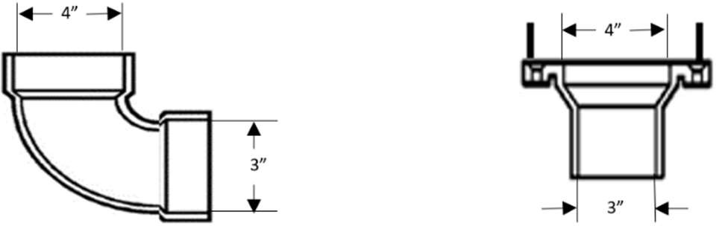

(dc) Heel or Side-inlet Bends.: A heel or side-inlet quarter bend shall not be used as a dry vent when the
inlet is placed in a horizontal position, or any similar arrangement of pipe and fittings producing a similar effect, except when the entire fitting is part of a dry vent arrangement. See 10.05: Example 2

10.05: Example 2 – Side-Inlet Bend
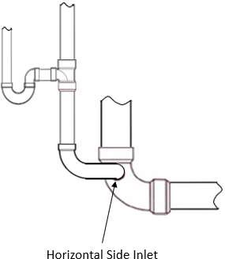

- Trenching, Tunneling and Backfilling for Storm and Sanitary Systems.
  - Trenching and Bedding.
    - Trenches shall be of sufficientenough width to permit proper installation of the pipe.
    - Where shoring is required, ample allowance shall be made in the trench’s width to facilitate proper working conditions.
    - Where trenches are excavated to a grade such that the bottom of the trench forms the bed for the pipe:
      - care must be exercised to provide solid bearing between joints; and
      - bell holes shall be provided at points where the pipe is joined.
    - Where trenches are excavated below grade such that the bottom of the trench does not form the bed for the pipe, the trench shall be back filled to grade with sand tamped in place to provide a uniform bearing surface for the pipe between joints.
    - Where rock is encountered in trenching:
      - The rock shall be removed to a point at least three inches below the grade line of the trench
and the trench shall be backfilled to grade with sand tamped in place so as to provide a uniform bearing for the pipe between joints; and
      - care shall be exercised to ensure that no portion of the pipe, including its joints, rests on any portion of a rock.
    - If soft materials of poor bearing qualities are found at the bottom of the trench:
      - a concrete foundation shall be provided to ensure a firm foundation for the pipe; and
      - the concrete foundation shall be bedded with sand tamped in place so as to provide a uniform bearing for the pipe between joints.
      - In trenches where a firm foundation cannot be established, piping shall be properly suspended from the concrete above.
    - Where For PVC andor ABS pipingis installed underground. See 248 CMR 10.06(2)(o)19.:
      - Prepare a smooth, uniformly compacted trench bottom using granular fill. Place the pipe in uniform alignment and grade with a continuous bearing on the bottom quadrant of the pipe along its entire length.
      - Using granular fill, compact and backfill around the pipe to a point at least six inches over the crown of the pipe.
      - Do not allow large stones or pieces of earth to be dropped into the trench when completing the backfilling process.
      - The requirements of a, b and c above shall be the responsibility of the on-site licensed plumber.
  - Tunneling:
    - Where necessary, pipe may be installed by tunneling or jacking, or a combination of both. In
such cases special care shall be exercised to protect the pipe from damage either during installation or from subsequent unevenloading.
    - Where earth tunnels are used, adequate supporting structures shall be provided to prevent future settling or caving.
    - Pipe may be installed in a larger conduit that has been jacked through unexcavated portions of the trench.
  - Backfilling.:
    - Until the crown of the pipe is covered by at least two feet of tamped earth considerable care shall be exercised in backfilling trenches.
    - Loose earth, free of rocks, broken concrete, frozen chunks, and other rubble, shall be carefully placed in the trench in six-inch layers and tamped in place.
    - Care shall be taken to thoroughly compact the backfill under and beside the pipe to be sure the pipe is properly supported.
    - Backfill shall be brought up evenly on both sides of the pipe so that it retains proper alignment.

  - Safety Precautions. All laws, rules and regulations pertaining to safety and protection of workmen, other persons in the vicinity, and neighboring property shall be observed where excavating, trenching, blasting, or other hazardous operations are being conducted.

- Structural Safety. In the process of installing or repairing any plumbing installation, the finished floors, walls, ceilings, tile work or any other part of the building or premises that must be changed or replaced shall be returned to a safe structural condition upon completion of the plumbing work.

  - A structural member of any building shall not be weakened or impaired by cutting, drilling or notching.
  - Any cutting, drilling, or notching shall be completed in compliance with the local Inspector of buildings or as specified in 780 CMR: The Massachusetts State Building Code.

- Workmanship. Workmanship shall conform to generally accepted good practice. Particular attention shall be applied to all piping installations in regard to the alignment of piping (straight, level, plumb).

(8)(7) Protection of Piping.:
  - Corrosion. Any pipe that is in contact with or that passes through or under a masonry product,
concrete product or any other similar and potentially corrosive material shall be protected against external damage by application of a protective sleeve, coating, wrapping, or other means that will preventcorrosion.

  - Cutting, Notching, or Drilling.
    - A structural member of any building shall not be weakened or impaired by cutting, drilling or notching.
    - Any cutting, drilling, or notching shall be completed in compliance with the local Inspector of Buildings or as specified in 780 CMR: State Board of Building Regulations and Standards.
(c)(b) Freezing Prevention.:
- No water supply or drainage piping shall be installed outside of or under a building in an exposed, open or unheated area.
12. For water supply or drainage piping that is installed outside, under a building, exposed to the
elements, in an unheated area, in an exterior wall, unconditioned space or similar areas that may be directly influenced by freezing temperatures, adequate provision shall be made to protect all pipes from freezing.
33. The protection and covering of water and waste pipes shall be the responsibility of the installing plumber. (d)(c) Rodent Rat Proofing.:
- All strainer plates on drain inlets shall be designed and installed so that the diameter of the opening is no greater than or equal to ½one half inch.
- Meter boxes shall be constructed in such a manner that ratsrodents cannot enter a building by following the water service pipe from the box into the building.
(e)(d) Physical Damage.:
- Exposed Piping: All exposed drainage piping, vent piping, or water piping in parking garages, in residential garages, warehouses or similar type buildings must be protected against physical damage from all types of vehicles such as automobiles, carts, pallet jacks or forklifts.

- Concealed Piping: All water, waste, and vent piping other than cast/ductile iron, or any steel located within one inch of exposed framing shall be protected by steel shielding plates of not less than 18 gauge in thickness. Plates shall extend a minimum of two inches beyond the piping.

- Protection against Thermal Expansion. Protection of piping shall be provided as warranted by temperature variations or physical conditions. Protection of PVC against thermal expansion shall be provided using expansion joints or loops when temperature variations exceed the piping material’s coefficient of linear expansion, the length of pipe between directional changes, and the temperature differential.

- Non-Metallic Piping Through Firewalls or Rated Fire Separation Walls.
  - When piping passes through a rated fire separation wall or enclosure to another dwelling unitor space, the pipe shall be encased or shielded by a metal sleeve extended twenty inches on each side of the wall, floor, or ceiling. The metal sleeve shall be 18 gauge (.040 in.) or heavier.
  - The annular space between the metal sleeve and the piping shall be sealed with non-combustible fire-retardant material, alternate procedures may be used. To the extent applicable, see 780 CMR The Massachusetts State Building Code for licensing and other requirements governing such issues.
4. The piping connections that penetrate firewalls and ceilings in one- and two-family passenger car garages located beneath dwelling units are exempt and are not required to be encased. The pipe penetrations should be sufficiently sealed by means of caulking or other approved materials to prevent the passage of smoke from space to space.

(9)(8) Prevent Damage to the Drainage SystemPublic or Private Sewer. Systems. No person shall discharge by any meansmean into a building drain or sewer the following matter:
- ashes;:
- masonry products;:
- textiles;
- paints;:
- solvents;:
- flammables;:
- corrosive or explosive liquid(s);):
- gas;:
- oil;:
- grease; or
- any product that would or could obstruct, or damage a drain or sewer system.

(10)(9) Detrimental Wastes.: Waste that is detrimental to the public sewer system or to the functioning of the
sewage treatment plant shall be treated and disposed of according to the requirements of the stateState, local or federal
Federal authorities having jurisdiction.

(11)(10) Sleeves.: The annular space between the sleeve and a pipe that passes through an exterior wall shall be made water tightwatertight or weather tight.

- PVC or ABS piping which penetrate concrete floors, slabs or walls shall be provided with sleeves. Maintain an annular space of one inch between the pipe and sleeve.
- PVC or ABS Pipes which penetrate concrete slabs placed on grade shall also provide a sleeve. Maintain an annular space of one inch between the pipe and sleeve.

(12)(11) Second Hand or Previously Installed Plumbing Material.
  - No person shall install : If installation of second hand or previously installed plumbing material or a plumbing fixture unless the fixture or material fixtures or materials complies with the minimum standards set forth in 248 CMR 10.00.
  - If installation of a second hand or previously installed plumbing fixture is in compliance with 248 CMR 10.00248 CMR 10.00, before installation, it that fixture or material shall be thoroughly cleansed and disinfected.

(13)(12) Piping in Relation to Footings.:
- Outside of Footings.: Piping which is installed outside of and below a footing shall not destroy the bearing value of the soil.
- Through or Under Footings, Foundations or Walls.: No pipe shall be installed through or under a footing, foundation, or wall, except when a provision is made in the footing to carry the building or structural loads without transmitting such loads to the pipe.

(14)(13) Drainage belowBelow Sewer Level.: Drainage piping which is located below the sewer shall be installed as provided in 248 CMR 10.15(10 (9)

(15)(14) Connections to Plumbing System Required.: All plumbing fixtures, drains and appurtenances which are used to receive, or discharge liquid waste or sewage waste shall be properly connected to the sanitary or storm drainage system of the building or premises in accordance with the requirements of 248 CMR 10.00.

(16)(15) Sewage Disposal Connections (Buildings).):
- The plumbing of eachEach building shall have an independent connection to a public sanitary sewer outside of building, unless, in the opinion of the Inspector, a single separate connection is not feasible.
- If a public sanitary sewer is not available, the sewage shall be discharged into aor sewage disposal
system that complies with 310 CMR 15.00:. The State Environmental Code, Title 5: Standard Requirements for the Siting, Construction, Inspection, Upgrade and Expansion of On-site Sewage Treatment and Disposal Systems and for the Transport and Disposal of Septage.

(17)(16) Location of Fixtures.:
- Light and Ventilation.: Plumbing fixtures shall be located in compartments, rooms, spaces or areas that are provided with mechanical ventilation and illumination that conform to 105 CMR 410.000: Minimum Standards of Fitness for Human Habitation (State Sanitary Code, Chapter II) and 780 CMR: The Massachusetts State Board of Building Regulations and StandardsCode.
- Improper Location.: Piping, fixtures, or plumbing devices and equipment shall not be installed in a manner that will interfere with the normal operation of windows, doors, or other openings.

- Workmanship: Workmanship shall conform to generally accepted good practice. Particular attention shall be applied to all piping installations with regards to the alignment of piping (straight, level, and plumb).

- Manufacturer instructions: The licensee shall conform to the equipment manufacturers’ specific
requirements in completing an installation unless those requirements conflict with or are less stringent than this code.

- Temporary and Emergency Uses:
  - General: Where a new or existing building or structure is desired for use on a temporary or emergency basis but whose plumbing does not comply with 248 CMR 10.00: UNIFORM STATE PLUMBING CODE, the Inspector may approve said use on a temporary basis so long as the following provisions are adhered to:
    - No relief shall be granted unless a plumbing permit application has been filed. In cases of emergency requiring an immediate use of a building or structure to protect public health, safety, and general welfare and where the prospective permit applicant is unable to contact the Inspector, the use shall be allowed so long as the requirements of 248 CMR 3.05(1)(a)(4) are adhered to.
    - With the permit application, the applicant must submit in writing a description of the temporary or emergency use as well as the reason why compliance with 248 CMR 10.00: UNIFORM STATE PLUMBING CODE cannot be achieved prior to that use.
    - The uniform application for a permit to perform plumbing work must be filled out to show
all areas of plumbing work which would be required for full compliance with 248 CMR 10.00:
UNIFORM STATE PLUMBING CODE, regardless of whether the applicant intends to

complete that work prior to the end of the temporary use.
    - The Inspector shall not grant temporary or emergency approvals for the following:
      - A building which has no toilets or lavatories;
      - A building which is prohibited from being utilized due to an order by a building or fire official or a court of competent jurisdiction;
      - Allowing a use which has previously been denied by the Inspector and/or the Board; and
      - Any other uses which, in the opinion of the Inspector, would jeopardize public health, safety, or general welfare
    - The Inspector shall authorize temporary, or emergency uses by issuing said authorization
in writing in such format as deemed appropriate by the Inspector and shall accompany a permit to perform plumbing work to allow the applicant to achieve code compliance. Said authorization shall not be permitted for more than 60 days. Further extensions must be granted by the Board by way of the variance process.
  - Failure to obtain Inspector or Board approval of a temporary or emergency use.
As described in 248 CMR 10.02(27), the use of a building or structure that is not in compliance with 248 CMR 10.00: UNIFORM STATE PLUMBING CODE represents a significant danger to public health. Accordingly, any such building or structure whose use has not been approved by the Board or by the Inspector pursuant to this section shall be deemed unsafe for occupants regardless of the nature of deficient/missing plumbing. This applies even if the violation is minor or created by a change of use not accompanied by any plumbing work. Until such issues are corrected:
    - Permits for any and all additional work shall be denied per 248 CMR 3.05(1)(b)(10)(g); and
    - Inspectors shall not sign off on requests by other officials (such as building officials) regarding the safety of the building or structure for occupancy or other purposes.
  - Additional Relief.
Notwithstanding the requirements of this section, where there is a hardship or unusual circumstance not addressed in this section, the Board retains the right to issue variances as it deems appropriate pursuant to 248 CMR 3.04(2).

  - : Materials
    - Materials.General Rules:
      - Minimum Standards. All materialsproducts, systems, and equipment used in the construction, installation, alteration, repair,
replacement, or removal orof any plumbing or drainage system or part thereof, shall conform at least to the standards listed in 248 CMR 10.06, except that:
- material requirements in 248 CMR 10.06. For purposes of this requirement, all products, systems, and equipment must meet the requirements for acceptance under 248 CMR 3.04, including, but not limited to, meeting the requirements of generally accepted standards acceptable to the Board.
      - Notwithstanding this general rule, the Inspector may allow the extension, addition to, or relocation
of existing water, soil, waste and/or vent pipes with materials of like grade or quality as permitted under 248 CMR 10.04(6)(a); orin renovations or in renovations or alterations where the original installation met all code requirements then in effect.
      - The Board may accept products pursuant to 248 CMR 3.04(1) which do not adhere to the requirements of 248 CMR
10.06 when the Board has explicitly found that the material used in the product(s) are substantially equivalent to materials normally acceptable by 248 CMR 10.06 and otherwise, would not be detrimental to public health, safety, or welfare.
- materials not covered by the standards listed in 248 CMR 10.06 may be used with the approval of the Board as permitted under 248 CMR 3.04.

- Installation.

  - All materials installed in plumbing systems shall be so handled and installed as to avoid damage so that the quality of the material will not be impaired.

  - No defective or damaged materials, equipment or apparatus shall be installed or maintained.

  - All materials used shall be installed in strict accordance with the standards under which the materials are product accepted by the Board, including the appendices of the standards, and in strict accordance with the manufacturer's instructions.

- Standards and Approval.

  - Materials shall be used only as provided for in 248 CMR 10.00 or as permitted in 248 CMR 3.04.

    - Allowable Materials.

      - When installing fittings or piping for renovations or alterations within an existing soil stack, waste stack, vent stack or drain, the fitting or piping shall be of the same material as the existing stack or drain and be compliant with a joining method outlined in 248 CMR 10.07. Exception: In new residential construction cast iron pipe may be used exclusively with PVC for sound reduction.

      - Sheet Lead. shall meet the following requirements:

        - For a safe pan the sheet lead shall not be less than four pounds per square foot.

        - For vent terminal flashing the sheet lead shall not be less than three pounds per square foot.

        - For bends or traps the sheet lead shall not have less than an c inch wall thickness.

      - Sheet Copper. Sheet copper shall not be less than 12 ounces per square foot when used in the following applications:

        - safe pan;

        - shower pan;

        - flush tank linings;

        - vent terminal flashing; or

        - general use.

      - Floor Flanges. A floor flange used for a toilet or other similar fixture shall conform to the following requirements.
        - If the flange is composed of brass, the flange shall have a minimum thickness of c inch.

        - If the flange is composed of cast iron the flange shall have a minimum thickness of ¼ inch, and the minimum caulking depth shall be two inches.

        - If the flange is composed of hard lead, it shall weigh at least one pound nine ounces and be composed of lead alloy with not less than 7.75% antimony by weight.

        - Copper and plastic flanges may be used.

        - A plastic flange must meet current NSF Standards and shall be of the same material to which it connects.

        - A flange shall be secured to the finished floor on which it sets by screwing or bolting and shall be connected to the specific piping by soldering, caulking or solvent welding as provided for in 248 CMR 10.07.
(e) Cleanouts. Cleanout plugs shall meet the following requirements.
1. Shall be composed of brass or plastic.
2. Shall meet the latest Standards.
3. Shall have raised or countersunk square or hexagon heads.
4. If a tripping hazard may exist, only a countersunk head shall be used.
5. A plastic cleanout plug shall be of the same material to which it connects.

- This Section is purposely left blank.

- Storm and Sanitary Below Ground. The following materials may be used for storm and sanitary piping that is located below ground level, except for materials that are to be used for Special Hazardous Wastes (for Special Hazardous Wastes, See 248 CMR 10.13).

  - Extra heavy .or service weight cast iron soil pipe and fittings provided that the tarred or plain joints are made with packed oakum and molten lead or resilient gaskets.
2. Iron size brass or copper pipe with cast brass drainage fittings.
3. Hard drawn type K or L copper tubing, with cast brass drainage pattern fittings.

- Copper alloy tubing "Heavy" weight conforming to ASTM Standard, color coded aqua and incised marked as "Heavy" with cast brass drainage pattern fittings.

- Grade H or SL copper coated stainless steel tubing conforming to ASTM Standard, made of Type 430 or Type 439 stainless steel, marked in conformance with 248 CMR 10.06(2)(q); provided that the fittings are cast in the brass drainage pattern.

- ABS (Acrylonitrile-Butadiene-Styrene) Schedule 40 pipe and fittings as specified under 248 CMR 10.06(2)(p).

- PVC (Polyvinyl-Chloride) Schedule 40 pipe and fittings as specified under 248 CMR 10.06(2)(o).

- Epoxy re-enforced fiberglass piping system may be used only for storm water drainage.
10. Hubless Cast Iron Soil Pipe and Fittings.

  - Hubless cast iron soil pipe and fittings may be used in accordance with manufacturer instructions. :

  - Installations. Installations of hubless systems underground shall conform to 248 CMR 10.05(1)and (2)(a) through (d) and 10.06(1)(b).

  - Trenching, Tunneling and Backfilling. Trenching, tunneling and backfilling procedures for hubless systems underground shall conform to 248 CMR 10.05(5)(a) through (d) and 10.06(2)(g)10.d.

  - Hangers and Supports for hubless cast iron soil piping shall conform to the following requirements.

    - General piping shall be installed with provisions for expansion, contraction or structural settlement.

    - Material. Hangers, anchors and supports shall be composed of metal having sufficient strength to support the piping and its contents, except that piers may be composed of concrete or brick.

    - Attachments to Buildings or Structures. Hubless cast iron soil pipe shall be supported in accordance with the manufacturer's recommendations or as outlined in the most recent edition of the Cast Iron Soil Pipe Institute (CISPI) Handbook.

    - Base of Stacks. Bases of stacks shall be supported on concrete, brick laid in cement mortar or metal brackets attached to the building or structure.

    - Hubless Fittings.

      - There shall be a hanger installed at each change of direction.

      - When joining three or more fittings, there shall be a minimum of one hanger for every three- feet or part thereof.

    - Backfilling. The on-site licensed plumber or the holder of the permit for the underground hubless cast iron soil piping system shall notify the Inspector when the installation is to be backfilled. A licensed plumber shall be present during the backfilling procedure including when all concrete slabs are being poured. This notification provision shall not be subject to the 48 hour notice requirement of 248 CMR 3.05(3)(e).

11. Ductile pipe and approved compatible drainage fittings.
12. For Limited Use Only: Schedule 40 PVC, See 248 CMR 10.06(2)(o).

- Storm and Sanitary Above Ground. The following materials may be used for storm and sanitary piping that is located above ground level, except the following materials shall not be to be used for Special Hazardous Wastes (for Special Hazardous Wastes, See 248 CMR 10.13).

  - Extra heavy or service weight cast iron soil pipe and fittings provided that the tarred or plain joints are made with packed oakum and molten lead or resilient gaskets.2. [this number is intentionally left blank]

- Hubless cast iron soil pipe and fittings that are manufactured in accordance with CISPI Standard 301-75, and joined with a product approved clamp.

- Iron size brass or copper pipe with cast brass drainage fittings.

- Hard drawn Type K, L, M or DWV copper tubing having cast brass or wrought copper drainage pattern fittings;

- Copper alloy tubing "Heavy" and "Standard" weights conforming to ASTM Standard, color coded aqua and incised marked as either "Heavy" or "Standard" having cast brass or wrought copper drainage pattern fitting.

- Grades H, G, SL or SM copper coated stainless steel tubing conforming to ASTM Standard, manufactured of Type 430 or Type 439 stainless steel that are plainly marked in conformance with 248 CMR 10.06(2)(q) and provided that the relevant fittings are cast in a brass or wrought copper drainage pattern.

- Schedule 40 galvanized wrought iron or galvanized steel pipe provided that for sizes greater than two inches it has a plain or galvanized drainage pattern fittings.

- Schedule 40 galvanized wrought iron or galvanized steel pipe for cases when pipe and fittings are end grooved and are to be joined with an approved split and bolted galvanized steel coupling with gasket;

- Groove type couplings and fittings for applications that join storm water piping.

- ABS (Acrylonitrile-Butadiene-Styrene) Schedule 40 pipe and fittings as specified under 248 CMR 10.06(2)(p).

- PVC (Polyvinyl-Chloride) Schedule 40 pipe and fittings as specified under 248 CMR 10.06(2)(o).

- For Storm Water Drainage Only. Approved epoxy re-enforced fiberglass piping system.

- Aluminum DWV pipe with pipe end cap protectors manufactured and installed with hubless cast iron fittings manufactured according to CISPI Standard 301 and joined with a Product-accepted stainless steel no hub pipe clamp and elastomeric sealing sleeve.

- Ductile pipe and approved compatible drainage fittings.

- Vent Pipe and Fittings Below Ground. All materials listed under 248 CMR 10.06(2)(g)1. through 10.06(2)(g)11 may be used.

- Vent Pipe and Fittings Above Ground. For vent pipe and fitting above ground the following materials may be used.

  - All materials listed under 248 CMR 10.06(2)(h)1. through 10.06(2)(h)15.

  - Galvanized wrought or galvanized steel pipe not lighter than schedule 40, with cast iron or malleable iron screw or grooved end fittings, plain or galvanized.

- Water Service Piping (Outside Building). The materials used shall be those specified by the local municipality.

- Water Distribution Piping Below Ground (Inside Building). For water distribution piping that is installed inside a building and below ground, only the following materials may be used.

  - Type K or L tubing incised marked with cast brass fittings.

  - Copper alloy tubing "Heavy" weight conforming to ASTM Standard, color coded aqua and incised marked as "Heavy" with cast brass fittings.

  - Copper core pre-insulated cement pressure pipe that is PVC coated.

  - Any pipe, valve, pipe fitting, aerator, or faucet used in a potable water system shall comply with all applicable NSF-61 Standards.

  - Cross-linked Polyethylene (PEX) tubing and fittings installed in accordance with 248 CMR 10.06 and 248 CMR 10.08.

- Water Distribution Piping Above Ground (Inside Building). For water distribution piping that is installed inside a building and above ground, only the following materials may be used:

  - Iron size brass or copper pipe with cast brass fittings.

  - Type K or L hard drawn copper tubing that is incised marked and has cast brass or wrought copper fittings.

  - Copper alloy tubing "Heavy" and "Standard" weight incised marked, color coded aqua, conforming to ASTM Standard and having cast brass or wrought copper fittings.

  - Exposed galvanized wrought iron or galvanized steel pipe and galvanized fittings only when used for replacement in existing buildings or structures or when used for replacement of large size water mains.

  - CPVC (Chlorinated Polyvinyl Chloride) pipe and fittings may be used in the following situations provided that none of this material is located within 24 inches of any connection to a hot water tank as defined in
M.G.L. c. 142, § 17:

- for hot and cold water distribution that is located only in the dwelling portion of a residential dwelling, multiple family dwelling, hotel, motel, inn, condominium and similar building six stories; or

- In a building that is predominantly residential with a single non-residential use on a single floor meeting the following requirements:

  - the non-residential use would be categorized exclusively as employee (non industrial) per 248 CMR 10.10(18)(table 1) with no other uses;

  - the non-residential use would be limited to a maximum of four plumbing fixtures; and
iii. the sole plumbing fixtures are toilets, sinks (lavatory, residential, and service sinks only), and drinking water stations.

- for the exclusive cold water supply distribution beginning at the outlet of the water meter (or the control valve inside a building) directly dedicated to a drinking water fountain(s) in state licensed or accredited school buildings only.

  - Mechanically grooved pipe couplings and fittings when the following requirements are satisfied.

    - The couplings and fittings are used with exposed galvanized wrought iron pipe or exposed galvanized steel pipe on water supply distribution systems provided that the water supply systems operating condition temperature will not exceed 130°F.

    - The coupling housings and fittings are cast of malleable galvanized iron as described in ASTM A-47 or all products that meet the requirements of ASTM A-269.

    - The elastomeric gasket for the coupling has properties as designated by ASTM D-2000.

  - Cross-linked Polyethylene (PEX) Tubing and Fittings.

    - PEX may be used for residential dwellings/ buildings if the installation conforms to the following requirements:

      - The PEX tubing is used for hot and cold water distribution in residential dwelling/buildings up to and including six stories in height.

      - PEX tubing shall not be installed closer than 24-inches to any connection to a direct-fired water heater, tankless type hot water coil or heating boiler.

      - Mechanical compression type fittings shall not be concealed and must be accessible.

      - Fittings meet Board requirements unless otherwise Product-accepted by the Board as provided for under 248 CMR. 3.04.

      - PEX tubing and fittings shall be installed in accordance with the manufacturers recommendations and meet the U.L. flame spread requirements for return air plenums in commercial buildings in accordance with 780 CMR: The Massachusetts State Building Code.

b. PEX tubing may be utilized where a building is predominantly residential with a single non- residential use on a single floor meeting the following requirements:

- the non-residential use would be categorized exclusively as employee (non industrial) per 248 CMR 10.10(18)(table 1) with no other uses;

- the non-residential use would be limited to a maximum of four plumbing fixtures; and

- the sole plumbing fixtures are toilets, sinks (lavatory, residential, and service sinks only), and drinking water stations.

- PEX tubing and fittings may additionally be used in commercial buildings if the installation conforms to the following requirements:

  - PEX tubing is used in a commercial building for the purpose of conveying reverse osmosis or other similar technology processes that produce (“purified water” 248 CMR 10.03), from the point of treatment to a point or multiple points of use for drinking water.

  - PEX tubing shall be installed at a point which, begins on the outlet side of a Product-accepted reverse osmosis, (“purified water”) drinking water device and terminates at a point or multiple points of use e.g. Product-accepted dispensers and faucets.

  - PEX tubing and fittings are not to be used for steam flushing of water purification systems. Only type 316 stainless steel tube and fittings shall be used for this purpose.

  - Polybutylene or polyethylene tanks when used for Storage Heaters and when the tanks have been reinforced with a Product-accepted material.

  - 316 stainless steel tanks when used for storage heaters.

  - Polybutylene, polyethylene, natural polypropylene, Type 1 Grade 1 polyvinyl chloride meeting ASTM standard D 1784 and D 1785, schedule 40 or 80 and cross-linked polyethylene shall be used for the purpose of conveying reverse osmosis purified water from a point of purification to a final point of use.

  - The use of a Product-accepted polypropylene homopolymer drain tube assembly that is designed to be vertically mounted in the downturned outlet of a horizontally mounted relief valve provided that the capacity of the relief valve served by the approved drain assembly does not exceed 100,000 BTU per hour.

  - Any pipe, valve, pipe fitting, aerator, or faucet used in a potable water system shall comply with all applicable NSF-61 Standards.

- Pipe, Fittings and Gaskets. Resilient gaskets specified for use with cast iron soil pipe shall be marked as follows.

  - The exposed lip shall be marked clearly and legibly to include:

    - Manufacturer's name and/or registered trade-mark;

    - Neoprene;

    - Date of manufacture; and

    - ASTM standard.

  - Gaskets for service weight cast iron soil pipe shall bear the letters "SV" on the exposed lip.

  - Gaskets for extra heavy cast iron soil pipe shall bear the letters "XH" on the exposed lip.

- PVC Plastic Pipe and Fittings. The following requirements apply to PVC plastic pipe and fittings.

  - PVC shall not be used for drains, waste or vents in commercial kitchens, laundry rooms, public toilet facilities or other commercial areas located in assisted living facilities, hotels, motels, inns or similar establishments, except where provided for elsewhere in 248 CMR 10.06, i.e. 248 CMR 10.06(2)(o)2.

  - PVC, Schedule 40 Pipe and Fittings, may be used for the drains, waste and vent piping that serve the sanitary or storm drainage systems in the following buildings:

    - residential dwellings;

    - assisted living facilities;

    - hotels;

    - motels;

    - inns;

    - condominiums; and

    - other residential buildings that are similar to 248 CMR 10.06(2)(o)2.a. through 10.06(2)(o)2.f. and that are no greater than ten stories in height.
h. PVC Schedule 40 Pipe and Fittings may be utilized where a building is predominantly residential with a single non-residential use on a single floor meeting the following requirements:
i. the non-residential use would be categorized exclusively as employee (non industrial) per 248 CMR 10.10(18)(table 1) with no other uses;
ii. the non-residential use would be limited to a maximum of four plumbing fixtures; and

iii. the sole plumbing fixtures are toilets, sinks (lavatory, residential, and service sinks only), and drinking water stations.

  - Additional limited use of PVC for Commercial Buildings. PVC pipe and fittings may be installed for limited purposes in commercial buildings or establishments, provided that the following requirements are satisfied.

    - PVC is used for the drains, waste, or vents when the piping serves only the fixtures that are necessary to accommodate waste generated as a direct result of the conduct of business that is particular to the type of commercial establishment itemized in 10.06(o)(3)b.
    - PVC Schedule 40 may by used in the following buildings:

      - beauty salons;

      - barber shops;

      - manicure salons;

      - pedicure salons;

      - photo-labs; and

      - in commercial buildings that incorporate patron areas for the purpose of serving alcohol, soda or other similar carbonated type beverages where the carbonated liquid waste shall drain directly into a floor sink or floor drain.

    - The PVC Schedule 40 shall be installed in compliance with the following:

      - No PVC schedule 40 pipe and fittings may be used for the toilet fixtures and other plumbing connections in the building.

      - The piping shall be connected to a main drain or branch drain from other fixtures to provide a point of waste dilution.

      - A label shall be affixed at the point of dilution that reads “Limited Use Waste Drain” in one inch high lettering shall identify the piping.

      - The vent piping from the fixture discharging the waste shall extend to a point six inches above the flood rim of the fixture and then shall re-transition to cast iron or copper piping material as used throughout the rest of the commercial building.

  - Use of PVC Schedule 40 for Dialysis Equipment. Type 1 PVC pipe and fittings may be used as indirect waste piping for dialysis equipment in medical buildings.

  - PVC Schedule 40 perforated pipe may be used for subsoil drainage in commercial buildings.

  - Pipe and Fittings shall be manufactured from Type I, Polyvinyl Chloride (PVC) materials having a deflection temperature of 169ΕF under a load of 264 P.S.I.G. when tested in accordance with ASTM D-648.

  - PVC materials shall be classified as self-extinguishing when tested in accordance with ASTM D-635 and have a flamespread rating of 0-25 when tested in accordance with ASTM E-84.

  - PVC materials shall meet the requirements of ASTM, CS, and/or NSF Standards.

  - At the request of the Board, the manufacturer of PVC pipe shall submit to the Board the results of tests conducted by an Approved-testing-lab in compliance with 248 CMR 3.00.

  - Identification of PVC Pipe.

    - The pipe shall be in a light color such as beige, buff, grey, white, cream, and shall be marked in accordance with listed standards.

    - The following Listed Standards shall appear on opposite sides of the pipe: Schedule 40, “Size”, PVC, DWV-NSF stamp of approval, manufacturer's name and registered trademark, Type and Grade.

  - Pipe and Fittings.

    - Identification of Fittings. Fittings shall be in light color as for pipe and shall bear the following markings by molding on the body or hub:

      - Manufacturer's name or registered trademark;

      - NSF-DWV stamp of approval;

      - PVC 1; and

iv, Size.

    - Use PVC fittings ONLY with PVC pipe and ABS fittings ONLY with ABS. NEVER use PVC solvent weld on ABS pipe or ABS solvent weld on PVC pipe.

  - Transition Fittings. Fittings used to connect PVC to other Product-accepted materials shall meet the proper standard and comply with the requirements of 248 CMR 3.04:

  - Installation. The following installation requirements and procedures shall be followed when assembling PVC and ABS piping materials.

    - Solvent Welded Joint.

      - Clean joining surfaces of pipe and fitting with PVC primer.

      - With a natural bristle brush one inch or larger, apply a heavy coat of solvent cement to the pipe joining surface and then a light coat to the socket joining surface.

      - Immediately insert the pipe to the full socket depth while rotating the pipe fitting ¼ turn to insure even distribution of solvent cement.

      - Wipe excess solvent cement from the outside of the pipe at the shoulder of the fitting.

      - Do not turn pipe spigot in the socket while wiping.

      - If a fillet or bead of solvent cement is not visible after a joint is assembled, a heavier coat of solvent cement should be used on the pipe spigot.

      - The assembly can be handled with care within two minutes.

      - Do not attempt to adjust the joint after the solvent cement has set or damage will result.

      - Pipe and fittings conforming to these standards will normally have an interference fit, which maintains pressure between the joining surfaces during the solvent cementing process. Fittings that do not have an interference fit shall have not more than 0.009 inch clearance to produce strong watertight joints.
      - (NOTE --- CAUTION!) When using primers and solvents for plastics, plumbers and apprentices shall always follow directions carefully and be in a well ventilated area.

      - The solvent cement shall conform to the requirements of ASTM D2564-67 or CS 272-65 latest issue. The cleaner is a solvent that has a limited effect on PVC but will remove dirt and grease. The solvent cement shall be labeled with the NSF Seal of Approval.
    - Threaded Joints (I.P.S.). When threads are required or used for connecting PVC-DWV pipe to other materials:

      - do not thread the pipe use proper PVC male or female threaded adapters for transitioning;

      - note that threaded joints in a PVC-DWV system are primarily used for trap connections and clean out plugs.

  - Supports.

    - Conventional pipe clamps, brackets or strapping that have a bearing width of ¾ inch or more are suitable supports.

    - Supports for horizontal runs of pipe 1½ inches or less in diameter shall be at three-foot centers as a maximum. Supports for larger diameters shall have a maximum spacing at four-foot centers.

- Trap arms shall be supported at the trap discharge.

- Vertical pipes shall be supported at each story height but not more than ten-foot intervals and elsewhere as required to maintain alignment.

- All supports shall permit expansion and contraction of the pipe without binding.

- Horizontal piping shall be supported at each change of direction.

  - Thermal Expansion.
    - Thermal expansion of PVC pipe occurs at the rate of approximately d inch per ten feet length per 100°F temperature change.

    - In a PVC-DWV system an expansion allowance of ½ inch per ten feet length of pipe is required.

    - Expansion fittings utilize a rubber o-ring that shall be lubricated with grease, petroleum jelly or other water-resistant grease to facilitate assembly.

    - Protect the operating end of the expansion fitting from grime.

    - Expansion joints shall be provided at every other branch interval up to and including ten stories in height.

    - The expansion fitting shall be installed in a accessible location in horizontal runs exceeding 20 feet in length.

    - Expansion joints shall not be required underground.

    - Expansion fittings shall be installed as designed in proper alignment with the piping being served.

    - The expansion joint shall be set for the maximum expansion or contraction rate based on the installation temperature and manufacturer’s recommendations.
16. Roof Flashing. The piping that penetrates through the roof shall be made weather
tight with an approved flashing.
17. Lead Joints.

Lead may be utilized as a joining method.
18. Sleeving.

- The piping that penetrates concrete floors slabs or concrete walls shall be provided with sleeves. Maintain an annular space of one-inch between the pipe and sleeve.

- Pipes that penetrate concrete slabs placed on grade shall also provide a sleeve. Maintain an annular space of one-inch between the pipe and sleeve.
19. Piping Trench Installations.

- Prepare a smooth, uniformly compacted trench bottom using sand. Place the pipe in uniform alignment and grade with a continuous bearing on the bottom quadrant of the pipe along its entire length.

- Using sand or other fine granular material, compact and backfill around the pipe to a point at least six-inches over the crown of the pipe.

- Do not allow large stones or pieces of earth to be dropped into the trench when completing the backfilling process.

- The requirements of the above four sentences shall be the responsibility of the on-site licensed plumber.
20. Installation Through Fire-walls or Rated Fire Separation Walls.

- When piping passes through a rated fire separation wall or enclosure to another dwelling unit or space, the pipe shall be encased or shielded by a metal sleeve extended 20 inches on each side of the wall, floor or ceiling. The metal sleeve shall be 18 gauge (.040 in.) or heavier.

- The annular space between the metal sleeve and the piping shall be sealed with approved non- combustible fire retardant material installed in accordance with 780 CMR: The Massachusetts State Building Code.

- Alternate procedures and devices for fire-stopping may be used if installed in accordance with 780 CMR: The Massachusetts State Building Code.

- The piping connections that penetrate fire-walls and ceilings in one and two family passenger car garages located beneath dwelling units are exempt and are not required to be encased.

- The pipe penetrations should be sufficiently sealed by means of caulking or other approved materials to prevent the passage of smoke from space to space.

- ABS Plastic Pipe and Fittings. The following requirements apply to ABS plastic pipe and fittings:

  - ABS shall not be used for drains, waste, or vents in the commercial kitchens, laundry rooms, public restrooms or other commercial areas located in assisted living facilities, hotels, motels, inns and similar establishments except where provided for elsewhere in 248 CMR 10.06, i.e. 248 CMR 10.06(2)(p).

  - ABS - DWV (Acrylonitrile - Butadiene - Styrene) Schedule 40 Pipe and Fittings, may be used only for the drains, waste and vent piping that serve the sanitary or storm drainage systems in the following buildings:

    - residential dwellings;

    - assisted living facilities:

    - hotels;

    - motels;

    - inns;

    - condominiums; and

    - other residential buildings that are similar to 248 CMR 10.06(2)(p)2.a. through 10.06(2)(p)2.f. and that are no greater than ten stories in height.

    - ABS Pipe and Fittings may be utilized where a building is predominantly residential with a single non- residential use on a single floor meeting the following requirements:

    - the non-residential use would be categorized exclusively as employee (non industrial) per 248 CMR 10.10(18)(table 1) with no other uses;
ii. the non-residential use would be limited to a maximum of four plumbing fixtures; ; and

iii. the sole plumbing fixtures are toilets, sinks (lavatory, residential, and service sinks only), and drinking water stations.

4. Additional limited use of ABS for Commercial Buildings: ABS pipe and fittings may be installed for limited purposes in commercial buildings or establishments, provided that the following requirements are satisfied.

- ABS is used for the drains, waste, or vents when the piping serves only the fixtures that are necessary to accommodate waste generated as a direct result of the conducts of business that is particular to the type of commercial establishment as itemized in 10.06(2)(p)3.b.

- ABS may be used in the following buildings:

  - beauty salons;

  - barber shops;

  - manicure salons;

  - pedicure salons;

  - photo-labs; and

  - in commercial buildings that incorporate patron areas for the purpose of serving alcohol, soda or other similar carbonated type beverages where the carbonated liquid waste shall drain directly into a floor sink or floor drain.

- The ABS Schedule 40 shall be installed in compliance with the following:

  - No ABS schedule 40 pipe and fittings may be used for the toilet fixtures and other plumbing connections in the establishment.

  - The piping shall be connected to a main drain or drain from other fixtures to provide a point of waste dilution.

  - A label at the point of dilution that reads “Limited Use Waste Drain” in one inch high lettering shall identify the piping.

  - The vent piping from the fixture discharging limited use waste shall extend to a point six inches above the flood rim of the fixture and then shall transition back to compliant material in a commercial building.

- Installation. ABS-DWV pipe and fittings shall be installed

  - using the same methods and requirements as stated in:

    - 248 CMR 10.06(2)(o)13.a.ii. through x.;

    - 248 CMR 10.06(2)(o)12.; and

    - 248 CMR 10.06(2)(o)14. through 18.

  - In addition, the following requirements shall be satisfied:

    - For solvent welded joints clean joining surfaces of pipe and fittings shall be made with an ABS primer.

    - Expansion joints are not required.

    - An ABS solvent that is recommended by the manufacturer that meets the required standard shall be used for solvent welding or cementing in connecting the ABS materials.

    - The solvent cement shall conform to the requirements of ASTM D2564-67 or CS 272-65 latest issues. The cleaner is a solvent that has a limited effect on ABS but will remove direct and grease. The solvent cement shall be labeled with the NSF Seal or Approval.

- Identification of Pipe and Fittings.
a. Identification of Pipe and Fittings. The pipe and fittings shall be black in color and shall be marked in accordance with listed standard. The following markings shall appear on two (opposite) sides of the pipe:

- ABS-DWV Schedule 40 and the listed standard;

- NSF-DWV stamp of approval;

- Manufacturer's name and/or registered trademark;

iv Type;

- Grade; and

- Size.

b. Use PVC fitting ONLY with PVC pipe and ABS fittings ONLY with ABS pipes. NEVER use PVC Solvent weld on ABS or ABS solvent weld on PVC.

- Stainless Steel Tube Marking. Stainless steel tubing shall be in conformance with ASTM designated standard, Type 430 or Type 439, and shall meet the following marking requirements:

  - Tubing Grade H or SL shall be color-coded blue.

  - Tubing Grade G or SM shall be color-coded red.

  - Tubing shall be marked at intervals no greater than three feet in length in letters not less than 1/8 inch in height, with the following:

    - manufacturer's name or registered trademark; and

    - the ASTM designation nominal diameter and grade.

  - The name of the manufacturer shall be permanently incised in each tube at intervals not greater than 18 inches in length.

- Urinal Wastes. Urinal waste branches and urinal fixture wastes shall conform to the following:

  - They shall be made of:

    - extra heavy or service weight cast iron soil pipe and fittings with caulked joints

    - threaded cast iron pipe with cast iron drainage fittings; or

    - iron size copper or brass pipe with cast brass drainage fittings.

  - Resilient gaskets and no hub clamps with elastomeric sealing sleeves.

  - PVC and ABS schedule 40 plastic pipe and fittings may be used only in residential type buildings. (Refer to 248 CMR 10.07(4)(f) for (alternative) schedule 80 nipple requirements for carriers.)

- Sumps and Tanks for Sewage. All sumps and tanks for receiving sewage removed by mechanical or ejector methods, shall be constructed as follows:

  - Concrete. Three-inch minimum wall.

  - Cast Iron. Minimum ¼ inch thickness.

  - Steel.
    - Minimum d inch thickness for above ground.

    - For below ground installation the sump or tank shall be encased in concrete having a thickness of at least three-inches.

  - Fiberglass. Reinforced polyester resin glass fibers that comply with ANSI listed standards.

- Single Stack Sanitary Drainage System-(“So-Vent”). An engineered single stack system employing the use of aerator and de-aerator fittings, designed in compliance with Cast Iron Sovent Design Manual No. 802 and ANSI standard ASME/ANSI B16.45-87 may be used in buildings provided the following requirements are satisfied:

  - Every such system shall be:

    - designed or engineered by a qualified person;

    - plans of such system shall be approved by a Massachusetts registered professional engineer; and
    - Special-Permission must be sought and granted by the Board pursuant to 248 CMR 3.04 before installation of such system.
  - Piping material shall be Type K, L, M, or DWV hard drawn copper tubing or cast iron.

  - All fittings shall be made of cast brass or drawn wrought copper or cast iron and must be of DWV design.

  - No part of a copper system shall receive the waste from urinals.
  - Any change or redesign in the So-Vent system shall be subject to the requirements of 248 CMR 10.06(2)(t).
  - Every So-Vent system shall have at least one full size vent stack that meets the following requirements:
    - The diameter of the full size vent stack is no smaller than three inches.

    - The vent stack shall run undiminished in size from the base of the soil or waste stack to a point 18 to 24 inches above the roof or reconnect to a stack vent installed in accordance with 248 CMR 10.16(4)(b).

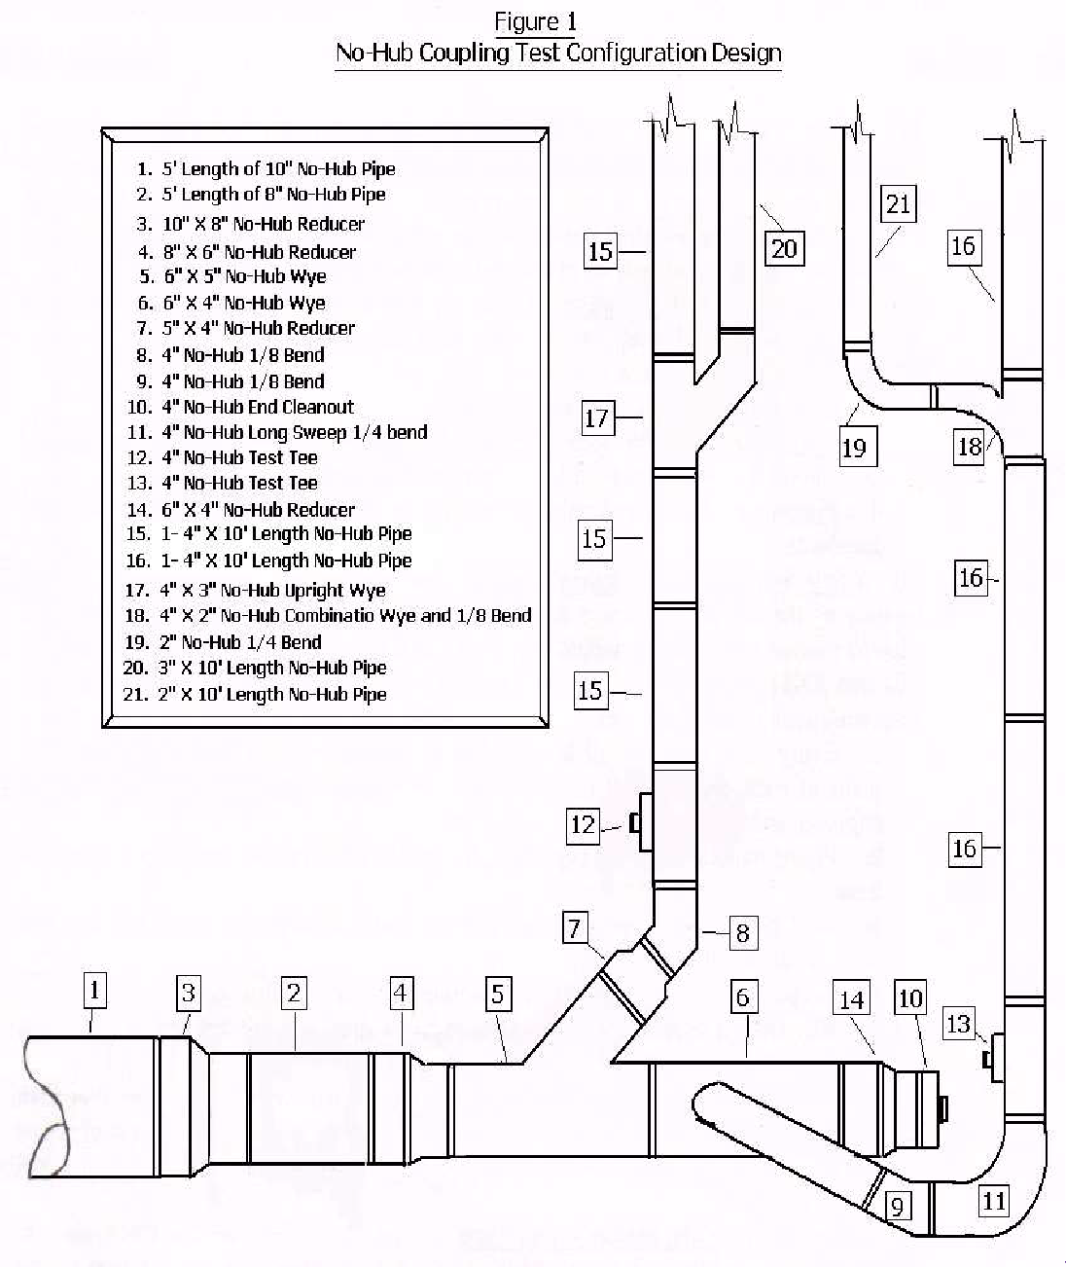
NOTE – BELOW FIGURE IS DELETED

- (d) Alternate Materials, Methods, and Systems.: The provisions of 248 CMR 10.06 are not intended to
prevent the use of materials, methods or systems that are not specifically authorized or prescribed by 248 CMR 10.06, provided such alternate materials, methods and systems meet the standards, use and intent of 248 CMR 10.06 and the Board has granted Product-Acceptanceapproval, a Variance, or a Test-site status pursuant to 248 CMR 3.00.

- Presure and Leak Test Procedure for Stainless Steel Couplings Used on Cast Iron Hubless Soil Pipe. Every manufacturer shall perform the tests as outlined in 248 CMR 10.06 (2)(v) for the purpose of determining liquid and/or gas leaks for pressures which may exist in a sanitary and/or storm drainage system. The administration of the test shall meet the following requirements:

  - The testing shall be performed by an Approved-testing-lab pursuant to 248 CMR 3.04(4).

  - Testing shall be completed at the expense of the manufacturer who shall perform such test.

  - The Approved-testing-lab shall give at least two weeks advance notice to the Board of the date scheduled for the test.
  - The test shall be conducted with:

    - hubless pipe and fittings manufactured in compliance with CISPI Standard Specification 301 latest issue; and

    - joints that have been assembled in accordance with the manufacturer's instructions and/or recommendations.

  - The test shall be for an eight-hour period of time, under a 30-foot hydrostatic head of water and at 13-
P.S.I.G. and shall show no visible signs of leakage.

  - The test assembly shall employ gauges at each end with means of expelling air and the gauges shall be graduated so that, at maximum test, the indicator on the gauges shall be approximately mid-point on said gauges.

  - The test results shall be certified by the Approved testing lab that conducted the testing and also by a Massachusetts registered professional engineer or a registered engineer having a reciprocal agreement with the Board of Professional Engineers for the Commonwealth of Massachusetts.

  - The test assembly and configuration shall employ pipe and fittings listed and as shown in 248 CMR 10.06, Figure 1 and shall be installed in accordance with the pertinent provisions of 248 CMR 10.00.

  - All repair and transition friction type couplings and clamps shall conform to the requirements stated in 248 CMR 10.06(2)(v).

- All pipe, valves and fittings used in a potable water system anticipated to be used for human consumption shall comply with the Federal Safe Water Drinking Act (SWDA) 42 USC Section 300 f.

- Notwithstanding the provisions of this code, all applicable products must meet the energy efficiency standards outlined in M.G.L. c. 25B, §§ 5 through 10 and 225 CMR 9.00: Appliance Energy-Efficiency Standards, Testing and Certification Program. To the extent these requirements are mandated by law, no variance or other relief can be granted by the Board to allow use of a non-compliant product.

- Allowable Materials:
  - Sheet Copper: Sheet copper shall not be less than twelve ounces per square foot when used in the following applications:
    - safe pan:
    - shower pan:
    - flush tank linings:
    - vent terminal flashing; or
    - general use.
  - Floor Flanges: A floor flange used for a toilet or other similar fixture shall be product accepted and made of copper, brass, cast iron, hubless cast iron or plastic.
  - Storm & Sanitary Above & Below Ground: Materials listed in 248 CMR 10.06 Table 1.
  - Vent Pipe & Fittings Above & Below Ground: Materials listed in 248 CMR 10.06 Table 1.

10.06 TABLE 1
STORM AND SANITARY WASTE AND VENT PIPING
VENT PIPE AND FITTINGS ABOVE GROUND
VENT PIPE AND FITTINGS BELOW GROUND
SANITARY AND STORM DRAINAGE ABOVE GROUND
SANITARY AND STORM DRAINAGE BELOW GROUND
1 | ABS Plastic Pipe and Drainage Pattern Fittings. See 10.06 (2) (g) | A | A | A | A
2 | ABS Cellular Core Plastic Pipe | A | A | A | A
3 | Aluminum DWV Pipe with Drainage Pattern Fittings | X | A | X | A
4 | Cast Iron Soil Pipe and Fittings (Extra-Heavy) | A | A | A | A
5 | Cast Iron Soil Pipe and Fittings (Service Weight) | A | A | A | A
6 | Cast Iron Soil Pipe and Fittings (No-Hub) | A | A | A | A
7 | Copper Tubing Hard Drawn & Copper Alloy (DWV) Color Coded Yellow | X | A | X | A
8 | Copper Tubing Hard Drawn & Copper Alloy (Type M) Color Coded Red | X | A | X | A
9 | Copper Tubing Hard Drawn & Copper Alloy (Type L) Color Coded Blue | A | A | A | A
10 | Copper Tubing Hard Drawn & Copper Alloy (Type K) Color Coded Green | A | A | A | A
11 | Copper DWV Fittings (Wrot) | X | A | X | A
12 | Copper DWV Fittings (Cast Brass) | A | A | A | A
13 | Copper Pipe (IPS) | A | A | A | A
14 | Ductile Iron Pipe and Drainage Pattern Fittings | A | A | A | A
15 | Galvanized Schedule 40 Steel Pipe with Drainage Pattern Fittings | X | A | X | A
16 | Polypropylene Pipe with Drainage Pattern Fittings | A | A | A | A
17 | Polyethylene Pipe with Drainage Pattern Fittings | A | A | A | A
18 | PVC Plastic Pipe and Drainage Pattern Fittings. See 10.06 (2) (g) & 10.12 (1) (a) 5. b. | A | A | A | A
18 | PVC Cellular Core Plastic Pipe. See 10.06 (2) (g) & 10.12 (1) (a) 5. b. | A | A | A | A
19 | Type 304 Stainless Steel Tubing with Drainage Pattern Fittings | X | A | X | A
19 | Type 316 Stainless Steel Tubing with Drainage Pattern Fittings | A | A | A | A
20 | Epoxy Reinforced Fiberglass Pipe & Fittings* | A | A | X | X
Note: Always follow manufacturers installation instructions wherever more stringent than 248 CMR.

A = Allowed: X = Not Allowed
* May be used only for storm water drainage
For a list if allowable materials for Special Waste, see 10.13: (2) (a) and (b)

  - Water Distribution Piping Above & Below Ground: Materials listed in 248 CMR 10.06 Table 2.

10.06 TABLE 2
WATER DISTRIBUTION PIPING
WATER DISTRIBUTION PIP AND FITTINGS ABOVE GROUND
WATER DISTRIBUTION PIPE AND FITTINGS BELOW GROUND
1 | Polypropylene Multilayer Pipe Fiberglass Layer and Compatible Fittings | X | A
2 | Copper Tubing Hard Drawn & Copper Alloy (Type L) Color Coded Blue | A | A
3 | Copper Tubing Hard Drawn & Copper Alloy (Type K) Color Coded Green | A | A
4 | Cast Bronze Threaded Fittings | A | A
5 | Copper Cast Solder Joint Fittings | A | A
6 | Copper Pipe (IPS) | A | A
7 | Ductile Iron Pipe with Compatible Fittings | A | A
8 | PEX (Cross Linked Polyethylene) See 10.06 (2) (f) | A | A
9 | CPVC Pipe and Fittings. See 10.06 (2) (f) | A | A
10 | Wrought Copper Solder Joint Fittings | A | A
11 | Type 304 Stainless Steel Tubing with Compatible Fittings | X | A
12 | Type 316 Stainless Steel Tubing with Compatible Fittings | A | A
13 | Other Plastics. See 10.06 (2) (h) | A | A
Note: Follow manufacturers installation instructions wherever more stringent than 248 CMR. A = Allowed: X = Not Allowed

  - CPVC Pipe and PEX Tubing and Fittings: CPVC and PEX may be used for hot and cold-water piping which is:

    - located in residential dwellings, hotels, motels, inns, condominiums, and similar buildings not exceeding six stories or,

    - located in a predominantly residential building where there is a single, non-residential use on single floor and meeting the following requirements:

      - the non-residential use would be categorized exclusively as employee (non-residential) per 248 CMR 10.10 (15) Table 1 with no additional uses and,

      - the non-residential use shall be limited to a maximum of four plumbing fixtures and.

      - the types of plumbing fixtures shall be limited to toilets, sinks (lavatory, residential, and service sinks) and drinking water stations.

    - used exclusively for dedicated cold-water piping beginning at the outlet of the water meter or main control valve inside any building directly to drinking water stations.

    - PEX tubing, and fittings may be used in commercial buildings for the purpose of conveying reverse osmosis or other similar processes that produce Purified Water from the point of treatment to one or more points of use for drinking water.

Exception:

- CPVC pipe and/or PEX domestic water tubing and fittings shall not be installed within twenty-four inches of the final connection to any domestic water heater.

- CPVC pipe and/or PEX tubing, and fittings shall not be used for steam flushing of water purification systems. Only type 316 stainless steel tube and fittings shall be used for this purpose.

  - PVC and ABS DWV Pipe and Fittings.

    - PVC and ABS schedule 40 pipe and fittings may be used for drains, waste, or vents in residential dwellings, hotels, motels, inns, condominiums and in residential areas of assisted living facilities not exceeding ten stories or,

    - located in a predominantly residential building where there is a single, non-residential use on a single floor and meeting the following requirements:

      - the non-residential use would be categorized exclusively as employee (non-residential) per 248 CMR 10.10(15)
Table 1 with no additional uses and
      - the non-residential use shall be limited to a maximum of four plumbing fixtures and.

      - the types of plumbing fixtures limited to toilets, sinks (lavatory, residential, and service sinks) and drinking water stations.
    - PVC and ABS schedule 40 pipe and fittings shall not be used for drains, waste, or vents in commercial kitchens, laundry rooms, public toilet facilities or other commercial areas located in assisted living facilities, hotels, motels, inns, or similar establishments. See 10.06, Example 1.
    - For the purposes of this section, ten stories shall be determined by the building permit. If no building permit is required, ten stories shall be determined by the authority having jurisdiction.

Exception:
- PVC and ABS schedule 40 pipe and fittings may be used for the drains, waste, and vent piping serving fixtures in commercial establishments which are specifically used only for that type of business in,
  - sinks used for washing of hair and/or coloring in barber shops and beauty salons,
  - fixtures used in salons for manicures and pedicures,
  - equipment used for processing in photo-labs or,
  - plumbing fixtures which incorporate alcohol, soda, or other similar carbonated type beverages in commercial buildings. These fixtures may discharge indirectly into the sanitary drainage system. Transition to commercially accepted materials shall be made immediately after the point of dilution. Refer to 248 CMR 10.12 (1) (a) 2.
Note: All piping for the above-mentioned fixtures shall be connected to the main or branch drain serving other fixtures to provide a point of waste dilution. Vent piping from
the fixture discharging the waste shall extend to a point six inches above the flood rim of the fixture and then shall re-transition to cast iron or copper piping material as used throughout the rest of the commercial building.
  - Type 1 PVC pipe and fittings may be used as indirect waste piping for dialysis equipment in medical buildings.
  - PVC Schedule 40 perforated pipe may be used for subsoil drainage in commercial buildings.
  - For thermal expansion of PVC DWV please see 248 CMR 10.05 (7) (e)

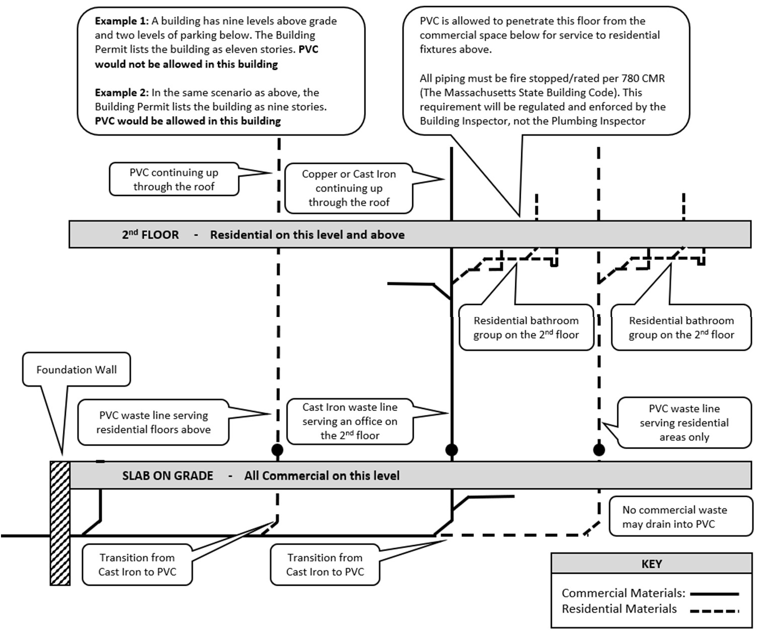

(h) Other Plastics
- Pipe and fittings from purified water systems installed from the point of purification to the final point of use as defined in 248 CMR 10.03 shall be of a size and material specified by the equipment manufacturer.
- Product-accepted multilayer polypropylene pipe with intermediate fiberglass layer and related fittings. Single wall Polypropylene pipe and fittings for cold water installations only.
- Urinal Wastes. Urinal waste branches and urinal fixture wastes shall be installed using the following:
  - Extra heavy or service weight cast iron soil pipe and fittings with caulked joints
  - Extra heavy, service weight or no-hub cast iron soil pipe and fittings with resilient gaskets or no hub clamps with elastomeric sealing sleeves.
  - Threaded cast iron pipe with cast iron drainage fittings.
  - Iron size copper or brass pipe with cast brass drainage fittings.
  - PVC and ABS schedule 40 plastic pipe and fittings may be used only in residential type buildings. 6. Schedule 80 PVC and CPVC threaded nipples may be used as a final point of connection for
toilets and urinals to carriers and fittings.
- Sumps and Tanks for Sewage. All sumps and tanks for receiving sewage removed by mechanical or ejector methods shall be watertight and designed and constructed as follows:
  - Concrete. Three-inch minimum wall.
  - Cast Iron. Minimum ¼-inch thickness.
  - Metal.
    - Minimum 1/8-inch thickness for above ground and treated to resist corrosion.
    - For below ground installation sumps and tanks shall be designed and accepted for that type of installation and treated inside and outside to resist corrosion,
  - Fiberglass. Reinforced polyester resin glass fibers that comply with ANSI listed standards.
- Single Stack Sanitary Drainage System-(“So-Vent”).
  - A Massachusetts professional engineer shall be responsible for the design of the so-vent plumbing system.
  - As part of the design process, the Massachusetts professional engineer shall be (wresponsible for assuring that the piping installation, including pipe sizing, dimension, and other aspects meet the requirements for proper functioning as designed.
  - The Local or State plumbing Inspector shall be responsible for all other aspects of the installation, as required by 248 CMR but is under no obligation to approve or otherwise involve themselves in the design process or ensuring the system meets the design specifications. An affidavit shall be provided by the designing engineer to the local plumbing inspector prior to final inspection.

(wl) Vacuum Drainage System. An engineered vacuum system that employs specifically designed
fixtures, piping arrangements and vacuum pumps that are designed and installed in compliance with the manufacturer’s recommendations may be used in a building or structure provided that in addition to being in conformance with 248 CMR
13.00 through 10.00 the following requirements are satisfied:
- Each system shall be designed or engineered by a Massachusetts registered professional mechanical engineer and Special-Permission must be granted by the Board.
- Piping material shall be type K, L, M or DWV hard drawn copper or cast iron.
- All fittings shall be made of cast brass or hard drawn wrought or cast iron and must be of DWV design.
- The plumbing Inspector shall be responsible for all other aspects of the installation, as required by 248 CMR but is under no obligation to approve or otherwise involve themselves in the design process or ensuring the System meets the design specifications. An affidavit shall be provided by the designing engineer to the local plumbing inspector prior to final inspection.
45. Any change or redesign in the vacuum drainage system shall be subject to the requirements of

(m) Relief Valve Discharge. The use of any non-ferrous pipe and fittings rated at a maximum service temperature of 200 degrees Fahrenheit on the outlet of a relief valve with a discharge not exceeding 105,000 BTU per hour shall be allowed.
10.07: Joints and Connections

- Consistency of Materials. When installing a fitting or inserting piping into an existing portion of a soil stack, waste stack, vent stack or drain, the fitting or piping shall be of the same material as the existing stack or drain using a joining method outlined in 248 CMR 10.07.

- Types of Joints for Piping Materials.

(a1) Copper Tubing Joints (Potable Water Supply Systems in Buildings).)

  - Joints shall be made with one of the following:
- Joining methods shall be in accordance with the manufacturer’s installation instructions and the following:
  - Copper water tube complying with ASTMB88.
  - Cast bronze fittings complying with ANSI Standard B16-18.
  - Wrought copper fittings complying with ANSI-ASME B16-22.
  - Flared or brazed connections for all underground piping inside the building. The joining method of copper underground shall be brazed or flared fittings.
  - Joints may employ the use of cast bronze flanges complying with ANSI Standard B16-24.
  - The joining method between copper and copper alloy tube and fittings shall be by soldering in accordance with ASTM B828-standard practice for making capillary joints by soldering of copper and copper alloy tube and fittings-latest issue or brazing in accordance with ANSI/AWS C3.4.
  - Fluxes used in the soldering or brazing of copper and copper alloy tube and fittings shall meet Board requirements and be leadfree.
  - Filler metals for soldering or brazing of copper and copper alloy tube and fittings shall meet Board requirements and be leadfree.
  - Fluxes used with brazing filler metals or solder filler metals shall be lead free.
- Burned Lead. Every burned (welded) lead joint:
- shall be lapped; and
- the lead shall be fused together to form a uniform weld at least as thick as the lead being joined.
- Caulked Cast Iron Soil Pipe. Every lead caulked joint for cast iron bell and spigot soil pipe shall:
- be firmly packed with oakum orhemp;
- be filled with molten lead that is not less than one inch-deep and does not extend more than c inch below the rim of the hub;
- not have paint, varnish, or other coatings on the jointing material until after the joint has been tested and approved; and
- have lead run in one continuous pour and shall have the lead caulked tight.
- Expansion. Every expansion material shall conform with the type of piping in which it is installed.
- Flared.
- Copper Tubing. Every flared joint for soft-copper water tubing shall be expanded with a flaring tool.
- Cross-linked Polyethylene (PEX). Every flared (metal insert or cold expansion) joint for cross-linked polyethylene (PEX) water tubing shallbe:
  - made with fittings meeting approved standards;and
  - installed in accordance with manufacturer’s recommended procedures.
- Hot Poured. Hot poured compound for clay or concrete sewer pipe or other materials shall conform to the following requirements:
- It shall not be water absorbent and when pouredagainst.
- A dry surface shall have a bond of greater than or equal to 100 P.S.I.G. All surfaces of the joint shall be cleaned and dried before pouring. If wet surfaces are unavoidable, a suitable primer shall be applied.
- The compound shall not soften sufficiently to destroy the effectiveness of the joint when subjected to a temperature of 160EF.
- The compound shall not be soluble in any of the waste carried by the drainage system.
- Approximately 25% of the joint space at the base of the socket, shall be filled with jute or hemp.
- A pouring collar, rope or other device shall be used to hold the hot compound during pouring.
- Each joint shall be poured in one operation until the joint is filled. Joints shall not be tested until one hour after pouring.
- Mechanical (Flexible or Slip Joint).
- Cast Iron Pipe or Ductile Iron Pipe. Every mechanical joint in cast iron pipe or ductile iron pipe shall be:
  - made with a flanged collar, rubber ring gasket, and appropriate number of securing bolts; or
  - made with a preformed molded ring secured by pulling the pipe together in such a way as to compress the molded ring.
- Clay Pipe. Flexible joints between lengths of clay pipe may be made by using resilient materials both on the spigot end and in the bell end of the pipe.

- Concrete Pipe. Flexible joints between lengths of concrete pipe may be made using rubber materials both on the spigot end and in the bell end of the pipe.
- Hubless Cast Iron Soil Pipe No-hub. Joints for hubless cast iron soil pipe and fittings shall be made with:
  - elastomeric sealing sleeve; and
  - stainless steel clamp, clamping screw andhousing.
- Split Couplings. Galvanized couplings made in two or more parts, with compression gaskets, may be used with grooved end pipe and fittings as specified under 248 CMR 10.06.
- Aluminum DWV Pipe. Joints for connecting aluminum DWV pipe or aluminum DWV pipe to hubless cast iron fittings shall be madewith:
  - an end capped adaptor; and
  - an elastomeric sealing sleeve and stainless steel clamp, clamping screw and housing.
- Plastic.
- ABS, PVC and CPVC.
  - Every joint in ABS, PVC and CPVC piping, except as specified under 248 CMR 10.13, shall be made with fittings by solvent weld connections.
  - Solvent weld connections shall be made only with solvent cement manufactured specifically for the materials to bejoined.
- Cross-linked Polyethylene(PEX).
  - All joints shall be made with fittings that a joined in the following manner:
    - metal insert fittings with copper crimp rings;
    - stainless steel press sleeves;
    - cold expansion fittings with (PEX) reinforcing rings;or
    - compression fittings (with formed gaskets) or mechanical joints.
  - All joints connecting to other materials shall be made with a transition fitting.
  - All joining methods are to conform to existing standards found in 248 CMR 10.06: Table 1 unless a Variance has been granted by the Board as specified in 248 CMR 3.04(2): Variances:
  - Exception: Metallic fittings used in purified water systems shall be type 316 stainless steel.
- Precast Requirements.
- Every precast collar shall be formed in both the spigot and bell of the pipe in advance of use.
- Collar surfaces shall be conical with side slopes of three-degrees with the axis of the pipe and the length shall be equal to the depth of the socket.
- Prior to making joint contact, surfaces shall be cleaned and coated with solvents and adhesives as recommended in the standard.
- When the spigot end is inserted in the collar, it shall bind before contacting the base of the socket.
- Material shall be inert and resistant to both acids and alkalies.
- Slip Requirements.
- Every slip joint shall be made using approved packing or gasket material, or ground joint brass compression rings.
- Ground joint brass connections that allow the adjustment of tubing while providing a rigid joint when made up shall not be considered slipjoints.
- Slip joints may be used on the inlet (“house-side”) of the trap only.

- 1. Soldered.:
1a. Every soldered joint for tubing shall be made with fittings.
2b. Surfaces to be soldered shall be properlythoroughly cleaned, reamed, and returned to -full-bore. 3c. The joints shall be fluxed properly and fastened using lead free solder.
4d. Joints in copper water tubing shall be made by appropriate use of brass or wrought copper water fittings and be properly soldered together.
- Soldered joints in copper alloytube and fittingsshall be fabricated in accordance with ASTM B-828 and shall utilize solder fluxes that meet the requirements of ASTM B-813.
  - Solder filler metals used in the fabrication of solder joints in potable water applications shall be lead free.
be lead free.

2. Flared Copper Tubing: Every flared joint for soft-copper water tubing shall be expanded with a flaring tool.

- 3. Threaded.:
- Every threaded joint shall conform to American National Taper Pipe Thread. 2a. All burrs shall be removed.
3b. Pipe ends shall be reamed and returned to size of full bore, and all chips shall be removed. 4c. Pipe joint Product-accepted pipe compounds and tapes shall be used on male threads only.
5d. Threaded joints used in the piping systems of the potable water supply system of a building shall be made with lead free polytetrafluoroethylene sealant (such as TeflonR), which shall be applied to the male threadonly.
- Threads in drainage fittings shall be tapped to provide proper grade and slope.
- Unions.
- Drainage System.
  - ​ Unions may be used only in the trap seal or on the inlet side of the trap.
  - ​ Unions shall have metal-to-metal groundseats.
- Water-supply System. Unions in the water-supply system shall be metal-to-metal with ground seats.

- Wiped.

- Every joint in lead pipe or fittings, or between lead pipe or fittings and brass or copper pipe, ferrules, solder nipples, or traps, shall be full wiped joints.
- Wiped joints shall have an exposed surface on each side of a joint that is greater than or equal to ¾ inch in width and be as thick as the material being joined.
- Wall or floor flange lead-wiped joints shall be made by the use of a lead ring or flange placed behind the joints at the wall orfloor.
- Joints between lead pipe and cast iron, steel, or wrought iron shall be made by means of a caulking ferrule, soldering nipple, or bushing.

- Brazed Joints.
- ​ Brazing flux, when required, shall meet the requirements of ANSI/AWS A5.31.
- ​ Brazing filler metal and brazing fluxes utilized for the fabrication of brazed joints in domestic water supply and potable water distribution system piping shall be lead free.
- Victaulic Joints:
- The victaulic press shall be used for joining pipes and fittings for copper, galvanized Schedule 40 and stainless steelpipe.
- The victaulic press 304 system shall be used for joining victaulic type 304 stainless steel pipe that meets the requirements of ASTM A-269 grade 304/304L (TP 304 UNS designation 530400).

(3) Types of Joints Between Different Piping Materials.
- Cast Iron to Copper Tubing. Every joint between cast iron and copper tubing shall be made by the use of a brass caulking ferrule and properly soldering the copper tubing to the ferrule.
- Cast Iron to Vitrified Clay.
  - Every joint between cast iron piping and vitrified clay piping shall be made either of hot poured bitumastic compound or by a preformed bituminous ring.
  - This ring shall, after ramming, completely fill the annular space between the cast iron spigot and the vitrified clay hub.
- Copper Tubing to Threaded Pipe Joints.

1e. Every joint transitioning from copper tubing to threaded pipe shall be made by the use of brass or wrought copper adapter fittings.

  - The joint between the copper pipe and the fitting shall be properly soldered and the connection between the threaded pipe and the fitting shall be made with a standard nominal pipe size connection.

- Lead Cast Iron, Wrought Iron, or Steel. Every joint between lead and cast iron, wrought iron, or steel pipe shall be made by means of wiped joints to a caulking ferrule, soldering nipple, bushing, or by means of a mechanical adapter.

- Brazed: Brazing filler metal and brazing fluxes utilized for the fabrication of brazed joints in domestic water supply and potable water distribution system piping shall be lead free.
- Mechanical Joints:
  - All joining methods must follow material manufacturers’ installation instructions.
    - Press-Connect
    - Push-Fit in accordance with the proper standard
    - Compression
    - Grooved
    - Flanged
    - Tee Forming
    - Ductile Iron
    - Other Board Approved joining methods

- Cast Iron Soil Pipe:
  - Caulked Joints firmly packed with oakum or hemp shall be,
    - filled with molten lead that is not less than one inch-deep and does not extend more than one eighth inch below the rim of the hub and,
    - Have lead run in one continuous pour and shall have the lead caulked tight.
  - Resilient Gaskets
  - Hub-less Cast-Iron Soil Pipe. Joints for hub-less cast-iron soil pipe and fittings shall be made with,
    - elastomeric sealing sleeve, stainless steel clamp, clamping screw and housing.
    - Hub-less stainless-steel clamps for installation underground shall be listed for that type of installation by the clamp manufacturer.

- Aluminum DWV Pipe: Joints for connecting aluminum DWV pipe or aluminum DWV pipe to hub-less cast iron fittings shall be made with:
  - an end capped adaptor; and
  - an elastomeric sealing sleeve and stainless-steel clamp, clamping screw and housing.

- Plastic:
  - ABS, PVC and CPVC shall be installed in accordance with the manufacturers’ installation instructions and joined using the following methods:

    - Solvent weld following the primer and solvent manufacturer’s installation instructions. Where primers are required, they shall be purple in color. Exception: Clear primer shall be allowed which is detectable by ultra-violet light. The licensee shall make a UV light detection device available at the time of inspection.
    - Mechanical joints
    - Threaded joints
    - Shielded stainless-steel clamps
  - Cross-linked Polyethylene (PEX).
    - All pipe, fittings and accessories used in the installation of Cross-linked Polyethylene (PEX) piping systems shall be approved by the product manufacturer for use with their system.
    - All joints shall be made with pipe and fittings joined in the following manner:
      - Flared joints with tools specifically designed for use in this type of system and in accordance with the product manufacturers installation instructions
      - Mechanical joints installed in accordance with the product manufacturers installation instructions.
      - Push-Fit joints installed in accordance with the product manufacturers installation instructions.
      - Compression joints installed in accordance with the product manufacturers installation instructions.
  - Polypropylene (PP)
    - All pipe, fittings and accessories used in the installation of Polypropylene (PP) piping system shall be approved by the product manufacturer for use with their system.
    - All joints shall be made with fittings joined in the following manner:
      - Heat-fusion
        - socket type
        - butt fusion
        - electro fusion
      - Mechanical and compression
      - Threaded

- Stainless Steel:
  - Mechanical Joints
    - All joining methods must follow the material manufacturers installation instructions.
      - Compression
      - Grooved
      - Flanged
      - Threaded
      - Press-Connect
  - Welded joints

- Slip and Ground Joints:
  - Every slip joint shall be made using proper packing or gasket material. Slip joints may only be used on the inlet fixture side of a trap. See 10.07: Example 1
  - Ground joint connections that allow the adjustment of piping while providing a rigid joint when made up shall be allowed within the trap seal. See 10.07: Example 2
  - Devices including strainers, PO (pull out) plugs, tail pieces, waste arms, bathtub wastes and overflows, and any other similar fixture to trap connections made of ABS, PVC, copper alloy or other non-corrosive metal shall have a thickness greater than or equal to 17 gauge.

10.07: Example 1 - Slip Joint 10.07: Example 2 - Ground Joint

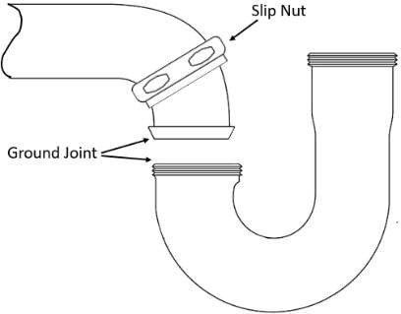
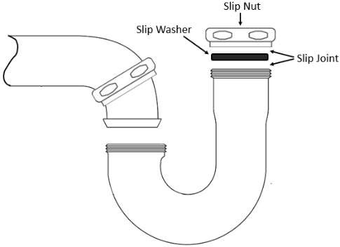
- Threaded Joints: All threaded pipe joints shall be in conformance with American National Taper Pipe Thread.
  - ABS or PVC (DWV) joints when threaded shall use the proper male or female threaded adapters.
  - Only thread tape, lubricant seal or other Product-accepted material as recommended by the manufacturer shall be used.
- Transition Joints Between Different Piping Materials:
  - Cast Iron to Copper or Brass (DWV)
    - Copper or brass soil pipe adapter with caulked and poured lead joint
    - Hub-less transition clamp installed in accordance with the clamp manufacturers’ installation instructions.
    - Threaded using the proper copper or brass threaded adapter.
    - Shielded stainless-steel transition clamp
  - Copper Tubing to Threaded Pipe.
    - Every joint transitioning from copper tubing to threaded pipe shall be made by using brass or wrought copper adapter fittings.

    - The joint between the copper pipe and the fitting shall be properly soldered and the connection between the threaded pipe and the fitting shall be made with a standard nominal pipe size connection. Exception: Other Product Accepted forms of connecting copper to threaded pipe shall be allowed.
    - Dielectric unions and fittings shall be allowed and water heaters unless prohibited by the water heater manufacturer.

  - (e) Threaded Pipe to Cast Iron. Every joint Joints between wrought iron, steel, orthreaded brass, stainless steel, galvanized schedule 80 PVC/CPVC or materials listed in 248 CMR 10.13 (2) and cast-iron pipe shall be either caulked or threaded or shall be made with approved adapter ortransitionfittings.
  - Plastic Pipe to Other Materials. Transitions shall be made with proper transition fittings listed by the manufacturer for their intended use.
    - Cast Iron to PVC or ABS.
      - Spigot Hub joints shall be connected by caulking with lead and oakum or by using a compression gasket that is compressed when the plastic pipe is inserted in the cast iron hub end of the pipe. No adapters are required for this connection.
      - No-Hub joints where the outside diameter of the two pipes or fittings to be joined are uniform in diameter may be joined with hub-less transition clamps.
  - Aluminum DWV Pipe to Hub-less Cast-Iron Pipe and Fittings: Joints for connecting aluminum DWV pipe or aluminum DWV pipe to hub-less cast-iron fittings shall be made with hub-less transition clamps.
  - PVC to ABS. Joints for connecting PVC to ABS shall be made by:
    - using a DWV male to female adaptor; or
    - by a hub-less transition clamp.
  - (f) Special Joints and Connections.: Unless specifically outlined in 248 CMR 10.07 or other applicable
sections of 248 CMR 10.00, unlike piping materials shall be joined or connected to by use of adapters, transition fittings, prefabricated sealing ring or sleeve.

- Unions (Water Supply & Distribution System):

  - Ground joint connections that provide a rigid joint
  - Dielectric type for dissimilar metals

- Precast Requirements: Connection of piping concrete tanks shall be by means of an approved coupling with elastomeric gasket, waterproof flexible sleeve, or hydraulic cement.

- ABS or PVC Plastic to Other Materials
  - Threaded Joints.
    - ABS or PVC (DWV) joints when threaded shall use the proper male or female threaded adapter.
    - Only thread tape or lubricant seal or other Product-accepted material as recommended by the manufacturer shall be used.
  - Cast Iron Spigot Hub Joints.
    - Joints shall be connected by caulking with lead and oakum or by the use of a compression gasket that is compressed when the plastic pipe is inserted in the cast iron hub end of the pipe.
    - No adapters are required for thisconnection.
  - No Hub Joints.
    - Joints where the outside diameter of the two pipes or fittings to be joined are uniform in diameter may be joined with an elastomeric sealing sleeve and stainless steel no hub clamp.
    - PVC to ABS connection shall be implemented by:
      - using a DWV male to female adaptor; or
      - by a no hub clamp.
- Aluminum DWV Pipe to Hubless Cast Iron Pipe or Fittings. Joints for connecting aluminum DWV pipe or aluminum DWV pipe to hubless cast iron fittings shall be made with an elastomeric sealing sleeve and stainless steel clamp, clamping screw and housing and end protector caps.

(411) Connections Between Drainage Piping and Certain Fixtures.:
- (a) Connections between drainage pipes and toilets, floor outlet service sinks, pedestal urinals,
earthenware trap standards or other similar fixtures with floor outlets shall be fastened with brass, wrought copper, hard lead, iron or plastic flanges, that is caulked, soldered or solvent welded to the flanged connection.
- (b) A gasket, washer or setting compound between the fixture and the flange is required.
- (c) Only brass or Brass, stainless steel or other corrosion resistant nuts and bolts shall be usedrequired.
- The floor flange shall be fastened to a structurally firm base.
- The use of commercial putty or plaster as a setting compound is prohibited.
- Schedule 80 PVC or ABS threaded nipples may be used to connect toilets and urinals to carriers of such fixtures.
(d) Flanges shall be secured to finished floor on which it sets using corrosion resistant screw or bolts.

(5) Tightness. Joints and connections in the plumbing system shall be gastight and watertight for the pressure required by test, with the exceptions of those portions of perforated or open joint piping that are installed for the purpose of collecting and conveying ground or seepage water to the underground storm drains.

- (6) Waterproofing of Openings.:
  - Joints terminating at the roof around roof drains and vent pipes shall be made watertight by the use of lead, copper, aluminum, or other flashing or flashing materials.

  - Caps for extended roof flanges shall be made to fit tight to the inside circumference of the vent pipe. The cap shall not decrease the pipe opening by more than the thickness of the cap material.
  - Exterior wall openings shall be made watertight.

(7) Increasers and Reducers. When interconnecting pipes and fittings, fittings and fittings, or pipes and fittings that have different sizes the size of the increaser or reducing fittings shall be selected and installed so as to prevent the restriction of flow between the interconnection.

10.08: Traps and Cleanouts

- General Requirements: Fixture traps shall be of standard design, weight and in compliance with 248 CMR 10.06 (2) (c) and (d). Exposed traps made of copper alloy tubing shall be a minimum of 17 gauge.

- (1) Fixture Traps.
  - Separate Traps for Each Fixture.:
    - Separate Trapping Required:
      - Individual plumbing fixtures shall be separately trapped by a water seal trap placed as close as possible to the fixture outlet.
      - The developed length distance from the fixture outlet to the trap weir shall not exceed 24 inches.
      - No fixture shall be double trapped.
    - A fixture need not be separately trapped. Exceptions toException: To the separate trapping requirements are as follows:
- a. Fixtures having integral traps.
- b. A combination plumbing fixture may be installed on one trap provided one compartment is not more than six inches deeper than the other and the waste outlets are not more than 30thirty inches apart.
- c. One trap may be installed for not more than three single compartment sinks or lavatories, immediately adjacent to each other, and in the same room. The trap is to be centrally located when three such fixtures are installed. The center-to-center measurement of the waste outlets shall not exceed 30thirty inches apart.
- d. The waste for a domestic type dishwasher may be separately trapped, or may connectconnected to the manufactured inlet side opening of a food waste grinder. A “wye” fitting may be installeddisposer or connected between the outlet of the food waste grinderkitchen sink and the inlet of the trap serving the kitchen sinkusing a “wye” fitting.

b. The vertical distance from the fixture outlet to the trap weir shall not exceed twenty-four inches. See 10.08: Examples 1 and 2

10.08: Example 1 - Vertical Distance from Fixture Outlet to Trap Weir
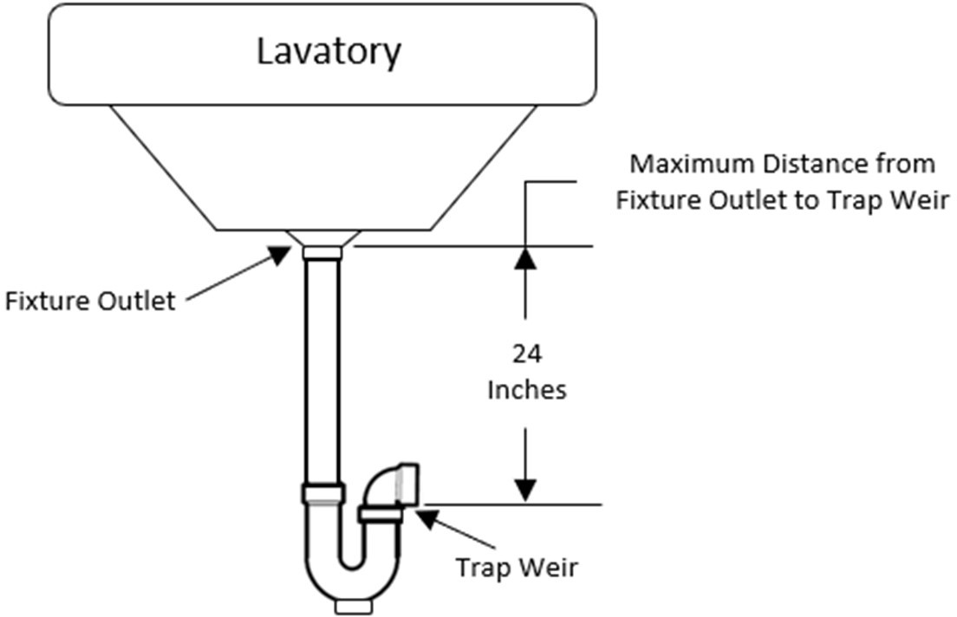

10.08: Example 2 - Vertical Distance from Fixture Outlet to Trap Weir
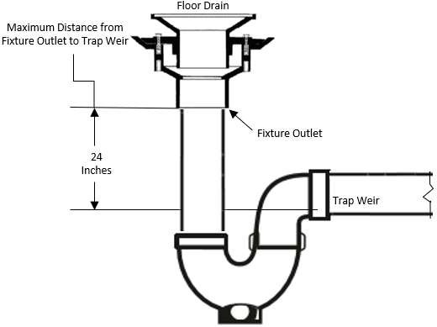

  - Size of Fixture Traps.:

    - The size of the fixture Fixture trap size (nominal diameter) shall be sufficient to drain the fixture rapidly and in no case less than outlined in 248 CMR 10.08: Table 1 (Minimum Size of Fixture Traps).
    - No The fixture trap shall be larger than the same pipe size as the drainage pipe drain into which it discharges.

TABLE 1

TABLE 1
MINIMUM SIZE OF FIXTURE TRAPS
PLUMBING FIXTURE | Trap Size in Inches
Bathtub (with or without overhead shower) | 1½
Bidet | 1½
Clothes washer (domestic)washing machine connection | 2
Combination sink and wash tray | 1½
Combination sink and wash tray with food waste  grinderdisposer unit | 1½
Dental unit or cuspidor | 1½
Dental Lavatory | 1½
Drinking Water Station, with Drain | 1½¼
Dishwasher, commercial | 2
Dishwasher, domestic | 1½
Floor drain | 2
Food waste grinderdisposer | 1½
Kitchen sink, domestic, with food waste grinderdisposer unit | 1½
Kitchen sink (two compartments) | 1½
Kitchen sink, domestic | 1½
Lavatory, common | 1½
Lavatory (barber shop, beauty parlor or surgeon's) | 1½
Lavatory, (multiple type) (wash fountain or wash sink) | 1½
Laundry sink (one or two compartments) | 1½
Shower stall | 2
Sink (surgeon's) | 1½
Sink (flushing rim type, flush with flushometer valve  supplies) | 3
Sink (service type with floor outlet trap standard) | 3

Sink (service trap with P trap) | 2
Sink, commercial (pot, scullery, or similar type) | 2
Sink, commercial (with food grinderdisposer unit) | 2

  - Prohibited Traps.: The following type traps are prohibited.
    - Traps which depend upon moving parts to maintain their seal.
    - Bell traps.
    - Crown vented traps.
    - Separate fixture traps which depend on interior partitions for their seal.
    - Full "S" traps.
  - Design of Traps.:
    - Fixture traps shall be self-scouring and shall have no interior partitions except where such traps are integral with the fixture.
    - Slip joints or couplings may be used on the trap inlet or within the trap seal of the trap if a metal-to-metal ground joint is used.
- Slip or ground joints that are part of a trap shall meet the requirements on 248 CMR 10.07 (6)
- Each fixture trap, except a trap that is cast integrally or in combination with the fixture in which the trap seal is readily accessible or except when a portion of the trap is readily removable for cleaning purposes, shall have an accessible cleanout plug of ample size that is protected by the water seal.
Exception:
  - Traps which are cast integrally or in combination with the fixture in which the trap seal is readily accessible or except when a portion of the trap is readily removable for cleaning purposes.
  - Traps for floor outlet and similar fixtures including bathtubs and showers where a cleanout would not be accessible. A cleanout shall be installed in the nearest accessible location.

  - Fixture Trap and Connection Material (HOUSE SIDE) shall meet ASME A112.18.2- 2002.
    - Fixture traps shall be made of cast brass, with a wall thickness of not less than .01 inches, or of schedule 40 ABS or PVC.
    - Cast iron traps may be used in connection with floor drains, slop sinks, building (house) traps, conductors (when necessary) and similar installations, weights and thicknesses to comply with like materials under 248 CMR 10.06.
    - Slip nuts used to connect fixture and appliance outlet piping to the trap, shall be composed of brass, copper or schedule 40 ABS or PVC.
    - Tubing traps made of brass or copper shall be of a thickness equal to a minimum of 17 gauge.
    - When devices including strainers, P.O. (pull out) plugs, tail pieces, waste arms, bathtub wastes and overflows, and any other similar fixture to trap connection, when of metal, shall be made of brass or other non-corrosive metal, and the device shall have a thickness greater than or equal to 17gauge.
    - All items listed in 248 CMR 10.08(1)(e)4. and 5. when made of ABS or PVC may be used, provided that they all comply with ASME A112.18.2 for PVC and ABS Tubular Traps and Fittings.

(ef) Trap Seal: Each fixture trap shall have a liquid seal of not less than two inches and not more than four inches, except where for special conditions, a deeper seal may be required. See 10.08: Example 3The protection of trap seals from siphonage, aspiration, momentum, oscillation, back pressure, evaporation, or capillary action shall be accomplished by the appropriate use of soil or waste stacks, vents, re-vents, dry vents, wet vents, loop vents, circuit, or continuous vents, or combinations thereof, installed in accordance with the requirements of 248 CMR 10.16, so that at no time shall the trap be subjected to a pressure differential of more than one inch of water.

10.08: Example 3 - Minimum Liquid Trap Seal
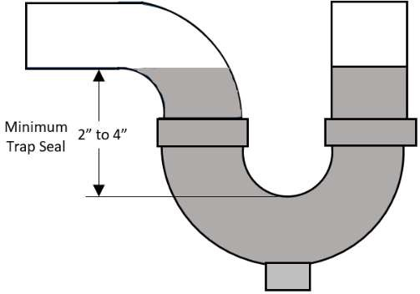
(g)(f) Trap Setting and Protection.: Traps shall be set level with respect to their water seals and, where wherever necessary, shall be protected from freezing.
(h)(g) Building and Running Traps.:
- Building (House/and running traps) traps shall not be installed, unless in the opinion of the Inspector they are deemed necessary.
Exception: Where a trap in compliance with 248 CMR 10.08 (d) may be subject to freezing temperatures, a running trap may be installed in an area not subject to freezing but as close as possible to the fixture it serves.
- Each building trap when installed shall be provided with aan accessible cleanout and with a
relieving vent or fresh air intake which need not be larger than ½one half the diameter of the drain to which it connects.
- Open Parking Garages. Parking garages containing openings in exterior walls on two or more sides of each level of not less than 20 percent of the total perimeter wall space on that level.
  - Installation of traps for floors drains which are located on the open level(s) shall not be

required.
  - A running trap shall be installed on the sanitary drain prior to entering the separation or containment system as required in 248 CMR Section 10.09 (1) (a) and equipped with,
    - an accessible cleanout
    - a vent four-inch in size run independently through the roof.
  - Stacks shall be installed in intervals not exceeding 60 feet and in accordance with 248 CMR
10.16 (3) (a)

(i)(h) Acid Resistant Trap.: Where a vitrified-clay or other brittlewarebrittle ware, acid-resistant trap is installed underground, it shall be embedded in concrete extending six inches beyond the bottom and sides of the trap.

(2)(3) Drainage Pipe Cleanouts.:
- Location.: Cleanouts shall not be placed no more than 50fifty feet apart in all horizontal drainage piping
and branch drain piping thatwhich is four-inch nominalin diameter or less. On horizontal piping thatwhich is over four inch nominalin diameter the, cleanouts shall not be more than 100one-hundred feet apart. See 10.08: Example 4.

10.08: Example 4 - Maximum Cleanout Distance on Horizontal Drain
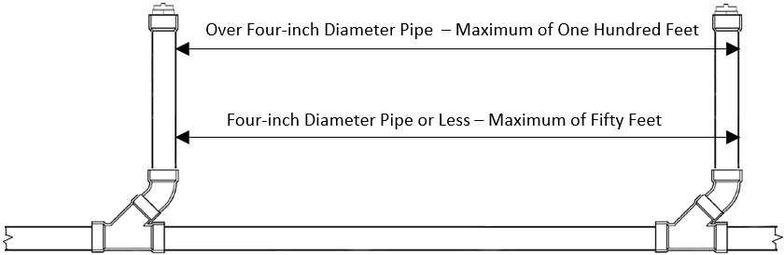

- Cleanout plugs shall meet the following requirements.
  - Shall be composed of brass or plastic.
  - Shall meet the latest testing standards.
  - Shall have raised or countersunk square or hexagon heads.
  - If a tripping hazard may exist, only a countersunk head shall be used.
  - Plastic cleanout plugs shall be of the same material to which it connects.
(b)(c) Underground Drainage.: Cleanouts, when installed on an underground drainage piping, shall be:
- extended vertically to or above the finished grade level; or
- extended to an accessible location immediately outside the building. See 10.08: Example 9 (c)(d) Change of Direction.: Accessible cleanouts shall be installed:
  - at each change of direction of the building drain; or
  - at each change of direction of horizontal waste or soil lines and branch lines, that are greater then than 45°. degrees.

(d)(e) Concealed Piping.: Cleanouts on concealed piping shall be extended through and terminate flush
with the finished wall or floor; or. Cleanouts located in floors, walls, pits or, and chases may be left in the wall or floor, provided they arean access panel of sufficient size to allow removal of the cleanout plug and proper cleaning of the system. See 10.08: Example 5.

10.08: Example 5
Concealed Cleanout in Floor Concealed Cleanout in Wall
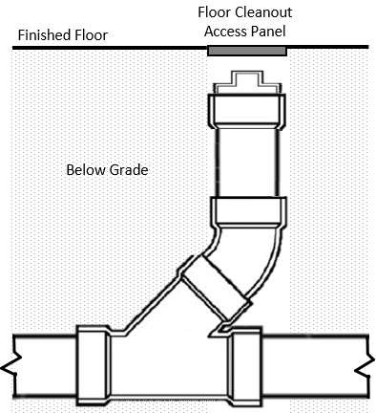
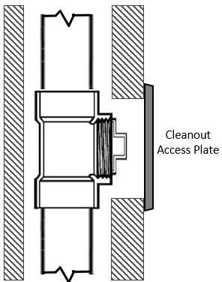

(e)(f) Base of Stacks.: A cleanout shall be provided at or near the base of each vertical storm water conductor, waste, or soil stack. See 10.08: Example 6

10.08: Example 6 - Cleanout at the Base of a Stack
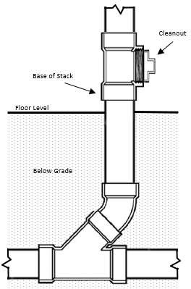
- Building Drain at Foundation Wall:
  - There shall be a clean-out installed on the building drain so located as to provide accessibility in direct line through the building drain to building sewer.
  - If necessary, a pit or manhole shall be provided.
  - Piping configuration shall be installed as diagramed in 10.08: Example 7 below and in compliance with 248 CMR 10.06 Table 1 and consistent with the materials being installed.
  - An additional full-sized cleanout may be installed outside of the building but not more than five feet beyond the foundation wall.

10.08: Example 7 - Piping Configurations of Building Drains at Foundation Wall
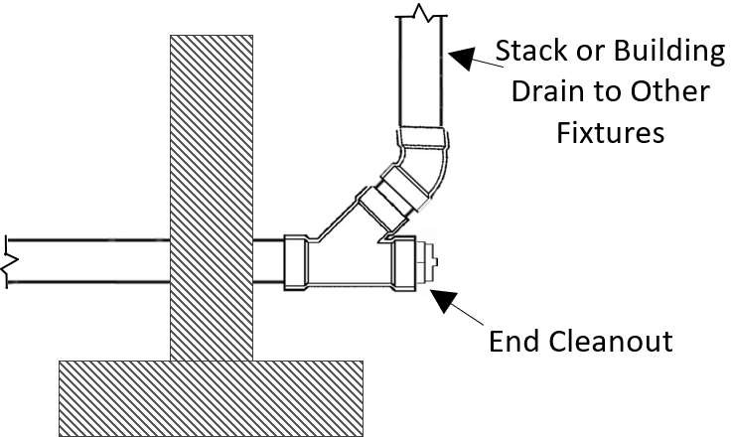
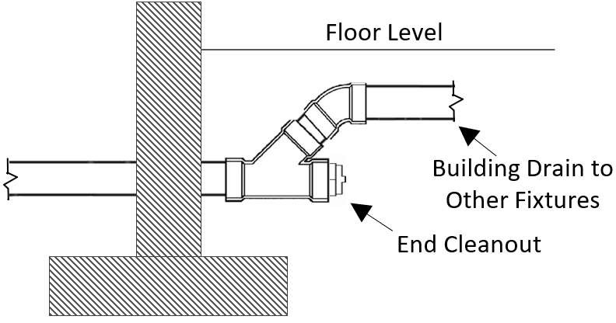
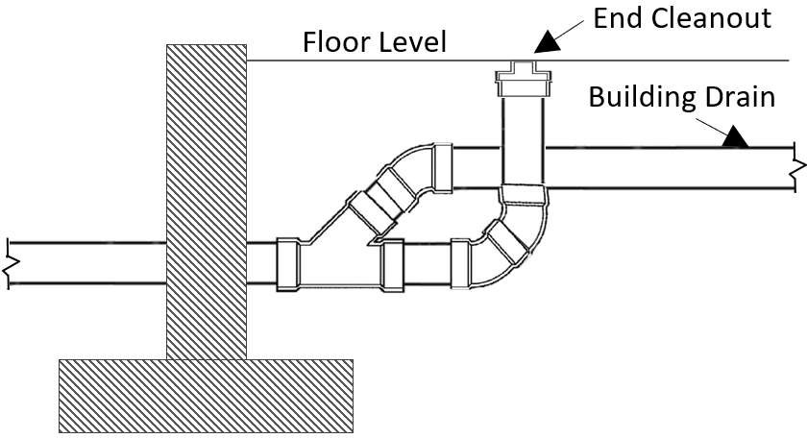

(f)(h) Inaccessible Stack Cleanouts.: For buildings with concrete floors (slabs) or with less than 18thirty-six inches of crawl space under the floor, or where a stack cleanout is not easily accessible, the following shall be provided in lieu of a cleanout at the base of the stack. Cleanout for the building drain may be installed outside of the building

but not more than five feet beyond the foundation wall.

    - The building drain shall be extended to the outside of the building and terminated in an accessible area.
    - The accessible area for the cleanout shall be not more than five feet beyond the foundation/building wall.

- Building Drain at Foundation Wall.
  - There shall be a cleanout on the building drain so located as to provide accessibility in direct line through the building drain to building sewer.
  - If necessary a pit or manhole shall be provided in a location determined by the Inspector.
  - When cast iron soil pipe and fittings are used, the joining methods shall comply with 248 CMR 10.07(2)(c)1. and shall be installed as diagramed in 248 CMR 10.22: Figure 18.

10.08: Examples 8 and 9

10.08: Example 8 10.08: Example 9
Inaccessible Cleanout at The Base of A Stack Building Drain Cleanout Installed Outside
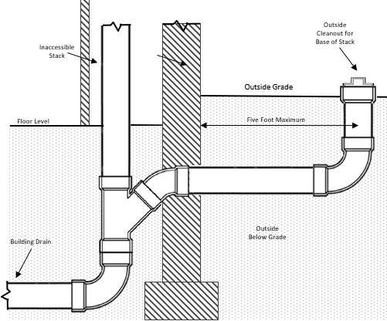
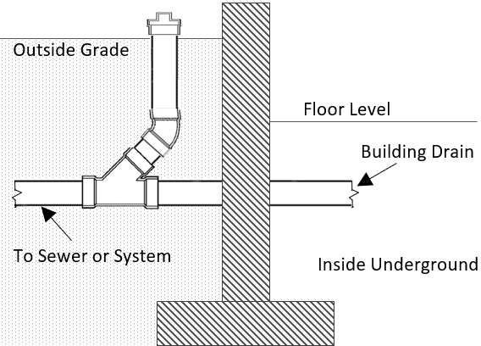

(h)(i) Direction of Flow.: Every cleanout shall be installed so that the cleanout opens in the direction of the flow of the drainage line or at right angles thereto.

(i)(j) Cleanout Size.: Cleanouts shall be of the same nominal size as the pipes up to four inches and not less than four inches for larger piping.

(j)(k) Cleanout Clearances: 10.08: Example 10.
- Large Pipe - 18 Inch Clearance.: Cleanouts on three inch or larger pipes shall be so installed that there is a clearance of not less than 18 inches for the purpose of clearing stoppages.
- Small Pipe - 12 Inch Clearance.: Cleanouts smaller than three inches shall be so installed that there is a 12-inch clearance for the purpose of clearing stoppages.

10.08: Example 10 - Cleanout Clearances
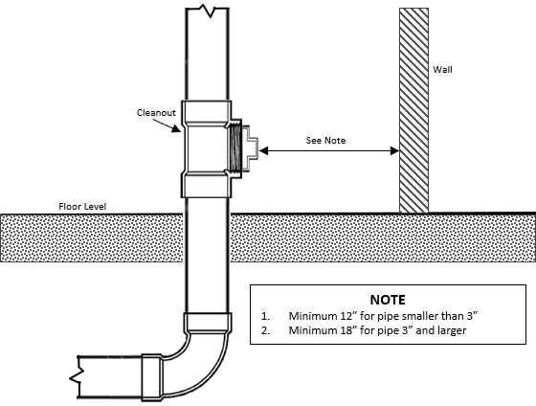

(k)(l) Cleanouts Shall Be Kept Uncovered and Accessible.:
- Cleanout plugs shall not be covered with cement, plaster, or any other permanent finishing material.
- Where it is necessary to conceal a cleanout plug, a covering plate or access door shall be provided which will allow ready access to the plug for removal. See 10.08, Example 5

(l)(m) Cleanout Equivalent.: The cleanout equivalent may be satisfied by one of the following methods if accepted by theInspector::
- a fixture trap that incorporatesincorporate a union connection;,
- a fixture with an integral trap; or
- roof drains covers that are readily removable without disturbing concealed roughing workrough piping.

(m)(n) Connections to Cleanouts Prohibited.: Cleanout openings shall not be used for the installation of any new or additional plumbing, except where another end-cleanout of equal access and capacity is provided. when:
  - approved in writing bythe Inspector; and
  - where another end-cleanout of equal access and capacity is provided.

(n)(o) Manholes for Large Pipes.:
- For underground and “dedicated system” piping that is over ten inches in diameter and is outside a building, manholes shall be provided and located at every change of size in diameter, alignment
, grade or elevation and at intervals of not more than 300three hundred feet except when the total
developed length of the drain is less than 150one hundred and fifty feet, cleanouts may be installed at 75 seventy-five- foot intervals.
- Manholes shall conform to current standards and engineering practices.

10.09: Interceptors, Separators and Holding Tanks

- Interceptors, Separators and Holding Tanks Required:. Interceptors, separators and holding tanks shall be provided to prevent the discharge of oil, gasoline, grease, sand, and other substances that are harmful or hazardous to building drainage systems, public and private sewer systems, systems governed by the
Department of Environmental Protection (DEP), sewage treatment plants, or other environmentally sensitive areas. No wastes other than those requiring treatment or separation shall be discharged into any interceptor, separator, or holding tank.

  - Interceptors Required

    - Interceptors separators, and holding tanks shall be provided to prevent the discharge of oil, gasoline, grease, sand, and other substances that are harmful or hazardous to the building drainage system, the public sewer, sewage treatment plant, sewage treatment processes, or other environmentally sensitive areas.

    - No wastes other than those requiring treatment or separation shall be discharged into any interceptor, separator, or holding tank.

(a)(b) Separation or Containment of Gas, Oil, and Other Petroleum Distillates.
Note: For purposes of 248 CMR 10.09(1)(b),this section, a motor vehicle shall be considered a self-propelled road vehicle, commonly wheeled, that include including but not limited to cars, buses, and trucks., and tractors.

- Required Locations. A separation or containment system shall be required for any building or structure containing:
  - Motor vehicle parking, repair/maintenance, washing, and storage areas; or
  - Other spaces which are sufficiently large enough to allow access by motor vehicles.
- Exceptions.Exception. A separation or containment system shall not be required for: ai. Single family residential garages;,
bii. Multi-family, condominium, and apartment garages which are sufficiently small that they could only hold a maximum of six motor vehicles;,
ciii. Buildings or structures whose floor is unfinished or paved such that the surface is sufficiently porous that any gas, oil, or other petroleum distillates would be absorbed by the surface prior to reaching any separation or containment systems;,
div. Buildings or structures that are exclusively classified as a storage group pursuant to
780 CMR: The Massachusetts State Board of Building Regulations and StandardsCode which are sufficiently small that they could only hold a single motor vehicle and there is no other plumbing;,
ev. Showrooms used for the purpose of selling used or new motor vehicles which are
located within a structure classified by the Plumbing Code, 248 CMR 10.10(18): ) (Table 1, ), as a mall (covered) or retail (mercantile) that is open to and used by the public; and
fvi. Installations where outside permanent bollards or other devices are spaced in front of entrances to the building or structure so as to prevent the entrance of a motor vehicle. Where permanent bollards are used, they shall be spaced no more than 48” apart.
- Sump pumps/drains used in elevator pits
  - Discharge from gravity drains or pumps entering the sanitary or storm drainage system shall comply with the requirements of 248 CMR 10.00. Elevators utilizing hydraulic oil or other petroleum distillates which may be harmful to the sanitary of storm drainage system shall discharge through a properly sized oil/water separator installed in compliance with 248 CMR 10.09.
  - Piping shall discharge into the building sanitary system.

Exception:
- Piping may discharge into the building storm drainage system if permitted by any local ordinance, bylaw, rule, or regulation.
- Product accepted pumps equipped with sensors which divert volatiles may be installed in lieu of a gas/oil separation system.

- Rules for Separation Systems.separation systems – For use when connecting to a sewer system
  - In general, one of the following separation systems must be utilized:
    - A system meeting the design specifications outlined in 248 CMR 10.22:09: Example 2 or Figure 15 or such other specifications approved by the Board;,

    - A product accepted separation system;,
    - A separation system designed by a registeredMassachusetts professional engineer whereby the engineerwho prepares all plans and specifications and certifies in writing to the inspector that the installation complies with these plans and specifications; or
    - for smaller installations involving a maximum of two vehicle bays, a pump connected to a double walled tank, both of which are rated by the manufacturer to hold volatile chemicals, meeting the requirements in 248 CMR 10.09(1)(b)3.a.iv.(i) through (iii):
      - The tank must hold a minimum of 60 gallons pervehicle;
      - The tank must be equipped with a liquid sensor to detect leaks; and
      - The tank must be vented through a roof.

  - Approvals of other agencies
    - Where specifically noted, the approval of other agencies may be required in order to complete the installation of a separation system, however, said approvals shall not be deemed to
supersede the requirements for a Permitplumbing permit as well as full inspection by the Inspector plumbing inspector of all components and connections of a separation system. If the approval of another agency would necessitate a violation of 248 CMR 10.00, 248 CMR 10.00, this Code must be followed unless a variance is granted by the Board.
    - Connection of a separation system to a sewer shall adhere to Massachusetts Department of Environmental Protection rules located at 314 CMR 7.00: Sewer System Extension and Connection Permit Programsewer system connection and extension permit program.

    - When in an area governed by the Massachusetts Water Resources Authority (MWRA), notice of the installation of a separation system must be made to the MWRA prior to the issuance of a plumbing permit. Thereafter, the installation shall adhere to MWRA rules located at 360 CMR 10.016: Sewer Use.

- Grease Traps and Interceptors When Installed Inside of Buildings.

  - Grease traps and interceptors shall be installed in the following establishments to prevent the discharge of fats, oils, and grease into the drainage system:
    - restaurants;
    - cafeterias;
    - hotels;
    - hospitals;
    - institutional facilities;
    - factories;
    - clubs;
    - bars where food is prepared and served;and
    - all commercial kitchens; food and meat packing and processing establishments; super markets, bakeries, and other establishments wherefats, oilsandgreasemaybe introduced into the building sanitary drainage system in quantities that can cause waste line obstruction or hinder sewage disposal.

  - Grease traps and interceptors may be installed on individual fixture waste branches.

  - Plumbing fixtures to be protected by grease traps and interceptors shall include:

    - pot sinks (with bowl depths exceeding teninches);
    - scullery sinks (with bowl depths exceeding ten inches),
    - floor drains;
    - floor sinks;
    - automatic dishwashers regardless oftemperature;
    - pre-rinse sinks;
    - soup kettles or similar devices;
    - wok stations; and
    - automatic hood wash units;

  - In unsewered areas refer to 310 CMR 15.00: The State Environmental Code, Title 5: Standard Requirements for the Siting, Construction, Inspection, Upgrade and Expansion of On-site Sewage Treatment and Disposal Systems and for the Transport and Disposal of Septage relative to grease removal at installations from which large quantities of grease can be expected to discharge.

  - Floor Drain Exception: Floor drains that may encounter grease residue and are specifically designed for this purpose may conduct grease to an outside grease interceptor. Grease interceptors may be installed on a separate building drain and shall only receive the discharge from fixtures or equipment which would allow fats, oils or grease to be discharged to the sanitary drainagesystem.

  - Food Waste Grinders and Pre-rinse Sinks.

    - The waste from dishwasher pre-rinse sinks that are not equipped with food waste grinders shall be discharged

to the drainage system through a grease trap interceptor.

    - A dishwasher pre rinse sink drain not equipped with a food waste grinder that conveys the waste discharge to a dish washing machine drain as shown in 248 CMR 10.22: Figure 22 shall be a minimum diameter of two inch. The total developed length of the horizontal waste drain from the dishwasher pre-rinse sink outlet to the weir of the dish washing machine trap shall not exceed eightfeet.

    - The waste discharge from a commercial food waste grinder (garbage disposal) shall not discharge to the sanitarydrainage system through a grease trap. Dishwasher pre-rinse sinks equipped with food waste grinders shall be discharged in accordance with 248 CMR 10.10(8)(b) through (d).

  - Sizing, Testing and Rating.

    - Grease traps and interceptors shall not be installed unless sized, tested, and certified according to PDI-G101 or ASME A112.14.3 or ASME A112.14.4.

    - Grease traps and interceptors must bear the certification seal of the Plumbing and Drainage Institute (P.D.I.) or AMSE. The Board may authorize the use of alternate design traps and interceptors in accordance with 248 CMR 3.04(2) or (3).

  - Capacity. Installed grease traps and interceptors shall have a grease retention capacity of not less than two pounds of grease for each G.P.M (gallon-per-minute) of flow.

  - Flow Control Device.

    - Grease traps and interceptors shall be equipped with flow control devices. A flow control device may be equipped with a vented (air intake) or be of an integral non-vented design. Integral non-vented flow control device shall be placed in accordance with manufacturers’ recommendations. A flow control device is required to be installed between the fixture and the grease trap/interceptor in accordance with manufacturers’ instructions.

    - The flow control device is designed to regulate the flow and discharge rate of waste water through the trap or interceptor.

    - The vented external flow control device air intake when installed in combination with a Grease Trap, may terminate to the free atmosphere provided it terminates a minimum of

    - The vented external flow control devices when installed in combination with a Grease Interceptor may connect to the sanitary venting system of a building or structure provided that the external flow control and fixture(s) are protected by a trap installed in accordance with all applicable provisions of 248 CMR 10.00.

    - A flow control device will not be required for interceptor/separators that are designed to provide a retention capacityof 30 minutes or less.

  - Water Cooled Interceptors/Separators. The use of water- cooled interceptors/separators is prohibited.

- Rules for containment systems – When not connecting to a sewer system

  - When in an area governed by the Department of Environmental Protection, (DEP) notice of the installation of a containment system must be made to the DEP prior to the issuance of a plumbing permit.

  - For smaller installations involving a maximum of two vehicle bays, a pump connected to a double wall tank, both of which are rated by the manufacturer to hold volatile chemicals, meeting the following requirements: See 10.09: Example 1
    - The tank must hold a minimum of sixty gallons per vehicle; and
    - The tank must be equipped with a liquid sensor to detect leaks; and
iv. The tank must be vented through a roof.
  - Piping for containment tanks shall comply with the following requirements:
    - The minimum inlet pipe size shall be four inch
    - The vent shall not be less than two inch and shall returned to the inside of the building and extend independently through the roof.
    - Prior to being put into service, the tank and related piping shall be tested.
    - Piping materials shall be limited to extra heavy, service weight and nu-hub.

10.09: Example 1 – Containment for Smaller Installations
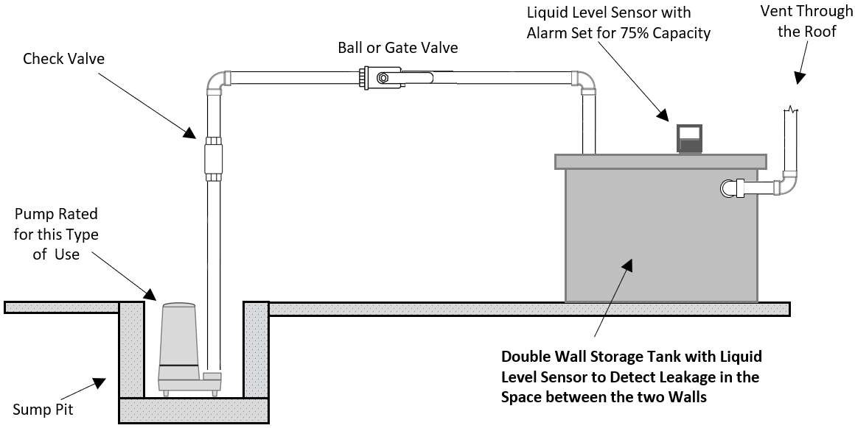

- Vents for Floor and Trough Drains: The vents for floor/trough drains that convey waste from all gas, oil and other petroleum distillate separation or containment systems shall be independent of the sanitary DWV systems. Vents for these floor/trough drains may connect to the chamber vent of the
separator or other containment system no less than six inches above the flood level rim of the floor/trough drain fixture. See 248 CMR (2), (g), 3. for exception to trap requirements in open parking garages.

- Design & Sizing of Separators. Where separators are required, they shall have a minimum volume of six cubic feet for the first one hundred square feet of area drained, plus one cubic foot for each additional one hundred square feet of area drained. In areas covered by this section which may encounter excessive flow, separators shall be sized in accordance with manufacturers specifications.

  - Interceptors Not Required.
    - Grease traps and interceptors are not required for residential building(s), structure(s), dwellings or dwelling units or any private residence.
    - Grease traps and interceptors shall be required in buildings deemed residential that incorporate commercial cooking accommodations.
  - Treatment Agents and Chemicals. Chemicals, liquids or agents of any type used for the primary purpose of emulsification and separation of grease that by formula allow grease to be transferred or conveyed from the trap or interceptor to the drainage system are prohibited.
  - Maintenance.

    - Grease and accumulated solids shall be removed from traps and interceptors and disposed of in accordance with applicable Federal, State and Local health code requirements by the owner or his or her agent. Federal, State and Local laws, regulations and by-laws may require monitoring and registration of installed traps and interceptors.

    - The local board of health official(s) or similar authority having jurisdiction may require other methods or programs to monitor maintenance of grease traps and interceptors.

    - A laminated sign shall be stenciled on or in the immediate area of the grease trap or interceptor in letters one-inch high. The sign shall state the following in exact language:
IMPORTANT
This grease trap/interceptor shall be inspected and thoroughly cleaned on a regular and frequent basis. Failure to do so could result in damage to the piping system, and the municipal or private drainage system(s).

  - Procedures for Sizing GreaseInterceptors.

    - Grease traps and interceptors shall be sized in accordance with the following Recommended Procedures For Sizing Grease Interceptor and 248 CMR 10.22: Figure 22.

    - Recommended Procedures and Formulas for Installing Grease Traps and Interceptors. As a general rule it is recommended that traps and interceptors be sized in accordance with the formulas indicated in 248 CMR 10.09: Tables 1 through 3. It is favorable policy to size the interceptor so that its rated capacity is never less than 40% of the individual fixture capacity in gallons. In the example below the actual fixture capacity is 59.8 Gals. and 40% of this would be 23.9 Gals. It is understood that a drainage period other than one or two minutes can beused.

248 CMR 10.09: Table 1: RECOMMENDED PROCEDURE FOR SIZING

GREASE TRAPS AND INTERCEPTORS INSIDE BUILDINGS
EXAMPLE (Single Compartment)

- Pre-Cast or Built-In-Place Separators. See 10.09: Example 2

  - Shall be located outside of a building wherever possible and equipped with an access cover having a minimum diameter of twenty-four inches. Exception: For separators which are installed inside a building, the access cover must be sealed tight.
  - The minimum inlet pipe shall be four inch and the outlet shall be equal to or greater than the inlet.
  - The invert of the inlet pipe shall be no less than four inches above the water line.
  - The chamber vent shall be four inch in size and located as close as possible to the top of the tank.
  - The chamber and outlet vents shall be four inch in size, returned to the inside of the building and extend independently through the roof.
  - All venting associated with the installation of a gas/oil separator shall be labelled.
  - Access ladder steps shall be non-corrosive and spaced eighteen inches apart.
  - All pre-cast separators shall meet or exceed the ASTM C-478 standard of 4,000 PSI
  - Joint sections shall use butyl rubber joint sealant per ASTM C-990 standard.
  - All separator pipe penetrations shall be sealed using hydraulic cement or butyl rubber sealant per ASTM C-990 standard.
  - All separators shall have a minimum liquid water seal depth of three feet.
  - The distance from the outlet pipe to the base of the tank shall be a minimum of two foot six inches.
  - All piping penetrations on a pre-cast or built-in-place separator shall be sealed with hydraulic cement.
  - Prior to being put into service, the separator shall be filled with water and tested.
  - Piping materials shall be limited to extra heavy, service weight and nu-hub cast iron.
  - Sizing of separator shall be in accordance with 248 CMR 10.09 Table
  - Discharge from storm separators may be connected directly to the building storm drain or storm sewer.
  - Discharge from sanitary separators may be connected directly to the building sanitary drain or sanitary sewer.

248 CMR 10.09: Table 1: RECOMMENDED PROCEDURE FOR SIZING GREASE TRAPS AND INTERCEPTORS INSIDE BUILDINGS
EXAMPLE (Single Compartment)

STEP 1. Determine the cubic content of the fixture by multiplying length x width x depth, (of each comp) | A sink 48" long by 24" width by 12" deep. Cubic content 48" x 24" x 12" = 13,824 cu. in. or Cubic contents 4' x 2' x 1' x 7.5 Gals. = 60 Gals.
STEP 2. Determine the total capacity in gallons.  1 gallon = 231 cubic inches | Contents in Gallons 13,824/231 = 59.8 Gals.
STEP 3. Determine actual drainage load. The fixture  is usually filled to approximately 75% of the capacity with waste water. The items being washed displace about 25% of the fixture content. Actual drainage load  = 75% of fixture capacity. | Actual Drainage Load .75 x 59.8 Gals. = 44.9Gals
STEP 4. Determine the flow rate and the drainage  period. In general, good practices dictate a one minute drainage period, however where conditions permit, a two minute period is acceptable. Drainage period is the actual time required to completely empty the fixture. | Calculate flow rate for one minute period.  Flow rate 44.9 Gals.1/min. = 44.9 G.P.M.  For two minute period  Flow rate 44.9 Gals./2min. = 22.5 G.P.M.
STEP 5. Select the interceptor which corresponds to
the flow rate calculated Note: Select larger size when flow rate falls between two sizes listed.
NOTE: The example above is representative of acceptable method(s) when purchasing an interceptor based on the total fixture flow rate capacity in gallons. When purchasing an interceptor based on grease retention pounds only, multiply the total gallon flow rate capacity of the fixture by two.

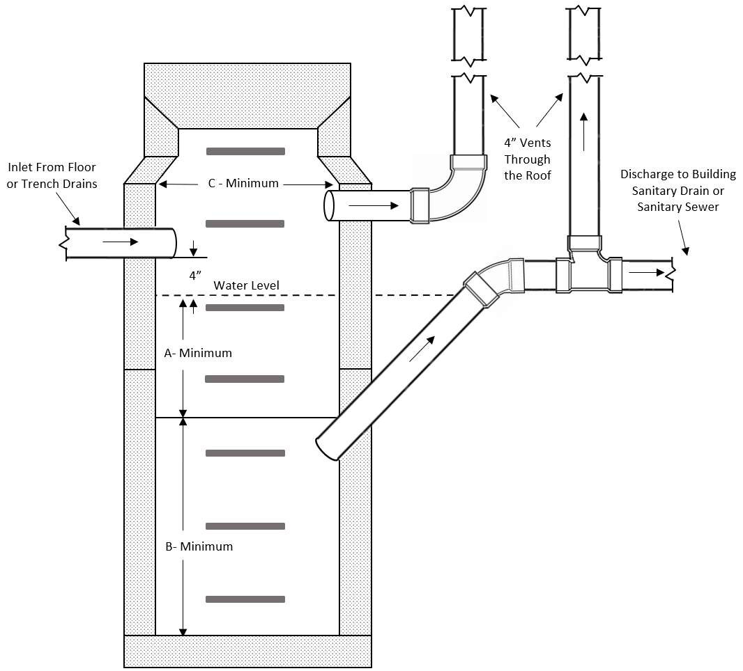
10.09 Example 2 - Pre-Cast or Built-In-Place Separator

- Grease Interceptors and Grease Removal Devices:
  - General Requirements.
Note: For purposes of this section, Grease Interceptors

TABLE 1
Sizing Separator

INLET | A | B | C
4” | 3’-0” | 2’-6” | 3’-6”
 | 5’-0” | 4’-0” | 3’-6”
5” | 3’-6” | 3’-0” | 4’-0”
 | 3’-0” | 2’-6” | 4’-6”
 | 5-’0” | 4’-6” | 4’-0”
6” | 4’-0” | 3’-6” | 4’-6”
 | 3’-6” | 3’-0” | 5’-0”
 | 6’-0” | 5’-0” | 5’-0”
8” | 4’-6”  4’-0” | 4’-0”  3’-6” | 5’-6”  6’-0”
 | 3’-6” | 3’-0” | 6’-6”

- Grease Interceptors and Grease Removal Devices:
  - General Requirements.
Note: For purposes of this section, Grease Interceptors and Grease Removal Devices shall be considered “interceptors”
    - Interceptors shall not be considered traps unless they meet the requirements of 248 CMR
10.08 (2) (e)
    - Interceptors shall be required to receive discharge from all fixtures and equipment which may produce grease-laden waste wherever food is prepared, or in other establishments where grease may be introduced into the sanitary drainage system.
    - Only gravity interceptors, hydromechanical and engineered systems which have been tested and approved to the applicable standards shall be allowed.
    - Grease removal is not required in dwellings or for fixtures which convey human waste.
    - In unsewered areas refer to 310 CMR 15.00: The State Environmental Code, Title 5: Standard Requirements for the Siting, Construction, Inspection, Upgrade and Expansion of
On-site Sewage Treatment and Disposal Systems and for the Transport and Disposal of Septage relative to grease removal at installations from which large quantities of grease can be expected to discharge.
  - Interceptors Installed Inside of Buildings.
    - Properly sized interceptors may be installed on individual fixture waste branches or form multiple fixtures. See 10.09: Example 3.
    - A vent shall be installed downstream of all interceptors
    - Individual fixtures to be protected by interceptors shall include but not be limited to:
      - pot sinks;
      - scullery sinks. Exception: Multiple Bay scullery sinks in patron areas for the purpose of serving alcohol, soda or other similar carbonated type beverages.
      - floor drains and floor sinks; Note: See 10.09 (1) (b) 2. e.
      - automatic dishwashers regardless of temperature,
      - pre-rinse sinks,
      - soup kettles or similar devices,
      - wok-stations; and
ix. automatic hood wash units
    - Waste branches for individual or multiple fixtures protected by interceptors may be sized equal to the inlet connection of the properly sized interceptor.
    - Floor Drain, Floor Sink and Dishwasher Exception: Individual or multiple floor drains, floor sinks and commercial dish washing machines which may encounter grease shall be allowed to conduct grease directly to an outside grease trap or interceptor. Individual or multiple fixtures conducting grease to an outside grease trap or interceptor shall be considered a dedicated system.
    - Interceptors shall be located not more than twenty-five feet of the most remote fixture being served. Exception: When an exterior grease interceptor or trap is installed within twenty-five feet of the most remote fixture being served; an inside interceptor shall not be required.

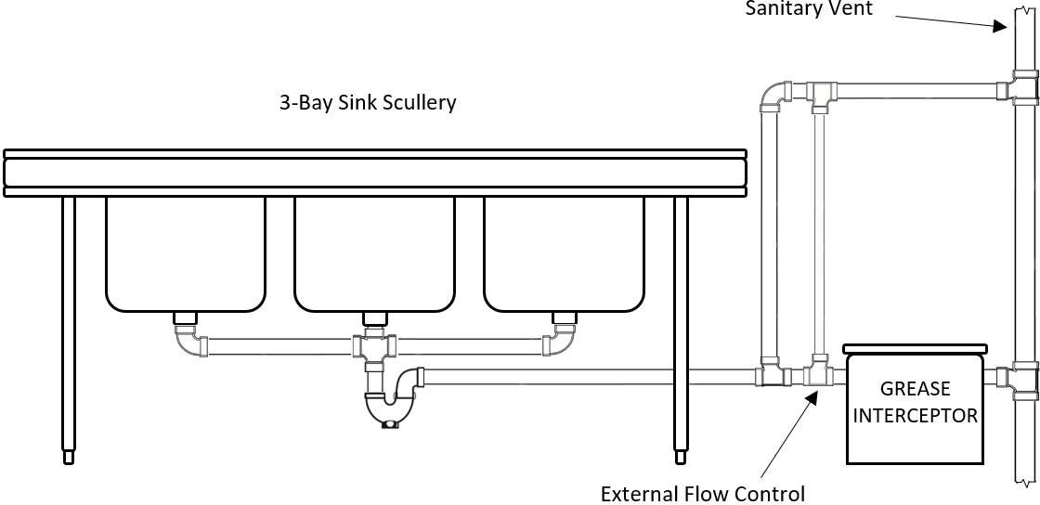
  - Food Waste Disposers and Pre-rinse Sinks.
    - A dishwasher pre rinse sink not equipped with a food waste disposer that conveys the waste discharge to a dish washing machine drain shall discharge through an interceptor and be a minimum diameter of two-inch. The total developed length of the horizontal waste drain from the dishwasher pre-rinse sink outlet to the weir of the dish washing machine trap shall not exceed eight feet. See 10.09: Example 4.
    - The waste discharge from a commercial food waste disposer shall not discharge into the sanitary drainage system through an interceptor. See 10.09: Example 5
    - Dishwasher pre-rinse sinks equipped with food waste disposer shall be discharged in accordance with 248 CMR 10.10 (4) (b).

10.09 Example 4 - Pre-Rinse Sinks and Dishwashers
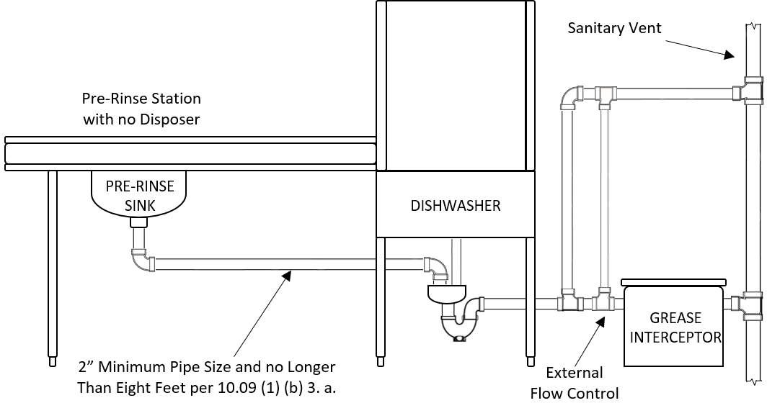

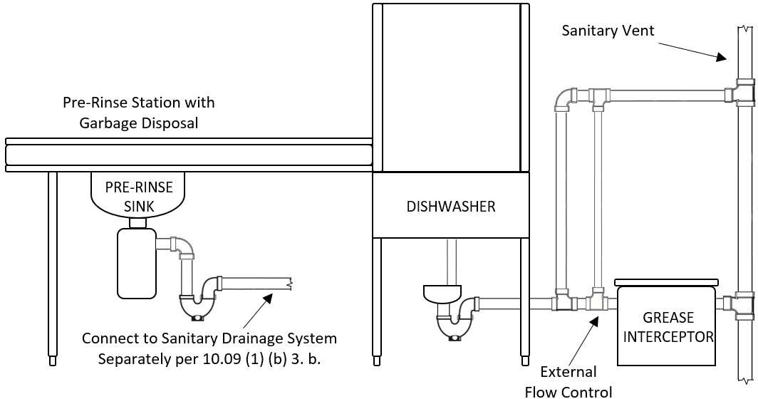

  - Sizing, Testing and Design. Interceptors shall be sized, tested, and designed in accordance with PDI-G101, PDI-G102, ASME A112.14.3, ASME A112.14.4, ASME A112.14.6 ANSI Z1001 or
CSA B481 standards. The Board may authorize the use of alternate design interceptors in accordance with 248 CMR 3.04.
  - Capacity. Interceptors shall have a capacity of not less than two pounds of grease for each gallon-per-minute (GPM) of flow.
  - Flow Control Device.
    - Hydromechanical and Grease Removal Devices shall be equipped with flow ratecontrol devices. A flow control device may be equipped with a vented (air intake) or be of an integral non-vented design. Integral non-vented flow control device shall be placed in accordance with
manufacturers’ installation instructions. A flow control device is required to be installed between the fixture and the interceptor in accordance with manufacturers’ instructions.
    - When installing an interceptor with an external flow control, the vent for the flow control shall be connected to the buildings sanitary venting system. The flow control vent shall not be considered a fixture vent.
  - Water Cooled Interceptors/Separators. Water- cooled interceptors/separators are prohibited.
  - Interceptors Not Required.
    - Interceptors are not required for residential buildings, structures, dwellings, dwelling units or any private residence.
Exception: Interceptors shall be required in buildings deemed residential that incorporate commercial cooking accommodations.
c. Fixtures used for culinary purposes. See 10.12 (1) (a) 3.
  - Treatment Agents and Chemicals. Unless accepted by the Board, chemicals, liquids or agents of any type used for the primary purpose of emulsification and separation of grease that by formula allow grease to be transferred or conveyed from the trap or interceptor to the drainage system are prohibited.
  - Maintenance.
    - Grease and accumulated solids shall be removed from traps and interceptors and disposed of in accordance with applicable Federal, State and Local health code requirements by the owner or his/her agent. Federal, State and Local laws, regulations and by-laws may require monitoring and registration of installed traps and interceptors.
    - The local board of health official(s) or similar authority having jurisdiction may require other methods or programs to monitor maintenance of grease traps and interceptors.
  - Procedures for Sizing Grease Interceptors.
    - Recommended Procedures and Formulas for Installing Grease Traps and Interceptors. As a rule, it is recommended that traps and interceptors be sized in accordance with the formulas indicated in 248 CMR 10.09: Tables 1 through 2. It is favorable policy to size the interceptor so that its rated capacity is never less than forty percent of the individual fixture capacity in gallons. Example below: The actual fixture capacity is 59.8 Gal. and forty percent of this is 23.9 Gal.

248 CMR 10.09: Table 1: RECOMMENDED PROCEDURE FOR
SIZING INTERCEPTORS INSIDE BUILDINGS

EXAMPLE (Single Compartment)
STEP 1. Determine the cubic content of the fixture by multiplying length x width x depth, (per compartment) | A sink 48” long by 24” width by 12” deep. Cubic content 48” x 24” x 12” = 13,824 cu. in. or  Cubic contents 4’ x 2’ x 1’ x 7.5 Gals. = 60 Gals.
STEP 2. Determine the total capacity in gallons. 1 gallon = 231 cubic inches | Contents in Gallons 13,824 = 59.8 Gals.  231
STEP 3. Determine actual drainage load. The fixture is normally filled to approximately 75% of the capacity with water. The items being washed displace about  25% of the fixture content, thus the actual drainage  load = 75% of fixture capacity. | Actual Drainage Load .75 x 59.8 Gals. = 44.9Gals
STEP 4. Determine the flow rate and drainage period. In general, good practices dictate a one-minute drainage period, however where conditions permit, a two-minute period is acceptable. Drainage period is  the actual time required to completely empty the fixture. | Calculate flow rate for one-minute period. Flow rate 44.9 Gals.1/min. = 44.9 G.P.M.  For two-minute period  Flow rate .9 Gal./2min. = 22.5 G.P.M.
STEP 5. Select the interceptor which corresponds to the flow rate calculated.
Note: Select larger size when flow rate falls between two sizes listed.
NOTE: The example above is representative of acceptable method(s) when purchasing an interceptor based on the total fixture flow rate capacity in gallons. When purchasing an interceptor based on grease retention pounds only, multiply the total gallon flow rate capacity of the fixture by two.

248 CMR 10.09 Table 2:
SIZING FORMULAS FOR LARGE CAPACITY GREASE INTERCEPTORS (INSIDE OR OUTSIDE BUILDINGS)

For Restaurants: | Other Establishments with Commercial Kitchens:
(S) X (GS) X (HR/12) X (LF) = Effective Capacity of Grease Traps and Interceptors in Gallons | (M) X (GM) X (LF) = Effective Capacity of Grease Traps and Interceptors in Gallons
WHERE: | WHERE:
S = Number of Seats in Dining Area GS = Gallons of Waste Water per Seat:  HR = Number of Hours Restaurant Is Open. LF = Loading Factor  Use 25 Gallons for Restaurants with China Dishes and/or automatic dishwashers  Use 10 Gallons for Restaurants with Paper or Baskets and no dishwashers. | M = Meals Prepared per Day  GM = Gallons of Waste Water per Meal (Use 5 Gallons)  LF = Loading Factor  Use 1.00 with dishwashing machines and  0.75 without dishwashing machine.
Loading Factors:
Use 2.00 Interstate Highway, Use 1.00 Main Highway,
Use 0.75 Other Highways Use 1.50 Other Roadways Use 1.25 Recreational Areas

248 CMR 10.09: Table 32:
CAPACITY OF GREASE TRAPS AND INTERCEPTORS
Total Flow Through Rating (g.p.m)G.P.M.) | Grease Trap/Interceptor Retention Capacity  (pounds)  (lbs.)
4 | 8
6 | 12
7 | 14
9 | 18
10 | 20
12 | 24
14 | 28
15 | 30

18 | 36
20 | 40
25 | 50
35 | 70
50 | 100

75 | 150
100 | 200
Note: For total flow through ratings (G.P.M) more than 100,
double the flow through rating to determine the proper grease
retention capacity in pounds.

- 12. Grease Interceptors or Traps Installed Outside of the Buildings

  - a. General Requirements for Outside Interceptors.. When an other authorities or agencies require the installation of an outside grease interceptor is installed/trap, the entire installation within the property line shall comply with 248 CMR 10.03, and the installation : Dedicated Systems. Where required, the design of said systems shall be designed specified by a registered professional mechanical engineer.the authority or agency requiring the installation, however, said requirements shall not be deemed to supersede the requirements of 248 CMR.

  - b. This installation shall require a chamber vent which shall:
1i. be piped to the inside of the building in compliance with 248 CMR 10.16(5)(e);; and 2ii. shall be not less than four-inch minimum pipe diameter.
iii. The chamber vent may connect into the buildings sanitary venting system.

- Special Use Installations.

  - Sand Interceptors - Floor Drains.

    - Wherever a floor drain discharges waste to an oil and gasoline separator, the floor drain shall be equipped with an approved sediment and sand control basket, or the floor drain shall discharge through a sandinterceptor.

    - Multiple floor drains may discharge into one sand interceptor

  - Sand Interceptors - Commercial Establishments. Sand and similar interceptors for heavy solids shall:

    - be so designed and located as to be readily accessible for cleaning; and

    - have a water seal of not less than six inches.

  - Special Use Interceptors and Separators.
    - General Requirements. Individual fixture traps shall be installed when special use interceptors or separators are connected to the drainage system which do not meet the requirements of 248 CMR 10.08 (2) (d) & (e).

    - Commercial establishments which need to be protected by special use interceptors and separators shall include but not be limited to:
      - Repair Garages
      - Laundries
      - Bottling Facilities
      - Slaughterhouses
      - Other facilities where products that are harmful or hazardous and may enter the building drainage system.

    - Special use interceptors shall be:
      - designed and located as to be readily accessible for cleaning; and
      - have a wire or sand basket capable of preventing the passage of sand or solids likely to cause a stoppage into the drainage system.

    - Sand interceptors shall have a water seal of not less than six inches.

- Laundries. Commercial laundries shall be equipped with an interceptor having a wire basket or similar device, removable for cleaning, that will prevent passage into the drainage system of solids ½ inch or larger in size, string, rags, buttons, or other materials detrimental to the public sewerage system.

- Bottling Establishments. Bottling plants shall discharge their process waste into an interceptor that provides for the separation of broken glass or other solids, before discharging liquid wastes into the drainagesystem.

- Slaughter Houses. Slaughtering room and dressing room drains shall be equipped with interceptors approved by the Plumbing Drainage Institute which shall prevent the discharge into the drainage system of feathers, entrails, and other materials likely to cause stoppage of the drainage system.

10.10: Plumbing Fixtures

- General Requirements.
(1)(a) Fixture Materials and Quality. Plumbing fixtures shall be constructed from Product-accepted
materials, have smooth and impervious surfaces, and be free from defects. Exception: Slip resistant surfaces in showers and bathtubs when required per testing standards.
(2)(b) Overflows.
  - 1. Design. When any fixture is provided with an overflow, the waste shall be arranged so that the
standing water in the fixture cannot rise in the overflow when the stopper is closed or remain in the overflow when the fixture isempty.
  - 2. Connection. The overflow from any fixture shall discharge into the drainage system on the inlet
or fixture side of the trap, except that the overflow from a flush tank serving a toilet or urinal shall discharge only into the fixture served.
(3)(c) Installation.
- 1. Cleaning. All fixtures must be installed so as to afford easy access for cleaning both the fixture and the area about areas around it.
- 2. Joints. Where a fixture comes in contact withmeets walls and floors, the joint shall be watertight.
- 3. Securing Fixtures. Floor outlet fixtures and wall hung fixtures shall be rigidly secured to the
finished floor or wall by corrosion resistant screws or bolts, or other methods in compliance with manufacturers
manufacturers’ instructions and codified in 248 CMR 10.05(717).
- 4. Wall-hung Bowls.Carriers and Supports. Wall hung toilet bowlsfixtures shall be rigidly supported by a concealed metal Product-accepted fixture carrier so that no strain is transmitted to the toiletfixture discharge connection, or the wall..
- 5. Setting. Fixtures shall be set plumb, level and in proper alignment with reference to adjacent walls.
walls and other plumbing fixtures.
- Toilets, Urinals and Lavatories. Toilets, urinals, and lavatories in public and employee restrooms shall be located no less than fifteen inches from the centerline of the fixture to the sidewall or thirty inches center-to-center to another fixture. See 10.10: Example 1. The minimum distance from the front of the fixture to an obstruction shall be no less than twenty-one inches.

Exception: Grab bars, paper holders or other accessories shall not be considered obstructions. These requirements shall not apply to fixtures for children covered under 606 CMR 7.00 (Massachusetts Department of Early Education and Care)

10.10 Example 1
Minimum Distances Public & Employee Rest Rooms
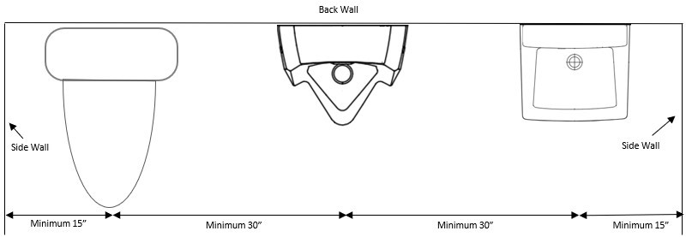

- Lavatories. Lavatories in public and employee restrooms shall be located in the same rest room as the toilet.
Exception: Lavatories in hotels, motels and dwellings may be installed outside of but in close proximity to the bathroom.
- Location of Fixtures. Plumbing fixtures or any other part of the plumbing system shall be installed in a manner as to not interfere with the proper operation of windows, doors or other equipment.
(4)(d) Prohibited Fixtures. The following fixtures are prohibited.
- A pan, valve, plunger, offset, washout, frost proof latrine, or other toilet which has
- Toilets with:
  - an invisible seal,
  - a mechanical seal or an unventilated space.,
- A toilet that has walls that are not thoroughly washed at each discharge.
- A toilet that may enable siphonage of the contents of the bowl back into the tank.
- Trough urinals and floor stall urinals
  - a device that may allow siphonage from the bowl to the tank.
- Urinals with:
  - trough drains,
  - stall type,
  - with an exposed trap,
  - an invisible seal

(5)(2) Toilets.

- Employee or Public Use. A toilet for public or employee use shall be of the elongated type. Exception:
In facilities where fixtures are provided for use of children under the age of six, toilets shall be sized suitable for their use.
- Flushing Device. A toilet tank shall have sufficient capacity to flush properly the toilet bowl with which it is connected.
- Float Valve and Ballcocks. A float valve or ballcock in a toilet flush tank shall be of anti-siphon design and shall provide sufficient water to refill the trap seal in the toilet bowl.
- Flushometer Valves.
  - A flushometer valve shall be so installed that it will be readily accessible for repairing.
  - When the valve is operated, it shall complete the cycle of operation automatically opening and closing positively under the service pressure.
  - At each operation the valve shall deliver water in sufficient volume and at a rate that will thoroughly flush the fixture and refill the fixture trap.
  - Means shall be provided for regulating the flushometer valve flow.
  - Not more than one fixture shall be served by a single flushometer valve.
  - Protection against backflow shall be provided as specified in 248 CMR 10.14(7 (8).
- Seats. A toiletToilets shall be elongated equipped with a seatopen-front seats of smooth non-absorbent material. The seat of a toilet that is provided for public or semi-public use shall be of the open front type with or without covers. Seats must be of proper size to fit the related toilet.

Exception:
  - Elongated or round front toilets with closed front seats shall be permitted in single family dwellings, condominiums, apartments, dormitories, hotel and motel guest rooms and private office bathrooms.
  - Round front toilets with closed seats shall be allowed in daycare, pre-school, and kindergarten facilities in compliance with local Board of Health regulations.
- Toilets shall use a maximum of 1.6 gallons (6.0 liters) per flush.
- Toilets in public or employee rest rooms shall be installed using separate compartments to ensure privacy.

Exception:
  - Unisex/gender-neutral single user toilet rooms
  - In childcare facilities where fixtures are provided for use of children under the age of six.
- Alternative Technology Toilet Systems.
Areas subject to 310 CMR 15.00: The State Environmental Code, Title 5: Standard Requirements for the Siting, Construction, Inspection, Upgrade and Expansionof On-site Sewage Treatment and Disposal Systems and for the Transport and Disposal of Septage or where sewers are unavailable innovative alternative technologytoilets maybe installed in 1. Innovative alternative technology toilets may be installed in place of a liquid sealed toilet. These
- Alternative technology toilets are considered plumbing fixtures under 248 CMR 10.00 and therefore the, plumbing permit requirements must be satisfied.
- The alternative technology toilet system shall be manufactured to NSF-41/ASNI standards and shall be installed in compliance with the manufacturer’s instructions.
- For additional fixture requirements, refer to 248 CMR 10.10, (15) Table 1.
- Installations in areas where no potable water is available, hand sanitizer stations may be installed in lieu of the required lavatory with prior approval from the local board of health.

(6)(3) Urinals.

  - Urinal Fixtures. Only pedestal urinals and wall hung urinals with integral traps shall be used.
- All urinals shall be of the type containing integral traps. See 10.10: Example 2

10.10: Example 2 - Example of Urinal with Integral Trap
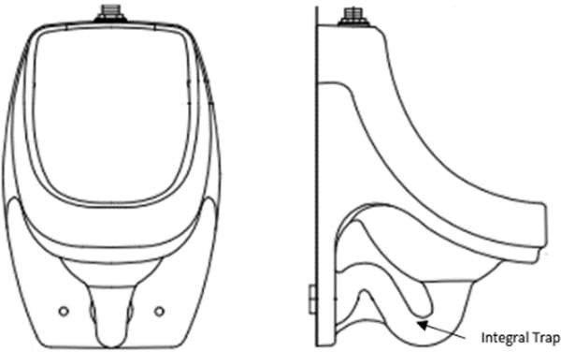
- Urinals shall be flushed only by means of an automatic flushing tank or flushometers equipped with a back flowbackflow preventer.
- Urinals shall use a maximum of 1 gallon (3.8 liters) per flush.
- Automatic Flushing Tank. A tank that flushes more than one urinal, shall be automatic in operation; and shall be of sufficient capacity to provide the necessary water to flush and cleanse properly all urinals simultaneously.

- Materials Surrounding Urinals for Public or Semi-public Usein Facilities Other Than Private Residences.
  - The floor areas one foot in front of the urinal lip and one foot on each side of the urinal, and the wall areas to four feet above the floor, shall be finished with so as to be non-absorbent. materials. See 10.10: Example 3

  - Wood and fiber boards are prohibited in the above noted areas.

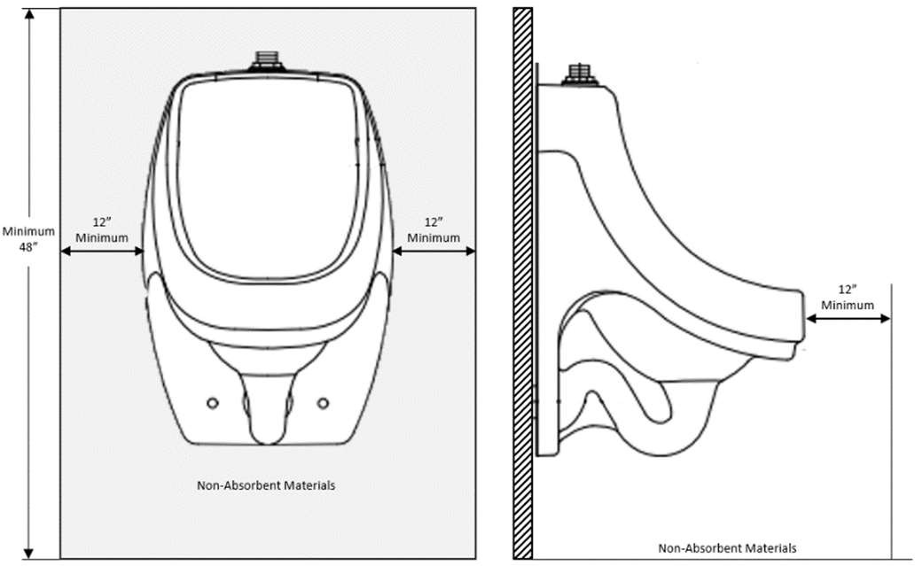
10.10 Example 3 - Example Non-Absorbent Materials Surrounding Urinals
- Urinals Every urinalshall be side shielded for privacy.

- Waterless Urinals:
  - shall have a liquid barrier trap seal
  - shall be installed downstream of at least one water supplied fixture
  - shall have a water line roughed in for future use to each waterless urinal
- Urinals may be substituted for toilets where indicated in 248 CMR 10.10, Table 1 Minimum Facilities for Building Occupancy and are listed by percentage.
- When urinals are installed in accessible rest rooms, at least one shall be set for handicapped use.

(7)(4) Bathtubs, Tub & Shower Baths, StallsUnits and CompartmentsShowers.

- Shower Head Supply Riser. Every shower head supply riser or extension from the shower valve to the shower head outlet, whether exposed or not, shall be securely attachedproperly secured to the structure. See 10.10: Example 4

  - Shower Waste Outlet.

10.10 Example 4 - Shower Head Securely Fastened to Structure
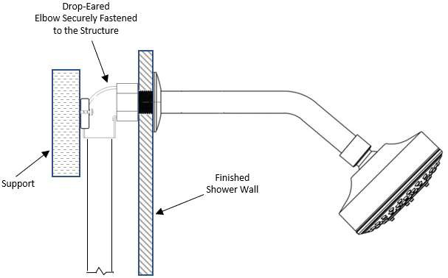

- Drain Size
  - The minimum size drain for a bathtub or tub & shower unit shall be one-and one-half inches.
  - The minimum size drain for a shower with one 2.0 G.P.M shower head operating at one time shall be one-and one-half inches.
  - The minimum size drain for a shower with more than one 2.0 G.P.M shower head which may operate simultaneously shall be two inches.
    - Multiple shower heads which operate simultaneously up to and including ten G.P.M shall have a minimum two-inch drain.
    - Multiple shower heads which operate simultaneously up to and including twenty G.P.M shall have a minimum three-inch drain.
    - Multiple shower heads which operate simultaneously up to and including fifty G.P.M shall have a minimum four-inch drain.
14. Waste outlets serving shower stalls and compartments that are not part of bathtubs shall be no less than two inches in diameter,showers shall have removable strainers not less than three inches in
diameter, and shall have strainer openings not less than ¼ inch in minimum dimension.one quarter inch. Exception: Other shower strainers which are product-accepted.

25. In shower rooms or in an area that Showers where multiple shower heads are installed and the individual shower space, area, stall or compartment is not provided with an individual waste outlet, the waste outlet shall be so located that the floor is designed and pitched so that waste waterwastewater from one shower head area does not flow over the floor area serving another shower head area.

36. Waste outlets shall be securely fastened to the waste pipe and make a watertight connection thereto.

  - Shower Compartments.

    - Shower compartments and stalls shall have at least 900 square inches of floor area and be not less than 30 inches in minimum dimension measured from its finished interior dimension as the side of a rectangle, altitude of a triangle or diameter of a circle or other angular shape.

    - The minimum required area and dimension shall be measured from its finished interior dimension at a height equal to the top of the threshold and at a point tangent to the centerline of the threshold.

7. Where a handicap accessible shower stall which does not incorporate a threshold is installed with an additional floor drain in the same bathroom, the waste outlet for the floor drain may connect to the vertical piping between the shower drain and the trap weir. See 10.10: Example 5

10.10 Example 5 - Second Drain for Accessible Shower Stall with no Threshold
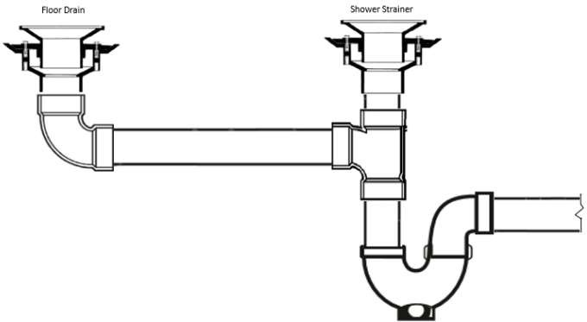

- Controls.
  - All control valves and diverters shall be installed to prevent by-passing of hot or cold water.
  - The water supply to a shower head shall be supplied through a Product-accepted individual thermostatic, pressure balancing or combination thermostatic/pressure balancing valve.
    - Hand-held showers shall also conform to this requirement.
    - Hand-held showers shall be equipped with a properly installed vacuum breaker.
    - Hand-held showers shall be considered a shower head.
  - Shower heads shall use a maximum of 2.0 gallons per minute (G.P.M.).
  - All control valves shall be equipped with devices to limit the maximum outlet temperature of mixed water to 120 degrees Fahrenheit and shall be adjusted by the installing plumber, prior to final inspection in accordance with 248 CMR 10.04 (2) (b).
  - Central type automatic temperature control mixing valves may be used in lieu of individual control complying with ASSE 1070, provided that the temperature control mixing valve limits the maximum temperature of the hot water supplied to individual shower controls to 120 degrees Fahrenheit during all periods when showers are in use.
    - A thermometer is required in the outlet piping of the automatic central control mixing valve for inspection and adjustment of temperature.
    - Check valves are required on the hot and cold-water inlets on all automatic central control mixing valves.
    - When the temperature in the incoming hot water supply piping to a shower station is controlled by an automatic temperature control mixing valve, individual shower controls maybe Product Accepted, two-handle or single-handle shower valves.
- Showers.
  - Size. The interior height of all showers shall be at least seventy-two inches above the drain. Where glass enclosures are provided, the interior shall be capable of encompassing a 30” circle.
    - Square or Rectangular. The rough-in dimension of a square or rectangular shower shall be no less than 32 inches front to back and 32 inches side to side. See 10.10: Example 6. Exception: The minimum 32 inch rough-in dimension shall not apply to shower compartments with an overall rough-in dimension of not less than 30 inches in width provided the shower is at least 48 inches in length.
    - Neo-Angle. The rough-in dimensions of a neo-angle shower shall be no less than 38 inches front to back and 38 inches side to side. See 10.10: Example 7.
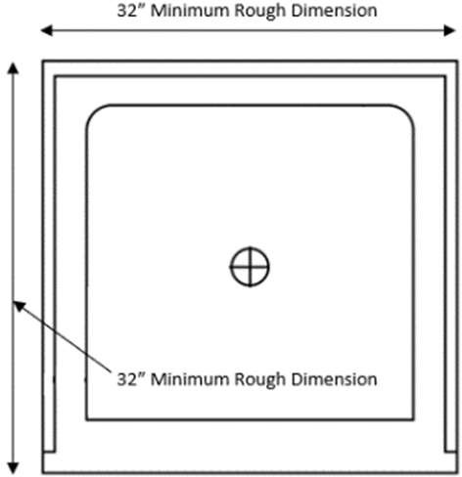
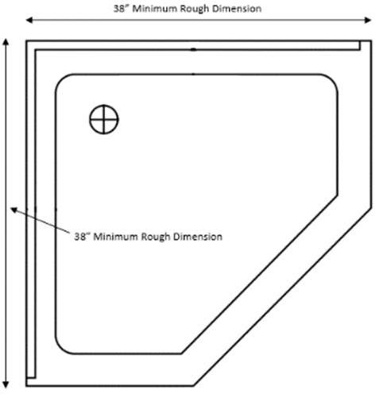
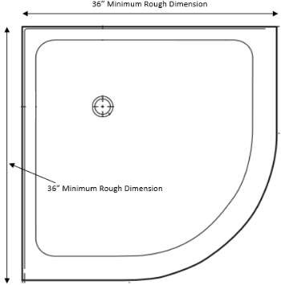
    - Neo-Round. The rough-in dimensions of a neo-round shower shall be no less than 36 inches front to back and 36 inches side to side. See 10.10: Example 8.

10.10: Example 6 | 10.10: Example 7 | 10.10: Example 8
Square or Rectangle | Neo-Angle | Neo-Round

  - Floors and Receptors.
    - Floors or receptors under shower compartments shall be laid on or be supported by a smooth and structurally sound base.
    - Manufactured shower pans, shower bases, and shower receptors shall be installed in accordance with the manufacturer’s installation instructions.
- Floors under shower compartments, other than those laid directly on the ground surface or where prefabricated shower base receptors have been provided, shall be lined, and made watertight by the provision of suitable shower pans of durable Product-accepted materials.
- Shower pans shall turn up on all sides other than the threshold at least three inches above the finished threshold level when one is present.
- Shower pans shall be securely fastened to the waste outlet at the seepage entrance making a watertight joint between the pan and the outlet.
- Floor surfaces shall be constructed of smooth, non-corrosive, nonabsorbent, and waterproof materials.
- Where showers are installed without a threshold and an additional drain is installed in the floor within the same bathroom, the waste for the second drain may be connected directly to the inlet side of a properly sized and vented trap. See 10.10: Example 5.
  - Outside Showers. Outside showers are not a requirement of 248 CMR.
    - When tempered water is provided, these showers shall meet the requirements of 248 CMR
10.10 (4)(c).
    - Drains for outside, uncovered showers shall not be required.
3.(e) Built-In Bathtubs: The wall area above built-in tubs having installed shower heads and in shower compartments or stalls shall be constructed of smooth, non-corrosive, and non-absorbent, waterproof materials to a height not less than six feetseventy-two inches above the floor level. Such walls shall form a watertight joint with each other and with the bathing tub, floor receptor, shower floor or base.

  - The waste outlet opening for individual shower compartments shall be two inches in diameter.

  - Shower Floors or Receptors.
    - Floors or receptors under shower compartments shall be laid on or be supported by a smooth and structurally sound base.
    - Floors under shower compartments, other than those laid directly on the ground surface or where prefabricated shower base receptors have been provided, shall be lined and made watertight by the provision of suitable shower pans of durable Product- accepted materials.
    - Shower pans shall turn up on all sides at least above the finished threshold level.
    - Shower pans shall be securely fastened to the waste outlet at the seepage entrance making a watertight joint between the pan and the outlet.
    - Floor surfaces shall be constructed of smooth, non-corrosive, nonabsorbent, and waterproof materials.

  - Shower Controls.
    - When a flow control valve or shower head is designed to completely shut-off and is installed on the outlet pipe from a shower control unit, check valves shall be provided in the hot and cold water supplies to the unit to prevent by-passing of hot or cold water. An exception to the requirement above is when Product-accepted shower control units are designed to preventby-passing.
    - All showers, shower stalls, shower compartments, gang showers, and shower baths, either multiple or single, shall be equipped with an approved adjustable self-cleaning and draining shower head.
    - The water supply to a shower head shall be supplied through a Product-accepted individual thermostatic, pressure balancing or combination thermostatic/pressure balancing valve complying with ASSE 1016. The device shall conform to the following requirements:
      - the device shall incorporate a design that limits the maximum deliverable temperature of hot water to 112EF; and
      - the device shall be designed to prevent bypassing of water.
    - Automatic Temperature Control Mixing Valves.
      - A central type automatic temperature control mixing valve may be used in lieu of individual thermostatic, pressure balancing or combination thermostatic/pressure balancing valve complying with ASSE 1070, provided that the temperature control mixing valve limits the maximum temperature of the hot water supplied to individual shower controls to 112EF during all periods when showers are in use.
      - A thermometer is required in the outlet piping of the automatic central control mixing valve for inspection and adjustment oftemperature.
      - Check valves are required on the hot and cold water inlets to the automatic central control mixing valve.
      - The automatic temperature control mixing valve is a secondary control for hot water that is supplied to individual shower stations and is in addition to the primary controls used to maintain the water temperature in the domestic hot water system.
      - When the temperature in the hot water supply piping to a shower stations is controlled by an automatic temperature control mixing valve, individual shower controls may be Product-accepted two handle or single handle shower valves.
      - All automatic temperature control mixing valve devices shall be adjusted by the installing plumber, prior to a Final Inspection in accordance with (248 CMR 10.04(3)(e)). The device shall be set to deliver tempered water at a temperature not to exceed 110EF to 112EF.

  - Free Standing Tubs and Whirlpool Baths:
    - The hot water supply temperature shall not exceed 120 degrees Fahrenheit controlled by a temperature limiting device conforming to ASSE 1070.
    - For whirlpool baths, access shall be provided for service, repair, or replacement of the circulation pump.

(8)(4) Food-waste Grinder UnitsWaste Disposers.

- Residential or Domestic Food-waste Grinder-waste Outlets.Disposers. Domestic food-waste grinderdisposer units shall be connected to a drain of not less than 1½ inches in diameter. connected to a drain of not less than one- and one-half inches in diameter.
- Commercial Food-waste Grinder OutletsDisposers.
  - Commercial food-waste grinder unitsdisposers shall be connected to a drain of sufficient size to serve the unit, but in no case connected to a drain of less than two inches in diameter.
  - Commercial food-waste-grinder disposers units shall be connected and trapped separately from other fixtures or compartments.
  - These grindersdisposers shall be separately connected to a waste stack or branch drain.

- Water Supply Required.4. All Commercial food-waste grinder unitsdisposers shall be provided with an adequate supply of cold water properly protected from faucetsbackflow at a sufficient flow rate to insure proper functioning of the unit.

- Commercial Food-waste Grinders Required. All establishments summarized in 248 CMR 10.09(2)(a), (restaurants, cafeterias, hotels…) that are served by a municipal sanitary sewer and can seat 20 patrons or more shall incorporate food waste grinders.

(9)(5) Drinking Fountains. (Drinking Water Station)
- Design and Construction. A drinking fountain shall conform to any required standard per 248 CMR 3.04: Product, Design, and Testing Standards.
- Protection of Water Supply. Stream projectors shall be assembled to provide an orifice elevation as specified by ANSI Air Gaps in Plumbing Systems and ANSI Backflow Preventers.
- The minimum size trap for a drinking water station shall not be less than one and one quarter inches in nominal diameter.
- All drinking water stations shall be of the self-closing type and comply with the requirements of NSF-61
- Drinking water stations shall not be installed in toilet rooms
- When installing a drinking water station without a drain, rough plumbing shall be installed to facilitate a future connection.
- For purposes of this code, bottle filling stations with a drain shall be considered as drinking water stations.
- With relation to 248 CMR 10.10 Table 1, bi-level drinking water stations shall be counted as one fixture.
- Drinking fountains shall be permitted to discharge directly or indirectly into the sanitary drainage System.

(10)(6) Floor/Trough Drains.
- 1. Floor/Troughtrough drains shall have integral or separate traps providing a minimum water seal of three inches. The Floor/Trough drain and shall incorporate removable strainers.
- 2. The Floor/Trough draintrough drains shall be constructed so that it canthey may be readily cleaned, and the drain inlet shall be easily accessible at alltimes.
- 3. Floor/Troughtrough drains subject to backflow shall be provided with back water valves.
- 4. Size of Floor/Trough Drains. Floor/Troughtrough drains shall be of a size to serve efficiently the square foot floor area to be served or the purpose for which they are intended. The Floor/Troughtrough drain outlet pipeoutlets shall not be less than two inches in nominal diameter.
- 5. Proper Installation and Protection Against Loss of Trap Seal.
  - a. The design and installation of floor drains and /trough drains shall be at a grade to enable complete floor drainage from all directions.
  - b. All floor/trough drains and trough drains shall be installed with a, readily accessible automatic trap- primingresealing device, except that floor drains or . See 10.10: Example 9

Exceptions:
    - Floor/trough drains that will receive a continuous or semi-continuous discharge from other indirect waste fixture(s)fixtures pursuant to 248 CMR 10.12 may be allowed by the Inspector.
    - Product-accepted barrier type floor drain trap seal protection devices shall be allowed in a single room with multiple floor drains for up to 90 percent of the drains provided at least one
automatic trap-priming device is present. These devices shall not be allowed in a single room with only one floor drain.
    - an accessible wall hydrant within the room may be substituted for a trap-priming device.
  - 6. Special Hazardous Wastes.Floor/trough drains that may receive special hazardous waste shall comply with 248 CMR 10.13.

- Floor/trough drains shall be required in all commercial/industrial and multi-family laundries.
- Floor/trough drains shall be required in all commercial boiler rooms.
- Floor drains shall be required in all commercial or public rest rooms containing more than one flushing fixture. Where a urinal is present, the floor drain shall be installed in in the same vicinity.

10.10: Example 9 - Trap Resealing Device

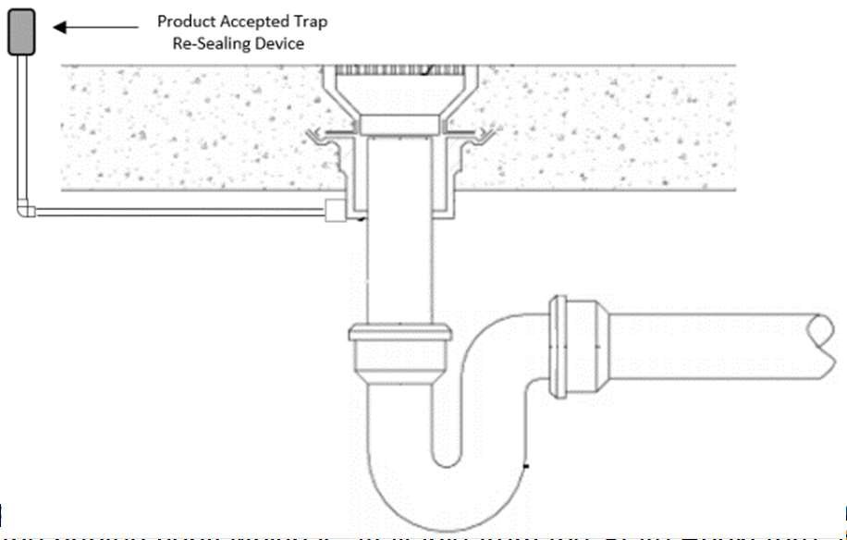
248 CMR - 64
The text of the regulations s Fitters is unofficial and for informational purposes only. The official version is the printed copy which is available from the State Bookstore at http://www.sec.state.ma.us/spr/sprcat/catidx.htm.
provided by the Board of State Examiners of Plumbers and Ga

(11)(7) Dishwashing Machines.
- Waste Discharge.
  - Domestic. The waste discharge shall comply with 248 CMR 10.08(1)( (2) (a)2.d 1. c. iv.
  - Commercial. Commercial dishwashing
    - Dishwashing machines that discharge by gravity shall be indirectly connected, except when
the machine is located above or within five feet of a trapped floor drain, the waste may be connected directly to the inlet side of a properly vented floor drain trap.
    - 3. Commercial. Dishwashing machines that incorporate drainage discharge by pumping shall discharge waste to the sanitary drainage system in accordance with the manufacturer’s recommendations.
  - (b) Portable Dishwashers. Portable Residential portable dishwashing machines (domestic) may discharge over the rim of a properly trapped and vented fixture.

(12)(8) Automatic Clothes Washing Machine.
- Requirements. A washing machine connection shall consist of a piping arrangement including hot and cold-water supplies and a properly sized trapped and vented drain connection in conformance with the following:
  - One- and Two-Family Dwellings. At least one washing machine connection. If only one washing machine connection is provided, it shall be located so that each occupant in the dwelling has access to the washing machine that may be affixed to the washing machine connection.
  - Multiple Dwelling.
    - One washing machine connection for every ten dwelling units, or fraction thereof.
- Dormitories. In dormitories, one washing machine connection for every 10 dwelling units or fraction thereof. For purposes of post-secondary school residential dormitories, the Board considers one dwelling unit to be equivalent to four students.
- Washing machine connections shall be located so that each occupant in the dwelling has access to the washing machine that may be affixed to the washing machine connection.
- (a) Water Supply. The water supplies to clothes washers shall be protected against backflow by the use of an air gap or a back flowbackflow preventer.
- (b) Waste Discharge.
  - Domestic Residential Machines.
    - The waste from a clothes washer shall discharge through an air-break into a standpipe or laundry utility/kitchen sink orstandpipeprovided the fixture trap is 2” or larger.
    - The standpipe shall extend to a minimum height of 30 inches above the base of the machine and shall not be less than 1½ inches in diameter.not more than thirty inches nor less than eighteen inches above the base of the machine and shall not be less than two inches in diameter. The trap shall not be installed below floor level. See 10.10: Example 10
    - Discharge into a properly sized floor drain shall be allowed provided a standpipe receptor is tapped and properly installed in the cover of the floor drain.

10.10: Example 10 Residential Washing Machine Drain
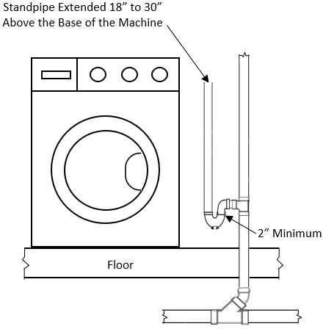

  - Commercial (Laundromats (Commercial).). The minimum size of a trap and standpipe for commercial clothes washing machines shall be not less than two inches in diameter, and shall connect to a drain of sufficientlarge enough in size to receive the simultaneous discharge of 75% of all clothes washing machines connected thereto.

- Laundry Sinks, Service Sinks, and Mop Receptors.
  - Laundry sinks shall have a minimum depth of twelve inches, a minimum waste outlet of one and one half inches and be equipped with a strainer. See 10.10: Example 11
  - Service sinks and mop receptors shall have a minimum waste outlet of two-inch and be equipped with a removable strainer. The floor areas one foot in front of the sink/receptor, one foot on each side, and the wall areas to one foot above shall be finished with non-absorbent materials.

10.10: Example 11 - Laundry Sink

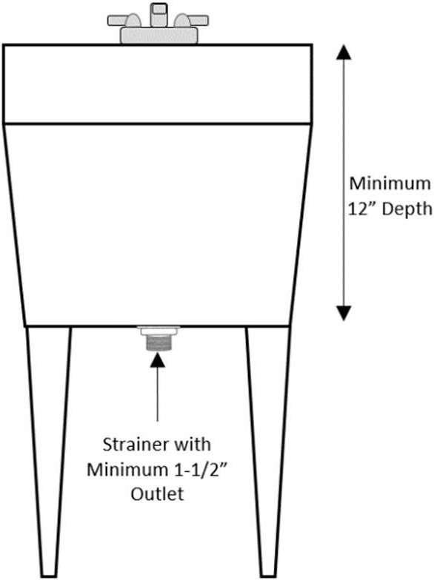

- Lavatories and Hand Washing Sinks.
  - Public and Employee
    - The maximum hot water temperature for shall be 120 degrees Fahrenheit
    - The maximum flow rate for faucets shall not exceed 0.5 gallons per minute (G.P.M.)
    - The maximum flow rate for metering faucets shall not exceed 0.25 gallons per metering cycle.
  - Residential: The maximum hot water temperature shall be 130 degrees Fahrenheit
(13) (c) Multiple Type Lavatory (Group Wash Sink). Provided that hot and cold or tempered water for hand washing is available for each 20 inch interval of a multiple use lavatory sinkFor drain and water pipe sizing purposes, every 20 inch unittwenty inches of usable length or circumference or of a straight-line or circular multiple use lavatory shall shall be considered equivalent to one lavatory as it affects the drainage and water supply piping sizes and fixture usage requirements.one lavatory.

(14)(11) Garbage/Trash Receptacle Washers.
- Garbage/Trash receptacle washers shall be separately trapped and vented.
- The fixture receiving the waste from garbage/trash receptacles shall be provided with a removable basket or strainer to prevent discharge of large particles into the building drainage system.
- Any water supply connection shall be protected against backflow by an air gap or Product-accepted backflow prevention device.

(15)(12) Special Fixtures and Specialties. Baptisteries, ornamental and lily pools, aquaria, ornamental fountain basins, fish tanks and similar constructed decorative water monuments type fixtureswhen provided with water supplies, shall be protected from back siphonage. Exception: Baptistries and similar type fixtures shall be allowed to discharge separately and directly to a drywell in the ground. If discharged into a drywell, the drain would not need to be trapped or vented.

(l3) Emergency Wash Systems. Wherever people are employed, emergency wash systems shall be required in all areas where the eyes or body of any person may be exposed to injurious corrosive materials, suitable facilities or quick drenching or flushing of the eyes and body shall be provided within the work area for immediate emergency use.

- Sacrarium.
  - The liquid discharge from a Sacrarium shall be conducted separately and directly to a drywell in the ground, and shall not be used for any other drainage purpose.
  - In no case shall the waste from a Sacrarium be connected to the building storm drainage, or sanitary drainage waste and vent system.
  - The waste from a Sacrarium shall not be trapped or vented.

- Minimum Facilities for Dwellings. Whenever plumbing fixtures are installed, the minimum number of each type of fixture shall comply with the requirements of 105 CMR 410.00: Minimum Standards of Fitness for Human Habitation (State Sanitary Code, Chapter II, and shall conform with 248 CMR 10.02(6)(b).

- Minimum Facilities for Building Occupancy Other than Residential.
  - Application of Standards and Establishing Occupancy.
    - Applicability of Changes: the requirements set forth in 248 CMR 10.10(18): Table 1 shall applyonlyto plumbing system installation, alteration or extension projects in which the process of designing the plumbing work to be performed begins on or after June 3, 1994.
    - When determining the number of plumbing fixtures after the population has been established by the authority having jurisdiction, should a fraction occur, round up to next fixture.
  - Classification of Places of Assembly.
    - Assembly (General).
      - All places in which alcoholic or non-alcoholic beverages are sold, or offered for sale, to be consumed on the premises; any room or space used for public or private banquets, feasts, dances, socials, card parties, weddings or for lodge or meeting halls or rooms; skating rinks, gymnastics, public swimming pools, billiard, pool, bowling, and table tennis rooms; halls or rooms used for public or private catering purposes, funeral parlors, recreation rooms; broadcasting studios; private clubs and all other places of similar occupancy shall be classified as general places of assembly.
      - Toilet facilities for each sex shall be provided in the amount specified in 248 CMR 10.10(18): Table 1 for assembly.
    - Assembly (Dedicated).

      - All places of worship, arenas, stadiums, theaters, cinemas, restaurants, pubs, and nightclubs shall be classified as dedicated places of assembly and toilet facilities for each sex male and female shall be provided in the amount specified in 248 CMR 10.10(18): Table 1 for dedicatedassembly.
      - Where the capacity is more than 2,000 persons, the number of toilets for the first 2,000 persons shall be calculated using the ratios in 248 CMR 10.10(18): Table 1. For the number of persons in excess of 2,000, the number of toilets shall be calculated at ratio of one per 100 for women and one per 200 for men.
      - In restaurants, pubs and nightclubs where the total combined number of employees and patrons that can be accommodated at any one time is 20 individuals and the total gross space is less than 2,000 square feet, one gender neutral, handicapped accessible toilet facility for use by both employees and the patrons shall meet the minimum fixture requirements of 248 CMR.
    - Nothing in 248 CMR 10.10(18)(b)2.a. through c. shall apply to single or multiple family dwellings, or to a place of incarceration or detention, a convent, or a monastery.
    - Plumbing fixtures for employees shall be included in 248 CMR 10.10(18): Table 1 for this type of occupancy.
    - When the occupancy ratio of 50% for each sex is not used to define fixture counts, the Inspector shall be notified in writing before construction begins, indicating the occupancy of each sex for the purpose of establishing fixture amounts.
  - Assembly (Places of Worship - Church, Synagogue etc.).
    - In no case shall there be less than one toilet and one lavatory provided for each sex to accommodate a congregation worshiparea.
    - Refer to 248 CMR 10.10(15) and (16) for baptistery and Sacrarium requirements.
    - For places of worship, which also have a function hall/multi-purpose area, the fixture number requirements for the halls/areas shall be calculated separately.
    - If sufficient fixtures are installed to accommodate the total occupancyfor the worship area and the fixtures are located within 300 feet of toilet facilities in the same building the requirements of 248 CMR 10.10(18)(c)1. and 3. shall not apply.
  - Bathing Beach Toilet Facilities (Public). When the occupancy of a beach area can exceed 4,000, toilets for the capacity in excess of 4,000 shall be installed at the rate of one per 1,000 for women, and one per 2,000 formen.
  - Day Care Toilet Facilities.
    - Refer to 102 CMR 7.00: Standards for the Licensure or Approval of Group Day Care and School Age Child Care Programs (Office for Children), for requirements regarding plumbing fixtures for this typeoccupancy.
    - Unisex toilet facilities (one toilet, and one lavatory) may be installed for children six years of age or younger. 248 CMR 10.10(18): Table 1 shall apply where more fixtures are required.
  - Police Station Lockup/Detention AreaFacilities.
    - A combination toilet and lavatory with a protective detention shroud shall be provided in each cell in where a person is detained for any part of a 24-hour day.
    - The lavatory shall be connected to the hot and cold water distribution systems.
    - Where individual toilet facilities are not required by 248 CMR 10.10(18)(f)1., fixtures shall be installed at the rate listed in 248 CMR 10.10(18): Table 1 for this type occupancy.
  - Dormitory Toilet Facilities.
    - Toilets in dormitory toilet facilities shall be of the elongated style and shall be equipped with solid plastic non- porous seats of the open front type.
    - In a toilet facility that contains more than one toilet or a toilet and an urinal, each toilet and urinal shall be separated by walls or partitions that will provide privacy.
    - Toilets, showers and lavatory facilities shall be accessible from within the building and shall be placed so that passing through any part of another dwelling unit or room is not required.
    - One laundry utility sink shall be installed for each 50 persons.
    - Toilet facilities, shower rooms and bathing rooms for males and females shall be separate and so designated.
  - Educational (School, College and University etc.) Toilet Facilities.
    - Each toilet facility shall have at least one lavatory except as provided by 248 CMR 10.10(18)(h)2.
    - In kindergarten or primary grades, unisex toilet facilities may be installed for children six years of age or younger. Lavatories may be installed in classroom areas or the toilet rooms. 248 CMR 10.10(18): Table 1 shall apply where more fixtures are required.
    - In auditoriums and multipurpose rooms that will be used at any time for community service, toilet facilities shall be provided asfollows:
- Women: one toilet for each 200 seats or majority fraction thereof.
- Men: one toilet for each 600 seats and one urinal for each 200 seats or majority fraction thereof. Women and men's toilet facilities shall be located within 300 feet.
    - Separate toilet facilities shall be provided for teachers and other staff employees. These toilet facilities shall be in addition to the requirements of 248 CMR 10.10(18): Table 1, See Educational Use Group E (staff) for teacher occupancy toilet facility requirements.
    - In addition to 248 CMR 10.10(18)(h)4., there shall be separate toilet facilities for kitchen (staff) employees, which shall comply with the requirements of 248 CMR 10.10(18)(i)1. through 3. and Table 1, Educational Use Group E (staff) for kitchen employee toilet facilityrequirements.
    - All secondary and post secondary schools that conduct sporting programs or physical activities on the school premises or grounds and include a gymnasium where the activities may be conducted shall provide separate men and women shower facilities to accommodate the students.
    - All schools, which incorporate vocationaltrade programswhere students mayhappen to become unclean due to work activities, shall comply with 248 CMR 10.10(18)(h)6.

- The systems shall include but not be limited to Drench/Deluge Showers, Hand-Held Body/Face washers and Deck Mounted Drench Hoses.
- The systems shall be in the same room and as close to the main door as possible but in no case exceeding locations that take no more than ten seconds to reach.
- Safety showers shall be capable of discharging a continuous spray at a rate of 20 Gallons Per Minute for fifteen minutes at a temperature between sixty- and one hundred-degrees Fahrenheit and sized for two emergency showers operating simultaneously.
- Piping for systems shall be installed in a manner that prevents the stagnation of water. Piping from the main to each individual emergency equipment fixture connection shall not exceed a developed length

of fifteen feet.
- The permit holder shall provide the local plumbing & gas inspector with a signed document from the owner or owner’s agent assuring weekly flushing operation of each fixture as required by ANSI Z-358.1 and OSHA will be of long enough duration to empty the volume of supply water from the circulated tempered piping loop main to the fixture outlet.
- Additional design features for emergency systems may be designed by a Massachusetts professional engineer. The design shall assure that the piping installation, including pipe sizing, dimension, and other aspects, meet the requirements for proper functioning and safety. Once the installation is complete but prior to final inspection, the installer must provide the Inspector with written certification by a Massachusetts professional engineer that the installation complies with the
design drawings and specifications. The Inspector shall not be responsible for approving or inspecting design specifications but must ensure the installation adheres to the provisions of 248 CMR.
- In existing facilities and smaller renovation projects consisting of five or less emergency fixtures where tempered water is inaccessible, cold potable water shall be permitted with prior permission of the fire prevention safety officer.
- 8.Emergency Wash Stations are required and shall be installed in the laboratory classrooms of schools, college’s and universities where flammable liquids and open flame devices are used. See 248 CMR10.13(1)(l) colleges, and universities where corrosive materials, flammable liquids, and/or open flame devices are utilized.

- Funeral Establishment Preparation Rooms. Funeral establishment preparation rooms shall comply with the provisions of 239 CMR: Board of Registration in Embalming and Funeral Directing, 3.07 Preparation Room
  - The preparation room of a Funeral establishment shall be provided with a floor drain and flushing rim sink with proper backflow protection compliant with 239 CMR 3.07(4).
  - An additional reduced pressure zone backflow preventer shall be installed on the water distribution system to the building at the outlet side of the meter or main control valve.
  - Emergency Wash Stations shall be installed and be compliant with the provisions of 239 CMR.

- Minimum Facilities:
  - All inhabited buildings and structures shall contain plumbing facilities including persons with disabilities as required in 521 CMR. 248 CMR 10.10 shall apply to new buildings, additions, and changes where a plumbing permit is required.
  - Dwellings. Whenever plumbing fixtures are installed, the minimum number of each type of fixture shall comply with the requirements of 248 CMR 10.02 (6) (b), 10.10 (14): Table 1 Minimum Facilities for Building Occupancy and 105 CMR 410.00: Minimum Standards of Fitness for Human Habitation State Sanitary Code, Chapter II,
  - Establishing Fixture Requirements.
    - Total fixture requirements shall be determined by using 50 percent male and 50 percent female. The occupancy ratio of 50% for each sex shall not be required when statistical data indicates the occupancy of the facility would be other than 50% for each sex.
      - In buildings or structures containing multiple classifications under 248 CMR 10.10 Table 1, all classifications shall be satisfied when determining the total fixture requirements.
    - If a fraction should occur while determining the number of plumbing fixtures required in 248 CMR 10.10 (14): Table 1 Minimum Facilities for Building Occupancy, rounding up to the next fixture shall be required.
    - Separate facilities shall be provided for each sex.
Exception: In establishments other than residential where the maximum number of employees and patrons do not exceed twenty and the total gross square footage does not exceed 2,000.
    - In establishments other than residential, rest room facilities shall be clearly designated and no further than four hundred feet in developed direct distance away from the regular place of daily work activity of any person for whose use it is required. Elevator usage may be taken into consideration when determining the developed direct distance. In multi- story buildings, access to the required toilet facilities shall not exceed one vertical story. Access to the required toilet facilities for customers shall not include passing through areas designated as for employee use only such as kitchens, food preparation areas, storage rooms, closets, or similar spaces. Toilet facilities accessible only to private offices shall not be included to determine compliance with this section.

- Employee Toilet Facilities for (Non-industrial) Establishments.
  - In each establishment where people are employed, there shall be separate toilet facilities for male and female employees. The toilet facilities shall be located in the tenant establishment and shall be plainly designated for male or females.
  - Toilet facilities in establishments referred to in 248 CMR 10.10(18)(j)1. within two branch levels shall be acceptable. Toilet facilities shall not be required for mezzanines. See 248 CMR 10.03. In no case may a toilet facility be located more than 300 feet in developed direct distance away from the regular place of daily work activity of any person for whose use it is required. Except where elevators accessible to the employees are provided.
  - Gender-neutral toilet facilities may be allowed if they meet the requirements of 248 CMR 10.10(18)(m) and (r).
- 4. In business or commercial establishments (except other than residential or industrial) where the total number of employees that can be accommodated at any one time is 20twenty individuals and the total gross space is less than 2,000 two thousand square feet, or do not have reasonable access (within 300four hundred feet and on the
same floor level) to core or common toilet facilities, one toilet room located within the establishment provided with the number of fixtures according to the standard set forth in 248 CMR 10.10(18): (14): Table 1 Minimum Facilities for Building Occupancy for employee facilities, shall meet the minimum requirement.
- 5. In every business or commercial establishment where only one person is employed or works, there shall
be one toilet and one lavatory for use by the tenant provided inwithin the establishment or a core toilet facility shall be located within 300four hundred feet of the tenant establishment. Core or common facilities (defined in 248 CMR 10.10(18)(i)4.), located on the same floor as the establishment being serviced and having separate designated male and

female toilet facilities may be used to meet this requirement. The number of fixtures in the core or common toilet facilities shall be in accordance with 248 CMR 10.10 (14): Table 1 Minimum Facilities for Building Occupancy or
employee toilet facilities, non-industrialbe in accordance with 248 CMR 10.10(18): Table 1 for employee toilet facilities (non-industrial).
- Where core toilet facilities are permitted and are in compliance with the occupancy requirements as outlined in 248 CMR 10.10(18): Table 1 additional designated (male and female) toilet facilities shall be permitted within the establishment. These fixtures shall not be credited towards the fixture count requirements of 248 CMR 10.10(18): Table 1.
- When individual rest rooms are installed in business or commercial establishments which also
contain core facilities, the individual rest rooms may not be included in the core facility fixture count requirements of 10.10 (14) Table 1.
- Additional fixtures installed over and above the requirements of 248 CMR 10.10 shall be allowed.
- Agricultural Buildings and structures used exclusively for agriculture including but not limited to farming and livestock and are uninhabited shall not be required to have facilities.
  - Dairy Farms: A facility or structure where cows are kept and all or part of the dairy products produced are sold or delivered for sale. The minimum fixture requirements shall be determined using the maximum number of employees on duty at any one time.
- For Places of Assembly, the minimum fixture requirements shall be determined by:
  - The number of seats in the establishment and,
  - The maximum number of employees on duty at any one time.
  - For establishments serving food and/or beverages which may be consumed and the premises, inside and outside seating shall be included when determining fixture requirements if the outside seating is provided by the establishment for use by patrons only.
  - For places of worship which also have a function hall/multi-purpose area, the fixture requirements for the halls/areas shall be calculated separately based on the use. Core facilities shall be allowed provided enough fixtures are installed to accommodate the total occupancy for the worship area and the function hall/multi-purpose area combined, and the rest rooms are
located within four hundred feet within the same building. If core facilities are used, rest rooms shall be required on every other floor level.
  - For public beaches, fixture requirements shall be based on persons per parking spaces available.
- For Places of Business, the minimum fixture requirements shall be determined by:
  - The average number of patrons visiting at any one time and,
  - The maximum number of employees on duty at any one time.
- For Educational Facilities, the minimum fixture requirements shall be determined by:
  - Pre-School & Day Care
    - The total combined number of staff and children
    - Refer to 606 CMR 7.00: Standards for the licensure or approval of family child-care, small group and school age and large group and school age child-care programs for requirements regarding additional plumbing fixtures in this type of occupancy.
  - Public & Private Kindergarten through Post-Secondary (Students)
    - Seating capacity
  - Public & Private Kindergarten through Post-Secondary (Staff)
    - The maximum number of staff on duty at any one time
  - Students Six Years of Age or Younger
    - Unisex/gender-neutral toilet facilities may be installed.
    - Lavatories may be installed in classroom areas or the toilet rooms.
  - Public and private schools, kindergarten, elementary, middle, and high schools:
    - Separate toilet facilities shall be provided for teachers and other staff employees on every other floor-level.
    - Rest rooms for students shall be provided on every floor level.
  - Post-Secondary schools:
    - Separate toilet facilities shall not be required for teachers and female. Seeother staff employees
    - Rest rooms for students shall be required on every other floor level.
  - All secondary and post-secondary schools that conduct sporting programs or physical activities on the school premises or grounds and include a gymnasium where the activities may be conducted shall provide separate men and women shower facilities to accommodate the students.
  - Where core rest rooms are installed, lavatories may be installed in an area common to both males and females directly outside the toilet facilities within the rest room area. The minimum
number of lavatories shall be determined by the total fixture count as required in 248 CMR 10.10 Table 1.

- Employee Toilet Facilities for (Industrial) Buildings.
  - In every industrial establishment, all toilet facilities where such toilet facilities include the number and type of plumbing fixtures, the floors, walls, windows, ceilings, lighting, ventilation, doors, partitions, design and location of the toilet facilities shall comply with 454 CMR 2.00: Toilets in Industrial Establishments.
  - Separate toilet facilities shall be provided for each sex and shall be plainly so designated male and female. See 248 CMR 10.03.
  - The number of toilets and lavatories shall be provided within reasonable access (as defined in 248 CMR 10.10(18)(j)4.) and in accordance with 248 CMR 10.10(18): Table 1 for industrial facilities.
  - Distance of direct access for industrial establishments requires that; in no case may a toilet facility be located more than 300 feet in developed direct distance away from the regular place of daily work activity of any persons for whose use it was designed. Except where service elevators, accessible to the employees, are provided.
  - Each 20 linear-inches, or 18-inch circumference-inches of usable sink access will be considered the equivalent of one

lavatory.
  - In industries and manufacturing facilities with departments where there is excessive exposure to substances or liquids or where the work performed may create dust and grit conditions, one lavatory sink may be required for every five persons and in all cases, a potable water supply of hot and cold water shall be provided.
- Medical and Health Care Building ToiletFacilities.
  - In all medical and health care buildings there shall be separate designated toilet facilities on each floor for male and female patients and visitors.
  - The toilet facilities may be located in a common or core area on each floor so long as the toilet facilities are within 300 feet of alloffices.

- For Industrial & Warehousing Facilities, the minimum fixture requirements shall be determined using the maximum number of employees on duty at any one time.
- For Institutional Facilities, the minimum fixture requirements shall be determined by:
  - Detainees: The total number of cells in the detention area.
  - Staff: The maximum number on duty at any one time.
- For Medical Facilities, the minimum fixture requirements shall be determined by:
  - Hospitals & Nursing Homes
    - Patients: The total number beds.
    - Staff: The maximum number on duty at any one time.
    - Visitors: The maximum number of seats in the waiting rooms.
  - Facilities and offices where procedures may be performed
    - Patients: The maximum number who may be in the facility at any one time.
    - Staff: The maximum number on duty at any one time.
    - In facilities where the maximum number of employees does not exceed fifteen and the maximum number of patrons and visitors does not exceed fifteen, one unisex/gender-neutral rest room may be installed for staff and one unisex gender-neutral rest room for patrons provided the total gross square footage does not exceed three thousand.
    - Hand washing facilities shall be provided in all examination rooms.
  - Facilities and offices where medical procedures would not be performed.
    - Patients & Staff: The maximum number who may be in the facility at any one time. Separate rest rooms are not required for patients & staff.
  - 3. Accessibility to theall toilet facilities shall be direct; it and shall not require going from one medical office through another for access to the toilet facilities.
  - 4. Handicap toilet facilities are accessible rest rooms for patients and visitors shall be required on eachevery floor level.
    - A minimum of one drinking fountain shall be installed for each set of toilet facilities.
  - Limited-Service Health Clinics.
    - Toilet facilities installed in compliance with 248 CMR shall be handicap accessible and open to the public. These facilities may be located within a locked area of the facility being served or in a common core area within four hundred feet of the clinic area so long as there is signage indicating the location of said facilities.
    - Showers shall not be required.
    - If above ground gravity drainage is not available within ten feet, the discharge for an exam sink may be pumped.
    - A drinking water station without a drain shall be allowed. This may be located within the existing retail establishment.

- Covered Malls Toilet Facilities.
  - In all covered malls there shall be separate designated public toilet facilities for male and females. These toilet facilities shall be centrally located in the common core area on each floor.
  - These facilities are in addition to the requirements of 248 CMR 10.10(18)(i) regarding toilet facilities for male and female employees.
  - When the occupancy exceeds 9,000, toilets shall be installed at the rate of one per 1,500 for women and one per 3,000 for men. Lavatories shall be installed as listed in 248 CMR 10.10(18): Table 1.

- For Mercantile Facilities, the minimum fixture requirements for employees when the occupancy exceeds employees and patrons shall be determined using the total square footage of the building divided by three hundred.
Example: A building measures 360 x 320 feet: Figure the area by multiplying 360 by 320 = 115,200 square feet. Divide 115,200 by 300 = 384 occupancy. 192 males and 192 females.
In covered malls and other multistory mercantile facilities, public rest rooms shall be located on every floor level.
- For Residential, the minimum fixture requirements shall be determined by:
  - For single and multi-family dwellings follow the requirements as stated in 248 CMR 10.02 (6).
  - For Hotels, Motels, Inns, Bed & Breakfast and similar facilities, fixtures requirements shall be based on the number of guest rooms.
  - For Dormitories, Sororities, Boarding Houses, Fraternities and similar facilities, fixture requirements shall be based on the number of occupants.
    - Bathrooms and rest rooms containing more than one toilet, or a combination of toilets and urinals shall be separated by walls or partitions providing privacy.
    - Facilities utilizing core rest room and shower facilities shall be accessible from within the building and shall be placed so that passing through any part of another dwelling unit or room is not required.
    - One laundry utility sink of every fifty persons.
    - One washing machine connection for every ten dwelling units or fraction thereof. For

purposes of this code, in post-secondary school residential dormitories, one dwelling unit shall be equivalent to four students. The washing machine connection shall be located so that each occupant in the dwelling has access to the washing machine that may be affixed to said connection.
    - Toilet facilities, shower rooms and bathing rooms for males and females shall be separate and so designated.
  - For Adult Day Care Facilities, fixture requirements shall be based on the total combined number of staff and adults. Separate facilities for staff and adults shall not be required.
  - For common areas of Assisted Living Facilities, fixture requirements shall be based on:
    - The total number of occupants
    - The maximum number of staff on duty at any one time
    - Facilities shall be located within 400 feet.
- For Small Occupied Structures such as Ticket Booths, Guard Shacks, and similar facilities, fixture requirements shall be determined by:
  - No fixtures shall be required provided accessible rest rooms are located within four hundred feet.
  - One unisex/gender-neutral rest room shall be installed if no rest rooms are located within four hundred feet.
- For unoccupied structures which may require maintenance such as pumping stations, sub- stations, and similar type facilities, one unisex/gender-neutral restroom shall be required within the facility.
- For Facilities storing goods, vehicles, aircraft, marine, food products and similar type when no work is performed, the fixture requirements shall be based on the maximum number of people working at any one time.

(m)(d) Handicap Toilet Facility Requirement. Facility for the physically handicapped person:
- Plumbing fixtures The dimensional requirements for plumbing fixtures in public rest rooms shall be installed in conformance accordance with 521 CMR 30.0: 00 (Public Toilets (for fixture dimension requirementsonly).Toilet Rooms)
- When public toilet facilities are to be installed, handicap plumbing fixtures shall comply with the requirements of 248 CMR10.10(18)(m).Gender
  - Unisex/gender-neutral handicap toilet facilities may be allowed by the Board bythrough the variance process as outlined in 248 CMR 3.04 (2): Variances:
    - A variance is not required if the fixtures in an existing or proposed men'smen’s and women'swomen’s toilet
facility and the fixtures in a Unisex/gender-neutral handicapped toilet facility meet the minimum fixture requirements of 248 CMR 10.10(18 (14): Table 1 Minimum Facilities for Building
Occupancy. A Unisex/gender-neutral toilet may be counted only one time toward the total minimum fixture requirements.
    - These toilet facilities shall always be kept clear of obstructions at all times in accordance with 105 CMR:
Department of Public Health.
4.3. Wherever drinking fountainswater stations are provided, a drinking fountainthey shall be accessible to the physically impaired.
5.4. In Additional sanitary facilities for the physically impaired;, handicap toilet stalls placed within a fully compliant 248 CMR toilet facility may also provide an additional accessible handicap lavatory within the toilet stall area. The lavatory placement shall comply with the requirements of 521 CMR.: Architectural Access Board.

(n)(e) Toilet Facilities General. 1. Toilet facilities in all commercial and public rest rooms containing more than one flushing fixture shall be equipped with a floor drain and hose connection. accessible to the public which have two or more toilets or urinals, or two or more thereof in any combination, shall provide a floor drain equipped with an automatic trap priming device and a valved hose connection equipped with a backflow preventer. The hose connection is for the purpose of floor cleaning in the toilet facility.
- Floor drains shall be installed in the vicinity of the urinal(s) and placed at a grade to enable floor drainage to the floor drain from all directions.
- Toilets for public use shall be of the elongated style and the seats shall be solid plastic, non-porous and of the open front type. Refer to 248 CMR 10.10(5)(a) through (e).
- When a urinal(s) is provided in a toilet facility the floor areas one foot in front of the urinal lip and one foot on each side of the urinal and the wall areas to four feet above the finished floor surface, shall be protected by non-absorbent building products and material. Wood and fiber boards are prohibited in these areas. Refer to 248 CMR 10.10(7)(c).
- In a toilet facility with more than one toilet, or with a toilet and a urinal, each toilet shall be enclosed. Each urinal shall be side shielded for privacy.
- When two or more urinals are required, a shield shall be provided between urinals.

  - Laundries. Laundry facilities requirements. A washing machine connection that consists of a piping arrangement that includes a cold water supply, hot water supply and a sufficient drain connection shall be provided in conformance with the following:.
    - One and Two Family Dwelling. At least one washing machine connection.
    - Multiple Dwellings.
      - Non-elderly Housing. In multiple dwellings that are not restricted to the elderly, one washing machine connection for every ten dwelling units, or fraction thereof.
      - Elderly Housing. Inhousing that is restricted to the elderly, one washing machine connection for every 20 dwelling units or fraction thereof.
      - Dormitories. In dormitories, one washing machine connection for every ten dwelling units or fraction thereof. For purposes of post-secondaryschool residential dormitories, the Board interprets one dwelling unit to be equivalent

to four students.
      - The washing machine connection shall be located so that each occupant in the dwelling has access to the washing machine that may be affixed to the washing machine connection.

  - Urinals.
    - Urinals may be substituted for toilets where indicated in 248 CMR 10.10(19): Table 1 are listed bypercentage.
    - Urinals listed for elementary, secondary, post-secondary and industrial factory/warehouse are in addition to the toilets required.
    - When urinals are used at least one shall be set for handicapped use.

(q)(f) Bathroom Group Defined. a A bathroom group shall consist of at least one bath tubbathtub or shower stall, one toilet, and one lavatory.

(r)(g) Use of Unisex/Gender-neutralNeutral Toilet Rooms. For purposes of the minimum fixture requirements of
248 CMR, wherever 248 CMR 10.00the code requires two or more toilet fixtures designated by gender, those facilities may be replaced with single use Gendergender-neutral toilet rooms pursuant to one of the following options:
- Every gender designated toilet fixture is replaced with an equal number of single use unisex gender-neutral toilet rooms (such that there are no gender designated fixtures);) or;
- Where the code requires four or more toilet fixtures combined for males and females, gender
designated fixtures may be replaced by single use Genderunisex/gender-neutral toilet rooms in increments of two such that for every male designated fixture replaced by a Genderunisex/gender-neutral toilet room, a female designated fixture must also be replaced by a Gender-unisex/gender-neutral toilet room, and vice- versa (e.g. instead of three men's toilets, four female toilets, there may be installed two men's
toilets, three female toilets, and two single use Gender unisex/neutral toilet rooms).

- Multi-User/Gender Neutral Toilet Rooms. For all buildings, the minimum fixture requirements of 248 CMR may be met by the use of one or more multi-user -/Gender Neutral Toilet Rooms whereby multiple users may utilize the fixtures regardless of gender. The following rules govern the use of such rooms:
  - At least one Single User/Gender-Neutral Toilet Room must be installed on the same floor and within 300 feet of a Multi-User/Gender Neutral Toilet Room;
  - Each toilet must be separated by lockable partitions that extend from floor to ceiling to provide privacy;
  - Calculating Required Fixtures. Multi-user/gender-neutral toilet rooms shall be calculated as serving an equal number of individuals per gender. Installation of multi-user gender-neutral toilet rooms does not allow for the installation of multi-user toilet rooms for one gender but not the other.
  - For conversions of existing gender specific toilet rooms to Multi-User/Gender Neutral Toilet Rooms, existing partitions that are not floor to ceiling may remain so long as they have functional locking mechanisms. New partitions installed in the future must extend from floor to ceiling.

Table 1: Minimum Facilities For Building Occupancy.

Building Clarification | Use Group | Toilets |  | Urinals Males | Lavatori es Each  Sex | Drinking Fountain | Bath/ Show. | Other Fixtures | Pertinent Regulations. 248 CMR  10.10(18)
Building Clarification | Use Group | Females | Males
Theaters | A-1 | 1 per 30 | 1 per 60 | 50% | 1 per 100 | 1 per 1000 |  | 1 service  sink per floor | (b), (i)1., (m), (n), (p), (r)
Nightclubs, Pubs | A-2 | 1 per 30 | 1 per 50 | 50% | 1 per 75 |  |  |  | (b), (m), (n), (p), (r)
Restaurants | A-3 | 1 per 30 | 1 per 60 | 50% | 1 per 200 |  |  |  | (b), (m), (n), (p), (r)
Hall, Museums, Libraries etc. | A-3 | 1 per 50 | 1 per 100 | 50% | 1 per 200 |  |  |  | (b), (i)1., (m), (n),
Hall, Museums, Libraries etc. | A-3 | 1 per 50 |  |  |  |  |  |  | (p), (r)
Coliseums, Arenas | A-3 | 1 per 30 | 1 per 60 | 50% | 1 per 150 |  |  |  | (b), (i)1., (m), (n),  (p), (r)
House of Worship | A-4 | 1 per 50 | 1 per 100 | 50% | 1 per 200 |  |  |  | (b), (c), (m), (n),
House of Worship | A-4 | 1 per 50 |  |  |  |  |  |  | (p), (r)
Stadiums etc. | A-5 | 1 per 30 | 1 per 60 | 50% | 1 per 150 |  |  |  | (i)1., (m), (n),  (p), (r)
Pool | A-5 | 1 per 40 bathers | 1 per 40 bathers | 33% | 1 per 60  bather  s | At least one source | 1 for every 40 bathers |  | (i)1., (m), (n), (p),  (r). See 105 CMR  for bather load.
Bathing (Public Beaches) |  | 1 per 200 | 1 per 500 | 33% | 1 per |  | 1 per | 1 Service | (d), (m), (n), (p), (r)
Bathing (Public Beaches) |  |  |  |  | 1000 |  | 1000 | Sink
Day Care Facility (Child) | E-I-3 | 1 per 20 | 1 per 20 |  | 1 per 20 |  |  | 1 Service  Sink | (e), (m), (n), (r)
(Staff) | N/A | 1 per 20 | 1 per 25 | 33% | 1 per 40 |  |  |  | (i), (m), (n), (p), (r)

Detention Facility (Detainee) | I-3 | 1 per 6 | 1 per 8 | 33% | 1 per 6 |  | 1 per 8 |  | (f), (m), (p), (r)
(Staff) | N/A | 1 per 20 | 1 per 25 | 33% | 1 per 40 |  |  |  | (i), (m), (n), (p), (r)
Dwellings (Single) | R | One Bathroom Group and One Kitchen Sink |  |  |  |  |  |  | (o), (q, (r)
(Multiple) | R | One Bathroom Group and One Kitchen Sink per Unit |  |  |  |  |  |  | (o), (q), (r)
(Hotel/Motel) | R | One Bathroom Group per Unit |  |  |  |  |  |  | (m), (q), (r)
(Dormitories) | R-2 | 1 per 6 | 1 per 8 | 33% | 1 per 8 |  | 1 per 8 | 1 Service Sink per  Floor | (g), (m), (n), (p), (r)
Educational (Kindergarten) | E | 1 per 20 | 1 per 20 |  | 1 per 20 | 1 per 75 |  | 1 Service Sink Per Floor | (h), (i), (m), (n),  (p), (r)
(Elementary) | E | 1 per 30 | 1 per 60 | 1 per 60 | 1 per 60 | 1 per 75 |  | 1 Service Sink Per Floor
(Secondary) | E | 1 per 30 | 1 per 90 | 1 per 90 | 1 per 90 | 1 per 75 |  | 1 Service Sink Per Floor
(Post Secondary) | E | 1 per 90 | 1 per 180 | 1 per 180 | 1 per 180 | 1 per 75 |  | 1 Service Sink Per Floor
Staff) | E | 1 per 20 | 1 per 25 | 33% | 1 per 40
Employee (Non-industrial)* |  | 1 per 20 | 1 per 25 | 33% | 1 per 40 |  | 1 per 15* | 1 Service | (i), (m), (n), (p), (r)
 |  |  |  |  |  |  |  | Sink per Floor | (i), (m), (n), (p), (r)

Building Clarification | Use Group | Toilets |  | Urinals Males | Lavatories Each Sex | Drinking Fountain | Bath/ Show. | Other Fixtures | Pertinent Regulations. 248 CMR  10.10(19)
Building Clarification | Use Group | Females | Males
Employee (Industrial Factory/  Warehouse and Similar Usage | F | 1 per 15 | 1 per 20 | 1 per 40 | 1 per 30 |  | 1 per 15 |  | (j), (m), (n), (p),  (r)
Institution  Hospital (Private/Semi) | I | 1 per Room |  |  | 1 per Room | 1 Per each set of rest- rooms | 1 per 15 (in ICU) | 1 Service | (i), (m), (n), (r)
 |  | Nursing Homes: 1 toilet and 1  lavatory with direct access from each bedroom (shared by 8 beds max),  can be unisex. |  |  |  |  | 1 per 12 (inpatient facilities other than ICU) | Sink  Per  Floor
 |  |  |  |  |  |  | 1 per 6 patients (Psychi- atric Hosp.)
 |  |  |  |  |  |  | 1 per 8 (Rehab facility)
Nursing Homes (Ward) |  | 1 per 8 | 1 per 10 | 33% | 1 per 10 |  | 1 per 15 |  | (i), (m), (n), (p),  (r)
Malls (Covered) | M | 1 per 750 | 1 per | 50% | 1 per 2000 | 1 per 2000 |  |  | (i), (l), (m), (n),
Malls (Covered) | M |  | 1500 |  |  |  |  | 1 Service  Sink  Per  Floor | (p), (r)
Medical/Health Care Building | B | 1 per 45 | 1 per 55 | 50% | 1 per 200 | 1 Per each set of rest- rooms | 1 per each set of rest-  rooms | 1 Service  Sink  Per  Floor | (i), (k), (m), (n), (p), (r)
Office Buildings | B | 1 per 20 | 1 per 25 | 33% | 1 per 50 | 1 per Floor |  | 1 Service  Sink  Per  Floor | (i), (m), (n), (p),  (r)
Retail (Mercantile) | M | 1 per 20 | 1 per 20 | 33% | 1 per 40 |  |  | 1 Service  Sink  Per  Floor | (i), (m), (n), (p),  (r)
Waiting Rooms (Airports,  Railroad and Bus Stations) | A | 1 per 35 | 1 per 75 | 50% | 1 per 200 | 1 per 500 |  | 1 Service  Sink  Per  Floor | (b), (m), (n), (p), (r)

  - TABLE 1: MINIMUM FACILITIES FOR BUILDING OCCUPANCY

CLASSIFICATION | DESCRIPTION OF USE | TOILETS |  | URINALS | LAVATORIES |  | DRINKING WATER STATIONS | BATHTUBS OR SHOWERS | OTHER FIXTURES | NOTES
CLASSIFICATION | DESCRIPTION OF USE | Female | Male | URINALS | Female | Male
Agricultural Unoccupied | Stables, Greenhouses, and similar buildings used exclusively for farming  and/or livestock
Agricultural  Occupied | Dairy Farms, Greenhouses  and similar buildings | 1-25 | 1-50 | Up to 50% | 1 per 50 | 1 per 50 | One for each set  of rest rooms |  | One Mop  Sink per floor
Places of Assembly | Theaters, Concert Venues and Auditoriums with fixed seating | 1-25 up to 200  1-50 201 to 500  Over 500 add  1 for every 100 | 1-50 up to 200 1-100 201 to 500  Over 500 add  1 for every 100 | Up to 50% | 1-50 | 1-50 | One for each set of rest rooms |  | One Mop Sink per floor
Places of Assembly | Nightclubs and Pubs, Lounges, Restaurants, Food Courts and Service  Plazas | 1-25 up to 200  1-50 201 to 500  Over 500 add  1 for every 100 | 1-50 up to 200 1-100 201 to 500  Over 500 add  1 for every 100 | Up to 50% | 1-50 | 1-50 |  |  | One Mop Sink per floor
Places of Assembly | Meeting Halls, Galleries, Libraries, Banquet Halls, Funeral Parlors, Gymnasiums without  permanent seating. | 1-25 up to 200  1-50 201 to 500  Over 500 add  1 for every 100 | 1-50 up to 200 1-100 201 to 500  Over 500 add 1 for every 100 | Up to 50% | 1-50 | 1-50 | One for each set of rest rooms |  | One Mop Sink per floor
Places of Assembly | Indoor Recreational Facilities, Rinks, Swimming Pools, Gymnasiums and Others Without Spectator  Seating (Patrons & Staff) | One per 40 | One per 40 | Up to 50% | 1-50 | 1-50 | One for each set of rest rooms | One per Men’s Room One per Ladies Room | One Mop Sink per floor
Places of Assembly | Indoor Recreational Facilities, Rinks, Swimming Pools, Gymnasiums and Others with Spectator  Seating (Patrons & Staff) | 1-50 up to 200  1-100 201 to 2000  1 for each add ‘l 200 over 2000 | 1-100 up to 200 1-200 201 to 2000  1 for each add ‘l  400 over 2000 | Up to 67% | 1-75 | 1-75 | One for each set of rest rooms | One per Men’s Room One per Ladies Room | One Mop Sink per floor
Places of Assembly | Outdoor Stadiums and Indoor Arenas for Professional Sporting  Events (Patrons & Staff) | 1-25 up to 200  1-50 201 to 2000  1 for each add ‘l  100 over 2000 | 1-50 up to 200 1-100 201 to 2000  1 for each add ‘l  200 over 2000 | Up to 67% | 1-75 | 1-75 | One for each set of rest rooms |  | One Mop Sink  per floor
Places of Assembly | Quasi Professional Higher Education Outdoor Stadiums and Indoor  Arenas (Patrons & Staff) | 1-50 up to 200 1-100 201 to 2000  1 for each add ’l  200 over 2000 | 1-100 up to 200 1-200 201 to 2000  1 for each add ‘l  400 over 2000 | Up to 67% | 1-75 | 1-75 | One for each set of rest rooms |  | One Mop Sink per floor
Places of Assembly | Secondary School Outdoor | 1-60 up to 300 | 1-120 up to 360
Places of Assembly | Stadiums and Indoor Arenas (Patrons & Staff) | 1 for each add ’l  150 over 300 | 1 for each add ‘l 150 over 360 | Up to 67% | 1-75 | 1-75 | One for each set  of rest rooms |  | One Mop Sink  per floor
Places of Assembly | Places of Worship | 1-50 | 1-100 | Up to 50% | 1-50 | 1-50 | One for each set  of rest rooms |  | One Mop Sink  per floor
Places of Assembly | Health Clubs and Spas With or Without Swimming Pools | 1-40 | 1-40 | Up to 50% | 1-50 | 1-50 | One for each set of rest rooms | One per Men’s Room One per Ladies Room | One Mop Sink per floor | *One unisex shower allowed if total number of patrons and staff at any time does not exceed  twenty.
Places of Assembly | Public Beaches | 1-500 up to 2,000  1 for each add ’l  1000 | 1-1,000 up to 2,000  1 for each add ‘l 2,000 | Up to 67% | 1-250 | 1-250 |  |  | One per each set of  restrooms
Places of Assembly | Casino Gaming Areas | 1-50 up to 200 1-100 201 to 2000  1 for each add ’l  200 over 2000 | 1-100 up to 200 1-200 201 to 2000  1 for each  additional 400 over 2000 | Up to 67% | 1-75 | 1-75 | One for each set of rest rooms |  | One Mop Sink per floor
Places of Assembly | Passenger Terminals | 1-50 up to 200 1-100 201 to 2000  1 for each add ’l  200 over 2000 | 1-100 up to 200 1-200 201 to 2000  1 for each add ‘l  400 over 2000 | Up to 67% | 1-75 | 1-75 | One for each set of rest rooms |  | One Mop Sink per floor
Places of Business | Buildings Offering Service Type Transactions. Banks, Salons, Laundries, Veterinary Clinics, Offices, Shops, Service Stations, and similar usage (Patrons & Staff) | 1-20 up to 100  Over 100 add 1  for every 50 | 1-25 up to 100  Over 100 add 1 for every 50 | Up to 50% | 1-50 | 1-50 | One for each set of rest rooms |  | One Mop Sink  per floor | A single set of rest rooms may be used by patrons and employees when figuring the fixture  requirements.

CLASSIFICATION | DESCRIPTION OF USE | TOILETS |  | URINALS | LAVATORIES |  | DRINKING  WATER STATIONS | BATHTUBS OR SHOWERS | OTHER FIXTURES | NOTES
CLASSIFICATION | DESCRIPTION OF USE | Female | Male | URINALS | Female | Male
Educational Facilities | Public and Private Pre-School and Day Care | One per 20  Children & Staff | One per 20 Children & Staff |  | 1 per 10 | 1 per 10 | One for each set of rest rooms |  | One Mop Sink per Floor | One single user rest room allowed for up to 20 children and staff  combined.
Educational Facilities | Public & Private Schools.  Kindergarten, Elementary, Middle & High School | 1-25 up to 100 Over 100 add 1 for every 50 | 1-25 up to 100 Over 100 add 1 for every 50 | Up to 50% | 1 per 25 | 1 per 25 | One for each set of rest rooms |  | One Mop Sink per Floor
Educational Facilities | Staff | 1 per 20 | 1 per 25 | Up to 33% | 1 per 20 | 1 per 20
Educational Facilities | Public & Private Post-  Secondary Schools including Staff | 1-30 up to 120  Over 120 add 1 for every 60 | 1-34 up to 120  Over 120 add 1 for every 80 | Up to 67% | 1 per 50 | 1 per 50 | One for each set of rest rooms |  | One Mop Sink per Floor
Industrial, Warehousing, Research & Development facilities | Buildings & warehouses where employees assemble or process products that may be stored and/or shipped | 1-20 up to 100 Over 100 add 1 for every 40 | 1-40 up to 120 Over 120 add 1 for every 80 | Up to 67% | 1 per 15 | 1 per 15 | One for each set of rest rooms | One per 20 Males and One per 20 females | One Mop sink per floor
Institutional Facilities | Correctional Facilities/Prisons | 1 per cell | 1 per cell |  | 1 per Cell | 1 per Cell |  | 1 per 15 Inmates | One Mop Sink per Floor | See 013 CMR  920.08 for multiple inmates. See  920.07 for single  cell
Institutional Facilities | Staff | 1-20 up to 100 Over 100 add 1 for  every 40 | 1-25 up to 125 Over 125 add 1 for  every 50 | Up to 67% | 1 per 40 | 1 per 40 | One per Each Set of Rest  Rooms | 1 Male & 1 Female | One Mop Sink per Floor
Institutional Facilities | Detention Centers, Correctional Facilities  and Juvenile Centers | 1 per 8 | 1 per 8 | Up to 67% | 1 per 8 | 1 per 8 | 1 per Floor | 1 per 8 Male 1 per 8 Female | One Mop Sink per Floor
Institutional Facilities | Staff | 1-20 up to 100 Over 100 add 1 for  every 40 | 1-25 up to 125  Over 125 add 1 for every 50 | Up to 67% | 1 per 40 | 1 per 40 | One per Each  Set of Rest Rooms |  | One Mop Sink per Floor
Medical Facilities | Hospitals & Nursing Homes, Addiction Recovery Centers, Psychiatric centers and  similar
Medical Facilities | Patients | 1 per Room* |  |  | 1 per Room* |  |  | 1 per Room* | One Mop Sink per Floor
Medical Facilities | Staff | 1-20 up to 100  Over 100 add 1 for every 40 | 1-25 up to 125  Over 125 add 1 for every 50 | Up to 67% | 1 per 40 | 1 per 40 | One per Each  Set of Rest Rooms |  | One Mop Sink per Floor
Medical Facilities | Waiting Rooms for visitors | 1-20 up to 100 Over 100 add 1 for  every 40 | 1-25 up to 125 Over 125 add 1 for  every 50 | Up to 67% | 1 per 40 | 1 per 40 | One per Each Set of Rest  Rooms |  | One Mop Sink per Floor
Medical Facilities | Doctor/Dental offices, labs, and similar facilities where procedures may  be performed.
Medical Facilities | Patients | 1-20 up to 100  Over 100 add 1 for every 40 | 1-25 up to 125  Over 125 add 1 for every 50 | Up to 67% | 1 per 40 | 1 per 40 | One per Each Set of Rest Rooms |  | One Mop Sink per Floor
Medical Facilities | Staff | 1-20 up to 100 Over 100 add 1 for  every 40 | 1-25 up to 125 Over 125 add 1 for  every 50 | Up to 67% | 1 per 40 | 1 per 40
Medical Facilities | Chiropractors, physical therapy and similar facilities where medical procedures are not  performed*** | 1-20 up to 100 Over 100 add 1 for every 40 | 1-25 up to 125 Over 125 add 1 for every 50 | Up to 67% | 1 per 40 | 1 per 40 | One per Each Set of Rest Rooms |  | One Mop Sink per Floor
Mercantile Facilities | Retail Stores, Supermarkets, Shopping Centers, Big Box Stores Covered Malls, and similar types accessible  to the public | 1-25 up to 100 Over 100 add 1 for every 100 | 1-50 up to 200 Over 200 add 1 for every 100 | Up to 50% | 1 per 100 | 1 per 100 | One per Each Set of Rest Rooms |  | One Mop Sink per Floor

CLASSIFICATION | DESCRIPTION OF USE | TOILETS |  | URINALS | LAVATORIES |  | DRINKING  WATER STATIONS | BATHTUBS OR SHOWERS | OTHER FIXTURES | NOTES
CLASSIFICATION | DESCRIPTION OF USE | Female | Male | URINALS | Female | Male
Residential Buildings | One and Two Family  Dwellings | 1 per Dwelling |  |  | 1 per Dwelling |  |  | 1 per Dwelling | 1 Kitchen Sink  per Dwelling | Laundry See  10.10 (8) (a) 1
Residential Buildings | Dwellings Three Family  and Above | 1 per Dwelling |  |  | 1 per Dwelling |  |  | 1 per Dwelling | 1 Kitchen Sink  per Dwelling | Laundry See  10.10.(8) (a) 2
Residential Buildings | Hotel, Motels, Inns and Similar | 1 per Guest Room |  |  | 1 per Guest Room |  |  | 1 per Guest Room
Residential Buildings | Bed & Breakfast | 1 per Every 3 Guest Rooms |  |  | 1 per Every 3 Guest Rooms |  |  | 1 per Every 3 Guest Rooms
Residential Buildings | Dormitories, Boarding Houses, Sororities, Fraternities, and Similar  Facilities | 1 per 6 | 1 per 8 | Up to 33% | 1 per 8 | 1 per 8 |  | 1 per 8 Male 1 per 8 Female | 1 Mop Sink per floor
Residential Buildings | Custodial  Adult Day Care | 1 per 20 Including Staff |  |  | 1 per 20 Including Staff |  |  |  | 1 Mop Sink  per floor
Residential Buildings | Assisted Living Facilities | 1 per 6 | 1 per 8 | Up to 33% | 1 per 8 | 1 per 8 |  | 1 per 8 | 1 Mop Sink  per floor
Residential Buildings | Staff | 1-20 up to 100 Over 100 add 1 for  every 40 | 1-25 up to 125 Over 125 add 1 for  every 50 | Up to 67% | 1 per 40 | 1 per 40
Small Occupied Structures | Ticket Booths, Guard Shacks, and Similar  Facilities | None required if accessible facilities are located within 400 feet
Unoccupied Structures | Pumping, Equipment, Sub-Stations, and Similar  Facilities | 1 Accessible unisex/gender-neutral rest room within the facility
Storage Facilities | Goods, Vehicles, Aircraft, Marine, Food Products, Appliances and Similar where no  work is being performed | 1 per 150 | 1 per 150 | Up to 67% | 1 per 150 | 1 per 150 | 1 per Each Set of Rest Rooms |  | 1 Mop Sink per Floor | One single user rest room shall be allowed for up to 20 visitors and  staff combined.
* Patrons and Staff may be combined to determine total number of fixtures required.
** Nursing Homes: 1 toilet and 1 lavatory with direct access from each bedroom shared by a maximum of 8 people. (May be Unisex/gender-neutral)
*** May be shared between Staff, Patients, and Visitors

- Funeral Establishment Preparation Rooms. Funeral establishment preparation rooms shall comply with the provisions of 239 CMR 3.07: PreparationRoom.
  - The preparation room of a Funeral establishment shall be provided with a floor drain and flooring that is compliant with 239 CMR 3.07(3): Preparation Room.
  - The preparation room shall include a flushing rim sink and the preparation room shall be protected byproper backflow devices.
  - An additional reduced pressure zone backflow preventer shall be installed on the water distribution system to the building at the outlet side of the meter or main control valve.
  - Emergency Wash Stations shall be installed and be compliant with the provisions of 239 CMR: Board of Registration in Embalming and Funeral Directing.

  - Hangers and Supports

    - General. Piping shall be installed with provisions, when necessary, for expansion, contraction and/or structural settlement. Piping shall not be supported by other piping which is connected to the plumbing system.

    - Material. Hangers, anchors, and supports shall be of metal or other material of sufficient strength to
support the piping and its contents, except thatwhere piers may be of concrete, brick, or other Product-acceptedacceptable material. Hangers, anchors and supports shall comply with piping and hanger manufacturers installation instructions.

    - Attachment to Building. Hangers and anchors shall be securely attached to the building at sufficiently close intervals to support the piping and its contents.

    - Intervals of Supports.
      - Vertical Piping. Vertical pipe of the following materials shall be supported at not more than the following distance intervals:
        - Cast iron soil pipe -- at: At base and at each story height.
        - Threaded pipe (SPS) -- every): Every other story height.
        - Copper tubing -- at: At each story height but not more than ten-foot intervals.
        - Plastic (PVC and ABS) pipe at: At each story height, but not more than ten-foot intervals and elsewhere as required to maintain proper alignment.
        - Stainless steel tubing at: At each story height, but not more than ten-foot intervals.
        - Aluminum DWV at: At each story height, or at intervals not exceeding ten feet.
        - For Cross-linked Polyethylene (PEX) Tubing: The licensee shall consult the individual manufacturers’ installation instructions.
      - Horizontal Piping. Conventional pipe clamps, brackets or strapping that have a bearing width of three quarters of an inch or more. Horizontal pipe of the following materials shall be supported at not more than the following distance intervals.

        - Cast Iron Soil Pipe --: At five-foot intervals except that where ten-foot lengths of cast iron soil pipe are used, ten-foot intervals between supports are acceptable.
        - Threaded pipe -- 12 : At twelve-foot intervals.
        - Copper tubing (1¼ inches or less) --): At six-foot intervals.
        - Copper tubing (1½ inches or over) --): At ten-foot intervals.
        - Plastic (PVC and ABS) pipe (1½ inches or less) --): At three-foot intervals, (two inches or over) ---): At four-foot intervals, (Refer to 248 CMR 10.06(2)(o) and (p)..
        - For Cross-linked Polyethylene (PEX) Tubing shall meet the following requirements:
- the maximum hanger spacing is to be 32-inch intervals for all sizes;
- the tubing is to be secured rigidly to studs or joist with hangers and supports that enable adequate expansion and ease ofmovement;
- Plumber: The licensee shall consult the individual manufacturers’ installation instructions.manufacturers
recommendations for other specific installation methods.
        - Stainless steel tubing at each story height, but not more than ten foot intervals.
        - 7. Stainless Steel Tubing (1¼ inches or less) --): At six-foot intervals.
        - 8. Stainless Steel Tubing (1½ inches or over) --): At ten-foot intervals.
        - 9. Aluminum DWV pipe: At ten-foot intervals.
        - 10. CPVC pipe sizes one inch(1 inches or less shall be supported at): At three-foot intervals and sizes .
        - 11. CPVC pipe (1¼ and greater shall be supported atinches or over): At four-foot intervals.

    - Base of Stacks.
      - Bases of cast iron stacks shall be supported on concrete, brick laid in cement mortar, metal brackets attached to the building, or by other generally accepted methods approved by the Inspector.
      - Other piping material shall be properly supported so anchored as not to take cause any additional stress or strain at the load offbase of the stack at the base.

    - Piping in Masonry.
      - Piping which is installed in and parallel to the faces of reinforced concrete or masonry walls shall be installed in adequately sized pipe space chases formed in the concrete or masonry walls.
      - The pipe chase spaces shall be accessible, or the piping shall be otherwise installed free of the reinforced concrete or masonry.

  - : Indirect Waste Piping

    - Indirect Wastes Required.
      - Food and Beverage Handling Establishments.
        - Food and beverage handling establishments engaged in the storage, preparation, selling, serving, processing, or in any manner the handling of food shall provide: indirect waste piping for
refrigerators, refrigerator coils, walk-in freezers or coolers, ice compartments, ice making machines, steam kettles, steam tables, potato peelers, egg boilers, coffee urns, coffee, soda and beverage trays and all similar types of enclosed equipment.
        - In establishments which serve soda and alcohol, individual sink compartments which store ice shall discharge independently into a floor drain or floor sink.
        - 2. Dishwashing pre-rinse sinks installed in combination with a commercial dishwasher, pot sinks,
scullery sinks and other, hand washing sinks are excluded from the indirect waste requirementand similar shall not be indirectly wasted and shall be directly connected to the sanitary drainage system.
        - 3. Single compartment culinary/produce sinks or individual compartments of multi-bay sinks for culinary/ or produce shall be individually discharged into a properly vented floor sink or floor drain. These compartments specifically designated andshall be properly labeled for produce preparation shall convey the waste from these fixtures or compartments indirectly to a properlytrapped and vented floor sink. The produce preparation compartment shall be authorized and approved by the Local Board of Health or other designated municipal health official.4. The produce preparation label must beusing a laminated sign with letters two -inches in height that reads: “This Compartment ONLY Is Designated for Produce Preparation.” See 10.12: Example 1

10.12: Example 1 - Culinary Sink
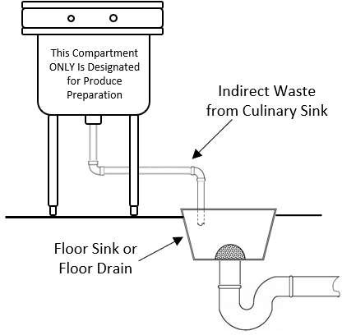
        - All indirect waste shall discharge either through an air gap or air-break into a properly trapped

and vented receptor except that an. See 10.12, Example 4. An air gap isshall be required whereif the indirect waste
pipe may be is under vacuum (less than atmospheric pressure)..
        - Vacuum Systems for Food Service Facilities.
- Vacuum drainage systems shall be installed in accordance with the equipment manufacturer’s installation instructions or be designed by a Massachusetts professional engineer, regardless of discipline.
- Plastic pipe and fittings shall be allowed within ten feet of the equipment or above the equipment being served prior to transitioning to commercial materials. See 10.12: Example 2

10.12: Example 2 - Plastic with Vacuum Systems
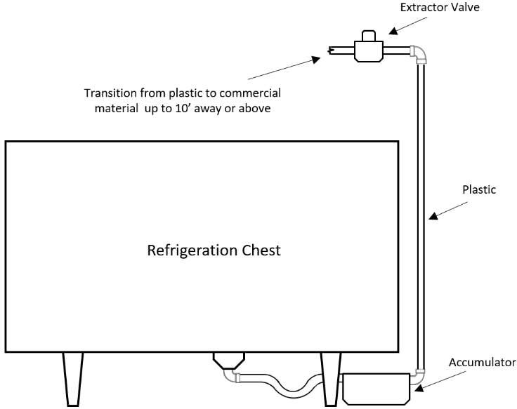

      - Connections from Water DistributionsDistribution System. Indirect waste connections shall be provided for drains, overflows, or relief lines from the water distribution system by means of an air gap.
      - Sterilizers. Appliances, devices, or apparatus such as stills, sterilizers, and similar equipment
requiring waste connections and used for sterile materials shall be indirectly connected by means of an air gap.
      - Drips or Drainage Outlets. Appliances, devices, or apparatus not regularly classed as plumbing fixtures but which have drips or drainage outlets may be drained by indirect waste pipes discharging into indirectly discharged into an open receptacle through either an air gap or air-break.
      - Clear Water Wastes.
        - All clear water waste shall be cooled to a temperature no greater than one hundred and fifty degrees Fahrenheit prior to discharging into the storm or sanitary drainage system.
- 2. Expansion tanks, fire sprinkler systems, air conditioning equipment, drip, or overflow pans, or
similar devices that waste clear water only, shall discharge waste into the building storm drainage system. The clear water waste shall discharge through an indirect waste by means of an air gap, except: or air-break. The flood level rim of the indirect fixture shall be a minimum of two inches above floor level. See 10.12: Example 3
- When clear water waste is discharged into a storm system through a vented trap, the vent for that trap shall be labeled “storm vent”. Labels shall be:
  - At a minimum of every ten feet:
  - At all changes of direction:
  - On each side of a penetration through a partition, wall, ceiling, or roof.

Exceptions:
- Clear water waste may discharge to sanitary systems in cities and towns with written authorization from the authority having jurisdiction whose system will be accepting the discharge.
- b. The waste discharge from safe waste pans serving water heaters or hot water, storage tanks is exempt from this requirement and and boilers may discharge to a properly trapped and vented fixture by means of an air gap to the sanitary drainage system.
- c. Clear water condensate waste that is produced in cumulative amounts of 12.5 gallons per hour or 300three hundred gallons per day or less in buildings by air conditioning equipment, air compressor blow-down discharge (free of petroleum hydrocarbons) or other similar apparatus or appliances may be discharged to the sanitary drainage system in accordance with 248 CMR 10.12(1)(a)5. . The clear water waste requirement is not withstanding any local ordinance, by-law, rule, or regulation to the contrary.

SafeExample 3 -Clear Water Waste Required.Discharge
  - ​ A safe waste pan shall be installed under a water heater or hot water storage tank that is installed in a position elevated above any occupied space.
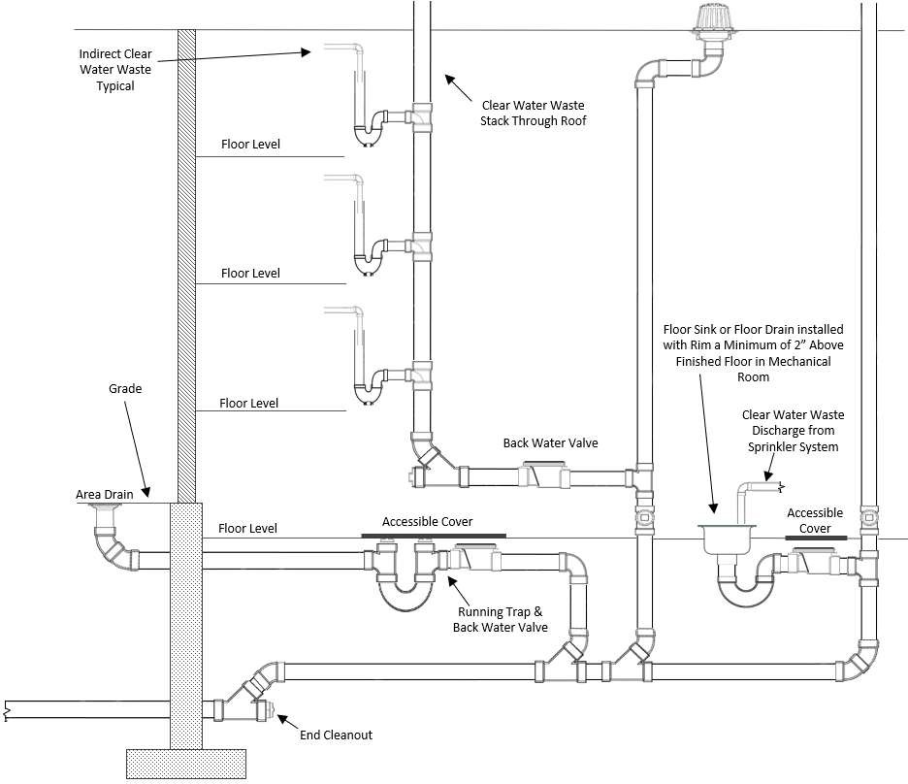
The safe

      - Swimming Pools.
        - Pipes that convey waste water from swimming or wading pools including pool drainage, back wash from filters, water from scum gutter drains or floor drains which serve walks around pools, shall be installed as an indirect waste.
        - Circulation pumps may be utilized to lift waste water when the indirect waste line is below the sewer grade.
        - The indirect waste shall discharge into the storm drainage system through an air gap.
        - All indirect waste from swimming pools shall be free of chlorine prior to discharge to the storm drainage system.

      - Pressure Tanks, Boilers and Relief Valves. The drains from pressure tanks, boilers, relief valves and similar equipment when connected to the storm drainage system shall discharge through an indirect waste by means of an air gap.

      - (f) Safe Waste Required Pan.
1. A safe waste pan shall be installed under a water heater or hot water storage tank that is installed in a position elevated above any occupied space.
- 2. The safe Safe waste pans shall be installed under water heaters and hot water , storage tanks or boilers that have a storage tanks where there is occupancy below capacity of six gallons or more and installed in a position elevated above any occupied space.
- Safe waste pans shall be piped indirectly to a properly trapped and vented fixture.fixtures or to a point within twelve inches of the lowest floor level. See 10.12: Example 4, Drawing 1 for single heater installation and Drawing 2 for multiple heater installations.
Exception: When installing a replacement water heater, storage tank or boiler, an acceptable alternate method may be to install a product accepted automatic water heater shut off device and a
safe waste pan without the related drain piping. If this method is used, the water heater temperature and pressure relief valve shall discharge into the water heater safe waste pan. See 10.12: Example 4, Drawing 3.
- The Minimum size waste pipe is toshall be 1¼-one inch pipe.. See 10.12: Example 4, Table for Sizing Safe Waste Pans.
- Where floor drains and other acceptable points of indirect discharge are installed on the same floor level, no safe waste shall be required.
      - Safe Waste Pans.
- 1. Safe waste pans shall be at least two inches deep and have a minimum clearance of two inches around the base of the hot water storage tanksappliance being served.
2. Safe waste pans shall be installed for hot water storage tanks that are six gallons in capacity or larger. See 248 CMR 10.22: Figure 14.
      - 6. Materials for the Discharge Piping of Safe Waste Pans. Materials shall comply with materials

covered under 248 CMR 10.06 relating to commercial and residential installations.

10.12: Example 4 - Safe Waste Pan Installations

10.12 Drawing 1 10.12 Drawing 2
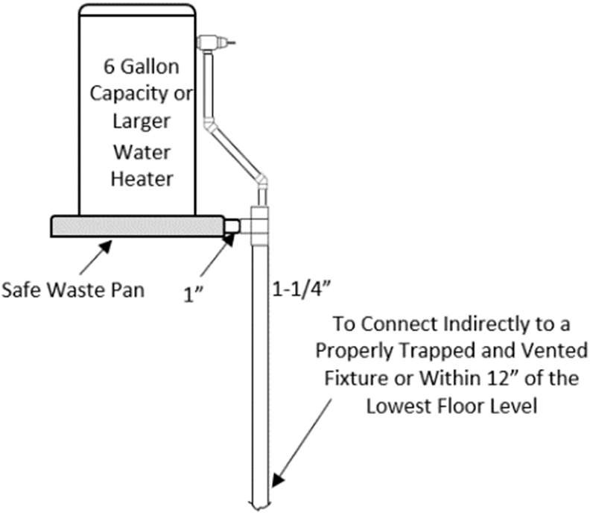

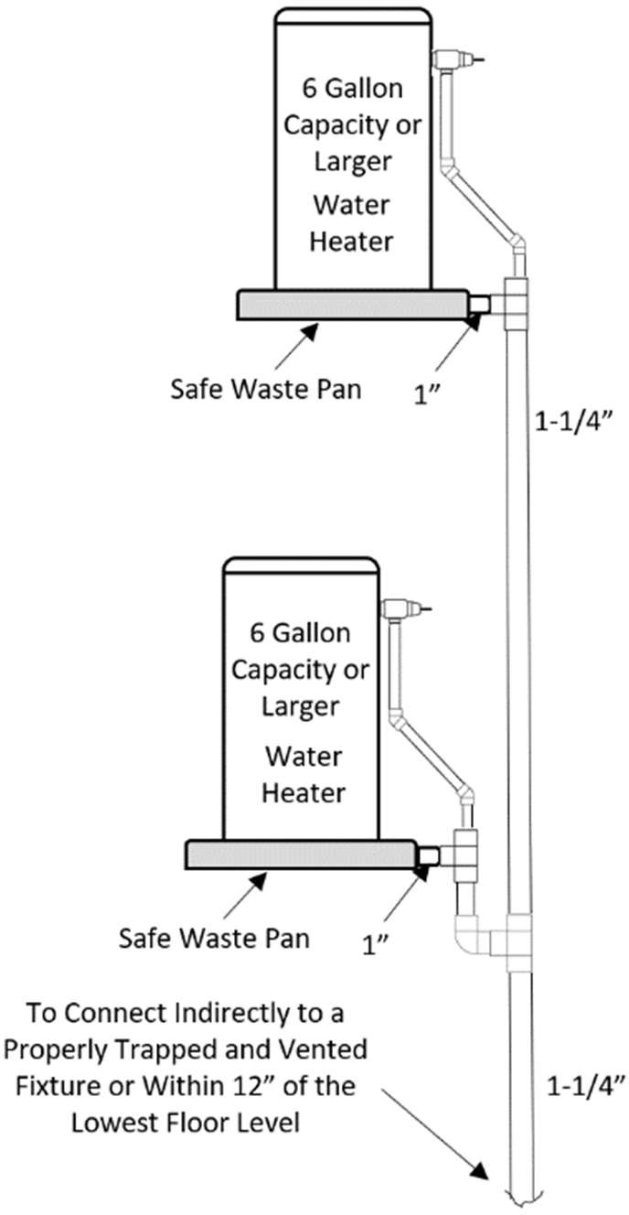
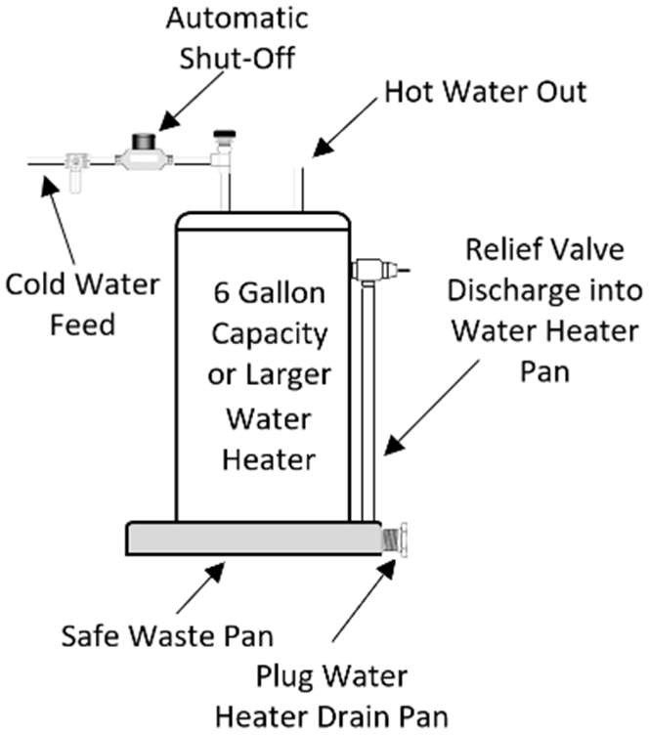
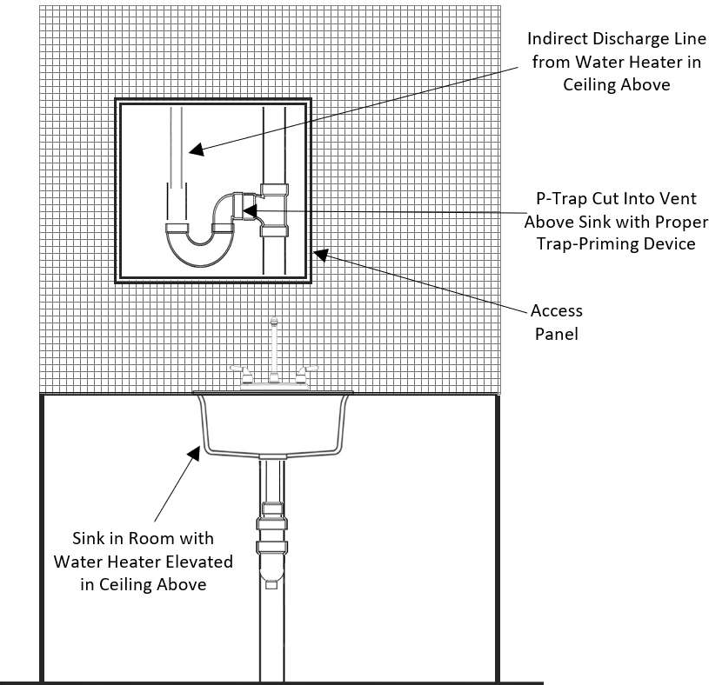
Table for Sizing Safe Waste Pan Mains
10.12 Drawing 3
10.12 Drawing 4
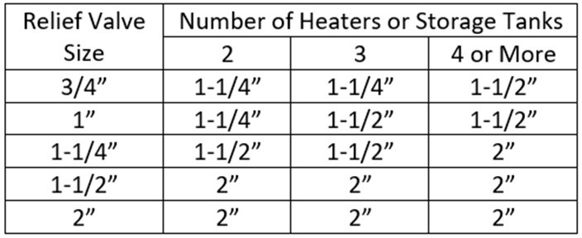

    - Air Gap or Air-Break Required. All indirect waste piping shall discharge into the building sanitary or
storm drainage system through an air gap or air-break, as set forthstated in 248 CMR 10.12 (1)(a)5., and in no instance shall the indirect waste be trapped ahead of the air gap or air-break.
      - Methods of Providing an Air Gap. The air gap between the indirect waste and the building sanitary or storm drainage system shall be at least twice the effective diameter of the drain served and shall be provided by one of the following methods: See 10.12: Example 5, Drawing 1
        - To a Receptor: a. Extend the indirect waste pipe to an open, accessible individual waste sink, floor drain, or otheranother fixture which is properly trapped and vented.
- The indirect waste shall terminate a sufficient distance above the flood level rim of the receiving fixture to provide the required air gap, and shall be installed in accordance with 248 CMR 10.00.
        - To the Inlet Side of Trap: Provide an air gap in the drain connection on the inlet side of the trap
which receives the waste from the indirect waste.
      - Methods of Providing an Air-Break. When an air-break is required between the indirect waste and
the building sanitary or storm drainage system, the distance to which the outlet of the indirect waste pipe extends below the flood level rim of the receptacle into which it is discharging shall be prescribed in 248 CMR 10.00.in 248 CMR 10.12. See 10.12: Example 5, Drawing 2

10.12: Example 5 - Use of Air-Gap and Air Break

Drawing 1: Use of Air Gap for Drawing 2: Use of Air-Break for
Indirect Waste with a Floor Sink Indirect Waste with a Floor Sink
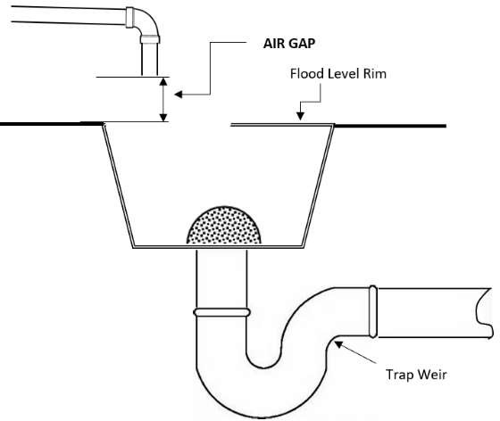
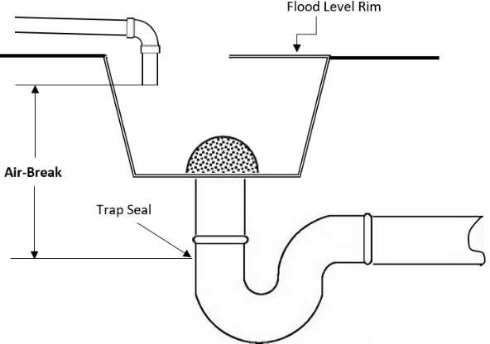

    - Receptors or Sumps.
      - Installation. Indirect waste receptors and sumps serving indirect waste pipes shall not be installed in
toilet facilities or in any location that is an inaccessible or unventilated space such as a closet, storeroom, or crawl space.
      - Size of Receptor. The pipe size serving a receptor shall be a minimum of one size larger than the largest indirect waste it serves.
(b)(c) Cleanout Location. If the indirect waste receptor is set below floor level, it shall be equipped with a running trap adjacent thereto with the trap cleanout brought level with the floor.
(c)(d) Strainers and Baskets. Every indirect waste receptor shall be equipped with a readily removable metal basket over which all indirect waste pipes shall discharge, or the indirect waste receptor outlet shall be equipped with a beehive strainer not less than four inches in height.
(d)(e) Splashing to Bebe Prevented. All plumbing receptors receiving the discharge of indirect waste pipes, shall be of a design and capacity so as to prevent splashing or flooding of the adjacent area.
(e)(f) Domestic or Culinary Fixture Prohibited as Receptors. No plumbing fixture which is used for domestic or culinary purposes shall be used to receive the discharge of an indirect waste pipe, except that
in a residence a kitchen sink is acceptable for use as a receptor for dishwashers and portable clothes washingmachines provided the kitchen sink drain in a minimum of two inch.
- The Stand Pipe Receptors. The stand pipe receptor for an automatic clothes washing machine shall be installed in one of the following ways:
  - The stand pipe receptor shall be individually trapped and vented.
  - The stand pipe shall be no more than 30 inches nor less than 18 inches above its trap and in no case shall the trap be installed below thefloor.
  - The stand pipe receptor shall be installed in the cover of a floor drain provided that the cover is properly tapped to receive the stand pipe.
  - The floor drain or trench drain shall be sized based on the discharge rate of the automatic clothes washer.

    - Condenser Sumps.
      - No steam condenser waste pipe shall directly connect to any part of a sanitary or storm drainage system, nor shall any water above 150EF150 degrees Fahrenheit be discharged into any part of a sanitary or storm drainage system.
      - Steam condenser piping may require temperature control by discharging to an approved boiler blow-off tank. Steam condenser piping shall be connected by discharging into an indirect waste receptor connected to the sanitary drainage system.

    - Installation of Indirect Waste Piping.
      - Accessibility. Indirect waste piping shall be installed so as to enable ready access for flushing, cleaning, or replacement.
      - Material, Slope, Sizing., and Approval.
        - The piping material to be used, its size and the slope at which it is installed shall meet the requirements of 248 CMR 10.00.
        - Any fixture or piece of equipment to be indirectly wasted that has a waste outlet smaller than 1¼one and one quarter
inches in diameter shall be connected to an indirect waste pipe one size larger than said outlet.

      - Indirect Waste Piping Described.
        - Individual Indirect Waste. An indirect waste which connects to one waste outlet and extends to the receiver shall be classified as an Individual Indirect Waste.
        - Indirect Waste Branch. An indirect waste which connects to one waste outlet and extends to either an indirect waste main or an indirect waste branch main shall be classified as an Indirect Waste Branch.
- 3. Indirect Waste Main. An indirect waste which connects to more than one waste outlet and extends to the receiver shall be classified as an Indirect Waste Main.
- 4. Indirect Waste Branch Main. A branch from an indirect waste main which connects to more than one waste outlet shall be classified as an Indirect Waste Branch Main.
- Indirect Waste Branch. An indirect waste which connects to one waste outlet and extends to either an indirect

waste main or an indirect waste branch main shall be classified as an Indirect Waste Branch.
      - Traps.
        - Prohibited.
- A trap shall not be installed on an indirect waste main or on an indirect waste branch main.
- Where Allowed. On waste branch.
2. A trap may be installed on any indirect waste branch or individual indirect waste where it is necessary or desirable to prevent the flow of air from inside the indirect waste piping through the indirect waste branch.
      - Air Circulation Through Indirect Waste Piping.
        - Provision shall be made so that air can circulate freely through an individual indirect waste, an indirect waste main or an indirect a waste branch main.
        - Only an indirect waste branch may be trapped and when the trapping of indirect waste branch or branches will interfere with the free flow of air through the indirect waste main or branch main, additional ventilation outlets shall be provided to enable the free flow of air.
- When a waste branch is trapped a properly sized vent shall be installed.
- An indirect waste stack receiving the discharge from fixtures on two or more floors shall be extended to the outer air as required for a stack vent.

    - Multiple Occupancy.

      - When a system of indirect waste piping serves buildings or premises having more than one tenant occupancy, it shall be designated as a "Central Indirect Waste System" and connection to it from separate tenant occupancies shall be designated as "Separate Indirect Waste Systems."
      - Separate indirect waste systems shall be connected to "Central Indirect Waste Systems" as follows:
        - The indirect waste branch to a separate occupancy shall be trapped, and this trap shall serve as a secondary indirect waste receiver for the separate indirect waste system.
        - The indirect waste branch to a separate occupancy may be from a horizontal indirect waste main or branch main, or from an indirect waste stack.
      - Secondary Indirect Waste Receivers.
        - Traps serving secondary indirect waste receivers shall be protected from siphonage by adequate individual battery of stack vents.
        - Vents on indirect waste piping systems shall not be connected to the vents of any other piping system but shall be extended separately to the outer air as required for stack vents.

  - : Piping and Treatment of Special Hazardous Wastes

    - General.
      - In no case shall special hazardous wastes discharge into the plumbing system without being thoroughly diluted, neutralized, or treated by passing through a properly constructed and acceptable diluting or neutralizing device.
      - Only special wastes shall be discharged into neutralization systems. Exception: Hand washing sinks and floor drains within a laboratory as designed by a Massachusetts professional engineer.
(b)(c) The required diluting or neutralizing device shall be automatically provided with a sufficient intake of diluting water or neutralizing medium so as to make its contents non-injurious before being discharged into the drainage system. The neutralizing device shall have an accessible cover for maintenance.
(c)(d) All plans and specifications for Special special hazardous waste piping and treatment systems shall be prepareddesigned by a registeredMassachusetts professional engineer with reference to 314 CMR 12.00, 310 CMR 30.00, 314 CMR 7.00, 257 CMR 2.00 and shall be submitted to the local inspector. 105 CMR 480 which contain others requirements applicable to wastewater discharges. No provision of 248 CMR 10.13 is intended to modify or affect the regulation of applicable wastes pursuant to the above regulations.
        - Plans stamped by a Massachusetts professional engineer with a list of special waste material to be discharged into the system shall be submitted to the local inspector prior to a plumbing permit being issued.
        - The design shall include a pH monitoring system with an audio/visual alarm. The installation, including pipe sizing, dimension, and other aspects shall meet the requirements for proper functioning, safety, and this code. See 10:13 Example 3
        - Once the installation is complete but prior to final inspection, the installer must provide the plumbing inspector with written certification by the designing Massachusetts professional engineer
stating the installation complies with the stamped drawings and specifications. The Inspector shall not be responsible for approving or inspecting design specifications, but must ensure the installation adheres to the provisions of 248 CMR 10.00.
        - All special waste piping shall be labeled in the following manner:
          - At a minimum of every ten feet:
          - At all changes of direction:
          - On each side of a penetration through a partition, wall, ceiling, or roof.
          - The labels shall be yellow with black lettering that:
            - indicate “Special Waste” and:
            - the letters shall be sized equal to a minimum, the pipe diameter. However, for piping with a diameter exceeding two inches, said lettering does not need to be larger than two inches.
(e) Treatment and/or disposal of special waste shall be conducted in conformance with 310 CMR 30.00:
Hazardous Waste (DEP) or other authorities if applicable.
- Systems requiring special consideration by the engineer are those handling organisms containing recombinant DNA molecules, radioactive, nuclear, solvents and perchloric wastes.
- When required, the plans, specifications, and other pertinent data, as requested, shall be submitted by the designer to the
Department of Environmental Protection (DEP) or other authorities for their review andapproval
- Permits shall be applied for on the basis of plans approved under 248 CMR 10.13(1)(c) and inspections shall be

conducted for the work described in 248 CMR 10.13 in accordance with the requirements noted in 248 CMR 10.13.
- All special hazardous wastes shall be conveyed in separate piping systems
- 248 CMR 10.13 shall include, but shall not be limited to, all special hazardous wastes such as organisms containing recombinant DNA molecules, chemical, nuclear, radioactive, deionized liquids, acids, perchloric, solvents and alkalines from laboratories and industrial activities.
- Nuclear or radioactive waste treatment and/or disposal shall conform to the standards of the Nuclear Regulatory Commission, N.R.C.
- Color Marking requirements:
  - Lines conveying special hazardous wastes shall be painted yellow.
  - This requirement may be met by painting three inch wide bands at intervals of not more than 25 feet and at points where piping passes through walls, floors and roofs, in which case the bands shall be applied to the piping on both sides of the walls and both above and below the floor or roof.
  - Snap-on bands marked "special hazardous wastes" may be used and spaced as described herein for paintedbands.
  - Points outlet for special hazardous wastes shall also be color-coded yellow.
- Special hazardous waste of material treatment and/or disposal shall be conducted in conformance with 310 CMR 30.00: Hazardous Waste (DEP) and local bylaws.
- Emergency Wash Systems shall meet the following requirements:
  - The systems shall be required in every school, college, university, or building laboratory newly constructed or renovated, or any room used for similar purposes wherein:
    - corrosive or flammable liquids arehandled;
    - chemicals are stored or used; or
    - where open flame devices are used.
  - The systems shall include Drench/Deluge Showers, Hand Held Body/Face washers and Deck Mounted Drench Hoses.
  - The permanently mounted showers shall be located as close to the main door of the laboratory as possible (to provide escape route), but shall not be located greater than 50 feet from an experimental area.
  - The permanently mounted shower shall be capable of discharging a continuous spray at a rate of 30 Gallons Per Minute.
  - The systems shall be tempered to between 70EF and 90EF and be installed in a manner that prevents the stagnation of water in the piping that supplies permanently mounted showers and face/eye wash stations.
  - An exception to the tempered water requirement is: in existing buildings where tempered water is inaccessible, cold potable water shall be permitted with prior permission of the fire prevention safety officer and Inspector.
  - Existing laboratories shall be compliant with the most recent provisions of 527 CMR 10.02(2): Fire Extinguishers.
    - Product-accepted Materials: Fixtures and Piping Systems.
- Materials.
  - Primary. List of Fixture Materials used for primary ping systems shall include, but not limited to:

PRIMARY SECONDARY (optional)
    - High silicon (14.5% cast iron) A. All items 1 - 8 Primary
    - Polypropylene B Poly-Vinyl Chloride (PVC)
    - Polyethylene
    - Glass
    - Chemical stoneware
    - Stainless Steel Type #316-18-8
    - Chemical resistant monolith epoxy resins
    - Polyvinylidene Fluoride(PVDF)
- High silicon (14.5% cast iron)
- Polypropylene
- Polyethylene
- Glass
- Chemical stoneware
- Stainless Steel Type #316-18-8
- Chemical resistant monolith epoxy resins
  - Secondary Containment. Materials for secondary piping systems shall include but not be limited to;
    - Poly-Vinyl Chloride (PVC)
    - All materials allowed for primary piping
- All materials listed in 248 CMR 10.13(2)(a) shall be installed and joined in accordance with the manufacturer's recommendation and 248 CMR 10.11.
- Pipes shall be furnished in straight lengths and each length shall be marked with the manufacturer's name and the type of material.
- For applicable material standard, refer to 248 CMR10.06.

- Installation Methods for Special Hazardous-waste Piping: Installation for special Hazardous-waste piping shall conform to 248 CMR 10.13(3): Tables 1 and 2:

248 CMR 10.13(3): TABLE 1

PIPE AND FITTINGS PRIMARY
Materials | Joining Methods | Above  Ground | Below  Ground
High Silicon cast iron | Acid Resistant Packing with caulked lead joint or Mechanical Clamp | Yes | Yes
Glass Pipe | Mechanical Clamp | Yes | Yes (a)(c)
Polypropylene Sch. 40 or 80 | Heat Fusion | Yes (b)(e) | Yes (e)
Polypropylene Sch. 40 or 80 | Mechanical Joints Clamp or Flange | Yes (b)(d)(e) | Yes (c)(e)
Polyethylene | Heat Fusion | Yes (b)(e) | Yes (e)
Polyvinylidene | Heat Fusion | Yes (b)(d) | Yes
Polyvinylidene | Mechanical Joints | Yes (b)(d) | No

  - Buried glass pipe shall be sleeved with rigid foam casing.
  - Shall be flame retardant aboveground.
  - Only stainless steel mechanical joint clamps or heat fusion joining method shall be used underground.
  - Flanges may be used above ground with proper gasket material for corrosive resistance to the waste carried and compatibility with the piping material.
  - I.P.S. threaded joints may be used on schedule 80 polypropylene, polyethylene.

248 CMR 10.13(3): TABLE 2
PIPE AND FITTINGS SECONDARY

Material | Joining Methods | Above  Ground | Below  Ground
a. All items listed above for primary | all items listed above for primary | Yes | Yes
b. Poly Vinyl Chloride | Injection Bonding, Solvent cement,  Approved mechanical joints | Yes | Yes

- Vents Serving Special Hazardous Wastes. Vent pipes shall not be connected to vents of the sanitary system but shall be extended through the roof with acid resistant pipe vents from biomedical facilities and shall be designed in accordance with the NIH guidelines.
- The Design and Installation of New Special Hazardous Waste Systems Including Additions, Renovations, Alterations or Revisions to Existing Systems.
  - The owner shall submit a notarized letter stating the materials to be disposed of, or discharged into the special hazardous waste system. This letter shall be attached to the plans submitted per the requirements in 248 CMR 10.13(1), and will be the basis of the engineer's design.
  - The special hazardous waste system receiving the discharge of corrosive liquids, regardless of the size or number of fixtures, shall be installed separately from the other parts of the building plumbing system.
  - The waste shall terminate at a point ten feet beyond the outlet of the final treatment or the inner face of the exterior foundation wall and shall be a minimum size of four inches.
  - That portion of piping from the outlet of the neutralizing and treatment device to a point ten feet beyond the inner face of the foundation wall shall be of a material that is Product- acceptedspecifically for special hazardous waste systems.
  - Pumps that discharge special hazardous waste shall be constructed of pressure rated pipe and fittings, and be of material compatible with Product-accepted material specifically for special hazardous waste systems.
  - Pump wetted parts, pit lining, pit frames, and pit covers shall be constructed of materials chemically resistant to the liquids being collected and discharged.
  - Alternate design of a system, materials and/or termination points shall be considered only where evidence is presented
that the standard contained in 248 CMR 10.13(4)(a) through (f) cannot reasonably be complied with. Before a permit may be issued, plans for an alternative special hazardous waste system shall be submitted to the Inspector for review and approval.

    - Design and Installation Special Waste Systems.
      - Special waste systems shall be designed to adjust the pH of waste to a level of between six and nine.
      - Discharge from special waste treatment systems may connect to either the building sanitary drain or building sanitary sewer but in no case less than ten feet from the neutralization system.
      - Venting systems for special wastes shall be piped independent of the building sanitary venting system.

      - Pumps discharging special waste shall be designed specifically for a special waste system
      - Fume Hoods and enclosed equipment shall be individually trapped and vented.

- Plumbing Layouts for Laboratory Sinks and Tables.
  - General. The installation of waste and venting system for piping handling special hazardous liquids shall be the same as sanitary waste and vent piping, except as modified in 248 CMR 10.13.
  - Traps. A trap serving a fume hood or similar type piece of enclosed equipment may not be used to serve another fixture
outside the hood enclosure and more than one fume hood may not be served by the sametrap.
  - Individual Venting of Traps.
    - Individual vents shall be provided whenever a battery waste and vent system is not being used.
    - When more than one fixture is served by a single continuous waste and vent, the branch fittings to receive the discharge from traps need not be at the same elevation.
(d)(f) Battery Systems of Waste and Vent Piping. See 10.13: Example 1
- The main horizontal branch drain shall be one pipe size larger than that required by the fixture units connected to it. (Figure cupCup sinks shall be figured as one fixture unit.).
- Horizontal piping size three inches and smaller shall have a minimum slope of ¼ inch per foot.
- In battery venting, the
- The vent shall be connected to the drain between the last and second last branches totwo fixture traps and a.
- A relief vent shall be connected to the main drain between the waste stack and the branch upstream of the first branch to fixture trap on all, but the highest connection to a stack. branch connected to the stack.
- Additional relief vents are required on battery systems of waste and vent piping when the total number of traps served on any one main drain or branch main drain exceeds six, and each additional relief vent may serve from one to five additional traps.
- Minimum The minimum size of relief ventsvent shall be two inches.
- Any branch from a main battery waste which has a separate trap vent may be considered as a relief vent and every.
- Every branch waste having a developed length exceeding ten feet shall be individually vented.
- 8. The vent for a main battery waste shall be at least ½one half the diameter of the horizontal branch drain.
- 9. Floor drains may be connected to the horizontal main battery drain with traps below the floor . In such cases: provided:
  - the minimum size of the branch shall be not less than threeinches;-inch.
  - the main branch to which the floor drain waste is connected need not be larger than the branch to the floor drain;
  - b. a separate trap vent is not required unless the developed length from the centerline of the floor drain trap
inletweir to the horizontal main battery drain exceeds 15fifteen feet.
  - c. Floor drain traps shall be included in determining relief vent requirements.
6.10. Whenever the main horizontal branch of battery waste piping is below the floor on which the fixtures occur, either a drum trap or a P trap may be used. and a A cleanout shall be installed in the vertical waste above the floor. See 248 CMR 10.22: Figure 11.
(g) When a secondary containment system for special waste is specified, it must be installed in compliance with 248 CMR
10.13 and tested in compliance with 248 CMR 10.04.

Example 1 - Special Waste Piping System
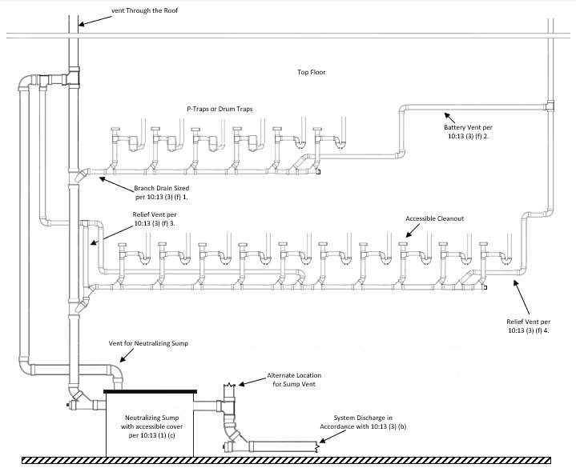

- Sizing for Neutralizing Sumps
  - The normal laboratory sink will produce on the average about ten gallons per hour of affluent and this is the basis which should be used to size the neutralizing sump.
  - The smallest size sump to be used should have a capacity of five gallons which will handle a single laboratory sink or a
cupsink.
  - To size a sump for more than one sink, 248 CMR 10.13(7): Table 3 should be used.
248 CMR 10.13: Table 3

Maximum  Number of Sinks Handled | Tank Capacity In Gallons | Minimum Inlet Outlet and Vent Sizes
1 | 5 | 2
4 | 15* | 2
8 | 30 | 3
16 | 55 | 4
25 | 100** | 4
40 | 150 | 4
60 | 200 | 4
75 | 250 | 4
100 | 350 | 4
150 | 500 | 4

* Sumps 15 gallons and larger shall be chamber vented
** When in the judgement of the professional engineer, a neutralizing tank is to be equipped with a pH system, the pH system should be equipped with an audio-visual alarm. The regulatory agency may also require an "outflow" recorder for pH. The alarm and recorder shall function when the system is operating.

    - Installation of Point-of-Use Limestone Chip Tanks.
      - Product-Accepted limestone chip tanks may be used when a full special waste system is not necessary. These tanks function on a flow-through basis and generally involve a vertical cylindrical tank filled with calcium carbonate (more commonly known as limestone). See 10.13: Example 2
      - Tank installations shall comply with 248 CMR 10.13 (1) (d) 1, 2, and 3.

      - Point-of-Use tanks with a capacity of fifteen gallons or larger must be chamber vented.

- The neutralizing materials to be used should beeither:
  - For Dilute Acid Waste Water.
    - Limestone in pieces of one to three inches diameter size range must contain a high calcium carbonate content in excess of90%.
    - If the neutralizing medium selected is limestone, then its fill level must be from the sump tank bottom to the invert of the inletpipe.
  - For Acidic and Alkaline Waste. Caustic Soda (NaOH) and Sulfuric Acid (H2SO4) or other neutralizing agents may be added through metering pumps to control the pH.
- Maintenance of Neutralizing Sumps.
  - To insure the correct operation of this system, it shall be inspected monthly (by removing the cover, checking the level of limestone chips and adding chips if necessary) and neutralizing materials be replaced or replenished as required.
- All tank installations shall include a pH monitoring system with an audio/visual alarm.
2.(e) A laminated sign shall be stenciled on or in the immediate area of the sumpeach chip tank in letters one inch high. This sign shall readstate the following:
IMPORTANT
"This sump tank must be inspected on a regular basis and the neutralizing medium or agent media replenished when necessary. Failure to do so maywill result in serious damage to the piping building drainage system.”

10.13: Example 2 - Chip Tank
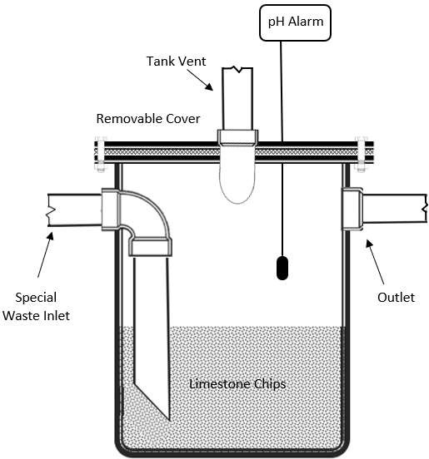

- Materials of Sumps:
  - The following materials are Product-accepted by the Board:
    - High-Density Polyethylene***
    - Chemical Stoneware
    - Polypropylene
    - Fiber Glass Reinforced Plastic (FRP)***
    - Precast or poured in place concrete chambers with a liner resistant to the hazardous waste being discharged.
    - The use of materials other than those specified above must be Product-accepted by the Board.
  - Sumps 15 gallons and larger shall be chamber vented.
  - When in the judgment of the professional engineer, a neutralizing tank is to be equipped with a pH system, the pH system should be equipped with an audio-visual alarm. The regulatory agency may also require an "outflow" recorder for pH. The alarm and recorder shall function when the system is operating.
  - Sump material subject to distortion by heat or other factors, when in use, such as Fiber Glass Reinforced Plastic, must be restrained or enclosed.
- Curbing Around Sumps. DEP standards require curbing around sumps above certain sizes.
- Discharge of Waste Through Troughs.
  - Laboratory furniture and casework which utilize troughs for the discharge of wastes shall be independently trapped, wasted or vented unless the waste outlet is within 30" of a properly wasted and vented sink.
  - Where troughs or floor trenches are required to intercept floor spills, or are required for tank or equipment drainage, the outlets from the trough or trenches shall be equipped with acid resisting grating and lining and the system shall be trapped and vented as hereinbefore specified.

*** Sump material subject to distortation by heat or other factors, when in use, must be restrained or enclosed.

- pH Adjustment Tanks.
  - Where it is inadvisable or impractical to install a neutralizing sump with either marble or limestone chips to bring pH factor of waste materials up to neutral zone or where the pH factor of anticipated wastes may vary from acid range through neutral zone and up into the alkaline range, a pH adjustment tank shall be provided.
  - pH adjustment tanks may be installed for partial or entire building systems.
  - pH adjustment tanks will consist of an acid/alkaline resisting tank, receiving wastewater from one or more sinks. The tanks shall meet the following requirements:
    - This tank is to be sized according to 248 CMR 10.13(6).
    - The tank is to have an agitator, which will operate when lab sinks and cup sinks or other hazardous waste fixtures are in use.
    - The tank will also have a sensor, to detect the pH of tank contents, within a range of two to 12 (alkaline), where the sensor shall be electrically connected to a control panel. This control panel is to be connected to acid/alkaline pumps. Acid/alkaline pumps are to be inserted into tanks containing neutralizing agents to bring tank contents up from an acid pH or down from an alkaline pH to a range of six to nine. The discharge of each pump is to run directly to the top of the adjustment tank. See schematic sketch in 248 CMR 10.13(8): Figure 1.
  - When in the judgement of the professional engineer a neutralized tank is to be equipped with a pH system, the pH system shall be equipped with an audio-visual alarm, which shall function at all times the system is operating
  - The regulatory agency may also require an "outflow" recorder for pH, which shall function at all times the system is operating.
  - Solvent bearing waste shall not be introduced into the building drainage system or sewer but shall be disposed of according to the applicable regulations of the DEP, EPA, or other appropriate regulating agency.
  - Acidic wastes shall be neutralized before being discharged into the building’s drainage system.

FIGURE 1
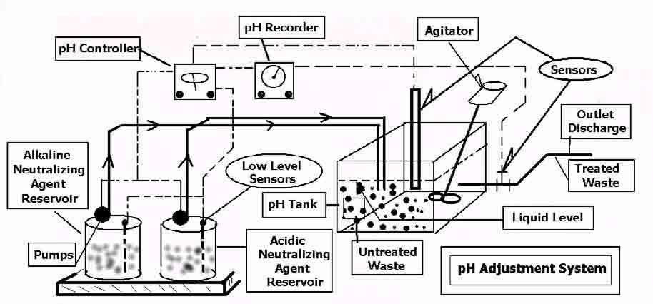

- Recombinant D.N.A. LaboratoryWastes
(a) Viable organisms containing recombinant deoxyribonucleic acid (DNA) as defined in the latest revision of the National Institutes of Health Guidelines for Research Involving Recombinant DNA Molecules (NIH guidelines), except those qualifying as Good Large Scale Practice (GLSP) organisms, shall not be introduced into the building drainage system or sewers without first being sterilized, treated or inactivated as described in 248 CMR 10.13(9)(b) and (c).
- In laboratories where both fermentation and purification take place, the waste for each shall be treated by methods proven to be effective and appropriate for the specific type of waste (as required by Massachusetts Law, 310 CMR 30.000: Hazardous Waste, and Water Resource Commission, Regulation of Waste into Sewerage Works) prior to their discharge into the building's drainage system orsewer.
- Laboratory wastes, generated by biomedical research or production laboratories, which contain viable recombinant DNA organisms not qualifying as GLSP organisms, shall be sterilized or treated according to the regulations and standards of the National Institute of Health (Recombinant DNA Guidelines and the Laboratory Safety Monograph) or the applicable requirement of other agencies having jurisdiction. The owner of the laboratory shall:
  - submit the proposed treatment procedures to the registered professional engineer who prepares the plans and specifications of the hazardous waste system;
  - submit the proposed treatment procedures to the relevant authorities, including the Inspector; and
  - receive their approval prior to connection to the building's drainage system.
- Waste containing recombinant DNA organisms shallbe:
  - Sterilized or treated at the point of origin or, where there is more than one point of origin, these wastes may be collected in a central holding tank for sterilization and treatment.
  - The holding tank is to have a sampling device and a high water alarm.
  - The alarm shall be activated when the tank's contents have reached a predetermined level.

  - The sampling device is to consist of a pump or other device or means to transfer a selected sample into the control area of the laboratory for verification that it contains no living organisms.
  - When the sample contains no living organisms, the contents of the tank can then be allowed to enter the sewer system. If the sampling process discovers live cells, the contents of the tank shall be re-sterilized and re-tested before being allowed to enter into the sewer. See reference cited below concerning "steam sterilization" and chemical disinfection".
- Testing and Monitoring.
  - The adequacy of treatment methods as selected by an institution is to be monitored on a periodic basis.
  - Biomedical research or production laboratories shall maintain records indicating the results of such testing.
  - In the event of a testing failure, the system is to be corrected immediately.
- Neutralizing chambers or tanks employing marble or limestone chips shall not be used to adjust pH for wastes generated by biomedical research or production laboratories.
- Approved and recommended references for "steam sterilization" and "chemical disinfection".
  - Laboratory Safety Monograph (A supplement to the NIH Guidelines of Health and Human Services Section11- E-8, Selecting Chemical Disinfectants in Recombinant DNA Research, 102-105.
  - Disinfection, Sterilization and Preservation 3rd Ed. Edited S. S. Bock, Lea and Febiger, Philadelphia, 1983. (Part 1 Chemical and Physical Sterilization, Chapter 1 Sterilization by Heat.)

(11)(5) Industrial Wastewater. When usage of either a neutralizing sump or a pH adjustment tank would be inadequate to treat the industrial wastewater discharge and therefore not comply with applicable regulatory limits on hazardous waste, an industrial wastewater treatment system Industrial wastewater treatment systems shall be designed by ana Massachusetts professional engineer and plans and specifications shall be submitted to the Massachusetts Department of Environmental Protection (DEP) or other authorities as required.

(12) Secondary Containment.
- When a secondary containment system for hazardous waste is specified, it must be installed by a licensed plumber in compliance with 248 CMR 10.13.
- The system must be able to withstand a ten-foot hydrostatic head pressure.
- The outer system shall be air tested to five P.S.I.G. for ten minutes.
- The gauge used shall be calibrated in increments no greater than 1/10 P.S.I.G.
- The system shall allow for thermal expansion and contraction, and inner and outer piping support.

10.13: Example 3 – Example of pH Neutralization System
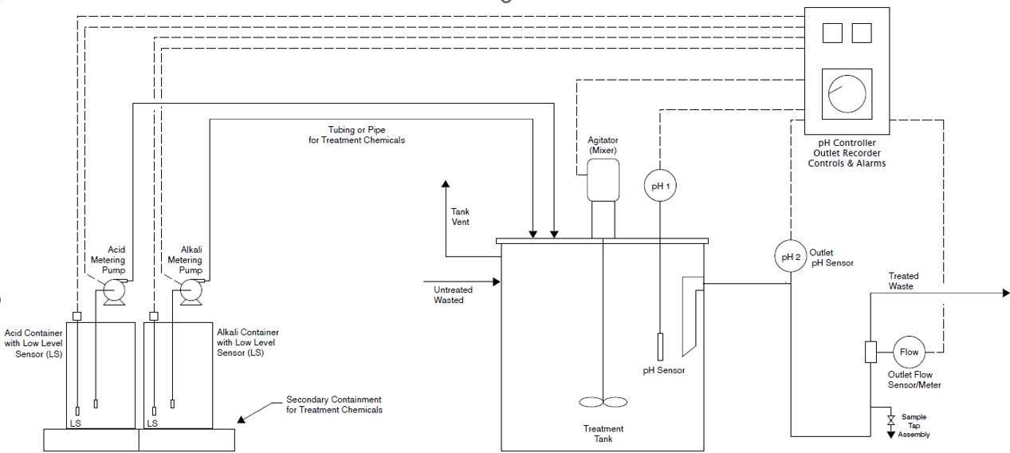

10.14: Water Supply and the Water Distribution System
- General:
  - All water for human consumption shall comply with the requirements of the Safe Water Drinking Act (SWDA), 42 U.S.C. § 300f et. seq.
  - NFPA 13D multipurpose residential fire sprinkler systems which utilize potable cold-water piping as part of a fire sprinkler protection system in one-and two-family dwellings shall comply with the requirements of 248 CMR 10.14. Installation of these systems includes the direct connection of sprinkler heads to potable water piping. When installing said system, the plumber shall adhere to the design plans of a Massachusetts professional engineer, who is responsible for ensuring the
design complies with 248 CMR and NFPA 13D (2022 edition), including the requirements as to pipe sizing and dimensions to ensure the proper functioning of the system as well as the safety of the consumers who will rely on that system.
- (1) Potable Water Supply.
  - (a) Buildings.:
    - 1. Every building equippedused for human occupancy or habitation shall be provided with plumbing fixtures andan adequate supply of potable water.
    - Every building used for human occupancy or habitation shall be provided with a potable supply of cold water in the amounts and at the pressures specified in 248 CMR 10.14.an adequate supply of hot water.

  - For permanent residences or buildings in which people are employed, hot water shall be provided.
- (b) Use of Non-potable Water Prohibited.: Only potable water shall be accessible to plumbing fixtures supplying water for:
  - 1. drinking;
  - 2. bathing;
  - 3. culinary use; or
  - 4. the processing of food, medical or pharmaceutical products.

(2)(c) Building Water Service.Piping: The building water service pipepiping shall be of sufficient size to furnish water to the building in the quantities and at the pressure required elsewhere in 248 CMR 10.00.
    - ​ It shall, in no case, be less than ¾ inch nominal pipediameter.
    - ​ Recommended methods for sizing the water service pipe shall be the same as required in 248 CMR 10.14(4).
- Conservation of Water.
  - Conservation of Hot Water.
    - Showers. Showers used for other than safety reasons shall be equipped with flow control devices to limit total flow to a maximum of 2.5 G.P.M. per shower head.
    - Lavatoryfaucets in public toilet facilities shall:
      - Limit the delivery of water to a maximum of .5 G.P.M. unless a metering faucet is provided that limits delivery to a maximum of 0.25 gallons per metering cycle.
      - Be equipped or installed with devices which limit the outlet temperature to a maximum of 110EF.
      - Metering faucets of any type are not required for toilet facilities designated and used by employeesonly.
    - The maximum temperature of the domestic hot water in residential buildings shall not exceed 130EF. Plumbing fixtures requiring higher temperatures for their proper use and function, such as dishwashers and hot water dispensers shall be exempted from 248 CMR 10.14.
  - Conservation of Cold Water for Toilets and Urinals.
    - Flushometer Toilets.
      - Flushometer toilets that are floor mounted or wall mounted shall be low consumption toilets which use a maximum of 1.6 gallons (six liters) perflush.
      - Flushometer type urinals shall discharge a maximum of one gallon (3.8 liters) per flush.
      - The Board maygrant Product-approval to standardflushometer toiletsand urinals which do not meet the specific standards when, in the opinion of the Board the configuration of the building drainage system requires a greater quantity of water to adequately flush thesystem.
    - Tank Type Toilets.
      - All two-piece toilets shall be low consumption toilets, which use a maximum of 1.6 gallons (six liters) per flush.
      - In satisfaction of the requirements of 248 CMR 10.14, the Board shall permit the installation of tank-type toilets equipped with devices which are found by the Board to meet applicable standards, in toilets having a tank capacity in excess of 1.6 gallons (six liters).
    - All other toilets not covered in 248 CMR 10.14(3)(b)1. and 2. shall be low consumption toilets that use a maximum of 1.6 gallons (six liters) perflush.

(4)(2) Designing and Sizing the Building Water Distribution System.
- Methods to Be Used.
  - The design of the building’s hot and cold-water distribution system shall conform to good engineering practices.
  - The methods used to determine pipe sizes shall be the procedure outlined in Appendix "D" of the United States Public Health Service publication #1038, or a system designed by a registered professional engineer, using the computation outlined in 248 CMR 10.14(4): Tables 1, 2, and 3. (An example of the use of these tables is shown following 248 CMR 10.14(4): Table 3).
1. The cold-water supply from the meter or main control valve when no meter is present to all branches, risers, final connection to fixtures and other connections shall be based on the total demand and procedures outlined within this section.
  - 2. The minimum size of a fixture supply pipe shall be in accordance with 248 CMR 10.14(4):
Table 1.
  - 3. The size of fixture supplies,Sizing the building water main and, branch distribution, risers and fixture supply piping mayshall be determined fromusing 248 CMR 10.14(4): Tables 1, 2, and 3. Exception: A system designed by a Massachusetts professional engineer.
  - To size the hot and cold water main or distribution branches for a building, they shall be computed on an individual basis.
  - 4. A demand factor, as recognized in 248 CMR 10.14(4): Table 2 shall be applied to determine the minimum diameter pipe size for the building main and water distribution system piping.
  - Size of Fixture Supplies.
    - 5. The minimum sizessize of a fixture water supply pipe shall be as shown in compliance with 248 CMR 10.14(4): Table 1: Minimum Sizes of Individual Fixture Branches and Factor Values.
    - 6. The individual fixture water supply pipebranch shall be extended to within at leastthe fixture connector and terminate with a fixture shut off valve.
- Fixture connectors shall not exceed 30 inches of the point of connection toand shall be product accepted by the fixture.Board. Exception: Dishwashers, washing machines and icemakers

TABLE 1
MINIMUM SIZES OF INDIVIDUAL FIXTURE WATER SUPPLY LINES
BRANCHES AND FACTOR VALUES

TYPE OF FIXTURE OR DEVICE | Nominal Pipe Size (inches) | Factor Value
Bathtub (with or without single shower head) | ½ | 2

Bidet | d½ | 1
Drinking fountainWater Station | d½ | 1
Dishwasher (Domestic) | ½ | 2
Dishwasher (Commercial) | ¾½ | 6
Kitchen sink, Residential | ½ | 2
Kitchen sink, Commercial (Pot and Scullery) | ¾½ | 6
Vegetable Prep or Bar Sink (Residential) | ½ | 2
Hand Wash Sinks | d½ | 1
Shampoo Sinks | d½ | 1
Lavatory | d½ | 1
Utility Laundry Sinks 1, 2, or 3 compartments | ½ | 2
Shower Valve (single head) | ½ | 2
Shower Valve (Multiple heads) | ¾ | 6
Sinks (service, slop) | ½ | 2
Sinks flushing rim | ¾ | 6
Laundry Valve | ½ | 2
Urinal (flush valveflushometer type) | ¾ | 6
Toilet (tank type) | d½ | 1
Toilet (flush valve type) | 1 | 12
Hose Connections/Sillcocks/Wall Hydrants | ½ | 2

TABLE 2

OCCUPANCY USE | DEMAND FACTORS
RESIDENTIAL
One- or Two-Family Dwelling | 0.50
Multi-residential | 0.35
Hotel | 0.70
SCHOOL
General | 0.75
Shower Room | 1.00
INSTITUTIONAL
General | 0.45
ASSEMBLY
General | 0.25
Restaurant, Café | 0.70
Club House | 0.60
BUSINESS AND MERCANTILE
General | 0.25
Laundry | 1.00
INDUSTRIAL
General, Exclusive of Process Piping | 0.90

TABLE 3
CAPACITY VALUES FOR SERVICE, MAINS, RISERS AND/OR BRANCHES
Nominal Pipe or Tubing Sizes (inches) | Capacity | Value
d | 1
½ | 1.1 to | 4
¾ | 4.1 to | 9
1 | 9.1 to | 16.5
1¼ | 16.6 to | 28
1½ | 28.1 to | 55
2 | 55.1 to | 107.5
2½ | 107.6 to | 182.5
3 | 182.6 to | 287.5
3½ | 287.6 to | 425
4 | 425.1 to | 700
5 | 700.1 to | 1100
6 | 1100.1 to | 1300

- Example: 248 CMR 10.14(4): Tables 1, 2 and 3 are used to determine the size of the cold water main for a one family residence having the following fixtures:
A | Two | Toilets (Tank type)
B | Two | Lavatories
C | One | Bathtub
D | One | Shower Stall
E | One | Utility Sink or Laundry Valve
F | One | Dishwasher (Domestic)
G | One | Kitchen Sink
H | Two | Wall Hydrants

FACTOR VALUES (248 CMR 10.14: from Table 1)

 |  |  | HOT | COLD
A | Two | Toilets (tank type) X 1 |  | 2
B | Two | Lavatories X 1 | 2 | 2
C | One | Bathtub | 2 | 2
D | One | Shower Stall | 2 | 2
E | One | Utility Sink or Laundry Valve | 2 | 2
F | One | Dishwasher (Domestic) | 2
G | One | Kitchen Sink | 2 | 2
H | Two | Wall Hydrant |  | 4
 |  | TOTAL | 12 | 16 | 28

  - 248 CMR 10.14(4): Table 2 indicates a Demand Factor of 0.50 for a Single or Two family dwelling.
  - Multiplying the total Factor Value of 28 by the Demand Factor of 0.50 results in a Capacity Value of 14.0
  - A Capacity Value of 14 is between 9.1 and 16.5 in 248 CMR 10.14(4): Table 3 and the related pipe size is equals to a one-inch diameter pipe.

- Prevent Water Hammer.
  - Installation and Design requirements.
    - All building water supply systems in which quick closing valves and solenoids are installed shall be provided with devices to absorb high pressures resulting from the quick closing of these valves.
    - These pressure-absorbing devices shall be air chambers that are provided with a means for restoring the air to the device should the chambers become waterlogged, or other Product- accepted mechanical devices.
    - Water pressure absorbers shall be placed as close as possible to the quick closing valves and shall be accessible for maintenance or replacement. See 10.14: Example 2.
  - Pressure Absorbing Devices. A mechanical pressure absorbing device may be installed:
    - at the ends of long runs of pipe; or
    - connected to piping serving a battery of fixtures.
  - Mechanical Devices. Where mechanical devices are used, the manufacturer's specifications shall be followed as to location and method of installation.

10.14: Example 2 – Pressure Absorbing Device
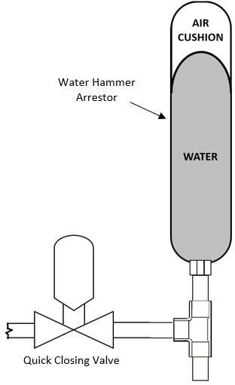

- Minimum Pressures Required in Water Distribution System.

  - When sizing a water distribution piping system, the minimum flow pressure at the point of discharge for each fixture shall not be less than that shown in 248 CMR 10.14(4): Table 4: Minimum Flow Pressure and MaximumFlow Rates. Exception: On-Demand domestic water heaters

TABLE 4
MINIMUM FLOW PRESSURE AND FLOW RATES
FIXTURE OR DEVICE | FLOW PRESSURE P.S.I. | FLOW RATE G.P.M.
Ordinary basin faucet | 8 | 2
Self-closing basin faucet | 8 | 2.5
Sink faucet, dinch | 8 | 4.5
Sink faucet, ½ inch | 8 | 4.5
Bathtub faucet | 8 | 6
Laundry valve, ½ inch | 8 | 5
Shower valves | 8 | 3
Ball-cock for toilet | 8 | 3
Flush valves for toilets (wide range due  to variation in design and type of toilet) | 15-20 | 15.35
Flush valves for urinal | 15 | 15
Drinking fountains | 15 | 0.75
Sillcock/wall-hydrant | 10 | 5

TABLE 4

MINIMUM FLOW PRESSURE AND MAXIMUM FLOW RATES
FIXTURE OR DEVICE | FLOW PRESSURE PSI | FLOW RATE G.P.M.
Lavatory Faucet (Residential) | 8 | 1.5
Lavatory Faucet (Non-Residential) | 8 | .5
Kitchen or Bar Faucet (Residential) | 8 | 2.2
Sink Faucet (Non-Residential) | 8 | 4.5
Bathtub Faucet | 8 | 6
Laundry Valve or Faucet (Residential) | 8 | 5
Shower Head | 8 | 2*
Tank-Type Toilet | 8 | 1.28
Flushometer-Type Toilet | 15-20 | 1.28
Flushometer-Type Urinal | 15 | .5
Drinking Water Station | 15 | 0.75
Outside Faucet or Hydrant | 10 | 5

* Exception: Emergency showers as defined in 248 CMR 10.10 (12)

(c)(d) Inadequate Water Pressure. Whenever water pressure from the street main, service, or other source
of supply is insufficient to provide flow pressures at fixture outlets as required under 248 CMR 10.14(4)(f (2) (c), a booster pump and pressure tank or other means in compliance with 248 CMR 10.00 shall be installed on the building water supply system.
- Variable Street Pressures. Where street main pressures fluctuate, the building water distribution system shall be designed for the minimum pressure available.
- Supply Demand. The supply demand in gallons per minute in the building water distribution system shall be determined on the basis of the load in terms of supply fixture units and of the relationship between load and supply demand.
- Minimum Pressures Required in Water Distribution System.
  - Based on the minimum static water pressure available, pipe sizes shall be selected so that under conditions of peak demand a minimum flow pressure at the point of discharge shall not be less than that shown in 248 CMR 10.14(4): Table 4.
- In determining minimum pressures at the outlets, allowances shall be made for the pressure drop due to friction loss.
- Excessive Water Pressure.
  - When the municipal service or other water service source provides water to a building that exceeds 80 P.S.I.G., a pressure reducing valve shall be installed in the water main pipe at the point of water service entrance to the building. This is to reduce the water pressure to a maximum of 80 P.S.I.G. or less. This requirement does not apply where the water service pipe supplies water directly to a water pressure booster system, an elevated water gravity tank, or to pumps provided in connection with a hydro- pneumatic or elevated gravity water supply tank system.
  - The Pressure at anyfixtureundernoflowconditionsshall be limited to no more than 80 P.S.I.G.
- Water Pressure Booster Systems. When water pressure in the public water main or individual water supply system is insufficient to supply the probable peak demand flow to all plumbing fixtures, a water pressure booster system shall be installed:
  - In one, two and three-family dwellings, a properly sized booster pump shall be installed.
  - In other than one, two and three-family dwellings, a booster system shall be designed by a Massachusetts professional engineer.
- Excessive Water Pressure.
  - If the pressure at any plumbing fixture, device or appurtenance exceeds 80 PSIG, a pressure
reducing valve shall be installed on the water piping upstream of the device, or appurtenance to limiting the pressure to 80 PSIG. Where pressure reducing valves are installed, a pressure gauge with a minimum range of 0-150 PSIG shall be installed within twenty-four inches downstream of the pressure reducing valve. See 10.14: Example 3.Exception: Water service supply piping upstream and downstream of a water pressure booster.

10.14: Example 3 - Pressure Reducing Valve
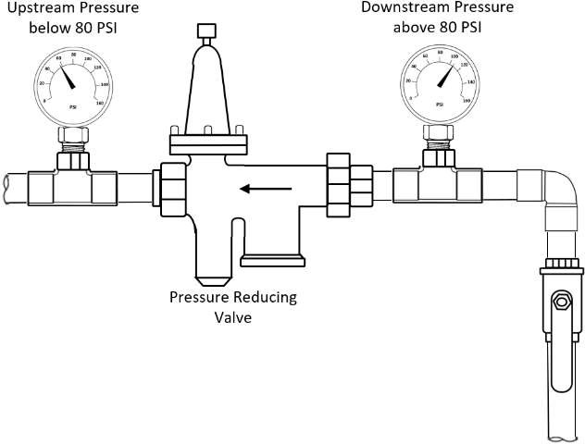

(h)(f) Return Circulation --- Where Required. Hot water supply systems in buildings where the developed
length of hot water piping from the source of the hot water supply to the farthest fixture supply exceeds 100 seventy-five feet shallbe: of the total return circulation type. For purposes of this section, the.“source” shall be the water heater or the recirculation loop. The minimum size recirculating line shall be one-half-inch.
- of the total return circulation type; or
- shall be maintained at the design temperature using a self-regulating heating cable.

(5)(3) Installation of the Building Water Distribution System.
(a) All valves shall be accessible
(a) (b) Main Control Meter Valve.
- A gate valve or other full-port main control valve shall be installed in the water supply main on the discharge side of each water meter or on the incoming water service where no meter is present.
- The valve shall be not less than the size of the building water service pipe. See 10.14: Example 4.
- A draw off valve shall be installed upstream of main control valve on the discharge side of each water meter. See 10.14: Example 4.

10.14: Example 4 - Main Control Valve
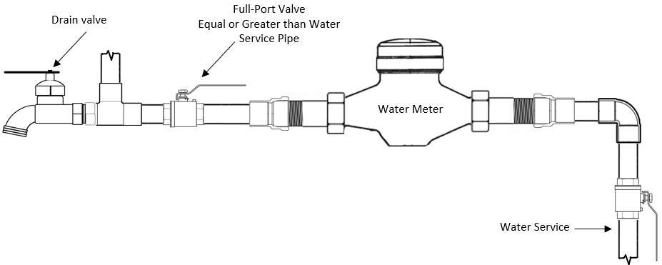
(b)(c) Branch and Riser Valves.
- Except in single family dwellings, a A full-port valve shall be installed at the base of each water supply riser. when servicing multiple fixtures on levels above the first floor. A draw off valve shall be installed upstream of each riser valve. See 10.14: Example 5.
- Branch valves installed servicing multiple fixtures shall be full port.
2. 3. In multistory buildings, a full-port valve shall be installed at the top of each water supply that is an upstream supply pipe from a booster system.
4. Dead Ends shall not be allowed. (see definition)

10.14: Example 5 - Risers
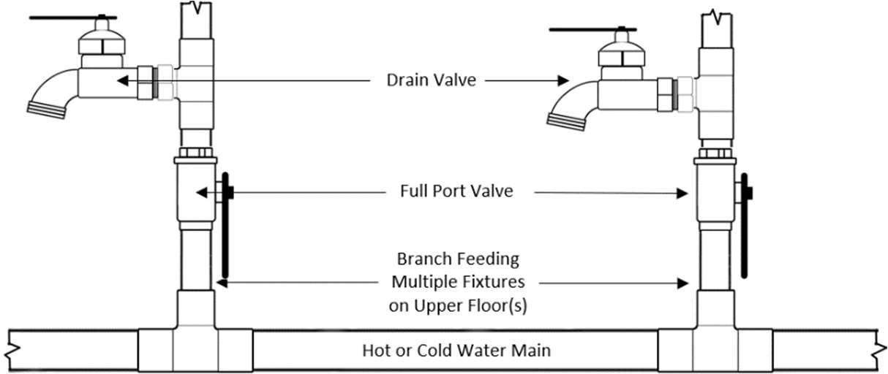
(c)(d) Valves in Multiple Dwelling Units.
1. If individual fixture valves are not installed in two-familyor multiple family dwelling units, one
1. One or more main control valvesvalve shall be provided so that the water to any unit may be shut off
without stopping the flow of water to other units. 2. These valves shall be readily accessible insideto the unit controlled.supplied without requiring access to other units.
- All main control valves, branch/riser valves and other devices installed on mains and branches of the water supply system shall be of the full-port type.
(d)(f) Individual Fixture Valves.
  - In all buildings that are occupied other than residential dwellings, the, water supply line to each fixturepipes feeding plumbing fixtures, devices, or other piece of equipmentappurtenances shall be
provided with a valve or a fixture stop to shut off the water to the fixturethat fixture, device, or appurtenance. Exception: Residential shower valves, tub and shower valves, tub fillers and other similar type fixtures.
  - All outside sillcocks, hose bibbs and wall hydrants shall be separately controlled by a shutoff valve installed inside the building.
(e)(g) Tank Controls. Supply lines from pressure or gravity tanks shall be provided with valves at or near the tanks.
(f)(h) Water Heating Equipment Valve. The cold-water branch to each hot water storage tank or water
heater shall be provided with a valve located near the equipment and above the top of the tank. See 10.14: Example 6.
- Valves to Be Accessible.
  - All water supply main control valves shall be placed so as to be accessible for service and maintenance.
  - All concealed tub or shower valves shall be provided with renewable seats.
- Main Control Valve Design. Except for single fixture shutoffs, main control valves on all water mains and branches, shall, when fully opened, have a cross sectional area not less than the cross sectional area of the pipe (full-port) in which they are installed.
- Draining Systems. Drain cocks or valves should be provided

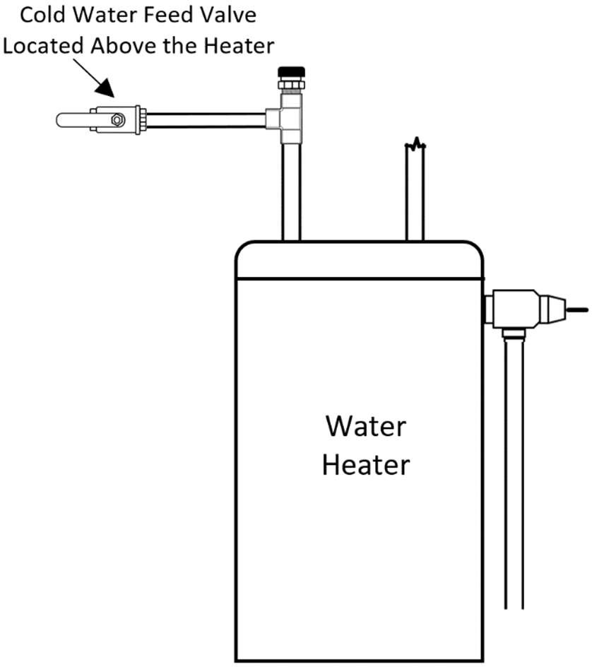
10.14: Example 6 – Valve for Water Heater
- Drain Valves.
  - In other than single family homes, a drain valve shall be installed at all low points of piping so that every portion of the water piping system can be drained. A
  - An accessible drain valve shall be required upstream and near the meter or main control valve. See 10.14: Example 4.
- Metering Devices with Check Valves.
  - Where water meters or When a metering devicesdevice with a check valves arevalve or backflow preventor is installed, which can create creating a potential hazard or nuisance due to thermal expansion, aclosed system, a properly sized thermal expansion tank shall be installed as close as possible to the water meter or metering devices. device.
  - The thermal expansion tank shall be of adequate size and constructed of materials approved in 248 CMR 10.06.
- Hose Connections.
  - Outside Hose connections, sillcocks or wall hydrants shall be installed in all residential buildings no more than 100- feet apart.
  - In all commercial buildings, sillcocksSillcocks and hose connections shall only be required in:
    - mechanical rooms;
    - mechanical penthouses; or
    - mechanical areas of similar use and nature.
  - A backflow preventer or vacuum breaker shall be installed on all sillcocks, hose connections and wall hydrants including faucets that incorporate a hose thread outlet.
- Prohibited Valves & Connections
  - (l) Saddle Valvesvalves.
- Saddle valves are prohibited in the water supply line.
- No water supply line shall be tapped, burned, welded, or drilled, except thatother than mechanical devices that have been Product-accepted by the Board which are designed and engineered to create
penetration in piping for specific joining methods may be used.

(6) Water Pressure Booster Systems

- Water Pressure Booster Systems Required. When water pressure in the public water main or individual water supply system is insufficient to supply the probable peak demand flow to all plumbing fixtures and other water needs freely and continuously with the minimum pressures and quantities, specified in 248 CMR 10.14(4)(f) or elsewhere in 248 CMR
10.00 and in accordance with good practice, the rate of supply shall be supplemented by:
- a gravity water tank;
- a hydro-pneumatic pressure booster system; or
- A pressure tank installed in accordance with 248 CMR 10.14(4)(c).
- Support. All water supply tanks shall be supported in accordance with 780 CMR: Board of Building Regulations and Standards or local building commissioner.
- Covers.
  - All water supply tanks shall be covered to keep out unauthorized persons, dirt, and vermin.
  - The covers of gravity tanks shall be vented with a return bend vent pipe having an area not less than the area of the down feed riser pipe.
  - The vent shall be screened with corrosion resistant screen of not less than 16 x 20 mesh.
- Overflows for Water Supply Tanks.
  - Each gravity or suction water supply tank shall be provided with an overflow having a diameter not less than shown in 248 CMR 10.14(6): Table5.
  - The overflow outlet shall discharge above and within not less than six inches of a roof or roof drain, floor or floor drain or over an open water supplied fixture.
  - The overflow outlet shall be covered by a corrosion resistant screen of not less than 16 x 20 mesh to the inch and by
¼ inch hardware cloth or shall terminate in a horizontal angle seat check valve.
  - Drainage from overflow pipes shall be directed so as not to freeze on roof walkways.
- Low Pressure Cut-off Required on Booster Pumps. When a booster pump is used on a water pressure booster system and the possibility exists that a positive pressure of ten P.S.I.G. or less may occur on the suction side of the pump, there shall be installed a low pressure cut-off on the booster pump to prevent the creation of a vacuum or negative pressure on the suction side of the pump, thus cutting off water to other outlets.

- Potable Water Inlet Control and Location.
  - Potable water inlets to gravity tanks shall be controlled by a ball cock or other automatic supply valve so installed as to prevent the tank from overflowing.
  - The inlet shall be terminated so as to provide an accepted air gap but in no case less than four inches above the overflow.
- Disinfection of Potable Water System Piping.

When necessary, the Inspector shall require that a Potable water distribution system, or any part thereof, which has been installed or repaired may require disinfection in accordance with one of the following methods before it is placed in operation:

  - The system, or part thereof, shall be filled with a water and chlorine solution which contains 50 parts per million of available chlorine; and the same shall then be allowed to stand six hours before the system, or part thereof, is flushed and returned to service.
  - The system, or part thereof, shall be filled with a solution which contains 100 parts per million of available chlorine, and the same shall then be allowed to stand two hours before the system, or part thereof, is flushed and returned to service.
  - Where it is not possible to disinfect a potable water storage tank as provided by 248 CMR 10.14 (7)
- or (b), the entire interior of the tank shall be swabbed with a solution which contains 200 parts per million of available chlorine; and the solution shall then be allowed to stand two hours before the tank is flushed and returned to service. For a potable water filter or similar device, the Massachusetts Department of Environmental Protection shall determine the dosage.

- Hot Water Supply System.
  - In all occupied premises and structures, hot water shall be supplied to all plumbing fixtures and equipment used for bathing, washing, culinary purpose, cleansing, laundry, or building maintenance.
  - Hot water storage systems shall be designed to adequately accommodate the fixtures being served.
  - The maximum temperature of domestic hot water in residential buildings shall not exceed 130 degrees Fahrenheit. Plumbing fixtures requiring higher temperatures for their proper use and function, such as dishwashers and hot water dispensers shall be exempted from this section.

MINIMUM & MAXIMUM HOT WATER TEMPERATURES
Hot Water Temperatures (Fahrenheit)
 | Minimum | Maximum
Residential | 120 | 130*
Water Entering the Sanitary Drainage System |  | 150
Shower Valve | 120 | 120
Tub Filler | 120 | 120
Public & Employee Lavatory | 120 | 120
Residential Lavatory | 120 | 130
Emergency Showers & Eyewash | 60 | 100
Hand Sink in Commercial Kitchen | 120 | 120
Kitchen Type Sink in Office | 120 | 120
Service Sink & Scullery Sink | 120 | 140
*See 10.14 (5) (c) for Exception

- Tank Type Water Heaters & Storage Tanks
  - Working Pressure of Storage Tank. To determine the working pressure of a hot water tank as
required by M.G.L. c. 142, § 18E, the street or service pressure only shall be considered, unless a water pressure booster system is used to raise the house pressure above the street pressure.
(bg) Tank Drains Pipes. Each A storage tank shall be equipped provided at its lowest point with a drain valve and pipe to permit for emptying at the tank lowest point accept when otherwise allowed by the Board.which shall discharge as required for overflow pipes and not smaller in size than shown in 248 CMR 10.14(6): Table 6.
- Cold Water Supply.
  - A check valve shall not be installed in the cold-water supply to any hot water heater or hot water storage tank.
  - A properly sized thermal expansion tank may be installed to prevent excessive pressure from developing due to thermal expansion.
- Prohibited Methods of Water Heating.
  - Hot Water Generators. No coils, boosters or other hot water heating devices shall be installed in direct contact with the heat generating source of any building heating system or heating unit.
  - Systems Without Automatic Control. No domestic hot water storage system, connected with or to, a direct heating device or appliance, shall be installed in any basement of any building or other unattended area unless such installation has fully automatic control to prevent raising of the temperature of the water in any part of the storage tank to 212 degrees Fahrenheit.
- Large Volume Water Heaters and Storage Tanks.
  - Water heaters and storage tanks shall be stamped as ASME compliant when:
    - Installed in other than a private residence or a single condominium unit where the heater is serving only that unit and,
    - Have a storage capacity of over 120 gallons and/or a recovery equal to or greater than 200,000
B.T.U. and,
    - are direct or indirect fired. When determining the B.T.U. rating for an indirect fired water heater, the maximum output of the stored or transferred energy shall be utilized.

Examples:

- An 80-gallon tank with a recovery rate 210,000 BTU must comply with ASME requirements.
Two tanks installed, each with 100-gallon capacity with an indirect water heater with a recovery rate of 199,000 BTU feeding tanks shall meet ASME requirements.
Exception: Water heaters and storage tanks which meet the following requirements:
- The tank conforms with the following UL-174 testing:
  - Section 33: Two (2) times the maximum working pressure or 300 PSIG maximum
  - Section 22: One hundred and fifty (150) PSIG and two hundred and ten (210) degree maximum.
- The tank has a minimum of a ten (10) year warranty
- A maximum of four (4) tanks may be installed in tandem
  - ASME Data Sheet.
    - Copies of an ASME data sheet attesting to the conformance with the requirements of the applicable section of the Code and signed by an authorized and qualified inspector shall be furnished to the owner and/or installing contractor.
    - A copy of the data shall be permanently displayed in a suitable mounting on a wall adjacent to the water heater.
- Safety Devices for Water Heaters Safety devices to be used on hot water tanks, tankless and on- demand heaters shall be installed to comply with the provisions of M.G.L. c. 142, § 19 and Standard ANSI 221.22.
  - Pressure Relief Valves.
    - Pressure relief valves installed on direct-fired water heaters having up to 200,000 BTU per hour input shall have a listed rating of not less than the heater input.
    - Pressure relief valves for on-demand water heaters shall have a listed rating of not less than the water heater input.
    - For tankless heaters connected to low pressure steam and hot water heating boilers, the pressure relief valve shall be sized according to 248 CMR 10.14(6)(f): Table 5, as follows:

TABLE 65
SIZES OF DRAIN PIPES FOR WATER TANKS

TANK CAPACITY  (Gallons)Heater Rating (GPM) | DRAIN PIPE  (Inches)Valve Size
Up to 7505 | 1½-inch
751 to 1,500 | 1½
1,501 to 3,000 | 2
3,001Over 5 up to  5,00020  Standard Z21.22 applies | 2½¾-inch
5,001Over 20 up to  7,50050 | 31-inch
Over 7,50050  ASME Standard applies | 41 - 1¼-inch

(h)Prohibited Location of Potable Supply Tanks. Potable water gravity tanks or manholes of potable water pressure tanks shall not be located directly under any soil or waste piping.

  - Combination Temperature & Pressure Relief Valves. (T&P) All storage water heating equipment capable of heating water in excess of two-hundred- and twelve-degrees Fahrenheit shall be equipped with a properly sized T&P relief valve.
    - T&P relief valves shall meet the requirements of pressure relief valves as provided in 248 CMR 10.14 (6) (f) 1.
    - A T&P valve shall be installed in a tapping directly in or on the tank, within twelve inches of the top of a vertical tank, or within six inches of the top of a horizontal tank, with no fittings between the valve and the tank, except that a bushing may be used to reduce the tapping to fit the valve, or the valve shall be installed in the hot water outlet pipe as close to the top of the tank
as possible but in no case more than five inches from the top of the tank.
    - The discharge outlet if the T&P relief valve shall be full-size and pipe using non-ferrous material or tubing rated to withstand the maximum relief valve temperature with no shut-off, to a fixture or a point to within twelve inches of the floor.
    - Heaters and storage tanks with ratings in excess of 200,000 BTU shall be equipped with T&P relief valves in compliance with the requirements of ASME and the current ANSI Z21.22 Standard.
- 3. Pressure Tanks -Vacuum Relief Valves.
  - a. All potable water Tank type water heaters and storage tanks shall be protected against loss of water from siphoning due to loss of supply pressure tanks shall be provided with a by a vacuum relief valve installed in the cold-water supply line at a level above the top of the heater or tank that will operate up to a maximum water pressure of 200 P.S.I.G and to a maximum water temperature of 200EF.with no shut off valve installed between the vacuum relief valve and the tank.
  - b. Vacuum relief valves shall be a minimum of one pipe size smaller than the tank drain size sized according to the following:
    - The relief valves shall have a cross sectional area at the valve seat that is not less than one pipe size
smaller than the cold water supply or the tank drain , whichever is larger.
    - The minimum size of the vacuum relief valves shall be ½inch.
    - Valves shall have a minimum ½ diameter orifice.
    - The air inlet opening on any vacuum relief valve shall not be smaller than the nominal pipe size of the valve.
  - c. Vacuum relief valves may be installed in multiples. and in compliance with 248 CMR 10.14
(6) (f) 3. Table 6.

TABLE 6
 | VACUUM VALVE SIZING CHART
 | Size of Tank Drain | Number of 1/2”  Valves Required | Number of 3/4"  Valves Required
 | 1/2" | 1
 | 3/4" | 1
 | 1” | 2 | 1
 | 1-1/4” | 3 | 2
 | 1-1/2” | 4 | 3
 | 2” and Larger | 5 | 4

(j) Pumps and Other Appliances. Water pumps, filters, softeners, tanks and all other appliances and devices used to handle or treat potable water shall be protected against contamination.
- Combination Potable Water/Space Heating System. These systems shall comply with the following requirements. See 10.14: Example 7.
  - The maximum distance from the water heater to the fan coil and returning to the water heater shall not exceed one hundred feet in developed length.
  - All piping materials between the water heater and coil shall be incompliance with 248 CMR 3.04 and 10.06.
  - Must contain an electronically controlled pump timer which operates at least once every six hours for a minimum of sixty seconds.
  - A properly sized potable water expansion tank shall be installed.
  - A mixing valve for service to the plumbing fixtures shall be installed.

10.14: Example 7
Combination Potable Water/Space Heating System
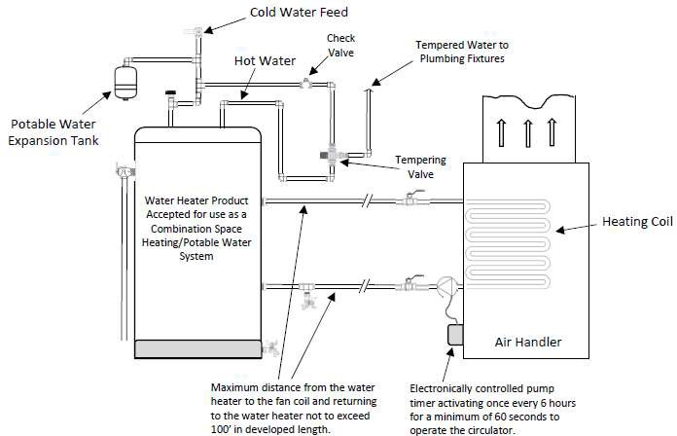

- Identification Tags for Water Heaters: Metal or foil tags permanently attach to most water heaters are considered in compliance with the provisions of M.G.L. c. 142, § 17.

- Protection of Potable Water Supply.
  - General. A potable water supply system shall be designed, installed, and maintained in such manner as to prevent contamination from non-potable liquids, solids, or gases from being introduced into the potable water supply through cross connections or anyother piping connections to the system.
  - Identification of Potable and Non-potablePotable Water. In all buildings where dual water distribution systems are installed, one potable water and the other non-potable water, each system shall be identified by color bands or metal tags. is installed within the same building or structure, the following additional conditions must be satisfied as well as those conditions required for each individual piping system:
    - Color Marking
      - When color marking is employed, potable water lines shall be painted green and non-potable water lines shall be painted yellow.
      - This requirement may be accomplished by painting three inch wide bands of green or yellow at intervals of not more than 25 feet and at points where piping passes through walls, floors and roofs. The colored bands shall be applied to the piping on both sides of the walls and above and below the floor or roof penetrations. Outlet locations, (the point of use) for non-potable water systems shall be marked with a tag or color coded identification.
    - Metal Tags.
      - When tags are used, three-inch diameter metal tags bearing the legend SAFE WATER in letters not less than
½ inch in height shall identify potable water lines.
      - Firmly attached metal tags having the shape of a four-inch equilateral triangle bearing the legend WATER UNSAFE in letters not less than 7/16 inches in height shall identify non-potable water supplylines.
      - As in the use of color bands, tags shall be attached to pipes at intervals of not more than 25 feet and at either side of points where pipes pass through walls and above and below points where pipes pass through floors or roofs.
- The potable and non-potable piping systems shall be labeled or painted in the following manner:
  - at a minimum of every ten feet
  - at all changes of direction
  - on each side of a penetration through a partition, wall, ceiling or roof;
  - at every shut off valve;
  - for potable water (color-coded green) and non-potable water (color-coded yellow), the labels shall be;
    - black lettering indicating “safe water” for potable and “unsafe water” for non-potable.
    - the letters shall be sized equal to a minimum of the pipe diameter. However, for piping with a diameter exceeding two inches, said lettering does not need to be larger than two inches.
  - Non-potable water shall be identified at each outlet location.

  - Cross Connection Control.
    - Cross connections between potable water systems and other systems or equipment containing water or other substances of unknown or questionable safety are prohibited; except when and where, as approved by the Massachusetts Department of Environmental Protection (DEP) or its designee, suitable protective devices such as the Reduced Pressure Zone Backflow Preventer or equal are installed, tested, and maintained to insure proper operation on a continuing basis.
    - No plumbing permit shall be issued for cross connection installations that require Reduced Pressure Zone Backflow Preventers or Double Check Valve Assemblies until the application for a
permit is accompanied by a letter of approval from the Massachusetts Department of Environmental Protection(DEP) or its designee.
    - The (DEP) or its designee shall be the authority having jurisdiction for the type of cross connection control required. The (DEP) shall be responsible for preventing the contamination of drinking water to the last free flowing outlets or consumer's tap.

  - Interconnections.
    - Individual Water Supplies. Cross connections between an individual water supply and a potable
public supply shall not be made unless specifically approved by the Massachusetts Department of Environmental Protection.(DEP).
    - Public Water Supplies. Interconnection between two or more public water supplies shall be permitted only with the approval of the health authority having jurisdiction.
  - Toxic Foreign Materials.
    - Construction. Piping conveying potable water shall be constructed of nontoxic material.
    - Materials and Substances. No materials or substances that could produce either toxic conditionscondition, taste, odor, or discoloration in a potable water system shall be introduced into or used in such systems.
    - Painting of Water Tanks. The interior surface of a potable water tank shall not be lined, painted, or repaired with any material that will affect the taste, odor, color, or potable condition of the water supply when the tank is placed into service or returned to service following maintenance.
  - Used Piping. Piping which has been used for any other purpose than conveying potable water shall not be used for conveying potable water.
  - Self Feeding Water Connections to Heating Boilers.
    - Potable water connections to a heating boiler shall be provided with an approved back flow preventer or air gap in the water line to prevent a cross connection.
    - Backflow preventers shall not be required on manually controlled water supply lines to residential type steam and/or gravity fed hot water space heating systems.
  - Prohibited Connections to Fixtures and Equipment. Connection to the potable water supply system for the following shall be protected against backflow:
    - bidets;
    - operating, dissection, embalming, and mortuary tables or similar equipment -- in such installation, the hose used for water supply shall terminate at least 12 inches away from every point of the table
or attachments;
    - pumps for non-potable water, chemicals, or other substances; note that priming connections may be made only through an air gap;
    - building drainage, sewer, or vent system; and
    - any other fixture of similar hazard.
  - Refrigerating Unit Condensers and Cooling Jackets.
    - Except where potable water provided for a refrigerator condenser or cooling jacket is entirely outside the piping or tank containing a toxic refrigerant, with two separate thicknesses of metal
separating the refrigerant from the potable water supply the inlet connection shall be provided with an approved double check valve installation.
    - Also adjacent to and at the outlet side of the check valve, an approved pressure relief valve set to relieve at five
P.S.I.G. PSIG above the maximum water pressure at the point of installation shall be provided if the refrigeration units contain more than 20 pounds of refrigerants.
  - Chemical Cleaning Dispensers.
    - Devices directly connected to the potable water system. (hard piped)
      - Shall require a plumbing permit
      - The public water supplier shall determine the proper backflow device to be installed.
    - Devices connected to the hose end of a faucet
      - Shall not require a plumbing permit
      - All dispensers shall have an Air Gap or, an alternative Certification of Listing under the ASSE 1055B Standard.
      - A pressure bleeder device shall be provided which will visually free flow water through the atmosphere from the faucet connection to a sink or drain. The bleeder device shall connect to the water source utilizing a quick disconnect coupling.
      - The Device that attaches to the Faucet shall be so arranged, so it is one piece that will not allow the removal of the bleeder from the Quick disconnect portion of this device.
(j)(k) Water Recycling/Re-Use Prohibited.
- Water used for cooling of equipment or other processes shall be discharged into the drainage system through an air gapped indirect waste. Under conditions where water shortage may occur, the water used for cooling may be used for non-potable purposes. Water used for cooling of equipment or other processes shall not be returned to the potable water system.
- Exceptions. Water recycling systems may be installed if Special-permissionPermission under 248 CMR
3.04 (3): Special-permission) has been granted by the Board. Such systems include but limited to:
- dedicated gray water systems;
- black water systems; or
- on site wastewater treatments systems.;
- systems Product-Accepted by the Board shall not require Special Permission. (k)(l) Protection Against Backflow and BacksiphonageBack siphonage.
- Water Outlets. A potable water system shall be protected against backflow and backsiphonage back siphonage in accordance with M.G.L. c. 111, § 160A, and 310 CMR: (Department of Environmental Protection)
relative to protection of the potable water supply)..
  - Air Gap. An air gap as defined in 248 CMR 10.03: Air-Gap (Water Distribution System) between the potable water outlet and the flood level rim of the fixture it supplies or between the outlet
and any other source of contamination.
  - Backflow Preventer. A backflow preventing device or vacuum breaker to prevent the drawing of contamination into potable water system.
- Minimum Required Air Gap.
  - How Measured.i. The minimum required air gap shall be measured vertically from the lowest end of a potable water outlet to the flood rim or line of the fixture or receptacle into which it discharges. and
  - Size.
    - The minimum required air gap shall be twice the effective opening of athe potable water outlet.
    - If the outlet is found to be at a distance that is less than three times the effective opening

away from a wall or similar vertical surface; the minimum required air gap shall be three times the effective opening of the outlet.
    - In no case shall the minimum required air gap be less than shown in 248 CMR 10.14(7 (8): Table 7: Minimum Air Gaps for Plumbing Fixtures:
      - Side wall ribs or similar obstructions do not effect air gaps when they are spaced from the inside edge of a spout opening at a distance greater than three times the diameter of the effective opening for a single wall; or greater than four times the diameter of the effective opening for two intersecting walls.
      - Vertical wall, ribs, or similar obstructions extending from the water surface to or above the horizontal plane of the spout opening require a greater air gap when spaced closer to the nearest inside edge of spout opening than specified in 248 CMR 10.14(7)(k)2.b.iii.(i). The effect of three or more such vertical walls or ribs has not been determined. In such cases, the air gap shall be measured from the top of the wall.
b. Backflow Preventer. A backflow preventing device or vacuum breaker to prevent the drawing of contamination into potable water system.

TABLE 7
MINIMUM AIR GAPS FOR PLUMBING FIXTURES

MINIMUM AIR GAPS FOR PLUMBING FIXTURES | Minimum Air Gap
MINIMUM AIR GAPS FOR PLUMBING FIXTURES | When not affected by a near wall(INCHES) | When affected by a near wall(INCHES)
Lavatories and other fixtures with effective openings  not greater than ½one half inch in diameter. | 1 inch | 1.50 inches
Sink, laundry sinks, goose neck bath faucets and other fixtures with effective openings not greater  than ¾three quarters of an inch diameter | 1.5 inches | 2.25 inches
Over rim bath fillers and other fixtures with effective openings not greater than one-inch diameter. | 2 inches | 3.0 inches
Drinking water fountains single orifice 7/16 (0.437) in. diameter or multiple orifices having total area of 0.150 sq. in. (area of  circle 7/16 in. diameter) | 1 | 1.50

Effective openings greater than one inch | 2X2 times the diameter of the effective opening | 3X2 times the diameter of the effective opening

- 2. Devices for the Protection of the Potable Water Supply. Approved backflow preventers or
vacuum breakers shall be installed with anyplumbingon any plumbing fixture or equipment, where the potable water supply outlet of which may be submerged and which cannot be protected by a minimum air gap.
- Certification of Devices.
  - Before any device for the prevention of backflow or backsiphonage is installed the following requirements shall be satisfied:
    - An Approved-testing-lab shall have first certified it as being acceptable.
    - The Board has recognized it as being Product-accepted.
    - These backflow devices shall be maintain in compliance with 310 CMR 22.22: Cross Connections Distribution System Protection.
- Labeling.
  - Piping after each device shall be labeled as “Water Subject to Questionable Safety”, black lettering on yellow background, sizes of lettering and background determined by ANSI A13.-85, Scheme for the Identification of Piping Systems.” in accordance with 248 CMR 10.14 (8) (b)(1) a through f.
  - The labels shall be placed along the installation every 25 feet and at both penetration points where pipes pass through walls and both penetration points where pipes pass through floors or roofs.
- 3. Installation of Devices.
  - Vacuum Breakers.
    - Vacuum breakers shall be installed with the critical level at least six inches above the flood level rim of the fixture they serve and on the discharge side of the last control valve to the fixture.
    - No shut-off valve or faucet shall be installed beyond the vacuum breaker.
    - iv. For closed equipment or vessels such as pressure sterilizers the top of the vessel shall be treated as the flood level rim but a check valve shall be installed on the discharge side of the vacuum breaker.
  - Reduced Pressure Zone Backflow. A reduced pressure zone type backflow preventer may be installed subject to full static pressure. Where damage may occur to the building or structure due to water discharge from the vent port precautions shall be taken.
  - Devices of All Types.
    - Backflow and backsiphonage back siphonage preventing devices shall be accessibly located preferably in the same room with the fixture they serve.
    - Installation in utility or service spaces, provided they are readily accessible, is also permitted.
- 4. Tanks and Vats - below-- Below Rim Supply.
  - Where a potable water outlet terminates below the rim of a tank or vat and the tank or vat has an overflow of diameter not less than given in 248 CMR 10.14(6): Table 85: Sizes of

Overflow Pipes for Water Supply Tanks, the overflow pipe shall be provided with an air gap as close to the tank as possible.
  - The potable water outlet to the tank or vat shall terminate a distance not less than 1½ times the height to which water can rise in the tank above the top of the overflow.
  - This level shall be established at the maximum flow rate of the supply to the tank or vat and with all outlets except the air gap, overflow outlet closed.
  - The distance from the outlet to the-high water level shall be measured from the critical point of the potable water supply outlet.
- Protective Devices Required. Approved devices to protect against backflow and backsiphonage shall be installed at all fixtures and equipment where backflow and/or back siphonage may occur and where a minimum air gap cannot be provided between the water outlet to the fixture or equipment and its flood levelrim.

TABLE 85
SIZES OF OVERFLOW PIPES FOR WATER SUPPLY TANKS

Maximum Capacity of Water Supply Line to Tank | Diameter of Overflow Pipe (inches ID)
0 – 50 G.P.M. | 2
51 – 100 G.P.M. | 2½
101 – 165 G.P.M | 3
166 – 355 G.P.M. | 4
356 – 640 G.P.M. | 5
641 – 1,040 G.P.M. | 6
OVER 1,040 G.P.M. | 8

- 5. Connections Not Subject to Back Pressure.
  - Where a water connection is not subject to back pressure, a non-pressure type vacuum breaker shall be installed on the discharge side of the last valve on the line serving the fixture or equipment.
  - A list of some conditions requiring protective devices of this kind is given in in 248 CMR 10.14(7): Table 8.9: Cross Connections Where Protective Devices Are Required and Critical Level (C-L) Settings for Backflow Preventers.

TABLE 9
SIZES OF DRAIN PIPES FOR WATER TANKS
 | TANK CAPACITY  (Gallons) | DRAINPIPE SIZE  (Inches)
 | Up to 750 | 1”
 | 751 – 1,500 | 1-1/2”
 | 1,501 – 3,000 | 2”
 | 3,001 – 5,000 | 2-1/2”
 | 5,001 – 7,500 | 3”
 | 7,500 and Larger | 4”

- 6. Barometric Loop. Water connections not subject to back pressure where an actual or potential
backflow or backsiphonageback siphonage hazard exists may in lieu of devices specified in 248 CMR 10.14(7)( (8) (k)5 2., be provided with a 35 thirty-five-foot barometric loop. Barometric loops shall precede the point of connection. 10 7. Pressure Type Vacuum Breakers. Water connections not subject to backpressure where an actual
or potential backflow or backsiphonageback siphonage hazard exists may be protected by the installation of a pressure type vacuum breaker, provided that such device is installed with the critical level a minimum of 12 inches above the highest outlet or fixture served by the connection.of 12 inches above the highest outlet or fixture served by the connection.
- 8. Anti-siphon or Backpressure Valvesbackpressure valves:
  - An anti-siphon or backpressure valve shall be installed on any chemical metering pump that pumps any chemical into a potable water supply to prevent back siphonage.
  - The anti-siphon or back-pressure valve must be spring loaded and set at a minimum of five-P.S.I.G.
PSIG (An example may be an anti-siphon or back-pressure valve installed on a positive displacement metering pump's discharge line and pumping sodium hypochlorite into a water main at a well house for disinfection purposed.)

TABLE 810
CROSS CONNECTIONS WHERE PROTECTIVE DEVICES ARE REQUIRED AND CRITICAL LEVEL (C- L) SETTINGS FOR BACKFLOW PREVENTERS
TABLE 8
CROSS CONNECTIONS WHERE PROTECTIVE DEVICES ARE REQUIRED AND CRITICAL LEVEL (C-L) SETTINGS FOR BACKFLOW PREVENTERS

Fixture or Equipment | Method of Installation
Aspirators and ejectors | C-L at least six inches above flood level or receptacle.
Dental units | On models without built-in vacuum breakers -- C-L at least six inches above flood level rim of bowl.
Dishwashing machines | C-L at least six inches above flood level of machine. Install on both hot and cold water supply lines.
Flushometers (closet and urinal) | C-L at least six inches above top of fixture supplied.
Garbage can cleaning machine | C-L at least six inches above flood level of machine. Install on both hot and cold water supply lines.
Hose outlets | C-L at least six inches above highest point on hose line.
Laundry machines | C-L at least six inches above flood level of machine. Install on both hot and cold water supply lines.
Lawn sprinklers | C-L at least 12 inches above highest sprinkler or discharge outlet.
Steam tables | C-L at least six inches above flood level.
Tank and vats | C-L at least six inches above flood level rim or line.
Trough urinals | C-L at least six inches above perforated flush pipe.
Flush tanks | Must be equipped with approved ball cock. Where ball cocks contact tank water they must be equipped with a vacuum breaker at least one inch above the overflow outlets. Where a ball cock does not contact tank water install the ball cock outlet at least one inch above the overflow outlet or provide a vacuum breaker as specified above.

TABLE 8A

TABLE 11
ACCEPTABLE TYPES OF BACKFLOW PREVENTERS FOR PREVENTION OF CROSS CONNECTIONS ON POTABLE WATER

AG RPBP DCVA AVB  BFPAV | Air Gap  Reduced Pressure Backflow Preventer Double Check Valve Assembly Atmospheric Vacuum Breaker  Backflow Preventer with Intermediate Atmospheric Vent
TYPE OF HAZARD ON PREMISES | ACCEPTABLE TYPES OF BACKFLOW PREVENTER |  |  |  |  | COMMENTS*
 | AG | RPBP | DCVA | AVB | BFPAV
1. Sewage Treatment Plant | X | X
2. Sewage Pumping Stations | X | X
3. Food Processing | X | X | X* |  |  | * If no health hazard exists
4. Laboratories | X | X | X* |  |  | * If no health hazard exists
5. Sinks with hose threads on inlets | X | X |  | X
6. Hospitals, Mortuaries, Clinics | X | X
7. Plating Facilities | X | X
8. Irrigation Systems** | X | X |  | X* |  | Each case should be evaluated  individually
 |  |  |  |  |  | * If no back pressure is possible
** Pressure Vacuum Breakers can be installed if no health hazard exists and back pressure
is not possible.
9. Systems or Equipment Using  Radioactive Material | X | X
10. Submerged Inlets | X | X |  | X* |  | * If no health hazard exists and  no back pressure is possible
11. Dockside Facilities | X | X
12. Valved outlets or fixtures with  hose attachments | X | X | X* | X** |  | Each case should be evaluated  individually
 |  |  |  |  |  | * If no health hazard exists
** If no health hazard exists
and no back pressure is possible
13. Commercial Laundries and Dry  Cleaners | X | X
14. Commercial Dishwashing  Machines | X | X |  | X* |  | If no health hazard exists
15. High and Low Pressure Boilers | X | X |  |  |  | If chemicals are added
16. Low Pressure Heating Boilers |  |  |  |  | X | Residential and small  commercial, having no chemicals added
17. Photo Processing Equipment | X | X
18. Reservoirs-cooling Tower  Recirculation Systems | X | X

AG RPBP DCVA AVB  BFPAV | Air Gap  Reduced Pressure Backflow Preventer Double Check Valve Assembly Atmospheric Vacuum Breaker  Backflow Preventer with Intermediate Atmospheric Vent
TYPE OF HAZARD ON PREMISES | ACCEPTABLE TYPES OF BACKFLOW PREVENTER |  |  |  |  | COMMENTS*
 | AG | RPBP | DCVA | AVB | BFPAV
19. Fire Fighting Systems
a. Any system which incorporates pumper connections into which chemical extinguishing agents or  non-potable water may be pumped. | X | X | X
b. Any system which incorporates storage tanks or fire pumps taking suction from covered tanks or reservoirs | X | X | X
c. Any system incorporating connections to chemical extinguishing agents, anti-freeze, or auxiliary water supplies. | X | X
20. Solar Energy Systems | X | X |  |  | X* | * Residential and small commercial having no chemicals or only USP Glycerin added to water
21. Single Jacketed Heat Exchangers | X | X |  |  |  | Each case should be evaluated individually

AG = Air Gap
RPBP = Reduced Pressure Backflow Preventer DCVA = Double Check Valve Assembly AVB = Atmospheric Vacuum Breaker
PVB = Pressure Vacuum Breaker
BPIAV = Backflow Preventer w/Intermediate Atmospheric Vent
Type of Hazard on Premises | Acceptable Types of Backflow Preventors |  |  |  |  | Comments*
 | AG | RPBP | DCVA | AVB | PVB BFPAV
1. Sewage Treatment Plant | X | X
2. Sewage Pumping Station | X | X
3. Food Processing | X | X | X* |  |  | *If no health hazard exists
4. Laboratories | X | X | X* |  |  | *If no health hazard exists
5. Fixtures with hose threads on inlets | X | X | X | X |  | In addition to an air-gap separation, all fixtures that have threaded hose type connections shall at a minimum, be equipped  with an AVB
6. Hospitals, Mortuaries & Clinics | X | X
7. Plating Facilities | X | X
8. Irrigation Systems** | X | X |  | X* | X** | Each case should be evaluated individually.  *An AVB may be used if no back pressure is possible and no health hazard exists.  ** A PVB should be installed if back pressure is possible.
9. Systems or Equipment Using Radioactive Material | X | X
10. Submerged Inlets | X | X |  | X* |  | *If no health hazard exists and no back- pressure is possible
11. Dockside Facilities | X | X
12. Valves Outlets or Fixtures with Hose Attachments | X | X |  | X* |  | Each case should be evaluated individually  *If no health hazard exists and no back- pressure is possible
13. Commercial Laundries & Dry Cleaners | X | X
14. Commercial Dishwashing Machines | X | X |  | X* |  | *If no health hazard exists
15. High- and Low-Pressure Boilers | X | X* |  |  |  | *If chemicals are added
16. Low Pressure Heating Boilers |  |  |  |  | X | Residential and small commercial having no chemicals added
17. Photo Processing Equipment | X | X
18. Reservoirs – Cooling Tower Recirculating Systems | X | X

AG = Air Gap
RPBP = Reduced Pressure Backflow Preventer DCVA = Double Check Valve Assembly AVB = Atmospheric Vacuum Breaker
PVB = Pressure Vacuum Breaker
BPIAV = Backflow Preventer w/Intermediate Atmospheric Vent
Type of Hazard on Premises | Acceptable Types of Backflow Preventors |  |  |  |  | Comments*
 | AG | RPBP | DCVA | AVB | PVB BFPAV
19. Fire Protection Systems: For cross connection control, fire protection systems may be classified on the basis of water source and arrangement of supplies as follows:  (a) Class 1: Direct connection from public water system mains only; no pumps, tanks, or reservoirs; no physical connection from other water supplies; no antifreeze or other additives of any kind; all sprinkler drains discharge to atmosphere, dry wells, or other safe outlets. These systems may or may not have fire department connections. Refer to 310 CMR  22.22(9)(d)1. | X | X | X |  |  | A backflow prevention assembly does not have to be installed on existing fire protection systems installed prior to March 21, 1997, provided that the fire protection system is registered with the public water system, equipped with a UL listed alarm check valve that is properly maintained in accordance with NFPA 25 and has not undergone substantial modification defined within 310 CMR 22.22(9)(d)3. Alarm check maintenance records must be available for inspection by the Department, its designee or the public water system
(b) Class 2: Same as Class 1 except that booster pumps may be installed in the connections from the street mains These systems may or may not have fire department connections. Refer to 310 CMR 22.22(9)(a). | X | X | X |  |  | A backflow prevention assembly does not have to be installed on existing fire protection system installed prior to March 21, 1997, provided that the fire protection system is registered with the public water system and equipped with a UL listed alarm check valve that is properly maintained in accordance with NFPA 25. Alarm check maintenance records must be available for inspection by the Department, its designee or the public  water system
(c) Class 3: Direct connection from public water system mains, plus one or more of the following: elevated storage tanks; fire pumps taking suction from aboveground covered  reservoirs, or tanks; and pressure tanks. | X | X* | X* |  |  | *RPBP or DCVA contingent on evaluation of auxiliary supply and on-site system in accordance with 310 CMR 22.22(9)(d)1.
(d) Class 4: Directly supplied from public water system mains, similar to Class 1 and Class 2 with an auxiliary water supply dedicated to fire department use and available to the premises, such as a non-potable water source located within 1700 feet of the fire department  connection, (FDC). | X | X* |  |  |  | *RPBP on evaluation of auxiliary supply and onsite system in accordance with 310 CMR 22.22(9)(d)1.
(e) Class 5: Directly supplied from public water system mains, and interconnected with auxiliary supplies, such as pumps taking suction from reservoirs exposed to contamination, or rivers and ponds; driven wells; mills or other industrial water systems; or where antifreeze or other additives are  used. | X* | X* |  |  |  | *RPBP or air gap contingent on evaluation of auxiliary supply and on-site system. Refer to 310 CMR 22.22(9)(d)1.

AG = Air Gap
RPBP = Reduced Pressure Backflow Preventer DCVA = Double Check Valve Assembly AVB = Atmospheric Vacuum Breaker
PVB = Pressure Vacuum Breaker
BPIAV = Backflow Preventer w/Intermediate Atmospheric Vent
Type of Hazard on Premises | Acceptable Types of Backflow  Preventors |  |  |  |  | Comments*
 | AG | RPBP | DCVA | AVB | PVB  BFPAV
(f) Class 6: Combined industrial and fire protection systems supplied from the public water mains only, with or without gravity storage or  pump suction tanks. | X | X* |  | X | X | *RPBP contingent on evaluation of on-site water system. Refer to 310 CMR22.22 (9)(d)1.
(g) Residential fire protection systems for one and two family detached dwellings and manufactured homes only. Fire protection systems in three family dwellings meeting NFPA 13D requirements as provided in 780 CMR, Chapter 9, are included in  this section. | X | X | X |  |  | Fire protection system in this category shall comply with the requirements set forth in class 1 through 4 as appropriate.
20. Solar Energy Systems | X | X |  |  | X* | Residential and small commercial having no chemicals or only USP Glycine added to  water
21. Single Jacketed Heat Exchangers | X | X |  |  |  | Each case should be evaluated individually

Source of Table 8A is Department of Environmental Protection (DEP) 310 CMR 22.22

- Hot Water Supply System.
  - In residences and buildings intended for continuous occupancy, hot water shall be supplied to all plumbing fixtures and equipment used for bathing, washing, culinarypurpose, cleansing, laundry, or building maintenance.
  - Hot water storage systems shall be designed to adequately accommodate the fixtures being served.
- Hot Water Tanks or Heaters.
  - Domestic Hot Water Storage Tanks and TanklessHeaters. Performance Efficiency.
    - All automatic, electric, domestic hot water storage tanks shall have a stand-by loss not exceeding four W/ft.2 of tank's surface area; when tested in accordance with ANSI STANDARD C72-1 entitled Household Automatic Electric Storage Type Heaters.
    - All gas and oil fired, domestic hot water storage tanks shall have:
      - a recovery efficiency (Er) not less than 75%; and
      - a stand-by loss percentage (S) not exceeding: S = 2.3 + 67/V; where….V = rated volume in gallons when tested in accordance with ANSI Standard 221.10.3-74 Gas Water Heaters Volume III, circulating tank, instantaneousand largeautomatic storage type water heaters.
    - EXCEPTIONS: All gas and oil fired heaters over 80 gallons capacity are exempt from the requirement on recovery efficiency. When using Std. RE-7, oil fired units have a CF = 1.0; Q equals total gallons of oil consumed; and H equals total heating value of oil in Btu/gal.
      - All gas and oil fired heaters with a Btu/h input rate over 75,000 are exempt from the requirements on recovery efficiency.
      - When using ANSI Z21.10.3-74, oil fired units have a CF = 1.0; Q equals total gallons of oil consumed; and H equals total heating value of oil in Btu/gal.
    - Insulation.
      - Heat loss from unfired hot water storage tanks shall be limited to a maximum of 15 Btu/h/sq. ft. of external tank surfacearea.
      - The design ambient temperature shall be no higher than 65EF for calculating heat losses.
    - Combination Domestic Hot Water/Space Heating Boilers. Service water heating equipment shall not be dependent upon year round operation of space heating boilers (that is, boilers that have winter space heating as another function), except for the following system:







Domestic Hot Water/Space Heating Boilers having a stand-byloss in Btu/h less than:

n = fraction of year when outdoor daily mean temperature exceeds 64.9EF.

The stand-by loss is to be determined for a test period of 24 hour duration while maintaining a boiler water temperature of 90°F above ambient.
    - Temperature Controls.
      - Domestic hot water systems shall be equipped with automatic temperature controls capable of adjustment from the lowest to the highest acceptable temperature settings for the intended use.
      - Shut down:
        - A separate switch shall be provided to permit turning off the energy supplied to electric domestic hot water systems.
        - A separate valve shall be provided to permit turning off the fuel supplied to the main burner(s) of all other types of domestic hot watersystems.

  - Minimum Capacity. The minimum capacity of a hot water storage tank or heater shall:
    - be based upon the hot water demand of the building which is served;
    - be in accordance with the generally accepted standards of engineering practice; and
    - comply with the minimum standards of 105 CMR 410.000: Minimum Standards of Fitness for Human Habitation (State SanitaryCode, Chapter II).
  - Working Pressure of Storage Tank. To determine the working pressure of a hot water tank as required by M.G.L. c. 142,
§ 18E, the street or service pressure only shall be considered, unless a water pressure booster system is used to raise the house pressure above the street pressure.
  - Tank Drains. A storage tank shall be equipped with a brass drain cock or valve for emptying at the lowest point or a valve or cock approved by the Board.
  - Cold Water Supply.
    - A check valve shall not be installed in the cold water supply to any hot water heater or hot water storage tank, unless Special-permission has been granted by the Board.
    - Thermal check valves that have a minimum of a c-inch diameter hole drilled in the clapper are permitted. A thermal expansion tank may be required or necessary on any cold water supply system where installation of Backflow Prevention Devices or pressure reducing valves would create a closed system and constitute an operating hazard or nuisance.
  - Prohibited Methods of Water Heating.
    - Hot Water Generators. No coils, boosters or other hot water heating devices shall be installed in direct contact with the heat generating source of any building heating system or heating unit.
    - Systems Without Automatic Control. No domestic hot water storage system, connected with or to, a direct heating device or appliance, shall be installed in any basement of any building or other unattended area unless such installation has fully automatic control to prevent raising of the temperature of the water in any part of the storage tank to 212EF.
  - ASME Requirements for Large Volume Water Heaters and StorageTanks.
    - Water heaters shall be constructed to conform to the specific sections of the ASME Code when the heaters have the followingfeatures:
      - Installed in other than a privateresidence.
      - Having a storage capacity of over 120 gallons and/or a recovery equal to 200,000 B.T.U.
      - Being unfired or heated by direct firing by means of oil, gas (natural, manufactured or bottled propane, etc.) or electric resistance elements.
      - All safety controls required by ASME shall be supplied in strict compliance with ASME standards.
      - Examples:
        - An 80-gallon tank with a recovery rate 210,000 BTU must comply with ASME Standards.
        - Two tanks installed each with 100 gallon capacity with an indirect water heater with a recovery rate of 210,000 BTU feeding tanks shall meet ASME standards.
      - The requirements of 248 CMR 10.14(10)(b)1. do not apply for water heaters installed in a single family dwelling only or a single Condominium unit having separate water heating source for the specific needs of that unit only.
    - ASME Data Sheet.
      - Copies of an ASME data sheet attesting to the conformance with the requirements of the applicable section of the Code and signed by an authorized and qualified inspector shall be furnished to the owner and/or installing contractor.
      - A copy of the data shall be permanently displayed in a suitable mounting on a wall adjacent to the water heater for examination by the plumbing inspector.
    - All unfired water heaters within the limits specified under 248 CMR 10.14(10)(b)1. and heated by steam or boiler water from a remote boiler shall be constructed and stamped in accordance with all the requirements of the latest edition of ASME Code, Section 8.
    - All direct fired water heaters specified under 248 CMR 10.14(10)(b)1. and containing an intermediate heating medium at a temperature of over 200EF and not exceeding 250EF or 160 P.S.I.G. shall be constructed and stamped in accordance with all the requirements of ASME Code, Section 4.
    - All direct fired water heaters within the specified under 248 CMR 10.14(10)(b)1. and containing an intermediate heating medium at a temperature of over 250EF and not exceeding 300EF, and not exceeding an operating pressure of 75 P.S.I.G. shall:
      - be constructed and stamped in accordance with all the requirements and guidelines of ASME Code, Section 1;
      - be fully stress relieved; and
      - have all welded joints fully radio graphed and found acceptable to the qualified inspector of the inspection agency.
    - Direct-fired Water Heaters:
      - No direct-fired water heater employing a heat transfer medium or intermediate heating medium operating above 300EF and 75 P.S.I.G shall be installed.
      - In no case shall the domestic water be heated by a direct-fired heater above 200EF.
      - All direct fired heaters employing an intermediate heat transfer system shall be provided with an adequate space within the heat transfer system for expansion of the heat transfer fluid. This shall be equal to at least 10% of the volume of the heat transfer system. A separate expansion tank of equal volume may be furnished.
      - All direct fired water heaters employing an intermediate heat transfer system shall be furnished with a relief valve in the vapor space of the expansion area or tank. The relief valve shall be ASME, National Board approved and rated and comply with Massachusetts Standards. The valve shall have a testing lever and shall be piped to an adequately size separated vent to the outside of the building.
  - Safety Devices for Hot Water Tanks.
    - Safety devices to be used on hot water tanks and tankless heaters shall be installed to comply with the provisions of
M.G.L. c. 142, § 19 and Standard ANSI 221.22.
    - Pressure Relief Valves.
      - Pressure relief valves installed on direct-fired water heaters, except for tankless heaters, having up to 200,000 BTU per hour input shall have a listed rating of not less than the heater input.
      - The minimum valve size shall be ¾-inch except that heaters with inputs of 15,000 BTU per hour or less may install
½-inch pressure relief valves.
      - For tankless heaters connected to low pressure steam and hot water heating boilers, the pressure relief valve shall be sized according to 248 CMR 10.14(9): Table 9, as follows:

TABLE 9

Heater Rating (Gal. per Min.) | Valve Size
Up to 5 | ½-inch
Over 5 up to 20  Standard Z21.22 applies | ¾-inch
Over 20 up to 50 | 1-inch
Over 50  ASME Standard applies | 1 - 1¼-inch

    - Temperature Relief Valves. Temperature Relief Valves shall meet the requirements of M.G.L. c. 142, § 19 and Standard ANSI Z21.22 latest issue.
      - Valves shall be minimum ¾-inch size except that for heaters with input of 15,000 BTU per hour or less, the valve can be ½-inchsize.
      - The automatic Temperature Relief Valve shall be self-closing and be equipped with a testing lever.
      - The thermostatic relieving element shall extend not more than five inches into the top of the tank.
      - The temperature relief valve shall have a minimum discharge in BTU per hour at least equal to the heat source input.
      - When the water heater is furnished with a separate relief valve tapping in the side and within the top six inches of the tank, the valve installed in such tapping may be equipped with either an extension or short thermostaticelement.
      - The official A.G.A. listed rating of an approved valve will be considered in compliance with the requirements of 248 CMR 10.14.
    - Combination Temperature & Pressure Relief Valves.
      - A combination temperature and pressure relief valve shall meet the requirements of both the temperature and pressure relief valves as provided in 248 CMR 10.14(11)(b) and (c).
      - For heaters over 200,000 BTU/Hr., inputrating:
        - The valve shall have a minimum ASME temperature steam rating of 200,000 BTU;
        - The valve shall comply with all construction and testing requirement of the current ANSI Standard Z21.22;
        - The valve shall have minimum one-inch inlet and outlet pipe connections.
        - The valve shall be ASME pressure steam rated;and
        - A temperature water rating, on the basis of 1250 BTU for each gallon per hour of water discharged at 30 lbs. working pressure and a maximum temperature of 210EF, will be acceptable for the temperature rating for heaters over 200,000 BTU/Hr. input rating. This rating must be certified by the valve manufacturer and must not be more than the ASME rating shown.
vi The use of a Product-accepted polypropylene homopolymer drain tube assembly that is designed to be vertically mounted in the downturned outlet of a horizontally mounted relief valve provided that the capacity of the relief valve served by the approved drain assembly does not exceed 100,000 BTU per hour.
    - Vacuum Relief Valves.
      - Water heaters and storage tanks shall be protected against loss of water from siphoning dueto loss of supplypressure by a vacuum relief valve installed in the cold water supply line at a level above the top of the heater or tank.
      - Where heating equipment has a bottom supply, the cold water supply piping shall be carried above the top of the heater before dropping down to the supply connection and have a vacuum relief valve installed in it at a level above the top of the storage tank.
      - The vacuum relief valve shall be in compliance with the Standard ANSI Z21.22 at latest issue.
      - Valves marked with the A.G.A. symbol and listed by the American Gas Association Laboratories will be considered in compliance with 248 CMR 10.14. Valves shall have minimum ½-inch diameter orifice and the air inlet opening on any vacuum valve shall not be smaller than the nominal pipe size of the valve.
      - Vacuum relief valves shall be sized to have a cross sectional area equal to a pipe not less than one pipe diameter smaller than the tank supply or drain, whicheverTable 8A is larger.
      - Vacuum relief valves may be installed inmultiples.

- Boiler Laws. See M.G.L. c. 142, §§ 17, 18, and 19.
- Disinfection of Potable Water System Piping. When necessary, the Inspector shall require that a potable water distribution system, or any part thereof, which has been installed or repaired may require disinfection in accordance with one of the following methods before it is placed in operation:
  - The system, or part thereof, shall be filled with a water and chlorine solution which contains 50 parts per million of available chlorine; and the same shall then be allowed to stand six hours before the system, or part thereof, is flushed and returned to service.
  - The system, or part thereof, shall be filled with a solution which contains 100 parts per million of available chlorine; and the same shall then be allowed to stand two hours before the system, or part thereof, is flushed and returned to service.
  - Where it is not possible to disinfect a potable water storage tank as provided by 248 CMR 10.14(13)(a) or (b), the entire interior of the tank shall be swabbed with a solution which contains 200 parts per million of available chlorine; and the solution shall then be allowed to stand two hours before the tank is flushed and returned to service. For a potable water filter or similar device, the Massachusetts Department of Environmental Protection shall determine the dosage.

10.15: Sanitary Drainage System

- Materials. Pipe, tubing, fittings, and traps to be used on any part of the sanitary drainage system in a building or adjacent to a building shall comply with all relevant sections of 248 CMR 3.00: through 10.00.

- Determining Size of Drainage System.

  - Fixture Units for Drainage Piping. The waste discharge calculations for the drainage system piping
shall be computed in terms of drainage fixture units in accordance with 248 CMR 10.15: , Table 1 and (2)(b).: Fixture Unit Values for Various Plumbing Fixtures and 248 CMR 10.15(2)(b).
  - Values for Continuous Flow. Fixture unit values for continuous or semi-continuous flow into a
building sanitary drainage system, such as from a waste pump, sewage ejector pump, or similar device that discharges sewage waste shall be computed on the basis of two fixture units for each gallon per minute of flow. Exception: Installation of ejector pumps installed in compliance with 10.15 (9) Table 5 with a maximum of 20 GPM.
  - Clear water condensate waste that is produced in cumulative amounts of 12.5 gallons per hour or 300 gallons per day or less in buildings by air conditioning equipment, air compressor blow-down discharge (free of petroleum hydrocarbons) or other similar apparatus or appliances may be discharged to the sanitary drainage system in accordance with 248 CMR 10.12(1)(a)4. The clear water waste requirement is not withstanding any local ordinance, by-law, rule or regulation to the contrary.

- Selecting the Size of Drainage Piping. Pipe sizes shall be determined from 248 CMR 10.15(7): Tables Table
1, 2 and 3 based on the basis of drainage fixture unit values calculated from 248 CMR 10.15(7): Table 1: Fixture Unit Valves for Various Plumbing Fixtures and (248 CMR 10.15(2)(b).

- Minimum Size of Soil and Waste Stacks. No soil or waste stack shall be smaller than the largest horizontal waste branch connected thereto. , (See 248 CMR 10.15(7): Table 1: Fixture Unit Values for Various
Plumbing Fixtures and Table 3. Exception: a 4 x 3 toilet connection shall not be considered as a reduction in pipe size.248 CMR 10.15(7): Table 3: Maximum Loads in Fixture Units for Any One Branch Interval on Multistory Soil and Waste Stacks).

- Minimum Size of the Stack Vent or Vent Stack. Any structure, in which a building drain is installed, shall have as a minimum one stack vent or a vent stack not less than three inches in diameter, (see 248 CMR 10.16(7): Table 2 for fixture unit values when determining appropriate stack vent or vent stack sizing) that shall be carried undiminished in size through the roof.

(6)(5) Provision for the Installation of Future Fixtures. (a) When future drainage provisions are employed forconsidered regarding the potential installation of other fixtures, the drains provided shall be considered in determining the final required sizes of drains and vent pipes.
- The future drain installations, (if provided) shall be terminated with approved material(s) and fittings.

(7)(6) Size of Underground Drainage Piping.
- Underground or Basement Floor. No portion of the drainage system installed underground or below a basement floor, shall be less than two inches in diameter.
- Sanitary Piping Installed Through the Foundation Wall.
  - Sanitary pipespiping that pass through an exterior foundation wall shall be no less than four inches in diameter, except:

Exceptions:
    - When serving a Hazardous Waste System installed in accordance with (248 CMR 10.13).
    - When serving a domestic laundry, wherein theresidential laundry drain is conducted to a separate (Local Board of Health Authorized) dry-well disposal system and . The minimum size drain shall be at least two inches in diameter.
    - When serving as the waste for a church Sacrarium, wherein the church Sacrarium drain may be two inches in diameter.
- When serving as a waste for baptistries or similar type fixtures, the drain shall be a minimum of two inches in diameter. See 248 CMR 10.10(11).
- When serving exclusively as the discharge from a semi-positive displacement grinder pump, and if so, the following shall be satisfied:
  - The minimum pipe size for a semi-positive displacement grinder pump discharge shall be 1¼-inch and shall provide a self-cleaning velocity of no less than two feet per second.
  - The velocity in the pipe shall not be more than seven feet per second.
  - A full port discharge valve and check valve shall be provided and made accessible inside the building.
  - The waste discharge from semi-positive displacement grinder pumps shall be protected from freezing when the piping is installed less than four feet below grade in outside locations.
- The discharge shall be installed in accordance with the manufacturer’s installation instructions:
- shall be a minimum of one and one quarter inch, and:
- an accessible check valve and full port shut off valve shall be installed on the discharge piping, and the discharge shall be properly protected from freezing.
- Secondary structures and cabanas located on residential properties which discharge into the sanitary drainage system or building sewer of the main structure. Piping shall be sized in accordance with 248 CMR 10.15 but in no case less than two inches in diameter.

TABLE 1
FIXTURE UNIT VALUES FOR VARIOUS PLUMBING FIXTURES
Type of fixture or group of fixtures | Fixture Unit Value
Automatic clothes washer (2-inch standpipe) | 3
Bathroom group consisting of a toilet, lavatory and bathtub or shower stall:
Flushometer valve closet | 8
Tank type closet | 6
Bathtub¹ (with or without overhead shower)Bathtub or Tub & Shower Unit | 2
Bidet | 32
Combination sink and drain board with food waste | 4
Combination sink and drain board with one 1½- | 2
Combination sink and drain board with separate | 3
Vegetable prep sink (residential or commercial) | 2
Dental chair unit or cuspidor | 1
Dental lavatory | 1
Drinking fountain/Water Station | ½1
Dishwasher, commercial | 6
Dishwasher, domesticResidential | 1
Trough or Floor/trench drain 32-inch | 54
Trough or Floor/trench drain 43-inch | 65
Floor drains² with 2/trench drain 4-inch waste | 36
Kitchen sink, domestic, Residential (with one 1½-inch wasteor without disposer) | 2
Kitchen sink, domestic, with food waste grinderLavatory with 1-1/4” outlet | 21
Lavatory with 1¼-inch wasteLaundry Connection Residential | 13
Laundry/Utility sink (1, 2 or 3 compartments)Sink | 2
Shower stall, domestic Residential | 2
Showers (group) per head | 2
Sinks:
Surgeons | 3
Flushing rim (with valve) | 6
Service (trap standard)Sink with Trap Standard | 3
Service (Sink with P trap)-Trap | 2
Commercial Pot, scullery, etc. (each section) See Note 1 Below | 4
Shampoo | 2
Toilet, tank operatedTank Type | 4
Toilet, valve operatedValve Operated | 6
Urinal, pedestal, siphon jet blowout | 6
Urinal, wall lip | 4
Urinal, Waterless | 1
Wash sink (circular or multiple) each 20 inches of usable length | 1
Unlisted fixture drains or trap size:Sizes for fixtures not listed above:
1¼ inch or less | 1
1½ inches | 2
2 inches | 3
2½ inches | 4
3 inches | 5
4 inches | 6

Note 1: A showerhead over a bathtub does not increase the fixture value. Note 1: See 248 CMR (1), (b), 2. d. for sizing using grease interceptors.
Note 2: See 248 CMR 10.15(2)(b) for method of computing fixture unit values of devices with continuous or semi- continuous flows.
Note 3: The size of floor drains shall be determined by the area of the floor surface to be drained in accordance with 248 CMR 10.10(10)(a).

TABLE 2
MAXIMUM LOADS IN FIXTURE UNITS FOR HORIZONTAL DRAINS (F.U.)
Diameter of drain (in inches) | Horizontal fixture branch¹Branch Drain (F.U.) | Building drain or building sewer²Drain
Diameter of drain (in inches) | Horizontal fixture branch¹Branch Drain (F.U.) | c1/8  in./ft. (F.U.) | ¼1/4  in./ft. (F.U.) | ½1/2 in./ft. (F.U.)
1½ | 3 | --- | --- | ---
2 | 6 | --- | --- | ---
2½ | 12 | --- | --- | ---
3 | 343-434* | --- | 403-440* | 483-448*
4 | 160 | 180 | 216 | 250
5 | 360 | 390 | 480 | 575
6 | 620 | 700 | 840 | 1,000
8 | 1,400 | 1,600 | 1,920 | 2,300
10 | 2,500 | 2,900 | 3,500 | 4,200
12 | 3,900 | 4,600 | 5,600 | 6,700
15 | 7,000 | 8,300 | 10,000 | 12,000

Note 1: Does NOT include fixture branches to thebuilding drain. Note 2: DOES include fixture branches to the buildingdrain.
Note 3: No more than two toilets or bathroom groups on a horizontal fixture branch nor more than three toilets or bathroom groups on a fixture branch of the building drain.
Note 4: No more than three toilets or three bathroom groups on a three inch building drain.
* Not more than four water closets

TABLE 3
MAXIMUM LOADS IN FIXTURE UNITS FOR SOIL AND WASTE STACKS HAVING ONE OR TWO BRANCH INTERVALS

Diameter of  SackStack (inches) | Maximum Load on Stack (F.U.)
1½ | 4
2 | 8
2½ | 20
3* | 48 **
4 | 240
5 | 540
6 | 930
8 | 2,100
10 | 3,750
12 | 5,850
15 | 10,500

**Note 1: Not more than two toilets or bathroom groups within each branch interval nor more than three toilets or bathroom groups on the stack.

*No more than four water closets

TABLE 4
MAXIMUM LOADSLOAD IN FIXTURE UNITS FOR ANY ONE BRANCH INTERVAL ON MULTISTORY SOIL AND WASTE STACKS¹STACKS
The table is meant to be used for building with fifteen or less branch intervals.
Please see formula and example below the table for buildings exceeding fifteen branch intervals.

Diameter of Stack | Number of Branch Intervals |  |  |  |  |  |  |  |  |  |  |  |  | Maximum Total Load  Limit for all StacksS  tack
 | 3 | 4 | 5 | 6 | 7 | 8 | 9 | 10 | 11 | 12 | 13 | 14 | 15
2 | 3 | ---- | ---- | ---- | ---- | ---- | ---- | ---- | ---- | ---- | ---- | ---- | ---- | 10
2 ½ | 8 | 7 | ---- | ---- | ---- | ---- | ---- | ---- | ---- | ---- | ---- | ---- | ---- | 28
323* | 20 | 18 | 17 | 16 | 15 | 14 | 13 | 12 | 11 | 10 | 10 | 10 | 10 | 102310  2
4 | 100 | 90 | 84 | 80 | 77 | 75 | 73 | 72 | 71 | 70 | 69 | 68 | 68 | 530
5 | 225 | 205 | 190 | 180 | 175 | 170 | 165 | 162 | 159 | 157 | 156 | 154 | 153 | 1,400
6 | 385 | 350 | 325 | 310 | 300 | 290 | 285 | 280 | 275 | 271 | 268 | 266 | 263 | 2,900
8 | 875 | 785 | 735 | 700 | 675 | 655 | 640 | 630 | 620 | 612 | 606 | 600 | 594 | 7,600
10 | 1,560 | 1,405 | 1,310 | 1,250 | 1,205 | 1,170 | 1,140 | 1,125 | 1,110 | 1,095 | 1,0801  80 | 1,075 | 1,062 | 15,000
12 | 2,435 | 2,195 | 2,045 | 1,950 | 1,875 | 1,825 | 1,790 | 1,755 | 1,730 | 1,705 | 1,685 | 1,670 | 1,655 | 26,000
15 | 4,375 | 3,935 | 3,675 | 3,500 | 3,380 | 3,280 | 3,210 | 3,150 | 3,110 | 3,060 | 3,030 | 3,000 | 2,975 | 50,000

¹ These limits are applicable only when the maximum load within any one* No more than three water closets
In buildings with three-inch stacks and more than fifteen branch intervals, no single branch interval is not greater than whereshall exceed more than ten fixture units.

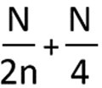
Formula to be used for buildings in excess of fifteen branch intervals
N = = The permissible load on a stack ofwith one or two branch intervals, and as shown in Table 3 n = number = Number of branch intervals on the stack under considerationto be sized

FORMULAS BELOW ARE DELETED

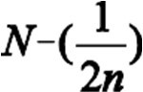







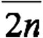
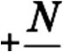





² There shall not be more than two toilets or bathroom groups within each branch interval nor more than three toilets or bathroom groups on thestack.

³ The formula contained in footnote 1 does not apply to three inch stacks. For three inch stacks above 15 branch intervals, no single interval shall exceed more than ten fixture units.

E.G. Find the maximum number of fixture to the branch units which can be connected to a four inch stack at any branch interval.

Example: Stack size = 4”
10 Branch Intervals Fixture Unit per Branch Interval

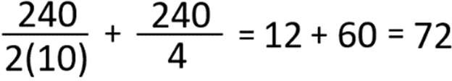

- Sizing of Offsets on Stacks and Vertical Drainage Piping.
  - Offsets of 45E45 degrees or Less. An offset in a vertical stack with a change of direction of 45E45 degrees or less from the vertical, may be sized as a straight vertical stack. In the event of a horizontal branch connects to the stack
within two feet above or below the offset, a relief vent shall be installed in accordance with 248 CMR 10.16(5)(c).2)(d). See 10.15: Example 1

  - Offsets of More than 45E45 degrees. A stack with an offset of more than 45E45 degrees from the vertical shall be sized as a horizontal drain and as follows: See 10.15: Example 2
    - The portion of the stack above the offset shall be sized as for a regular stackusing 248 CMR 10.15 Table 3 based on the total number of fixture units above the offset.
    - The offset shall be sized as for a building drain as shown inusing 248 CMR 10.15(7): Table 2.
    - The portion of the stack below the offset shall be sized as for the offset or based on the total number of fixture units on the entire stack, whichever is above including the largeroffset.
    - In buildings of five stories or more, a relief vent for the offset shall be installed as provided required elsewhere in 248 CMR 10.16(5)(c) and in2)(d).
      - In no case shall a horizontal branch connect to the offset or to the stack within two feet above or below the offset.

10.15 Example 1 10.15 Example 2
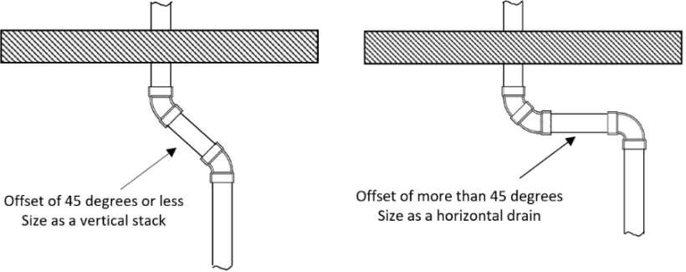
Offsets of 45 degrees or less Offsets of more than 45 degrees

  - Offsets Above the Highest Branch. An offset above the highest horizontal branch is an offset in the stack-vent and shall be considered only as it affects the developed length of the vent.
  - Offsets Below the Lowest Branch. In the case of an offset in a soil or waste stack below the lowest
horizontal branch, there shall be no change in diameter required if the offset is made at an angle of less than 45 degrees. If such an offset is made at an angle greater than 45 degrees to the vertical, the required diameter of the offset and the stack below it shall be determined using 248 CMR 10.15 Table 2.E. If such an offset is made at an angle greater than 45E to the vertical, the required diameter of the offset and the stack below it shall be determined as for a building drain in 248 CMR 10.15(7): Table 2.
  - Open Parking Garages.
    - The drainage system of open parking garages which are subject to freezing temperatures including open parking garages in which floor drains are installed, may exclude the use of traps.
    - Traps and their associated vents may be eliminated however, stacks shall be installed in accordance with 248 CMR 10.16(6)(a).
    - The maximum distance between stacks shall not exceed 60 feet intervals.

(9)(8) Drainage Piping Installations.
- See 248 CMR 10.05: General Regulations for the following:
  - Pitch of horizontal piping;.
  - Fittings used to change direction;.
  - Prohibited fittings;.
  - Heel or side inlet bends;.
  - Obstructions to flow;.
  - Dead ends.
- Back to Back Fixtures When Using a Single Fitting:
  - Horizontal: Shall by installed with the use of double sanitary wye fittings only to eliminate throw over.
  - Vertical: Shall be installed with the use of double sanitary drainage pattern tee fittings. See 10.15:
Example 2. Exception: For water closets, double wye fittings may be used if required by the water closet manufacturer’s installation instructions. See 10.15: Example 3

Example 2 Double Sanitary Tee Example 3 Double Wye
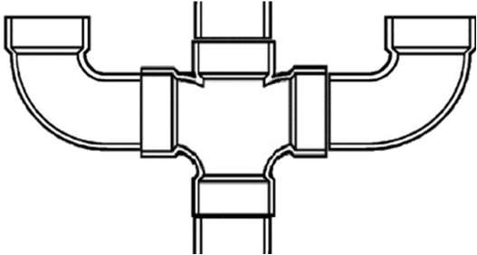
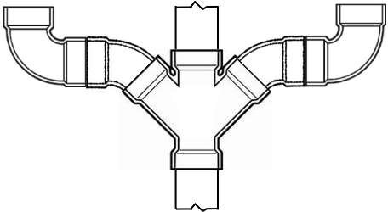

(b)(c) Kitchen Sink Wastes (DomesticResidential).
- Not less than a 1½one- and one-half inch branch waste or waste outlet shall be provided to receive
the fixture drain from a kitchen sink, which shall connect independently to the sanitary drainage system.
system.
- A kitchen sink shall not waste into any horizontal drain line that receives the waste from a bathtub or similar flat bottom fixture that is smaller than three inches in diameter .
- Roughing - Food Waste Disposer.
  - The fittings used in all sanitary drainage systems which receive the fixture waste receiving discharge from a flat bottom fixture.
- The roughed-in drain line for final connection to a kitchen sink, shall be installed at a height to
permit the installation of a food waste disposer, (approximate height 12 inches through 15 inches above the finished floor)..
  - The fitting shall be installed notwithstanding the installation of the food waste disposer.
- Kitchen Sink Clean-outs.
  - An end or dandy clean-out fitting the same
- A full-size as the drain to which it connectscleanout shall be installed under all kitchen sinks.
Exception: 2. A two-piece kitchen sink trap that canwhich may be disassembled to clean this drain may be usedfor use in lieu of thea clean-out.
(e)(d) Laundries Drains in Multi-storyStory Buildings.
- Where In buildings where laundries are installed in buildings with on more than three Branchbranch intervals, laundriesthe waste line shall be connected to an independent laundry stack. See 10.15: Example 4.
- 1. The independent laundry stacks shall connect to aan independent laundry main drain.
- 2. The independent laundry main drain shall connect to the building drain a minimum of 40 pipe diameters upstream and downstream of any soil or waste stack.
- 3. A suds relief vent shall connect to the laundry main drain a minimum of 40 pipe diameters downstream from the base of the laundry stack. The suds relief vent shall connect to a vent a
minimum of two branch intervals above the base of the laundry stack. (See 248 CMR 10.22: Figure 19.)
- 4. The Inspector may permit a variation from the above requirements in 248 CMR 10.15(9)(e)1. through 4. when conditions will not allow compliance.

10.15: Example 4 - Laundries Installed on More Than Three Branch Intervals

SUDS PRESSURE RELIEF VENT
WASTE SIZE | RELIEF VENT SIZE
2” | 2”
2” | 2”
2-1/2” | 2”
3” | 2”
4” | 3”
5” | 4”
6” | 5”
8” | 5”

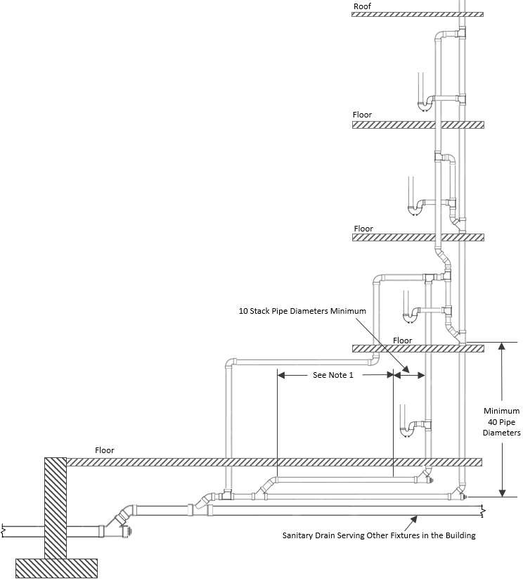
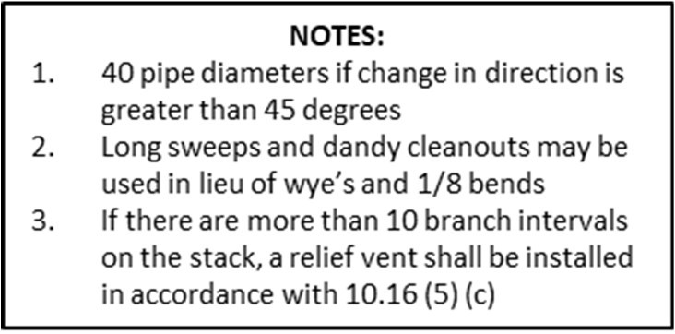
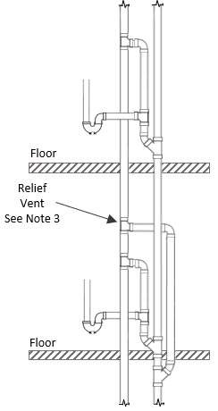
(10)(9) Sumps and Ejectors.
- Building Drains belowBelow Building Sewer. Where it is not possible or practical for a drain to be
  - Building drains that cannot be discharged to the sewer by gravity flow, the drain shall be discharged into a tightly covered and vented sump, from which the contents shall be lifted and discharged into the building gravity drainage system by automatic pumping equipment or by any equally efficient method approved by the Inspector.
  - Only drains located below the building sewer or building drain shall discharge into sumps. All other drains shall be discharged by gravity.
- Design of Sumps and Ejectors. Sump and pumping equipment shall be so designed:.
  - as to discharge all contents accumulated in the sump during the cycle of emptying operation; and
  - so that the storage of drainage in a sump or ejector does not exceed 12 hours.
- Duplex Equipment. Sumps or ejectors, in other than one or two family houses or residences, receiving the discharge of six or more toilets shall be provided with duplex pumping equipment.
- Drainage Pipe Venting. The system of drainage piping below the sewer level shall be installed and vented in a like manner to that of the gravity system to conform with 248 CMR 10.16.
- Prohibited Connections to Discharge Pipe. No fixtures or drains shall be connected to the sewage discharge pipe from an ejector or pump between the ejector or pump and the point where it enters the building drainage system or sewer.
- Drainage Backflow Prevention.
  - All sumps and ejectors shall be protected against backflow and backpressure from the building sewer or building drain by installing a backwater or check valve in the discharge pipe from the ejector or sumppump.
  - This required backflow protection shall also comply with 248 CMR 10.15(11).
- Size of Sumps and Pumps
  - All sumps shall have a holding capacity sufficient to meet the demand of a period not to exceed 12 hours.

- Sewage Pumps and Ejectors

  - 1. In single-family dwellings, a sewage-ejector sump receiving the discharge of toilets and other
fixtures shall be equipped with a sewage-ejector pump that provideshaving a full-size discharge and a minimum discharge capacity of 20 gallons per minute.
  - 2. In all installations other than single-family dwelling, sewage-ejector pumps shall be equipped
with a full-sized discharge and be sized in conformance with 248 CMR 10.15(10): Table 5.: Determining Capacities of Sewage Ejectors.
  - To calculate the capacities of pumps used in Sewage Ejectors, it is recommended that the following procedures be used in all types of building occupancies. The safety factors included in 248 CMR 10.15(10): Table 5 are sufficient for all installations. Any installation that does not meet the requirements of 248 CMR 10.15(10): Table 5 shall require Special-permission from the Board.
- The discharge piping from all sewage pumps and ejectors shall contain an accessible backwater or check valve and an accessible full port shut off valve installed downstream of the backwater or check valve. See 10.15: Example 5.
- For systems not determined using 10.15 Table 5, a variance shall be required.
Exception: Systems designed by a Massachusetts professional engineer.

10.15: Example 5 Discharge Piping from Sewage Ejector
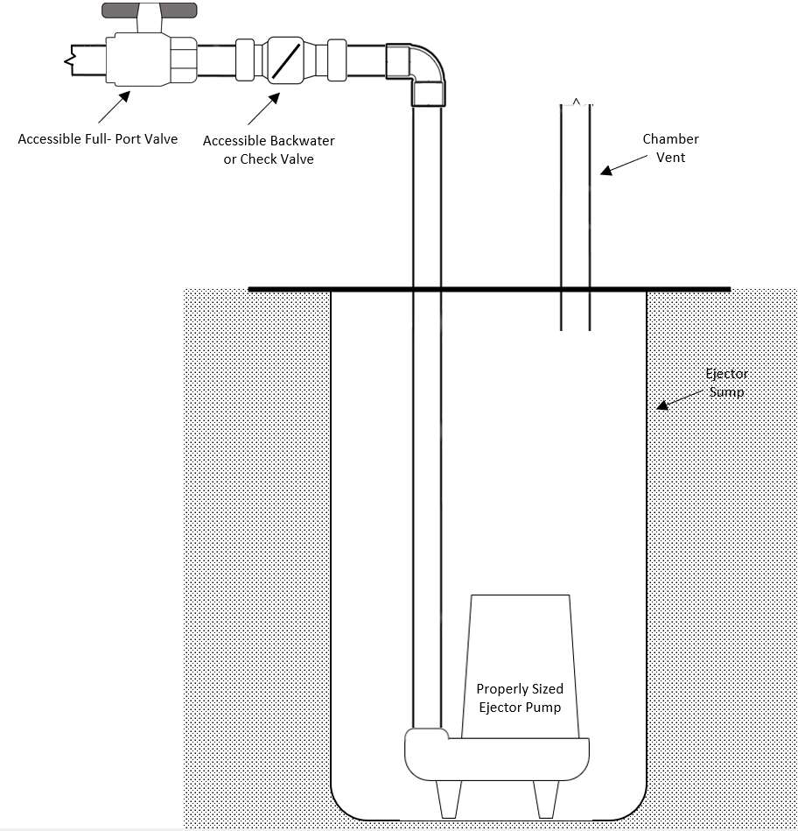

- Macerating Toilet Systems
  - All macerating toilet systems shall be product accepted by the Board and in compliance with ASME A112.3.4 or CSA B45.9
  - Systems shall be suitable for the application and installed in accordance with the product manufacturer’s installation instructions.
  - Shall have a minimum three-quarter inch discharge
  - With the exception of toilets, all fixtures connecting to a macerating system shall be properly trapped and vented prior to connecting to the pumping unit.
- Pneumatic Ejectors
  - The air pressure relief pipe from a pneumatic ejector shall not be connected to the regular venting system but shall be vented independently to the atmosphere through the roof.
  - The relief pipe shall be of sufficient size to relieve air pressure inside ejector atmospheric pressure within ten seconds but shall be not less than one inch in diameter.
- Grinder Pumps. Shall be product accepted, installed in accordance with the manufacturer’s installation and with 248 CMR 10.15 (6) (b) 1. D.
- Duplex Equipment. Sewage pumps and ejectors, in other than one- or two-family dwellings receiving the discharge of six or more toilets shall be provided with duplex pumping equipment.
- Connections to the Building Drainage System. The discharge piping from a sewage pump or ejector shall be connected independently to the building drainage system.
- To calculate the discharge capacities of sewage pumps and ejectors, the following procedures shall be used
  - 248 CMR 10.15(9): Table 5
  - Any installation that does not meet the requirements of 248 CMR 10.15(9): Table 5 shall be designed by a Massachusetts professional engineer.

TABLE 5
DETERMINING CAPACITIES OF SEWAGE EJECTORS

Number of toilets to be Served by each Ejector | G.P.M. Discharge of each Pump
1 | 20
2 - 3 | 75
4 - 5 | 100
6 - 7 | 125

8 - 10 | 150
11 - 15 | 200
16 - 20 | 250
21 - 25 | 300
26 - 30 | 350
31 - 35 | 375

- (i) Ejectors Handling Other Fixtures. Generally, there will be a certain amountnumber of fixtures other than toilets emptying into the ejector sump. If the total amount of these fixtures exceedexceeds four times the amount number of toilets used, the G.P.M. of the ejector pump should be increased at the rate of three G.P.M.
for each fixture in excess ofexceeding four times the amountnumber of toilets.

- EXAMPLE:

Example:
G.P.M. pump dischargeGPM Pump Discharge of four  toiletsToilets | 100  G.P.M.GPM
Number of additional fixtures to be handled | 20
Excess fixturesFixtures as calculated from above 20 - (4 x 4) = 4 | 4
Four @ 3 G.P.M.GPM | 12  G.P.M.GPM
Correct sewage ejector pumpSewage Ejector Pump to use | 112  G.P.M.GPM

(h)(j) Individual Sink Fixture Pumps.
- Individual fixtures other than toilets, urinals or similar fixtures may discharge directly into:
  - a fixture mounted pump; or
  - into sumps and receivers with ejectors or pumps.
- The waste discharge piping from the individual fixture pump shall have a check valve to prevent the discharged waste from returning to the pump or receiver.
- Individual fixture pumps may be used for sinks that are located below the building drain.
- 2. Individual fixture pumps may be used for sinks when unusual building structure conditions prevent the discharge of liquid waste by gravity.
- 3. Direct-mounted individual fixture pumps may be manually or automatically operated.
- 4. The individual fixture pumps shall be vented in accordance with the manufacturer’s instructions. Individual If individual fixture pumps may provide an adequate water seal in accordance with 248 CMR 10.03
additional traps mayshall not be required.

(11) Backwater Valves.

(a)(10) Drainage Fixtures Subject to Backflow.
- (a) A backwater valve shall Backwater valves may be installed in a branch of the building drain piping which receives the discharge only from a fixture or group of fixtures that isor drains subject to reverse flow or backpressure.backflow from the public sewer system. All other drains which are not subject to backflow shall not drain through a backwater valve. See 10.15: Example 6.
- Back Water Valves on Storm Drain Systems. A back water valve shall be installed in a branch of the building storm drain that serves lower roof areas in accordance with 248 CMR 10.22: Figure 23.
- Materials for Backwater Valves. Backwater valves shall have all bearing parts of corrosion-resistant material.
- Construction of Backwater Valves. Backwater valves shall be constructed so a mechanical seal against backflow will beprovided.
(d)(c) Diameter of Backwater Valves. Backwater valves, when fully opened shall have an effective opening not less than that of the pipes to which they are installed.
(e)(d) Location of Backwater Valves. Backwater valves shall be installed so their working parts will be readily accessible for service and repairs.
(f) Approval of Backwater Valves. In lieu of an acceptable standard for backwater valves, substitutes may be used after being Product-accepted the Board under 248 CMR 3.04: Product, Design, and Testing Standards.

10.15: Example 6 - Backwater Valve
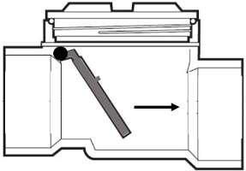
10.16: Vents and Venting

- Materials.
  - Above and below Ground. All pipe and fittings to be used on the venting system, or any part thereof, shall comply with 248 CMR 10.06.
  - Chemical Waste Systems. Vent piping on chemical and corrosive waste systems shall conform to that required for Hazardous Wastes under 248 CMR 10.13.
- Bow Vents.
  - Bow vents are permitted for fixture installations in island cabinets and peninsula cabinets that cannot be vented in a conventional manner.
  - The bow vent shall be sized in accordance with 248 CMR 10.16(16): Table 2.
  - The installation should conform to 248 CMR 10.22: Figures 13(a), (b) or (c).

(3)(1) Prohibited Venting.
- Combination Waste and Vent. A combination waste and vent system shall not be used unless no other system is possible or practicable, and only then after Special-permission is grantedbe prohibited without Special-Permission by the Board. See 248 CMR 10.16(15)(a) and shall comply with the following:
  - A combination waste-and-vent system is limited to the installation of floor drains and sinks.
  - A combination waste-and-vent system consists of a wet vented installation of waste piping in which fixture drains are not individually vented.
  - Every drainage pipe in a combination waste-and-vent system shall be not less than two pipe sizes larger than the size required in 248 CMR 10.15.
- Crown Venting Limitation.. No vent shall be installed within two pipe diameters of the trap weir. See 10.16: Example 1

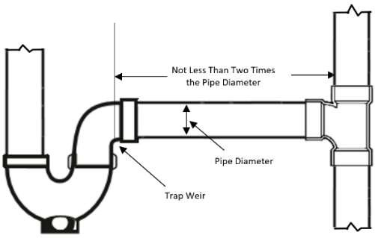
Example 1 - Crown Venting
- Extension of Horizontal Drain. The extension or continuation of a horizontal soil or waste drain pipe shall not serve as a vent, except:.

Exception:
  - When whenpermitted under wet venting 248 CMR 10.16(7);or5). and
  - When when a fixture waste of not more than two fixture units is connected to the vertical extension of the extended horizontal piping. See 10.16: Example 2

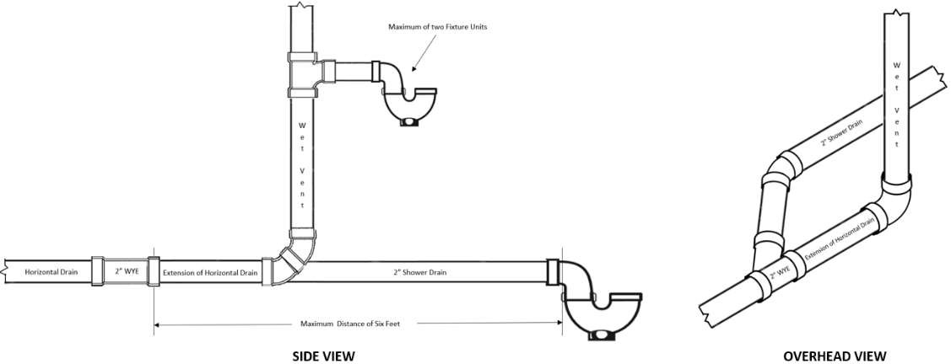
Example 2 - Wet Vent Extension of a Horizontal Drain
- Below Trap Weir. The vent pipe opening from a soil or waste pipe, except for water closets and similar fixtures, shall not be below the weir of the trap.
- Use Other than Venting. The sanitary vent system shall not be used for purposes other than the venting of the plumbing system.
(e) Automatic Vent Fittings and Air Admittance Valves: Automatic vents and air admittance valves are not permitted without Special-Permission from the Board.

(4) Protection of Trap Seals. The protection of trap seals from siphonage, aspiration, momentum, oscillation, back pressure, evaporation, or capillary action shall be accomplished by the appropriate use of soil or waste stacks, vents, re-vents, back vents, dry vents, wet vents, loop vents, circuit or continuous vents, or combinations thereof, installed in accordance with the requirements of 248 CMR 10.16, so that at no time shall the trap be subjected to a pressure differential of more than one inch ofwater.

(5)(2) Vent Stacks and Stack Vents.
- Vent Stack Required.
  - (a) Any All building drains within a structure, in which a building drain is installed, shall have as a shall, at minimum have at least one full size main stack vent or a vent stack no less than three inches in diameter. (See 248 CMR 10.16 (11): Table 2: Size and Lengths of Vents for fixture unit values to determine the appropriate stack vent or vent stack size). Buildings that incorporate with three or more branch intervals in which plumbing is installed shall have no less thanat least one main vent stack, (See 248 CMR 10.15(5)) that shall run undiminished in size and as directly as possible, properly sized in

accordance with 10.16 Table 2 from the building drain through to the open air above the roof or connect back to a main stack vent six inches above the flood level rim of the highest fixture being served.
  - (b) A vent stack or a main vent shall be installed with a soil or waste stack whenever backindividual vents, relief vents, or other branch vents are required.
(b)(c) Connections at Base and Top.
    - All main vents or vent stacks shall connect full size at their base to the drainage of the building or to the main soil or waste pipe, at or below the lowest fixture branch.
    - All vent pipes shall extend undiminished in size above the roof, or shall be reconnected with the main soil or waste stack a minimum of six inches above the flood level rim of the highest
fixture connection discharging into it. The minimum size of any vent through the roof shall be two inches in diameter. (c)(d) Offsets in BuildingBuildings Five or More Stories in Height.
- Except as provided in 248 CMR 10.15, offsets of more than 45E45 degrees from the vertical in a soil or waste stack may be vented:
  - as two separate soil or waste stacks;
    - by installing a relief vent as a vertical continuation of the lower section of the stack; or
    - as a sideyoke vent connected to the lower section between the offset and the next lower fixture or horizontal branch;.
ii. iii. The upper section of the offset shall be provided with a yoke vent; or.
iv. The diameter of the vents shall not be less than the diameter of the main vent, or of the soil and waste stack, whichever is the smaller. See 10.16: Example 3

10.16 Example 3 - Offsets of More Than 45 Degrees
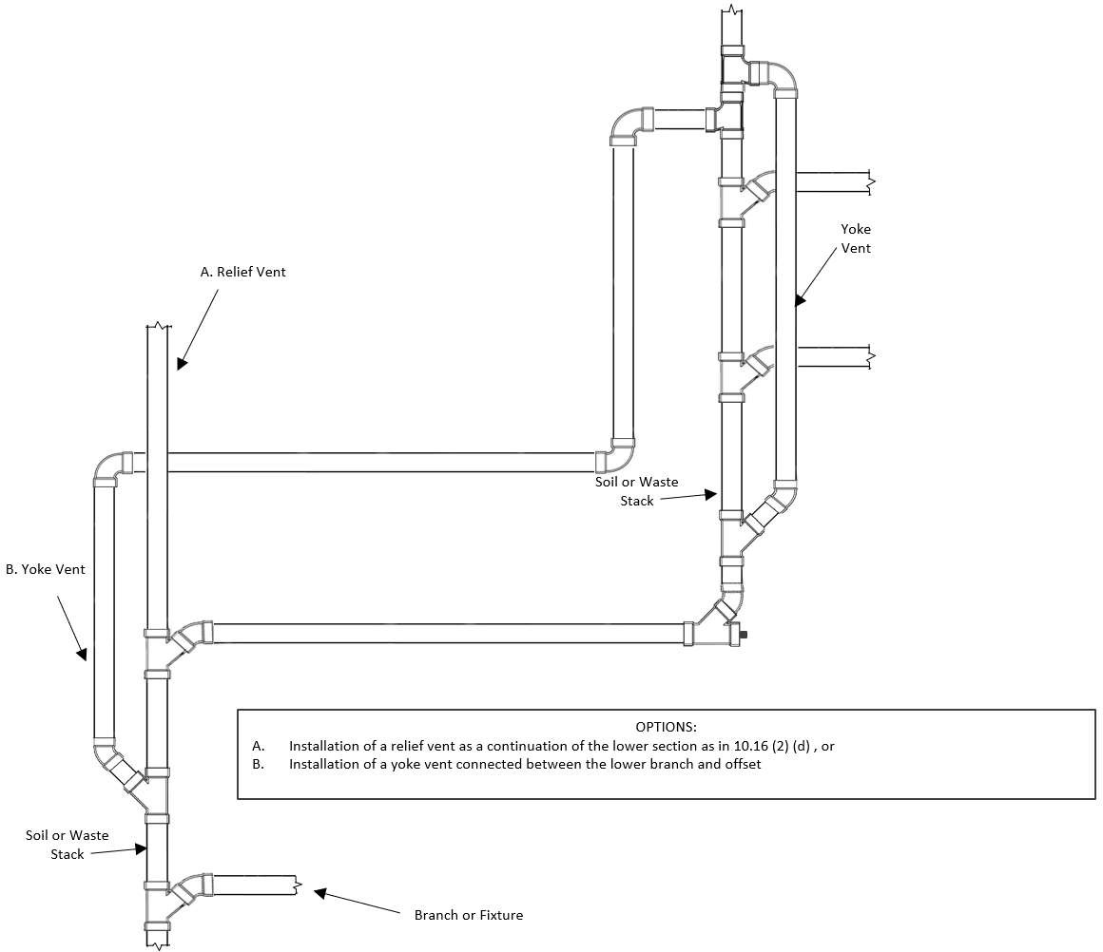

(d)(e) Vent Headers.
- Where vent stacks and stack vents connect to a vent header, the connections shall be made at the top of the stacks.
- The vent header shall connect to a vent extension through the roof.
- When more than two four-inch soil or waste stacks are connected, the vent header extension through the roof shall be five inches in diameter.
- When more than four four-inch stacks are connected, the diameter shall be six inches in diameter.
(e) (f) Relief Vents for Vents ofin Buildings with More thanThan Ten Branch Intervals.
- Soil and waste stacks in buildings having more than ten branch intervals shall be provided with a relief vent at each tenth interval installed, beginning withfrom the top floor down.
- The size of the relief vent shall be equal to the size of the vent stack to which it connects.
- The lower end of each relief vent shall connect to the soil or waste stack through a wye below the horizontal branch serving the floor and the upper end shall connect to the vent stack through a wye not less than three feet above the floor level.

(6)(3) Vent Terminals.
- Extension aboveAbove Roof.
  - The vent extension through a roof shall be no less than two inches in diameter and shall extend not more than 24 to a point between eighteen and twenty-four inches and not less than 18 inchesabove the penetration through the roof. See 10.16: Example 4

  - If the roof area is used for gardening, a parking deck, observation deck or similar purposes, the vent shall extend no less than eight feet above the roof and be increased one pipe diameter. See 10.16: Example 5
  - Increaser. The change in the diameter of a vent terminal shall be made by the use ofusing an increaser; and occur no less than one foot below the roof surface. See 10.16: Example 4

Example 4 - Vent Extension Through Roof Example 5 - Vent Extension Through
Observation Deck or Similar
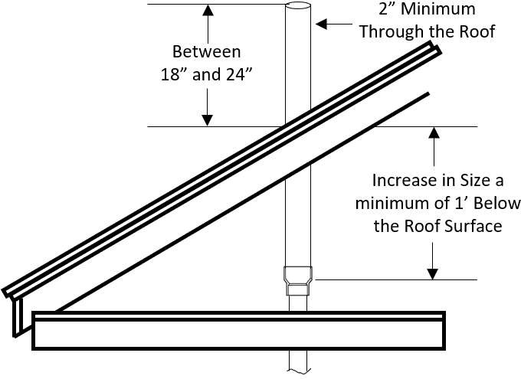
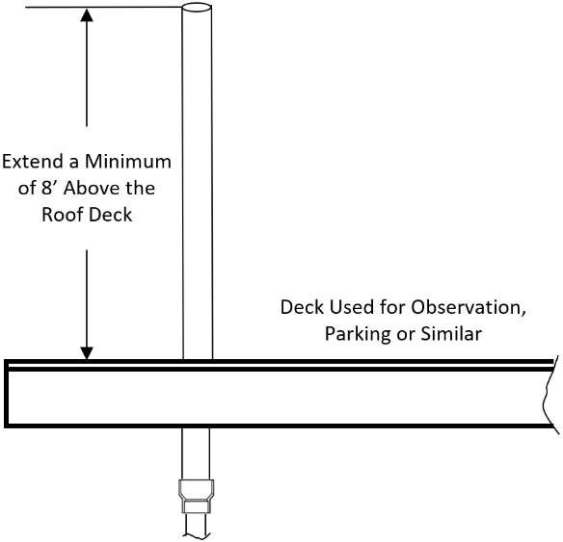

- Waterproof Flashings. Each vent terminal shall be made watertight with the roof by proper flashing.
- Flag Poling Prohibited. Vent terminals shall not be used for the purpose of flag poling, TV aerials, or similar purposes.

(d)(c) Location of Vent Terminal.
  - No vent terminal shall be located :
    - directly beneath any door, window, or other ventilating building opening of the building or of an adjacent building; or b. within ten feet horizontally of such anthe opening unless it is no less thanat least two feet above the top of suchsaid opening. See 248 CMR 10.16: Example 6
  - Plumbing vent terminals shall be located no less than 25 feet horizontally from all freshforced air intakes. 3. Plumbing vents that terminateVents terminating no less than two feet above the top of the freshforced air intake may be located as close as ten feet. from the forced air intake. 248 CMR 10.16(6)( (3) (a) does not apply in this case. See 248 CMR 10.16: Example 7.

Example 6 - Location of Vent Terminal Example 7 - Vent Terminal from Forced Air Inlet
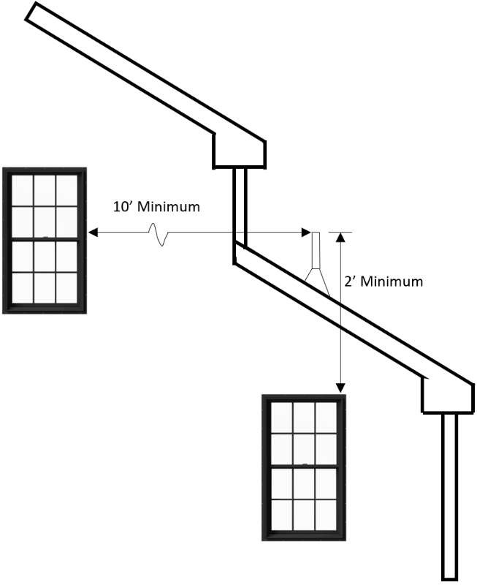
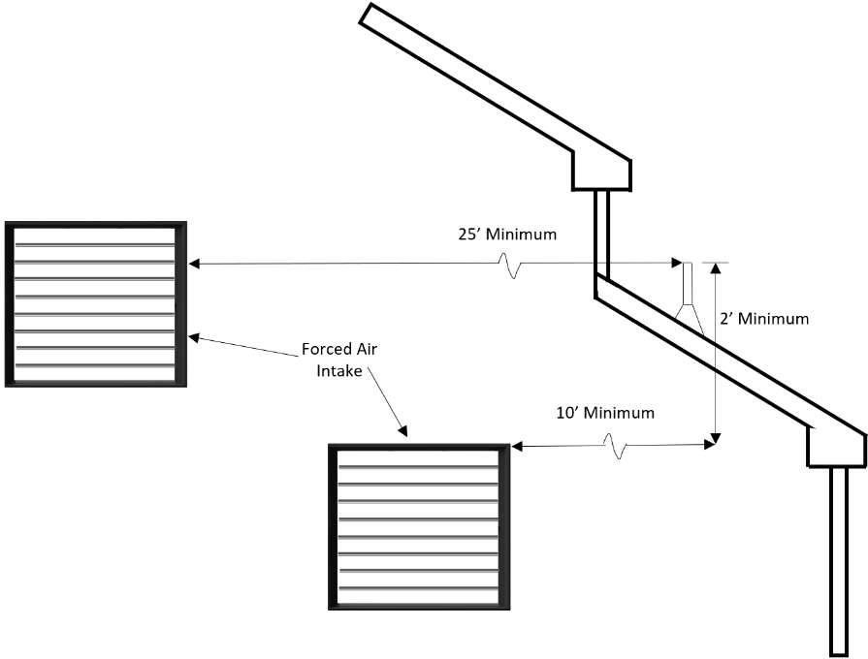

(e)(d) Vent Extensions Outside of the Building.
1. All soil, waste or vent pipe extensions shall be installed inside the building. Exception: 2. For
remodeling and alteration work only, vents may be installed outside the building with prior permission of the Inspector and when all other means of venting have been eliminated or are not practical and with prior permission of the Inspector.
(f)(e) Frost Closure. Where frost closure is likely to occur, each vent extension through a roof shall be at least three inches in diameter.

(7)(4) Vent Grades and Connections.
- Vent Grade. All vent and branch vent pipesvents shall be uniformly graded in accordance with 248 CMR10.05(2) and connected as to drain back to a soil or waste pipe by gravity.
- Vertical Rise.
  - Where vent pipes connect to a horizontal soil or waste pipe:
    - The vent shall be taken off above the center line of the soil or waste pipe drain.
    - For other than floor mounted fixtures, the Thevent pipe shall rise vertically, or at an angle of 45E45 degrees from the vertical, to a point at least six inches above the flood-level rim of the fixture it
is venting, before it may offset horizontally.
  - If it is not possible or practical to vent the fixture trap as required in 10.16(7)(b)1.:
    - A vent serving a floor drain, floor sink, or similar
c. For floor mounted fixture fixtures, the vent may be extended horizontally above the centerline of the drain of the fixture to the nearest practical location where it can rise vertically. The vent shall connect tocome off the soil or waste pipe above the centerline of the drain not less than 45E45 degrees from the horizontal before running in a horizontal position.
- Height aboveAbove Fixtures.
  - All connection between a vent pipe and a vent stack or stack-vent shall be made at least six inches above the flood-level rim of the highest fixture served by the vent.
  - Horizontal vent pipes forming branch vents, relief vents, or loop vents shall be installed at least six inches above the flood-level rim of the highest fixture served.

(8)(5) Wet Venting.
- Wet venting of fixture traps as hereinafter described may be used provided that the entire sanitary waste and vent piping system meet all other code requirements of 248 CMR 3.00 through 10.00.
- (a) Bathtub or Shower Bathroom Wet Vent. In a single bathroom having a commontwo-inch horizontal waste for a lavatory and bathtub, a two-inch waste and vent forextension of the horizontal drain connecting to a lavatory may serve as a wet vent for the bathtub or shower.fixtures it serves. See 10.16: Example 2. This would also apply to double or back-to-back bathrooms.
  - The lowest portion of the pipe serving as a wet vent shall break the centerline of the horizontal drain it serves. See 10.16: Example 11
- Double or Back to Back Bath Installations. In a double bathroom having a common horizontal waste for lavatories and baths, a two inch waste and vent for the lavatory may serve as a wet vent for the baths.
- Miscellaneous Wet Venting.
  - A two inch or larger waste pipe installed with drainage fittings may serve as a wet vent.
  - The lowest portion of this horizontal pipe serving as the wet vent shall be above the top or above the center line of the horizontal drain it serves except as specifically prohibited in 248 CMR 10.16(8)(e).
  - Toilets in a bathroom below the top floor need not be individually vented if the two inch wet vented waste, serving the lavatories and bath tubs or showers connect directly to the horizontal portion of the fixture branch for the toilet by breaking the centerline or connect above the centerline of the horizontal fixture drain servicing the toilet.
(e)(b) Piping Not to Serve as Wet Vents. A waste Waste and vent piping that serves: a kitchen sink, a garbage disposal, a dish washer, or other fixture installed for culinary use, or one that receives the discharge from a clothes washing machine may not serve as a wet vent for any other fixture.
- Kitchen sink
- Garbage disposal
- Dishwasher
- Washing machine
- Any fixture for culinary use.

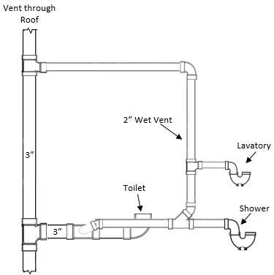
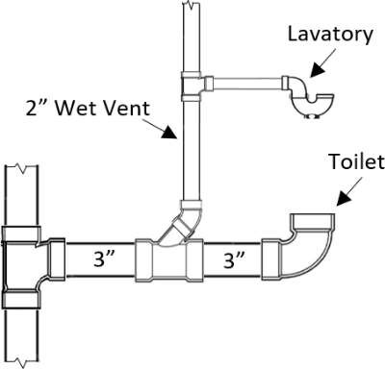
Example 10 - Miscellaneous Wet Venting
Example 11 - Wet Venting Breaking the Centerline
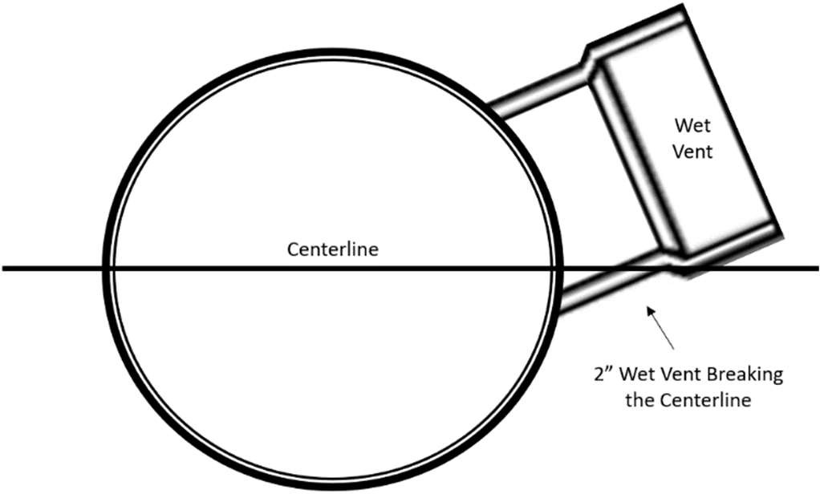

(9)(6) Stack Venting.
- Plumbing Fixtures at the Top Branch Interval of a Stack.
  - Plumbing fixtures at the highest level may enter intoa three-inch soil or waste stack.
  - The continuations of the a three-inch soil or waste stack as a vented through the roof or re-ventedconnected tointo the venting system above the highest fixture shall be accepted, provided that:
    - all such fixtures shall enter said stack independently; and,
    - the waste pipe from all fixtures shall have a pitch of not more than ¼-one quarter inch pitch per foot; and,
    - the toilet and bathtub or shower drain connect to the stack at the same floor level; and,
    - the traps from all fixtures shall be placed in compliance with 248 CMR 10.16(10): Table 1:
Distance of Fixture Trap from Vent. See 10.16: Example 12): Table 1. for Miscellaneous Stack Venting

Example 12 - Miscellaneous Stack Venting. (cont. on next page)
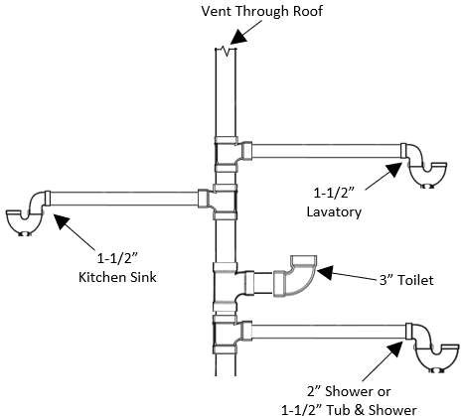
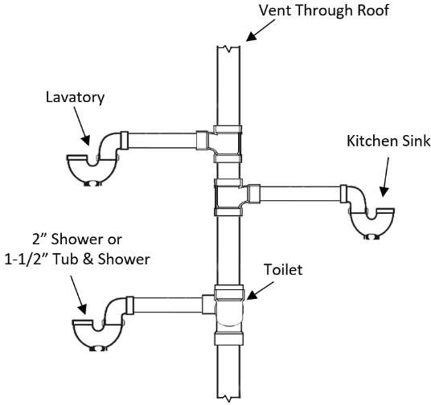

Stack Venting Top Floor Stack Venting Top Floor with Estabrook

Example 12 - Miscellaneous Stack Venting (continued)

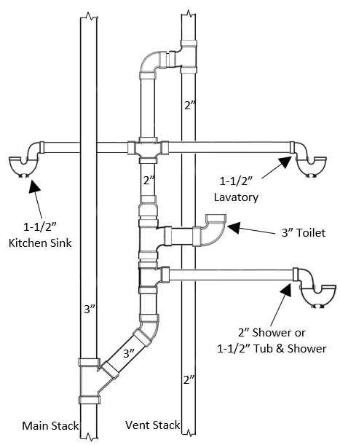
Stack Venting Lower Floors

- Stack Venting. Provided there is a soil and/or waste stack in a building as required under 248 CMR 10.16(52)(a), the continuation in an upwards direction of the vertical waste for a toilet may be reduced to
two inch and serve as the vent for the toilet and the waste for a lavatory, bath tubbathtub, or shower stall, and a kitchen sink.
See 10.16 Example 12, Stack Venting on Lower Floors
- Back to Back Installation (Stack Vented). Bathroom groups installed back-to-back shall be permissible provided they comply with the provisions of 248 CMR 10.16(96)(a).

(10)(7) Common Vents.
- Individual Vent as Common Vent. An individual vent, installed vertically, may be used as a common vent for two fixture traps when both fixture drains connect with a vertical drain at the same level.
- Side by Side. If two bathtubs or similar flat bottom fixtures are installed back to back or side by side, a common vent may be used in a vertical position to serve as the vent for both fixtures.
- Different Levels. A vertical vent may be used for two fixtures that are located in the same branch interval but connected to the stack at different levels, not exceeding ten inches center to center, provided:
  - The vertical drain is one pipe diameter larger than the upper fixture drain but is not smaller than the lower fixture drain, whichever is the larger.
  - That both wastes for said fixtures conform to 248 CMR 10.16(1210): Table 1.: Distance of Fixture FixturesTrap from Vent. See 10.16: Example 13, Drawing 3
- Fixtures Back-to-back Fixtures. Two fixtures setinstalled back-to-back, within the distance allowed between a the trap and its vent as stated in 10.16 (10): Table 1, may be served with have one continuous soil or waste vent pipe, provided that each fixture wastes separately into a double sanitary drainage tee fitting having inlet openings at the same level. See 248 CMR 10.15 (8) (b).
- Horizontal Waste Branch.
  - Two lavatories or similar fixtures installed adjacent or back-to-back within six feet of a main vented stack, proper wet vent, or continuous waste and vent, may be installed on a two-inch horizontal waste branch without re-ventinginstallation of an independent vent, provided:
    - the horizontal waste branch is not less than two inches throughout its entire length; and
    - the fixture wastes are connected into the side center of the branch. See 10.16, Example 13, Drawing 1
  - Back-to-back waste connections shall be through fittings with sufficient directional flow design to assure separate entrance of each waste into the horizontal branch.
  - The branch waste shall connect with its stack at a grade of not more than ¼-inch per foot.

Example 13 - Miscellaneous Types Venting

Drawing 1
See 248 CMR 10.16 (7) (e)
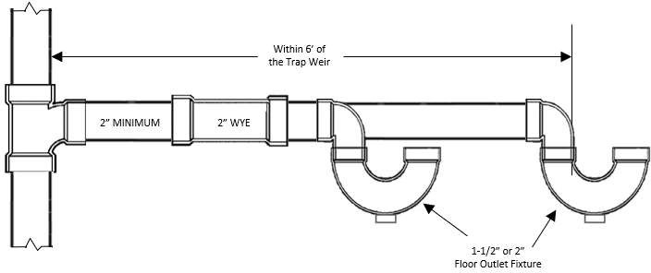

Drawing 2
Relief Vent Necessary Per 10.16 Table 1
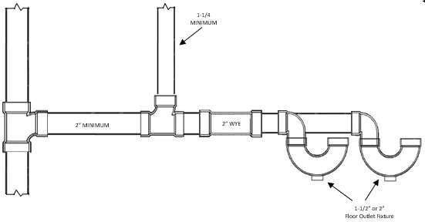

Drawing 3
See 248 CMR 10.16, (7) (c)
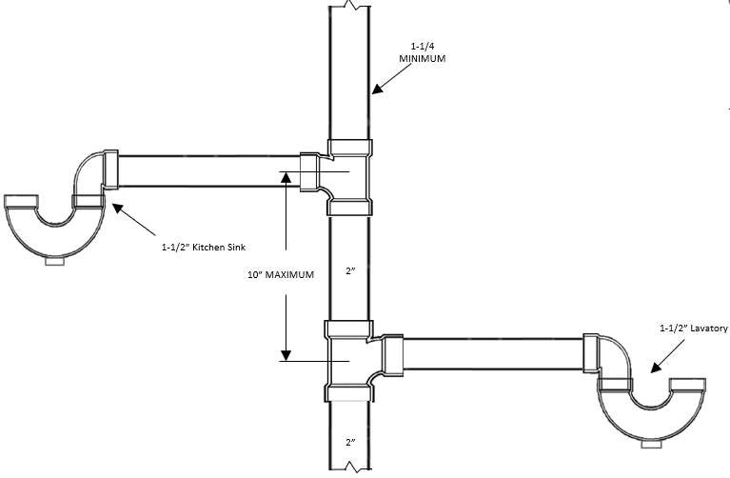
- Circuit and Loop Venting.

(a)(8) Venting of a Battery Venting.Drainage System.
  - (a) A horizontal branch drain soil or waste pipe may be vented by either a circuit or loop vent that shall be installed downstream of the last fixture connection of the battery ifprovided the horizontal branch drain soil or waste pipe: (a)is uniformly sized; and (b) has connected to it two, but not more than eight floor outlet toilets, pedestal urinals, trap standard to floor fixtures, shower stalls, shower bases or floor drains, or any combination thereof, that are connected in a battery and, discharge discharged into the side and center of the horizontal battery branch drain.
    - A circuit vent shall be connected to a proper vent upstream of the horizontal battery drainage system.
    - A loop vent shall be connected to a proper vent downstream of the horizontal battery drainage system.
  - (b) In addition, lower floor branches serving fixtures as described above in 248 CMR 10.16(1)(b), shall be provided with a relief vent installed vertically downstream of the first fixture connection of the battery and shall connect at the top of in the horizontal battery branch drainand shall connect back to the circuit or loop vent.
or loop vent. See 10:16: Example 14
  - 1. Where only two fixtures that are battery waste and vented are installed on the same branch, a relief vent as described above shall not be required.
  - When wall hung or wall outlet fixtures such as urinals, lavatories or similar fixtures discharge into the horizontal battery branch, the fixture waste from these fixtures shall be individual or common vented. (See 248 CMR 10.22: Figure 8 and Figure 9.)
  - 2. Batteries of more than eight fixtures as described in 248 CMR 10.16(11)(a)1.b. may be installed, providing aan additional vent as described above is installed for each eight or less of the fixtures so connected.
(c) Fixtures other than the floor outlet type may also connect to the battery drainage system but shall be

either individual or common vented.
(b)(d) Dual Branches. When parallel branches serve fixtures as described in 248 CMR 10.16(11)(a) all of are installed, all the provisions and requirements of 248 CMR 10.16(11)(a)this section shall prevail, except that the fixture connections.
Exception: Fixtures connecting to each parallel horizontal branch shall be limited to 50% sized based on fifty percent of the fixture connectionunits permitted on a horizontal branch in 248 CMR 10.16(11)(a).for a battery drainage system.
- Vent Connections. When the circuit, loop, or relief vent connections are taken off the horizontal branch, the vent branch connection Vents installed in a battery drainage system shall be taken off at a vertical angle above the centerline of the drain or from the top of the horizontal branch.
- Fixtures Back-to-back in Battery. When fixtures are connected to one horizontal branch through a sanitary tee installed in a vertical position:
  - A common vent for each two fixtures back-to-back or double connection shall be considered acceptable.
  - The common vent shall be installed in a vertical position as a continuation of the double-fixture connection.

Example 14 - Battery Venting Installations
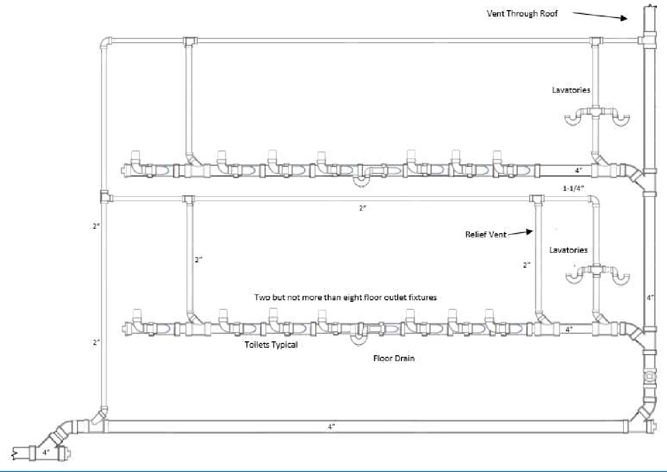

Example 15 – Circuit and Loop Venting
See 10.03: Definition of Circuit Vent and Loop Vent

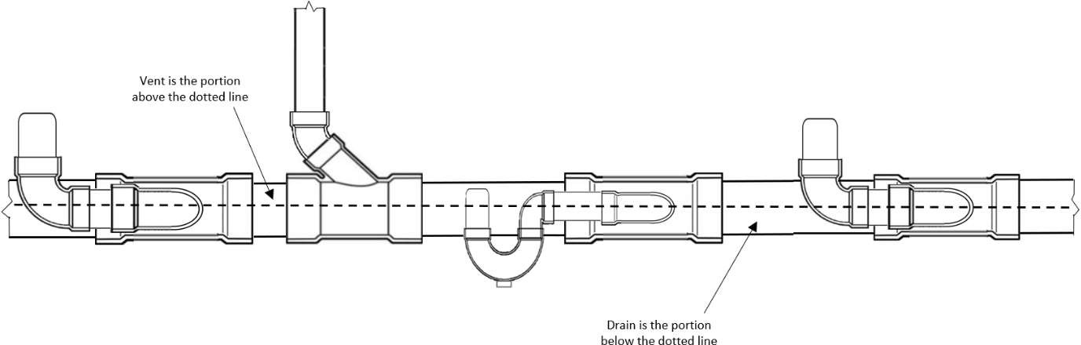

- Bow Vents.
  - Bow vents are permitted when a vent for an individual sink or lavatory cannot rise six inches above the flood level rim of the fixture before turning horizontal.
  - The bow vent shall be sized in accordance with 248 CMR 10.16 (11): Table 2: Size and Lengths of Vents.

Example 16 – Typical Bow Vent Installations

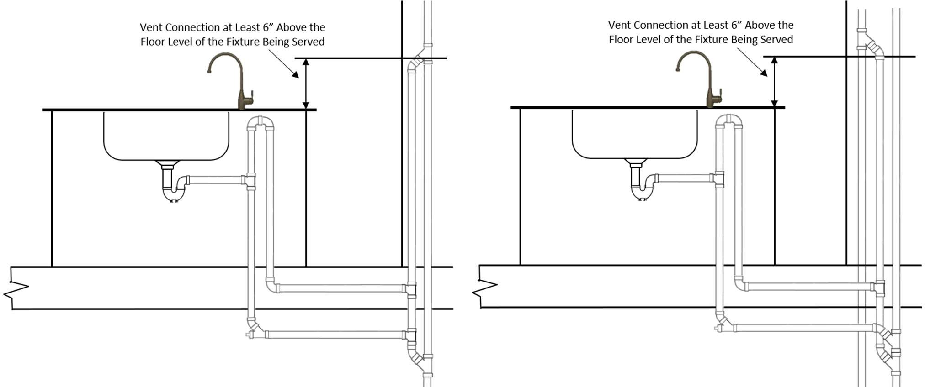

(12)(10) Fixture Vents.
- Distance of Trap from Vent. Each fixture trap shall have a protecting vent so located that the slope and thevent with a developed length in the fixture drain from the trap weir to the vent fitting are within the requirements set forth in 248 CMR 10.16(12): Table 1.

TABLE 1
Table 1: Distance of Fixture Trap from Vent.

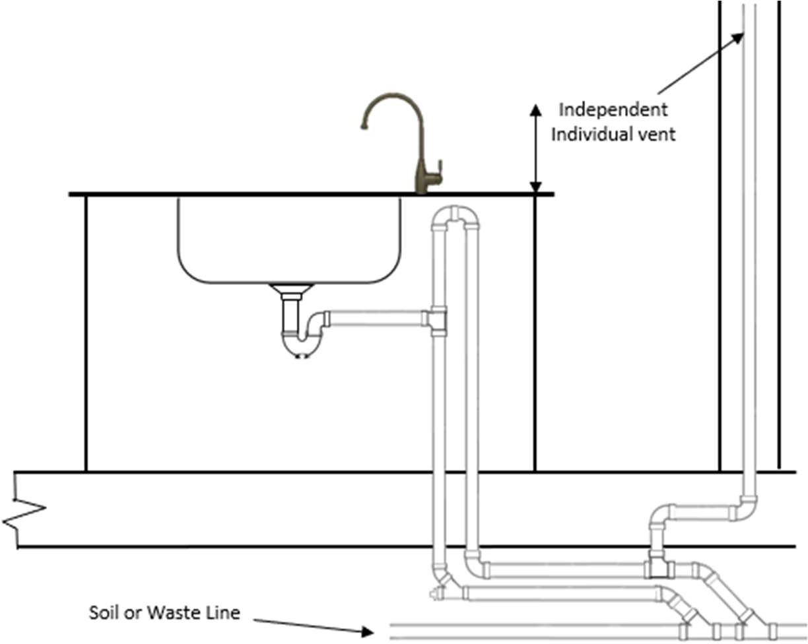

TABLE 1
DISTANCE OF FIXTURE TRAP FROM VENT
SizeDiameter of Fixture Drain, InchesPipe | Distance Trap to Vent,  FeetMaximum Developed Length of the Pipe
1½ ½ | 5'5”
2 | 6'6’
3 | 8'8’
4 | 10'10’
slopeSlope not to exceed ¼-inch¼” per foot

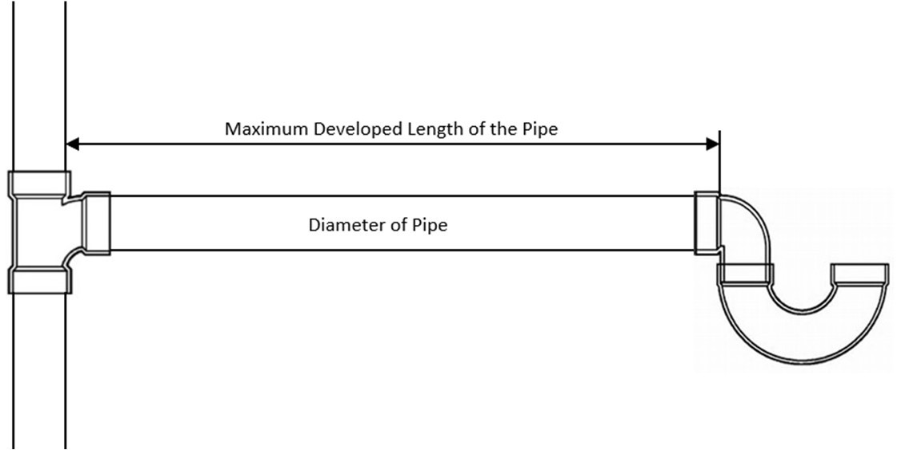

- Venting of Fixture Drain belowBelow Trap.
  - The vent pipe openings from a soil or waste pipe, except for toilets and similar fixtures, shall not be below the top weir of the trap.
  - An exception to 248 CMR 10.16(12)( (10) (b) willshall be permitted if the following requirements are satisfied:
    - The fixture has a flat bottom with a minimum area of 144 square inches.
    - The horizontal section of the fixture waste must comply with 248 CMR 10.16(12): (10): Table 1
1: Distance of Fixture Trap from Vent and the vertical section shall be at least one pipe size larger than the fixture trap and waste arm.
    - The vent opening shall be as high and close to the fixture as possible and the vent piping shall be installed to comply with 248 CMR10.16(7)..
- Floor-mounted Fixture Outlet.
  - When installing the piping for a floor outlet type toilet or similar fixture, the vertical piping

distance shall not exceed 20 inches from the finish floor of the fixture served to the center line of the horizontal drain serving such fixture.
  - If the vertical distance exceeds 20 inches the fixture shall be individually vented.

(13)(11) Size and Length of Vents.
- Size of Individual Vents. The minimum diameter of an individual vent shall be not less than 1¼-one and one quarter inch noror less than ½one half the diameter of the drain to which it connects.
- Size of Circuit, Loop and Relief Vents. The diameter of a relief vent shall be not less than ½ one half the diameter of the soil or waste branch to which it connects when fixtures are battery connected.
- Size of Circuit or Loop Vents. The diameter of a circuit or loop vent shall be not less than ½ the diameter of the soil or waste branch to which it connects when fixtures are battery connected.
(d)(c) Length and Size of Vent Stacks. The length and size of the vent stack or main vent shall be based on the total fixture units and its determined by the developed length from the lowest connectionconnect of the vent to the sanitary drainage system with the soil stack, waste stack, or building drain, to the vent stack terminal to the open air. See 248 CMR 10.16 (11) Table 2.
(e)(d) Size of Vents. The vent pipe sizes shall be determined from their developed length and the total
number of fixture units connected thereto, as listed in 248 CMR 10.16(16): Table 2. 248 CMR 10.16(16 (11): Table 2: Size and Lengths of Vents. This table shall be used to size all vents, except for those vents that are specifically sized elsewhere in 248 CMR 3.00 through 10.00.
(e) Size of Underground Vent Piping. No portion of the venting system installed underground or below a basement floor, shall be less than two inches in diameter.

- Future Venting.
  - In the basement of every building there shall be an accessible future vent connection.
  - Buildings that require a main vent stack shall have a future vent connection full size of the vent stack. In all other buildings (including residential) there shall be a minimum of a two inch future vent connection.
  - All future vent connections shall be drip connected identified and labeled “Future Vent”.

- Combination Waste-and-vent System. Special Permission Required. See 248 CMR 3.04(3)(b).
  - A combination waste-and-vent system is limited to the installation of floor drains and sinks.
  - A combination waste-and-vent system consists of a wet vented installation of waste piping in which fixture drains are not individually vented.
  - Every drainage pipe in a combination waste-and-vent system shall be not less than two pipe sizes larger than the size required in 248 CMR 10.15.

- Venting of Sumps and Ejectors.
  - Size of Vents. The size and length of all vent pipes serving building sanitary sumps and ejectors shall be determined from, and in accordance with 248 CMR 10.16(16): Table 3.
  - Pneumatic Ejector.
    - The air pressure relief pipe from a pneumatic ejector shall not be connected to the regular venting system, but shall be vented independently to the atmosphere through the roof.
    - The relief pipe shall be of sufficient size to relieve air pressure inside ejector atmospheric pressure within ten seconds, but shall be not less than one inch in diameter.
  - Automatic Vent Fittings.
    - The automatic vent fitting shall be installed in the vertical position not less than six inches above the crown of the trap it serves.
    - The piping distance from the trap outlet to the automatic vent fitting shall not be more than 12 inches.
    - The tailpiece from the fixture to trap shall not be longer than 12 inches.
    - The automatic vent fitting shall be installed on the run of a T-Y in the vertical or branch of a T-Y in the horizontal with the T-Y installed so the direction of flow is with the flow of waste.
    - The automatic vent fitting shall be installed in a location readily accessible for inspection and replacement. It shall never be installed in a concealed location.
    - Automatic vent fittings are not permitted, except with Special-permission from the Board.
  - Air Admittance Valves.
    - Air Admittance Valves are not permitted, except with Special-permission from the Board.
    - An individual vent, branch vent, wet vent, circuit vent, vent stack, or stack vent shall be permitted to terminate with a connection to an air admittance valve. Air admittance valves shall be installed in accordance with the manufacturer’s installation instructions.

248 CMR - 134

TABLE 2
TABLE 2
SIZE AND LENGTHS OF VENTS
Diameter of Soil or Waste Stack or Branch  in Inches | Total Fixture Units Connected to Stack or Branch in Fixture Units
 |  | 1¼ | 1½ | 2 | 2½ | 3 | 4 | 5 | 6 | 8 | 10
1½ | 4 | 50 | 150
2 | 10 | 25 | 50 | 150
2½ | 28 |  | 30 | 100 | 300
3 | 7 |  | 42 | 150 | 360 | 1040
3 | 21 |  | 32 | 110 | 270 | 810
3 | 53 |  | 27 | 94 | 230 | 680
3 | 102 |  | 25 | 86 | 210 | 620
4 | 43 |  |  | 35 | 85 | 250 | 980
4 | 140 |  |  | 27 | 65 | 200 | 750
4 | 320 |  |  | 23 | 55 | 170 | 640
4 | 530 |  |  | 21 | 50 | 150 | 580
5 | 190 |  |  |  | 28 | 82 | 320 | 990
5 | 490 |  |  |  | 21 | 63 | 250 | 760
5 | 940 |  |  |  | 18 | 53 | 210 | 640
5 | 1,400 |  |  |  | 16 | 49 | 190 | 590
6 | 500 |  |  |  |  | 33 | 130 | 400 | 1,000
6 | 1,100 |  |  |  |  | 26 | 100 | 310 | 780
6 | 2,000 |  |  |  |  | 22 | 84 | 260 | 660
6 | 2,900 |  |  |  |  | 20 | 77 | 240 | 600
8 | 1,800 |  |  |  |  |  | 31 | 95 | 240 | 940
8 | 3,400 |  |  |  |  |  | 24 | 73 | 190 | 720
8 | 5,600 |  |  |  |  |  | 20 | 62 | 160 | 610
8 | 7,600 |  |  |  |  |  | 18 | 56 | 140 | 560
10 | 4,000 |  |  |  |  |  |  | 31 | 78 | 310 | 960
10 | 7,200 |  |  |  |  |  |  | 24 | 60 | 240 | 740
10 | 11,000 |  |  |  |  |  |  | 20 | 51 | 200 | 630
10 | 15,000 |  |  |  |  |  |  | 18 | 46 | 180 | 570
Note 1: Table 2 shall also apply to the sizing of vents for branch soil and waste lines. To determine size of vent, use the following procedure:
- Compute total number of fixture units, using 248 CMR 10.15 (7): Table 1: Fixture Unit Values for Various Plumbing Fixtures and 248 CMR 10.15 (2)() (b).
- Knowing total fixture unit load, refer to 248 CMR 10.15 (7): Table 3: Maximum Loads in Fixture Units for Soil and Waste Stacks Having One or Two Branch Intervals or 248 CMR 10.15(7): Table 4: Maximum Loads in Fixture Units for any One Branch Interval on Multistory Soil and Waste Stacks depending on number of intervals, to determine size of stack.
- With selected stack size and total fixture unit load refer to 248 CMR 10.16(16): (11): Table 2: Size and
Lengths of Vents and determine size of vent. Follow same procedure to determine size of vents for branch soil and waste lines.

- Future Venting.
- In the lowest level of any building there shall be an accessible future vent connection.
- Buildings that require a main vent stack shall have a future vent connection full size of the vent stack. In all other buildings (including residential) there shall be a minimum of a two-inch future vent connection.
- All future vent connections shall be drip connected identified and labeled “Future Vent”.

- Venting of Ejector Sumps.
- Size of Vents. The size and length of all vent pipes serving building sanitary ejector sumps shall be determined from, and in accordance with 248 CMR 10.16 (14) Table 3: Size and Lengths of Sump Vents.
- Pneumatic Ejector.
  - The air pressure relief pipe from a pneumatic ejector shall not be connected to the regular venting system but shall be vented independently to the atmosphere through the roof.

TABLE 3
SIZE AND LENGTHS OF SUMP VENTS²
Diameter of Drain to Sump¹ | Diameter of Vent (inches)
 | 1¼ | 1½ | 2 | 2½ | 3 | 4 | 5 | 6 | 8 | 10 | 12
2 | 23 | 52 | 290
2½ | 5 | 13 | 89 | 290
3 |  | 2 | 30 | 110 | 290
4 |  |  | 1 | 17 | 57 | 280
5 |  |  |  |  | 10 | 80 | 280
6 |  |  |  |  |  | 20 | 97 | 280
8 |  |  |  |  |  |  | 3 | 41 | 270
10 |  |  |  |  |  |  |  | 1 | 53 | 250
12 |  |  |  |  |  |  |  |  |  | 61 | 230
Note 1: Where more than one drain connects to the sump, size vent on the basis of a drain diameter having a cross sectional area equal to the sum of the areas of the multiple drains.
Note 2: The above values provide for a maximum of one-inch pressure drop in the system

Example 17
Individual Venting – Wet Venting – Stack venting
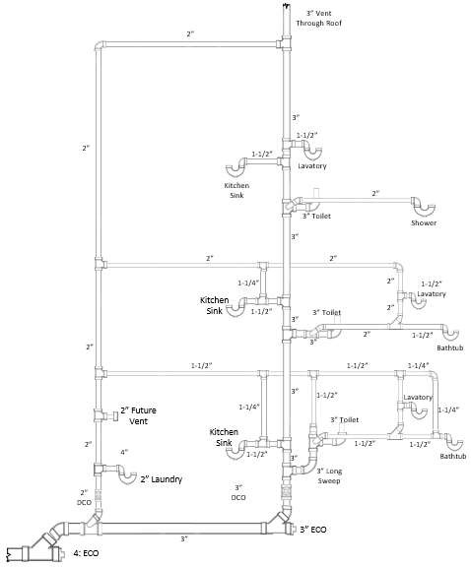
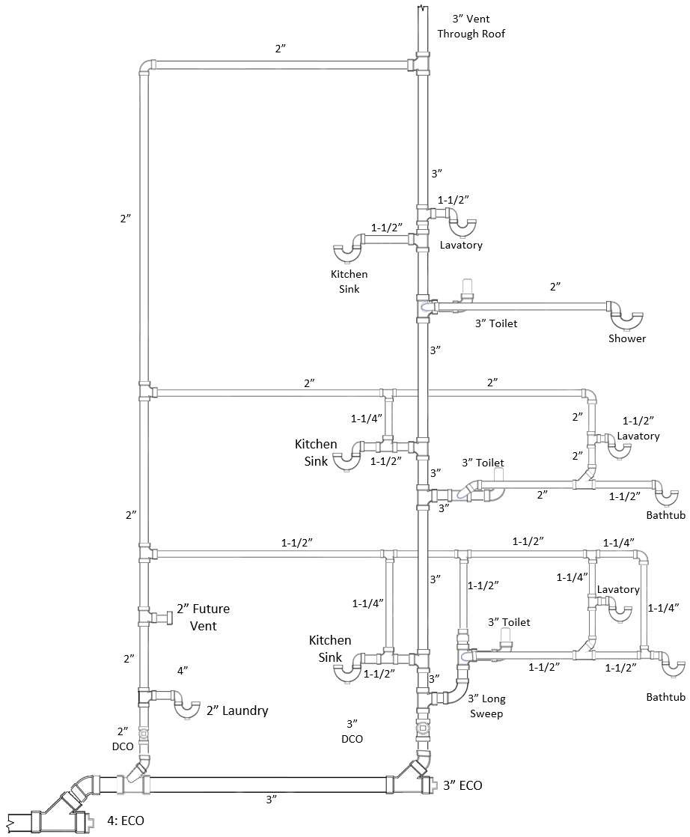

  - : Storm Drains
- Storm Water Drainage Any pipe receiving the discharge from rain or surface water which at any point enters the building or structure shall be considered storm water drainage piping including but not limited to area drainage and clear water waste.

(1)(2) Storm Water Drainage to Sewer Prohibited. Storm water shall not be drained into sewers intended for sewage only.

(2)(3) Size of Building Storm Drain. The size of the building storm drainage system including all horizontal
branches having a slope of ½ inch or less per foot, shall be based upon the maximum projected roof or paved surface area to be handled according to 248 CMR
10.17(2): Table 1: Size of Horizontal Storm Drains.
Exception: Siphonic Roof Drainage Systems.
  - A Massachusetts professional engineer is, per 248 CMR, responsible for the design of the symphonic roof drainage system.
  - As part of the design process, the Massachusetts professional engineer shall be responsible
for assuring that the piping installation, including pipe sizing, dimension, and other aspects, meet the requirements for proper functioning as designed.
  - The Local or State plumbing Inspector shall be responsible for all other aspects of the installation, as required by 248 CMR but is under no obligation to approve or otherwise involve themselves in the design process or ensuring the System meets the design specifications.

TABLE 1

SIZE OF HORIZONTAL STORM DRAINS
Diameter of Drain, in Inches | Maximum Projected Roof Area for Storm Drains of Various Slopes
Diameter of Drain, in Inches | c 1/8-inch Slope | ¼ inch Slope | ½ inch Slope
Diameter of Drain, in Inches | Square Feet | Square Feet | Square Feet
3 |  | 1,160 | 1,644
4 | 1,880 | 2,650 | 3,760
5 | 3,340 | 4,720 | 6,680
6 | 5,350 | 7,550 | 10,700
8 | 11,500 | 16,300 | 23,000
10 | 20,700 | 29,200 | 41,400
12 | 33,300 | 47,000 | 66,600
15 | 59,500 | 84,000 | 119,000
Note 1: Table 1 is based upon a maximum rate of rainfall four inches per hour.
(a)(4) Vertical Storm Conductor. A vertical storm conductor shall be based upon the maximum projected roof area to be drained according to 248 CMR 10.17(2): Table 2.: Size of Vertical Storm Drain Conductors and Outside Leaders.
TABLE 2
SIZE OF VERTICAL STORM DRAIN CONDUCTORS AND OUTSIDE LEADERS
Maximum Projected Roof Area  (Square Feet) | Diameter of Storm Conductor or Outside Leader  (Inches) | Maximum Projected Roof Area  (Square Feet) | Diameter of Storm Conductor or Outside Leader  (Inches)
720 | 2 | 8,650 | 5
1,300 | 2½ | 13,500 | 6
2,200 | 3 | 29,000 | 8
4,600 | 4

(3)(5) Values for Continuous Flow. Where there is a continuous or semi-continuous discharge into the building
storm drain or building storm sewer, as from a condensate pump, ejector, air conditioning equipment, or similar device discharging clear water waste, each gallon per minute of such discharge shall be computed as being equivalent to 24 square feet of roof area, (based upon a four-inch rainfall.)

(4)(6) Building Sub-drainsDrains.
- Building sub-drains located inside the building below the public gravity storm sewerwater drainage piping level shall discharge into a sump or receiving tank.
- The contents of the sump or receiving tank shall be automatically lifted and discharged into the storm drainage system as required for building sumps.

(5)(7) Sub-soilSoil Drains.
- When a subsoil drain for a building is subject to backwater:
  - An accessibly located backwater valve shall protect the subsoil drain.
  - Sub-soil drains may discharge into a properly trapped area drain or sump.
  - Such sumps do not require vents.
  - Piping used for sub-soil drains shall not be less than four inches in diameter.
- Materials for sub-soil drains shall comply with 248 CMR 10.06 and the following requirements shall be satisfied.
  - Piping may be either perforated PVC or installed with open joints.
  - Spigot end lengths shall have joints protected with screens securely fastened to pipes.
  - Screens and fastenings shall be non-ferrous or other approved corrosion resisting material.
  - Perforated piping shall be installed with sealed joints.
  - All sub-soil drain piping shall be installed with sufficient pea stone or similar aggregate to permit the flow of ground water to the piping.
- Area Drains.
  - All area drains shall be connected to the storm water drainage system.
  - They shall be provided with a trap and back-water valve in an accessible location that is not subject to freezing.
- Storm Drainage Subject to Backflow.
  - All roof, area and clear water waste piping subject to backflow shall be provided with a backwater valve with a trap installed in an accessible location that is not subject to freezing. See 10.17: Example 1.
- Size of Area Drains.
  - Area drains shall be of size to serve efficiently the square foot area for which they are intended to drain in accordance with 248 CMR 10.17(2): Table 1.

  - A backwater valve may be installed on area drains prior to connecting to the storm system. Refer for 248 CMR 10.15
- (b), (c) & (d) for materials, diameter, and location.
  - The outlet pipe shall not be less than three inches in nominal diameter.

Example 1
Backwater Valves for Roof, Area & Clear Water Waste Subject to Backflow

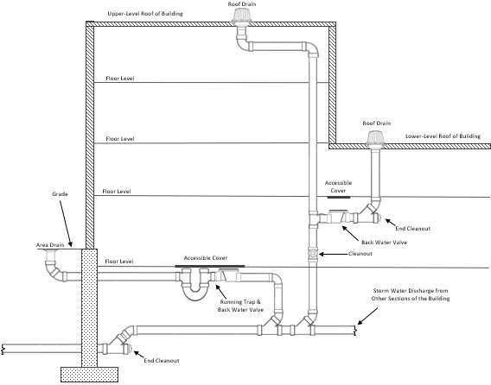

(6)(9) Traps on Storm Drains and Leaders.
- Where Required. Conductors and storm drains serving low roofs when connected to a combined sewer storm and sanitary system shall be trapped.
- Where Not Required. No traps shall be required for storm -water drains that are connected to a sewer system carrying storm water exclusively.
- Trap Material. Storm water traps, when required, shall be of cast iron.
- (c) Trap Size. Traps for individual conductors shall be the same size as the horizontal drain to which they are connected. (e)(d) Method of Installation.
  - Individual storm -water traps shall be installed on the storm -water drain branch serving each
conductor, or a single trap shall be installed in the main storm drain just before its connection with the combined building, sewer main, drain, or public sewer.
  - Conductor traps shall be located so that an accessible cleanout may be installed on the building side of the trap.

(7) (10) Conductors/Leaders and Connections.
- Not to Be Used Improperly.
  - Conductor pipes shall not be used as soil, waste, or ventpipes.
  - Sanitary drainage or vent pipes shall not be used as conductors.
- Protection of Rain Water Leaders. Rain water leaders installed along alley ways, driveways, or other locations where they may be exposed to damage shall be:
  - protected by metal guards; or
  - recessed into the wall.
- (a) Combining Storm with Sanitary Drainage.
  - The sanitary and storm drainage system of a building shall be entirely separate.
  - Where a combined sewer is available, the building storm sewer may be connected to the building sanitary sewer in the same horizontal plane through a single wye fitting to form a combined building sewer at least ten feet outside the inside face of the foundation wall.
- (b) Offsets.
  - Offsets of 45E45 degrees or less from the vertical, and offsets of more than 45E45 from the vertical that do not exceed ten feet in length, shall be sized according to 248 CMR 10.17(2): Table 2.: Size of
Vertical Storm Drain Conductors and Outside Leaders.
  - Offsets of more than 45° from the vertical in excess of ten feet shall be sized according to 248 CMR 10.17(2):
Table 1. : Size of Horizontal Storm Drains.

- (8) Roof Drains.
  - Material of Roof DrainsAll roof drains shall be of cast iron, copper, or other approved corrosion-resisting materialproduct-accepted.
  - Roof Drain StrainersAssemblies.
    - General Use.
      - All roof areas, except those draining to hanging scuppers and gutters, shall be equipped with roof drain assemblies having strainers that extend not less than four inches above the surface of the roof that is immediately adjacent to the roof drain assembly.
      - Strainers shall have an available inlet area, that lays upon the roof level, of not less than 1½ times the area of the conductor to which the roof drain assembly is connected.

      - Roof drain assemblies that serve vehicle parking decks or that serve the outside top
level of open parking garages shall convey storm discharge to aan independent gas, oil, and sand interceptor/separator in accordance with 248 CMR 10.09(1)(b) and shall discharge to the storm drainage system or other approved method of disposal.
    - Flat Decks. Roof drain strainersassemblies for use on sun decks, parking decks, and similar areas,
normally serviced and maintained, may be of the flat surface type, level with the deck and shall have an available inlet area not less than two times the area of the conductor to which the drain isconnected.
    - Roof Drain Flashings Required. The connection between roofs and roof drains which pass into
the interior of the building shall be made watertight by the use ofusing proper flashing methods and material.

- Expansion Joints Required. Expansion joints or sleeves shall be provided where warranted by temperature variations or physical conditions.

- (c) Sanitary and Storm Sewers. Where separate systems of sanitaryWhen a secondary roof drainage and storm water aresystem is installed in , it shall discharge independent of the same property, the storm and sanitary primary building sewers and drains may be laid side by side instorm system and shall terminate the building at a minimum of 18” and a maximum of 60” above grade in an area that will be visible to the same trench.people who occupy the building. This system shall be compliant with all federal, state, and local codes.

  - : Hospital Fixtures

    - General. The plumbing system in a hospital shall conform to the followingrequirements.
      - It shall meet the criteria of 248 CMR 10.18.
      - It shall conform to all other requirements contained in the body of 248 CMR 3.00 through 10.00.
      - It shall conform to the requirements of the Massachusetts Department of Environmental Protection.
In general, all plumbing installed in hospitals shall comply with the requirements of 248 CMR Sections 3 through 10 and the Massachusetts Department of Environmental Protection (DEP).

    - Definitions.

The following definitions shall be used for 248 CMR 10.18.

Aspirator. An aspirator is a fitting or device supplied with water or other fluid under positive pressure which passes through an integral orifice or "constriction" causing a vacuum. Aspirators are often referred to as "suction" apparatus, and are similar in operation to an ejector.

Autopsy Table. An autopsy table is a fixture or table used for the post-mortem examination of a body.

Bedpan Hopper (Clinic Sink). A bedpan hopper is a fixture meeting the design requirements of fixture, sometimes called a clinic sink.

Bedpan Steamer. A bedpan steamer is a fixture used for scalding bedpans or urinals by direct application of steam.

Bedpan Washer. A bedpan washer is a fixture designed to wash bedpans and to flush the contents into the soil drainage system. It may also be provided for steaming the utensils with steam or hot water.

Bedpan Washer Hose. A bedpan washer hose is a device supplied with hot and/or cold water and located adjacent to a toilet or clinic sink to be used for cleansing bedpans.

Clinic Sink. See 248 CMR 10.18(2): Bedpan Hopper (Clinic Sink) and (248 CMR 10.18(3)(b).

Flushing Type Floor Drain. A flushing type floor drain is a floor drain which is equipped with an integral water supply, enabling flushing of the drain receptor and trap.

Local Vent Stack. A local vent stack is a vertical pipe to which connections are made from the fixture
side of traps and through which vapor and/or foul air may be removed from the fixture or device used on bedpan washers.

Sterilizer, Boiling Type. A boiling type "sterilizer" is a fixture (non-pressure type) used for boiling instruments, utensils, and/or other equipment (used for disinfection). Some devices are portable, others are connected to the plumbing system.

Sterilizer Instrument. See 248 CMR 10.18(2): Sterilizer, Boiling Type.

Sterilizer, Pressure Instrument Washer-Sterilizer. A pressure instrument washer-sterilizer is a fixture (pressure vessel) designed to both wash and sterilize instruments during the operating cycle of the fixture.

Sterilizer, Pressure (Autoclave). A pressure sterilizer is a fixture (pressure vessel) designed to use steam under pressure for sterilizing. A pressure sterilizer is also called an Autoclave.

Sterilizer, Utensil. See 248 CMR 10.18(2): Sterilizer, Boiling Type.

Sterilizer Vent. A sterilizer vent is a separate pipe or stack, indirectly connected to the building drainage system at the lower terminal, which receives the vapors from non-pressure sterilizers, or the exhaust vapors from pressure sterilizers, and conducts the vapors directly to the outer air, sometimes called vapor, steam, atmospheric or exhaust vent.

Sterilizer Water. A water sterilizer is a device for sterilizing water and storing sterile water.

Still. A still is a device used in distilling liquids.

    - Fixtures.
      - General. Product-accepted flush rim bedpan hoppers (clinic sinks), bedpan washers, and/or other acceptable fixtures and equipment shall be provided for:
        - the disposing of bedpan contents; and
        - the cleansing and disinfection of bedpans in soiled utility (hopper) rooms.
      - Clinic Sink.
        - A clinic sink shall have an integral trap in which the upper portion of a visible trap seal provides a water surface.
        - The fixture shall be so designed as to permit complete removal of the contents by siphon and/or blowout action, and to reseal the trap.
        - A flushing rim shall provide water to cleanse the interior surface.
        - The fixtures shall have flushing and cleansing characteristics similar to a toilet.
      - Prohibited Use of Clinic Sinks and Service Sinks.
        - A clinic sink serving a soiled utility room shall not be considered as a substitute for, nor shall it be used as a janitor's service sink.
        - A janitor's service sink shall not be used for the disposal of urine, fecal matter, or other human wastes.
      - Ice Prohibited in Soiled Utility Rooms.
        - No machine for manufacturing ice, or any device for the handling or storage of ice shall be located in a soiled utility room.
        - Machines for manufacturing ice, or devices for handling or storage of ice intended for either human consumption or packs, may be located in clean utility room, floor pantry, or diet kitchen.

    - Sterilizer Equipment Requirements.
      - De-scaling of Equipment Prohibited. It shall be unlawful to de-scale or otherwise submit the interior of water sterilizers, stills, or similar equipment to acid or other chemical solutions while the equipment is connected to the water and/or drainage system.
      - ASME Standard. New pressure sterilizers and pressure instruments washer-sterilizers hereafter
installed, shall always display in a location to be clearly visible at all times, the ASME Standard symbol and data plate.
      - Sterilizer Piping. All sterilizer piping and/or devices necessary for the operation of sterilizers shall be accessible for inspection and maintenance.
      - Condensers.
        - Pressure sterilizers shall be equipped with an acceptable means of condensing and cooling the exhaust steam vapors.
        - Non-pressure sterilizers should be equipped with an acceptable device which shall automatically control the vapors in a manner to confine them within the vessel, or equipped with an acceptable means of condensing and cooling of vapors.
      - Gas Fired Equipment. Gas fired equipment or apparatus shall be installed in accordance with the requirements of the Massachusetts Fuel Gas Code 248 CMR 4.00 through 7.00.
      - Discharge from sterilizers into the sanitary drainage system shall be at a temperature of no more than one hundred- and fifty-degrees Fahrenheit.

    - Special Elevations.
      - Control valves, vacuum outlets, and devices which protrude from a wall of an operating, emergency, recovery, examining, or delivery room, or a corridor and/or other locations where patients may be
transported on a wheeled stretcher, shall be located at an elevation which will preclude bumping the patient or stretcher against the device.
      - When necessary to install at a lower elevation, safety precautions should be taken to protect the personnel.

    - Plumbing in Hospitals for the Psychologically Impaired.
      - In hospitals/facilities for the psychologically impaired exceptional consideration should be given to piping, controls, and fittings of plumbing fixtures given the nature of the patients.
      - No pipes or traps shall be exposed and fixtures shall be substantially secured to walls.

    - Drainage and Venting.

      - Ice Storage Chest Drains.
        - Any drain serving an ice chest or box shall discharge over an indirect waste receptor separate from all other fixture wastes.
        - Each terminal shall discharge through an air gap above the receptor.
        - The end shall be covered with a removable screen of not less than ten-mesh per inch, and if discharging vertically, the terminal shall be cut at an angle of 45E45 degrees.
      - Bedpan Washers and Clinic Sinks. Bedpan washers and clinic sinks shall be:
        - connected to the soil pipe system; and
        - vented following the requirements as applied to toilets, except that bedpan washers require additional local vents.

    - Sterilizer Wastes.
      - Indirect Wastes Required.
        - All sterilizers shall be provided with individual and separate indirect wastes, with air gaps of not less than two diameters of the waste tailpiece.

        - The upper rim of the receptor, funnel, or basket type waste fitting shall be not less than two inches below the vessel or piping, whichever is lower.
        - Except as provided in 248 CMR 10.18(8)(c) and 10.18(8)(e) a "P" p-trap shall be installed on the discharge side of, and immediately below, the indirect waste connection serving each sterilizer.
      - Floor Drain Required. In all recess rooms containing the recessed, or concealed portions of sterilizers, not less than one acceptable floor drain, connecting to the drainage system, shall be installed in a manner to drain the entire floor area.
      - Recess Room Floor Drains, Trap Seal Maintenance.
        - The recess room floor drain waste and trap shall be a minimum diameter of three inches.
        - It shall receive the drainage from at least one sterilizer within the recess room to assure maintenance of the floor drain trap seal.
        - The sterilizer drain shall be installed on a branch taken off between the floor drain trap and the drain head.
        - No individual sterilizer waste trap shall be required on this type of installation.
      - Prohibited Connections.
        - Branch funnel and branch basket type fittings, except as provided in 248 CMR 10.18(8)(e) are prohibited on any new installation or when relocating existing equipment.
        - Existing branch funnel or branch basket type installations shall be provided with an acceptable indirect waste below the branch connections.
      - Battery Assemblies. A battery assembly of not more than three sterilizer wastes may drain to one trap, provided:
        - The trap and waste are sized according to the combined fixture unit rating.
        - The trap is located immediately below one of the indirect waste connections.
        - The developed distance of a branch does not exceed eight feet.
        - The branches change direction through a tee-wye or wye pattern fitting.
      - Bedpan Steamers, - Additional Trap Required. A trap with a minimum seal of three inches shall be provided in a bedpan steamer drain located between the fixture and the indirect waste connection.
      - Pressure Sterilizer.
        - Except when an exhaust condenser is used a pressure sterilizer chamber drain may be connected to the exhaust drip tube before terminating at the indirect waste connection.
        - If a vapor trap is used, it shall be designed and installed to prevent moisture being aspirated into the sterilizer chamber.
        - The jacket steam condensate return, if not connected to a gravity steam condensate return, shall be separately and indirectly wasted.
        - If necessary, to cool a high temperature discharge, a cooling receiver, trapped on its discharge side may serve as the fixture trap.
      - Pressure Sterilizer Exhaust Condensers.
        - The drain from the condenser shall be installed with an indirect waste as prescribed in 248 CMR 3.00 through 10.00.
        - If condensers are used on pressure sterilizers, the chamber drain shall have a separate indirect waste connection.
      - Water Sterilizer. All water sterilizer drains, including tank, valve leakage, condenser, filter and cooling shall be installed with indirect waste or according to 248 CMR 10.18(8)(b).
      - Pressure Instrument Washer-sterilizer.
        - The pressure instrument washer-sterilizer chamber drain, and overflow may be interconnected. They also may be interconnected with the condenser.
        - The indirect waste shall follow the provision set forth in 248 CMR 3.00 through 10.00.
      - Aspirators.
        - In operating rooms, emergency rooms, recovery rooms, delivery rooms, examining rooms, autopsy rooms, and other locations except laboratories where aspirators are installed for removing blood, pus and/or other fluids, the discharge from any aspirator shall be indirectly connected to the drainage system.
        - The suction line of an aspirator shall be provided with a bottle or similar trap to protect the water supply.

    - Central Vacuum and/or Disposal Systems.
      - Wastes. The waste from a central vacuum (fluid suction) system of the disposal type and/or which is connected to the drainage system whether the disposal be by barometric leg, collecting tanks, or bottles shall be directly connected to the sanitary drainage system through a trapped waste.
      - Piping.
        - The piping of a central vacuum (fluid suction) system shall be of corrosion resistant material having a smooth interior surface.
        - No branches shall be less than one inch for one outlet and sized according to the number of vacuum outlets, and no main shall be less than one inch.
        - The pipe sizing shall be increased according to the manufacturer's recommendation as stations are increased.
        - All piping shall be provided with adequate and accessible clean-out facilities on mains and branches, and shall be accessible for inspection, maintenance, and replacements.
      - Water Systems for Space Cooling and Heating Condensate Drains.
        - The lowest point of a condensate riser or risers shall be trapped and discharged over an indirect waste sink.
        - The trap may be either "P" or a "running trap" with a cleanoutclean-out.
        - A branch shall be installed upstream from the condensate drain trap for flushing and resealing purposes.
        - The condensate drain and trap shall be located above the lowest floor level of the building.

    - Vent Material. Material for local vents serving bedpan washers and sterilizer vents serving sterilizers, shall be sufficiently rust proof, erosion and corrosion resistant to withstand:
      - intermittent wetting and drying from steam vapors;

      - the distilled water solvent action of the steam vapors; and
      - frequent and immediate changes of temperatures.

    - Vent Connections Prohibited.
      - Connections between local vents serving bedpan washers, sterilizer vents serving sterilizing apparatus, and/or normal sanitary plumbing systems, are prohibited.
      - Only one type of apparatus shall be served by a given vent.

    - Local Vents and Stacks. Bedpan Washers.
      - Bedpan washers shall be vented to the outer atmosphere above the roof by means of one or more local vents.
      - The local vent for a bedpan washer shall be not less than a two-inch diameter pipe.
      - A local vent serving a single bedpan washer may drain to the fixture served.

    - Multiple Installations.
      - Where bedpan washers are located above each other on more than one floor, a local vent stack may be installed to receive the local vent on the various floors.
      - Not more than three bedpan washers shall be connected to a two-inch local vent stack, six to a three-inch local vent stack, and 12 to a four-inch local vent stack.
      - In multiple installations, the connections between a bedpan washer local vent and local vent stack shall be made by use of the tee or tee-wye sanitary pattern drainage fittings, installed in an upright position.
      - Trap Required.
        - The bottom of the local vent stack, except when serving only one bedpan washer, shall be drained by means of a trapped and vented waste connection to the plumbing sanitary drainage system.
        - The trap and waste shall be the same size as the local vent stack.

    - Trap Seal Maintenance.
      - A water supply of not less than ¼-inch minimum tubing shall be taken from the flush supply of each bedpan washer on the discharge or fixture side of the vacuum breaker, trapped to form not less than a three-inch seal and connected to the local vent stack on each floor.
      - The water supply shall be so installed as to provide a supply of water to the local vent stack for cleansing and drain trap seal maintenance each time a bedpan washer is flushed.

    - Sterilizer, Vents and Stacks.
      - Connections.
        - Multiple installations of pressure and non-pressure sterilizers shall have their vent connections to the sterilizer vent stack made by means of inverted wye fittings.
        - Such vent connections shall be accessible for inspection and maintenance.
      - Drainage.
        - The connection between the sterilizer vent stack shall be designed and installed to drain to the funnel or basket-type waste fitting.
        - In multiple installations, the sterilizer vent stack shall be drained separately to the lowest sterilizer funnel or basket-type waste fitting or receptor.

    - Sterilizer Vent Stack Sizes.
      - Bedpan Steamers.
        - The minimum size of a sterilizer vent serving a bedpan steamer shall be 1½ inches in diameter.
        - Multiple installations shall be sized according to 248 CMR 10.18(16): Table 1: Stack Sizes for Bedpan Steamers and Boiling Type Sterilizers, (number of connections of various sizes sterilizer vent stacks).

TABLE 1
STACK SIZES FOR BEDPAN STEAMERS AND BOILING TYPE STERILIZERS

Stack Size | Connection Size
 | 1½ inches |  | 2 | inches
1½ - inch¹ | 1 | or |  | 0
2 - inch¹ | 2 | or |  | 1
2 - inch² | 1 | and |  | 1
3 - inch¹ | 4 | or |  | 2
3 - inch² | 2 | and |  | 2
4 - inch¹ | 8 | or |  | 4
4 - inch² | 4 | and |  | 4

Note 1: Total of each size Note 2: Combination of sizes

      - Boiling Type Sterilizers.
        - The minimum size of a sterilizer vent stack shall be two inches in diameter when serving a utensil sterilizer, and one inch in diameter when serving an instrument sterilizer.
        - Combinations of building type sterilizer vent connections shall be based on 248 CMR 10.18(16): Table 1: Stack Sizes for Bedpan Steamers and Boiling Type Sterilizers.
      - Pressure Sterilizers. Sterilizer vent stacks shall be 2½ inches minimum; those serving combinations of pressure sterilizer exhaust connections shall be sized according to 248 CMR 10.18(16): Table 2.: Stack Sizes for Pressure Sterilizers.
      - Pressure Instrument Washer-Sterilizer Sizes.
        - The minimum size of a sterilizer vent stack serving an instrument washer-sterilizer, shall be two inches in diameter.
        - Not more than two sterilizers shall be installed on a two-inch stack, and not more than four on a three-inch stack.

TABLE 2
STACK SIZES FOR PRESSURE STERILIZERS
Number of Connections of Various Sizes Permitted to Various Size Vent Stacks
 | Stack Size |  |  | Connection Size
 | ¾ |  | 1 inch |  | 1¼ inch |  | 1½ inch
1½ - inch¹ | 3 | or | 2 | or | 1
1½ - inch² | 2 | and | 1
2 - inch¹ | 6 | or | 3 | or | 2 | or | 1
2 - Inch² | 3 | and | 2
2 - inch² | 2 | and | 1 | and | 1
2 - inch² | 1 | and | 1 | and | 1
3 - inch¹ | 15 | or | 7 | or | 5 | or | 3
3 - inch² |  |  | 1 | and | 2 | and | 2
3 - inch² | 1 | and | 5 | and |  |  | 1
Note 1: Combination of sizes Note 2: Total of each size

    - Radioactive Materials.
      - All radioactive materials shall be disposed of in a manner so as to create no hazard to operation and maintenance personnel of the institution or to the public.
      - Specific permission shall be secured from the State Department of Public Health to dispose of any radioactive material to the drainage system.

4/30/21 248 CMR - 144

    - Water Supply.
      - Water Service. All hospitals shall have dual services installed in a manner to provide an uninterrupted supply of water in case of a water main break.
      - Hot Water Heater and Tanks.
        - The hot water equipment shall have sufficientenough capacity to supply water at 125EF 125 degrees Fahrenheit for hospital fixtures; water at 180EF180 degrees Fahrenheit for kitchens; and water at 180EF for laundrylaundries.
        - Where direct fired hot water heaters are used, they shall be of an approvedaccepted high-pressure type.
        - Submerged steam heating coils should be of copper. Storage tanks shall be fabricated of non- corrosive metal or be lined with non-corrosive material.
      - Hot Water Supply System.
        - Hot water circulating mains and risers should be run from the hot water storage tank to a point directly below the highest fixture at the end of each branch main.
        - Where the building is higher than three stories, each riser shall be circulated.
        - Each main, branch main, riser and branch to a group of fixtures of the water system shall be provided with valves.

    - Vacuum Breaker Installation.
      - Hose Connections. For ordinary hose connections the maximum height at which any hose is to be used shall be treated at its flood level.
      - Low Volume Flows.
        - Where low volume flows might cause leaking or spitting at the vacuum breaker parts, back pressure may be developed by installing an acceptable minimum orifice valve on the discharge side of the vacuum breaker. This shall be in addition to the regular control valve.
        - Low volume flow installation shall be subject to review and acceptance by the Inspector.
      - Prohibited Toilet and Clinic Sink Supply.
        - No jet or water supplied orifices, except those supplied by the flush connection, shall be located in and/or connected with a toilet bowl or clinic sink.
        - 248 CMR 10.18 shall not prohibit an acceptable bidet installation.
      - Special Equipment, Water Supply Protection. 248 CMR 10.18(19): Table 3: Hospital Fixtures and Their Water Supply Protection, sets forth the requirements which shall be followed in protecting the water supply for hospital fixtures against backflow or backsiphonageback siphonage.

TABLE 3
HOSPITAL FIXTURES AND THEIR WATER SUPPLY PROTECTION
Fixtures | Type of Protection¹ | Remarks
Aspirators:
Laboratory | Vacuum breaker
Portable | Vacuum breaker
Vacuum system | Vacuum breaker
Bedpan:
Washers | Vacuum breaker
Washer hose | Vacuum breaker | Locate five feet above floor.
Boiling type sterilizer | Air gap | Not less than twice the effective opening of the water supply.
Exhaust condenser | Vacuum breaker
Flush floor drain | Vacuum breaker
Hose connection | Vacuum breaker | Locate six feet above floor.
Pressure instrument washer-sterilizer | Vacuum breaker
Pressure Sterilizer | Vacuum breaker
(rubber Tube Testers-Washers) | Vacuum breaker
Vacuum systems
Cleaning | Air gap or vacuum breaker
Fluid suction | Air gap or vacuum breaker
Note 1: Where vacuum breakers are used, they shall be installed after the last control valve.

    - Clinical, Hydrotherapeutic and Radiological Equipment. All clinical, hydrotherapeutic, radiological, or any equipment, whether mentioned or not, which is water supplied and/or discharges to the waste system,
shall meet the requirements of 248 CMR 10.18 and the regulations covering cross-connections, air gaps, vacuum breakers, and check valves.

Special Equipment and Devices Found under These Classes Include:

Clinical | Hydrotherapeutic | Radiological | Other
Dental cuspidors | Control units | Violet X-Ray
Surgical cuspidors | Arm bath | Diagnostic X-Ray
Dental (flush rim) lavatories | Leg bath | Therapy X-Ray
Colonic irrigation | Foot bath | X-Ray target
Sitz bath | Tub bath | X-Ray transformers
Emergency bath | Immersion bath | X-Ray oil tank
Receiving bath | Shower bath | Diffraction
Prenatal bath | Needle bath | X-Ray developing
Infant bath | Tank | Photographic developing
Prophylaxis | Pool | Film developing
Shampoo | Hose | Microscopic
Massage | Syringe
 | Douche

Clinical | Hydrotherapeutic | Radiological
Dental cuspidors | Control units | Violet X-Ray
Surgical cuspidors | Arm bath | Diagnostic X-Ray
Dental (flush rim) lavatories | Leg bath | Therapy X-Ray
Colonic irrigation | Foot bath | X-Ray target
Sitz bath | Tub bath | X-Ray transformers
Emergency bath | Immersion bath | X-Ray oil tank
Receiving bath | Shower bath | Diffraction
Prenatal bath | Needle bath | X-Ray developing
Infant bath | Tank | Photographic developing
Prophylaxis | Pool | Film developing
Shampoo | Hose | Microscopic
Massage | Syringe
 | Douche

    - Condensate Drain Trap Seal.
      - A water supply shall be provided for cleaning, flushing, and resealing the condensate trap.
      - The source of the water supply shall be a refrigerator condenser discharge, a drinking fountain water station waste, or other acceptable method of flushing and resealing the trap.
      - The water supply shall be not less than ½ inch diameter pipe.
      - The water supply shall discharge through an air gap not less than twice the diameter of the supply pipe.

    - Valve Leakage Diverter. Each water sterilizer which may be filled with water through directly connected piping, shall be equipped with an acceptable leakage diverter and/or bleed-line on the water
supply control valve to indicate and conduct any leakage of unsterile water away from the sterile zone.

  - : Plumbing in Manufactured/Mobile Homes and , Modular Homes, Construction and Temporary Use Trailers

    - Definitions. The following definitions shall apply to 248 CMR 10.19.

- Plumbing in Manufactured/Mobile Home. Manufactured Home shall mean /Mobile home means a structure, built in conformance to the National Manufactured Home Construction and Safety Standards which is transportable in one or
more sections, which in the traveling mode, is eight8 body feet or more in width or 40 body feet or more in length
, or which when erected on-site, is 320 or more square feet, and which is built on a permanent chassis chassis and designed to be used as a dwelling unit with or without a permanent foundation when connected to the required utilities, and includes the plumbing, heating, air-conditioning, and electrical systems contained therein.in the structure.

  - Labeled: When referring to Manufactured/Mobile homes, labeled means a label, symbol or other identifying mark of a nationally recognized testing laboratory, inspection agency, or other organization concerned with product evaluation that maintains periodic inspection of production of labeled equipment or materials, and by whose labeling is indicated compliance with nationally recognized standards or tests to determine suitable usage in a specified manner.

Label. Labelmeans theadhesive-back aluminum foil decalwhichis permanentlyaffixed to each transportable section of each manufactured home manufactured for sale in the United States and which serves as the certification by the manufacturer of conformance with the rules made under the Federal Manufactured Home Construction and Safety Standard in effect on the date of manufacture.

Temporary Construction Trailer. A temporary construction trailer when supplied with toilet facilities that would be used during construction of a building or structure only.

- Scope.
  - Plumbing in manufactured homes shall comply to the latest Rules and Regulations established by the Secretary of the Department of Housing and Urban Development authorized by the National Manufactured Home Construction and Safety Standards.
  - Such rules are to be effective as of June 15,1976.
  - These rules and regulations supersede all State Plumbing and/or Gas Codes.
(b) Inspections: Plumbing and gas inspections for installation of Manufactured/Mobile homes shall be limited to connection of services to the existing structure.
(d)(c) Additions or Renovations: Additions and renovations made to the Plumbingplumbing and/or Gas Systemsgas systems of such units shall be made in compliance with all provisions of M.G.L. c. 142 and 248 CMR 3.00 through
10.00.
Exception: Individual fixture replacements which do not create a nuisance that may involve health or safety hazards.

- Modular Home: A modular home is not a Manufactured/Mobile home; it is simply a home that is built off-site, as opposed to on-site. These homes are often called factory-built, system-built or prefab (short for prefabricated) homes. Modular and manufactured homes are not the same. Manufactured/Mobile homes are not placed on permanent foundations. A modular home conforms to the building codes that are required at the specific location where they'll be delivered and have been certified by the Board of Building Regulations and Standards (BBRS) 780 CMR.

  - Disassembly Prohibited: Unauthorized destructive disassembly of certified buildings and building components shall not be performed in order to conduct tests and/or inspections of the plumbing system. (b) Opening Panels: Nondestructive disassembly may be performed only to the extent of opening access panels and cover plates.

- Construction and Temporary ConstructionUse Trailers. Temporary construction Trailers supplied with toilet facilities for use on a temporary basis. This would pertain to residential and commercial installations. These trailers are exempt from the material provisions of 248 CMR. 10.06. Refer to Basic Principle No. 25.The temporary water and sewer connection to a temporary construction trailer shall be the same material as supplied with the trailer by the manufacturer.

  - : Public and Semi-public Swimming Pools

    - General.
      - All Public and Semi-public swimming pools must be installed in full compliance with all provisions of 105 CMR 435.000: 00: Minimum Standards for Swimming Pools (State Sanitary Code: Chapter V).
      - The issuing of permits, payment of fees, inspection, approval and installation of all swimming pools must also conform to all provisions of 248 CMR 3.00 through 10.00.

    - Definitions.

Public Swimming Pool means and includes every artificial pool of water having a depth of two feet or more at any point and used for swimming or bathing, located indoors or outdoors, together with the bathhouses, equipment, and appurtenances used in connection with the pool. It does not include any residential pool as defined in 248 CMR 10.20(2): Residential Pool nor does it include any pool used primarily for baptismal purposes or the healing arts. Public Swimming Pool also means every swimming or wading pool admission to which may be

      - Public Pool: Means every swimming, wading or special purpose pool, admission to which may be gained by the general public with or without the payment of a fee.

      - Semi-publicPublic Pool:

(a) A semi-public pool is Means a swimming or, wading or special purpose pool on the premises of, or used in connection with a hotel, motel, trailer court, apartment house, condominium, country club, youth club, school, camp, condominium or similar establishment where the primary purpose of the establishment is not the operation of the swimming facilities, and where admission to the use of the pool is included in the fee or consideration paid or given for the primary use of the premises. Semi-public pool shall also mean a pool constructed and maintained by groups for the purposes of providing bathing facilities for members and guests only.

      - Residential Pool means: Means a swimming or wading pool established or maintained by an individual for his or her own or family's use or for the use of personal guests of his or her household.

      - Special Purpose Pool: Means a unit designed for recreational and therapeutic use which is shallow in depth and not meant for swimming or diving. These pools are not drained, cleaned, or refilled for each user. It may include, but not be limited to hydro jet circulation, hot water, cold water mineral baths, air induction bubbles, or any combination thereof. Industry terminology for such a pool includes but is not limited to, therapeutic pool, hydrotherapy pool, whirlpool, hot spa, hot tubs, float tanks, etc. This standard excludes residential units and facilities used or under the direct supervision and control of licensed medical personnel.

      - Wading Pool means a pool of water in a basin having a maximum depth of less than two feet intended chiefly as a wading place for children. It does not include any residential pool as herein defined in 248 CMR 10.20: Residential Pool.

Operator means any person who:
- ​ alone or jointly or severally with others owns a public or semi-public swimming pool or wading pool regulated by 248 CMR 10.00;or
- has case, charge or control of such a pool as agent or lessee of the owner or as an independent contractor.

Person means every individual, partnership, corporation, firm, association or group, including a city, town, county, or other governmental unit.

Board of Health means the appropriate and legally designated health authority of the city, town or other legally constituted governmental unit within the Commonwealth having the usual powers and duties of the board of health of a city or town, or his or her or its authorized agent or representative.

    - Plan Approval.
      - No person shall construct or install a Public or Semi-public swimming or wading pool or expand, remodel, or otherwise make any change which may affect the compliance of an existing Public or Semi- public swimming or wading pool with the requirements of 248 CMR 10.00 until the plans and specifications for the construction or change have been approved in writing by the Board of Health.
      - Nothing in 248 CMR 10.00 shall affect the authority of any person acting under appropriate sections of an applicable building, plumbing or electrical code, ordinance or regulation.

    - Conformance.
      - All work shall conform to plans and specifications as approved by the Massachusetts Department of Public Health or the Board of Health. 105 CMR 435.000: Minimum Standards for Swimming Pools (State Sanitary Code: ChapterV).
      - Changes to Plans or Specifications.
        - Any revision or change in the plans and specifications, as originally approved by the Massachusetts Department of Public Health or the Board of Health, which may affect the capacity or the health or safety features of the swimming or wading pool shall be submitted to the Board of Health for review.
        - Approval from the Board of Health of said change or revision of plans shall be obtained in writing before the work affected by the change is undertaken.

    - Notification.
      - The Board of Health shall be notified when a newly constructed, expanded, or remodeled swimming or wading pool is ready for use.
      - Notification shall be given at least one week prior to the completion of the project so that a date can be arranged for a final inspection.
      - Use of such pool shall not commence before a final inspection has been made and approval, in writing, to operate has been given by the Board of Health.

    - Prohibited Connections.
      - Under no circumstances shall piping systems be designed and constructed as to permit pool water to enter a potable- water-supply system nor waste water or sewage to enter the pool through backflow connections or interconnections.
      - Cross-connections or interconnections in the pool piping system whereby pool water mayunder some conditions enter a potable-water-supply system should be avoided using the following means:
        - by providing for the admission of make-up water above the overflow elevation of the pool or by pumping from a

pump suction well; or
        - where filters are installed and filter washing with the recirculation pump is not feasible, a wash-water pump of proper capacity should be installed and a suction well or small elevated tank used to supply water to the pump, the discharge to the suction well or tank being above the flow line.
      - In no case should valved cross-connections, wherebywater from a potable-water-supply may be admitted directly to the recirculation system for the purpose of filter washing, be permitted.

- Cross Connection Control.
  - Cross Connection Potable water supplying any public, semi-public, wading or special purpose pool, either directly or to the recirculation system, shall be supplied through an air gap or reduced pressure backflow preventor. In addition, no piping arrangement shall exist that will permit sewage, wastewater or any water of unknown or questionable quality to enter the pool or pool piping system.
      - (b) Pool No pool drains or drains from filters, where the re-circulating system is used, shouldshall be directly indirectly connected to sewers.
        - Such drains should discharge by an indirect connection to a properly trapped sump.
        - Where such indirect connections are not possible, pumping of pool and filter-wash drainage may be necessary.
- Pool Discharge
  - Pipes that convey wastewater from swimming or wading pools including pool drainage, back wash from filters, water from scum gutter drains or floor drains which serve walks around pools, shall be indirectly wasted.
  - Circulation pumps may be utilized to lift wastewater when the indirect waste line is below the sewer grade.
  - Wastewater may discharge to the storm or sanitary systems in cities and towns only with written authorization from the authority having jurisdiction and may need to be treated prior to discharge.

  - : Vacuum Powered Sanitary Drainage Systems

    - General. This section shall include all fixtures, piping, connections, vacuum equipment, associated tanks and the method of receiving discharge from or discharging to a conventional drainage system as regulated in 248 CMR 10.15: Sanitary Drainage System.
      - Vacuum drainage systems may be designed by a Massachusetts professional engineer.
      - Vacuum drainage systems shall be installed in accordance with the equipment manufacturer’s installation instructions.

  - : Boiler Discharge to the Building Drainage System

    - General
- Water entering the building drainage system shall not exceed 150 degrees Fahrenheit.
- The pressure of boiler discharge into the building drainage system shall not exceed 5 PSI.
- Steam discharge shall not be directly connected to a building, drainage system but shall first pass through a proper drain water tempering system or device.
- Potable water connection to blow-off tank must be properly protected by a backflow preventer.
d. Types of devices shall include but not be limited to boiler blow-off tanks, automatic cooling facilities and drain water tempering devices.

FIGURE 1: ILLUSTRATION OF BOILER BLOW OFF TANK

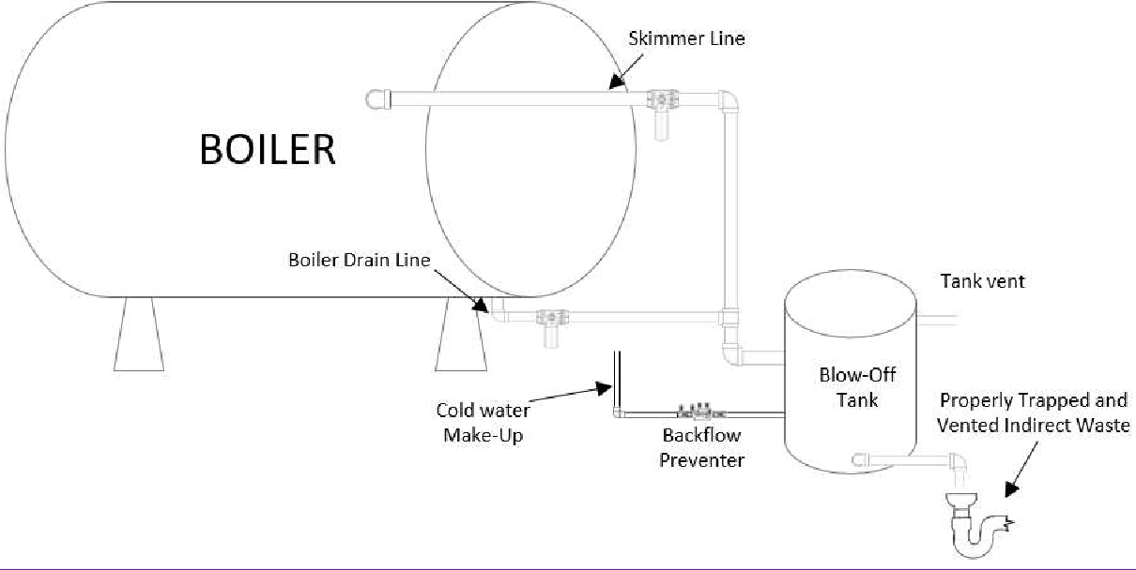

NOTE – EVERYTHING BEYOND THIS POINT IS DELETED

10.20: Boiler Blowoff Tank

- ​ Boiler Blowoff Tank. (See 248 CMR 10.22: Figure 1). A vessel designed to receive the discharge from a boiler blow-out outlet and to cool the discharge to a temperature of 150EF or less which permits its safe discharge to the drainage system.
  - Shall be in full accordance with the recommendations of the National Board of Boiler and Pressure Vessel Inspectors for Boiler Blow-off Equipment, Columbus, Ohio.
  - The temperature of water entering drainage piping from discharge of blow-off equipment shall not exceed 150EF.
  - ​ The pressure of the blow-down leaving any type of blow-off equipment shall not exceed five P.S.I.G.
  - ​ The blow-off piping and fitting between the boiler and the blow-off tank shall comply with the ASME Power Boiler Code, Paragraphs P-307 through 312.
  - All materials used in the fabrication of boiler blow-off equipment shall comply with material section of the ASME Boiler Code, Section II.
  - All blow-off equipment shall be fitted with openings to facilitate cleaning and inspection.

  - ​ The blow-off tank shall be designed in accordance with the ASME Boiler Construction Code, Section VIII for a working pressure of at least ¼ of maximum working pressure of the boiler to which it is connected. In no case, however, shall the plate thickness be less than d inch.

- ​ Direct Connections of Steam Exhaust, Blow-offs and DripPipes.

Discharge into Building DrainageSystem:
- ​ A steam exhaust, blow-off, or drip pipe shall not be directly connected to a building, drainage system but shall first pass through a blow-off tank as shown in 248 CMR 10.22: Figure 1.
- ​ Such waste water when it is discharged into a building drainage system shall have a temperature of not more than 150EF.
- ​ Automatic Cooling Facilities:
  - ​ Steam condensate which is to be discharged to the drainage system shall be provided with automatic cooling facilities to reduce the temperature of the water to a maximum temperature of 150EF.
  - ​ Automatic cooling facilities shall include storage so that heat may be dissipated and cooling water when required shall be added byuse of a thermostatically controlled device and only that portion of condensate about to be discharged to the drainage system shall be cooled.
  - ​ The requirements of 248 CMR 10.21(2)(b) apply particularly to systems of steam supply in which the steam condensate is discharged to waste rather than being returned to the steam generating plant such as steam supplied from street mains or from remote central steam generating plants.

10.21: Figures

Notes for Figures: The following applies for the figures in 248 CMR 10.22.

- ​ All figures are general schematics for illustrative purposes only. The figures are not meant to show every fitting, change of direction or every situation. Deviations from the illustrated figures maybe acceptable so long as the workmanship is in compliance with the relevant portion of 248 CMR.

- ​ All fixture waste and traps, as represented in the figures, shall be in compliance with 248 CMR 10.15(2)(a).

- ​ All cleanouts and locations, as represented in the figures, shall be in compliance with 248 CMR 10.08(2)(a) through (n).

- ​ All vents through the roof, as represented in the figures, shall be in compliance with 248 CMR 10.16(6)(a) through (f).

- ​ All branches and building drain sizes as per 248 CMR10.15(3).

- ​ All sizes of vents, vent stacks, branches etc. as represented in the figures, shall be in compliance with 248 CMR 10.16(13)(a) through (e) and 10.16: Table 2: Size and Lengths of Vents.

- ​ Symbols used in the figures in 248 CMR 10.22 have the following meanings. Note, for plans and specifications, these symbols may be used.

U.G. | Under Ground
A.G. | Above Ground
W&T | Waste and Trap
S.S. | Service Sink Trap Standard; Sanitary Sewer; or Storm Sewer (depending on context)
M.R. | Mop Receptor
F.D. | Floor Drain
F.V. | Future Vent
K.S. | Kitchen Sink (Single Compartment)
W.C. | Water Closet/Toilet
LAV. | Lavatories with 1¼ inch waste
V.T.R. | Vent through roof
C.I. | Cast iron
A.W. | Acid Waste

- ​ All trap distances from vents as represented in the figures are in compliance with 248 CMR 10.16(11)(a): Table 1.

- ​ See 248 CMR 10.13 before installation of any special hazardous waste system, Figure 16.

- ​ Figures are not to scale.

FIGURE 1: Illustration of Boiler Blowoff Tank.
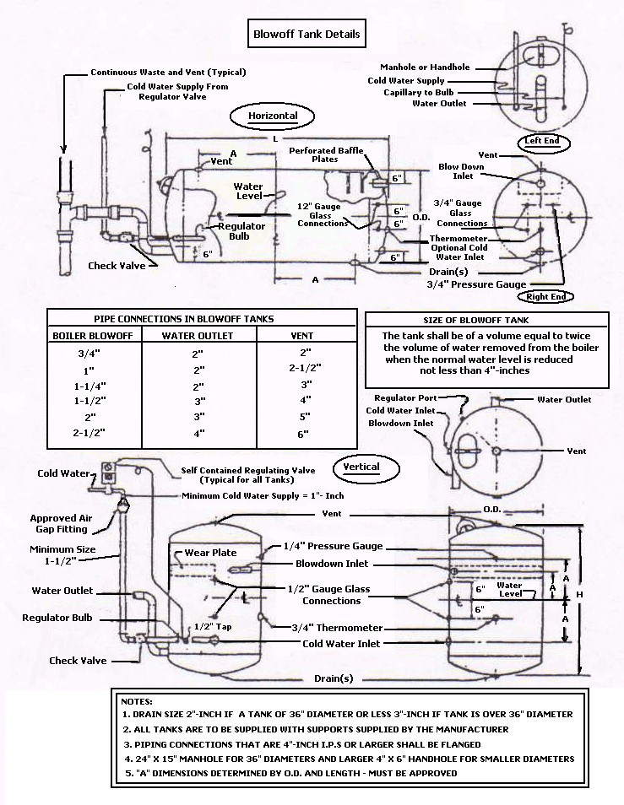

FIGURE 2: Illustration of Maximum Distance from Trap to Vent in Compliance with 248 CMR 10.16(12)(a): Table 1: Distance of Fixture Trap from Vent

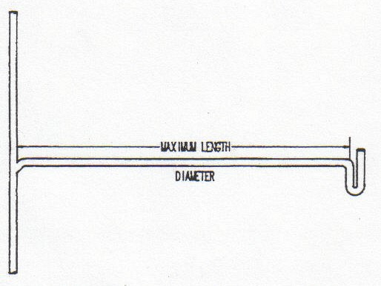
Note: These dimensions are from the vent to the weir of the trap along the developed length and the slope of the pipe in this distance is not greater than ¼ inch per foot.

Diameter of Pipe | Maximum Developed  Length of the Pipe
1½ inch waste and trap | Five feet
2 inch waste and trap | Six feet
3 inch waste and trap | Eight feet
4 inch waste and trap | Ten feet

FIGURE 3: Illustration of Miscellaneous Common Venting 248 CMR 10.16(9).
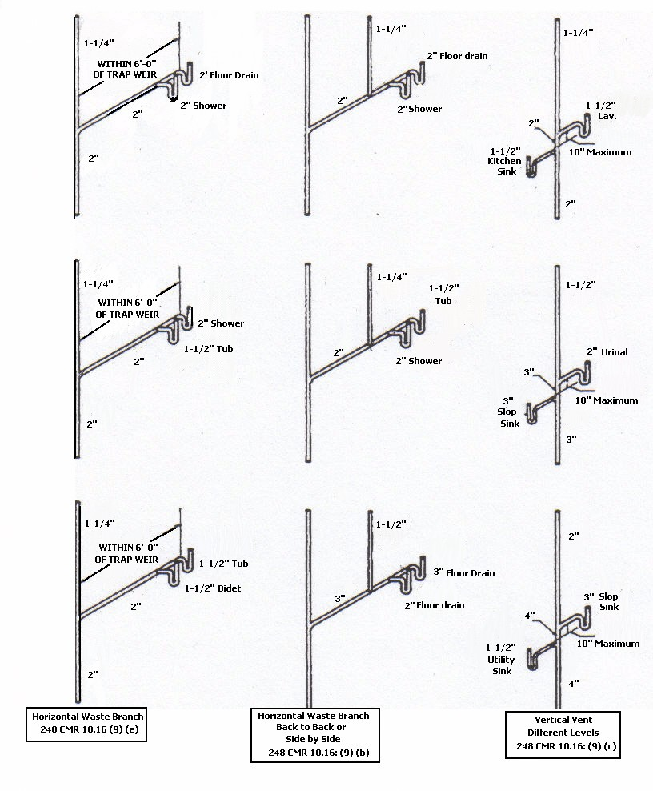

248 CMR - 155

FIGURE 4: Illustration of Stack Venting in Compliance with 248 CMR 10.16(8)(a) and (b).

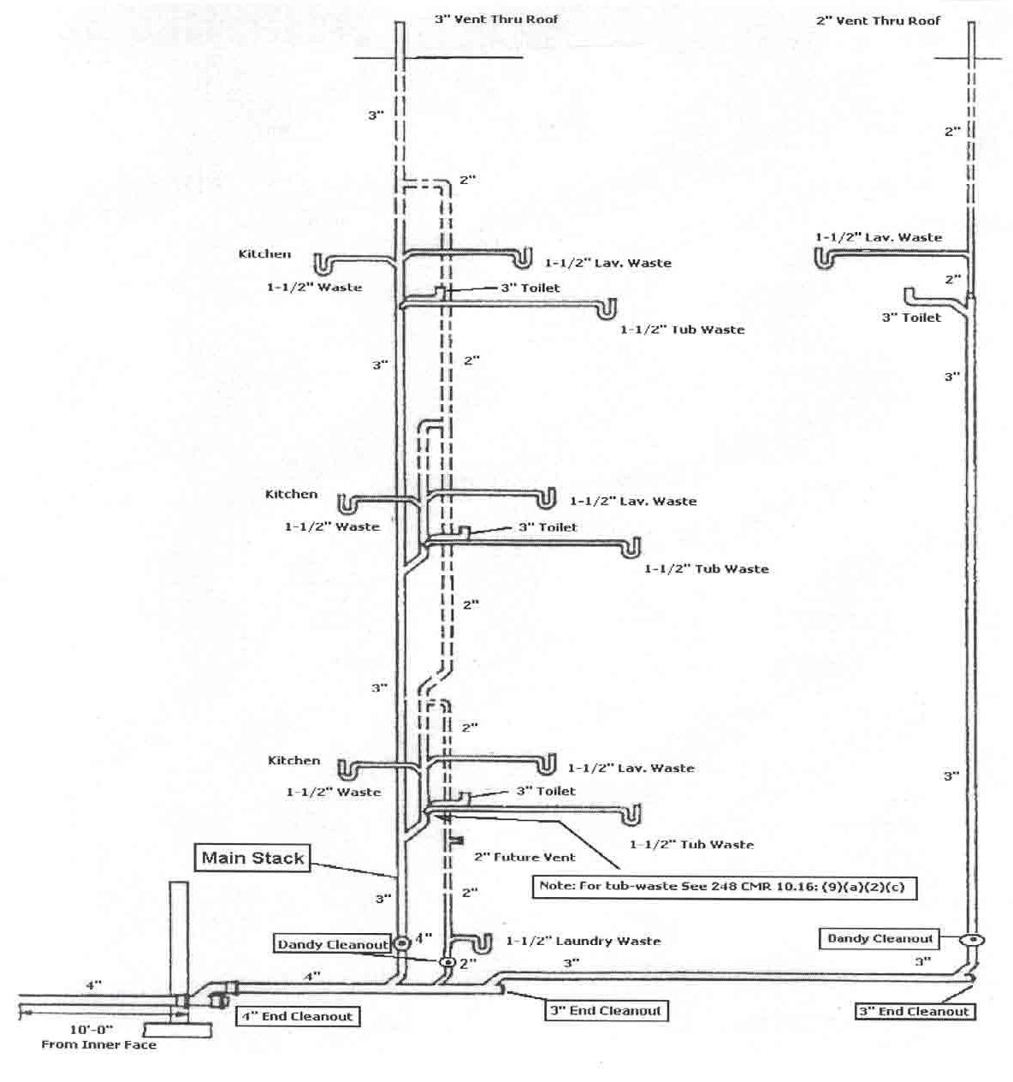

Include a bathtub or shower stall and a kitchen in the stack, on the extreme right hand side of the sketch. Such additional fixtures to be installed in accordance with 248 CMR 10.16(8)(a).

FIGURE 5: Illustration of Wet Venting.

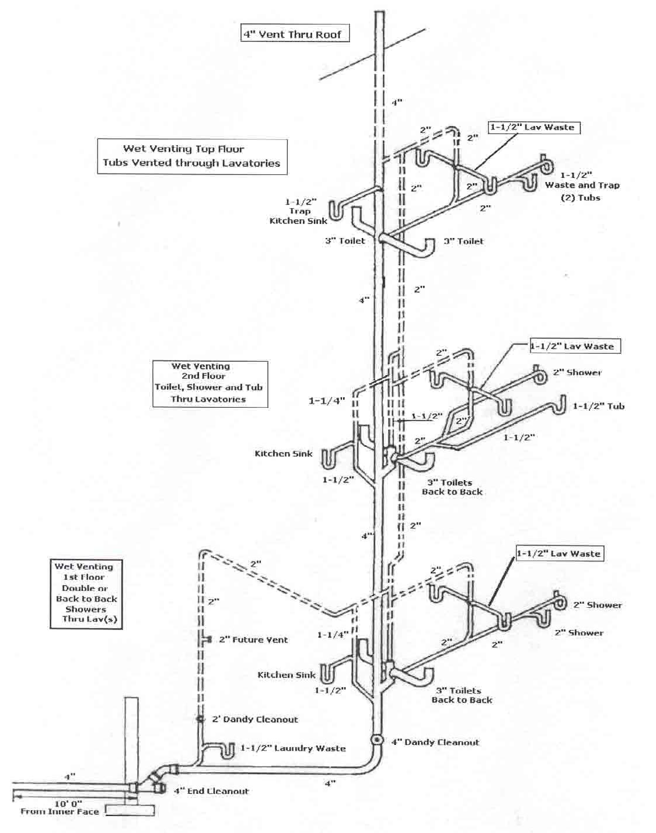

FIGURE 6: Illustration of Individual Vent First Floor, Wet Vent Second Floor, and Stack Vent
Third Floor.

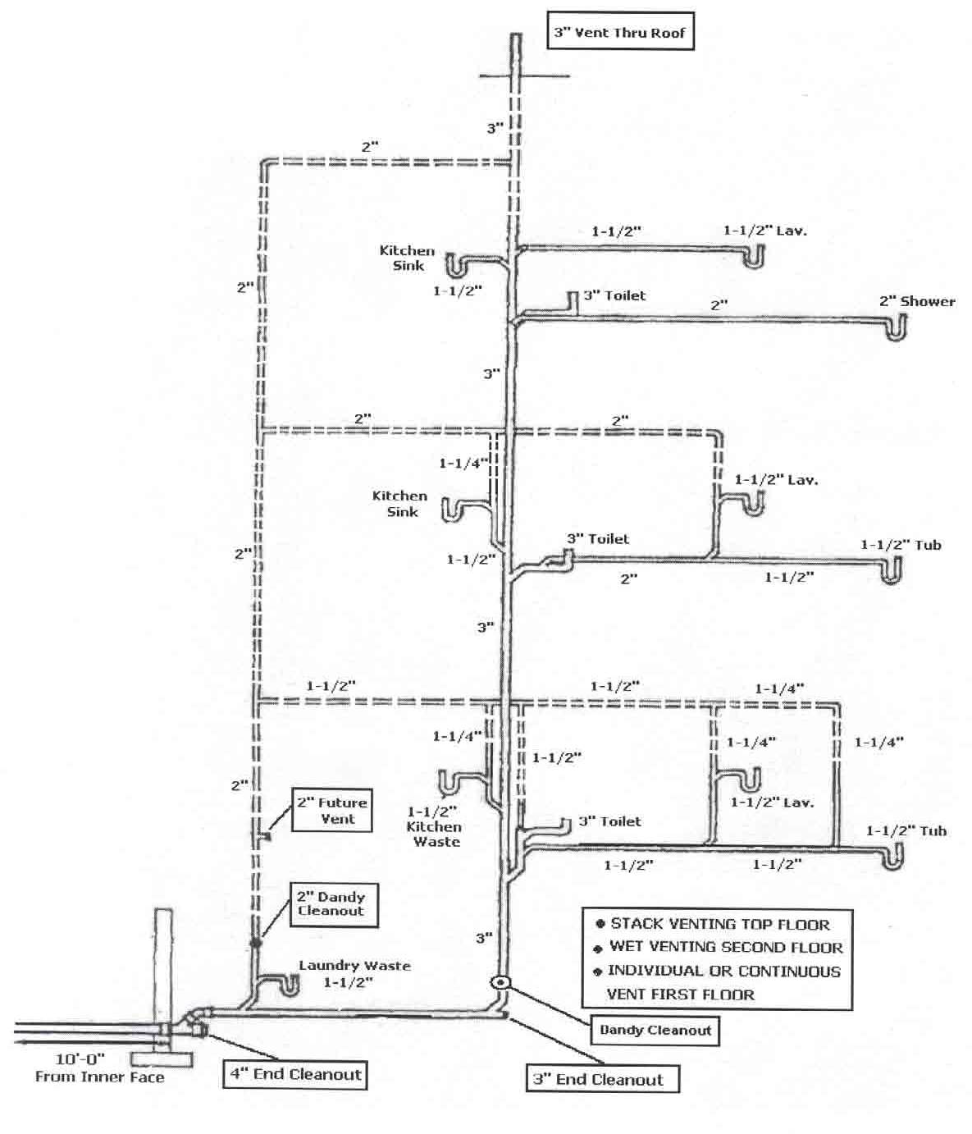

FIGURE 7: Illustration of Battery Circuit Vent, First Floor and Battery Loop Vent Second Floor.
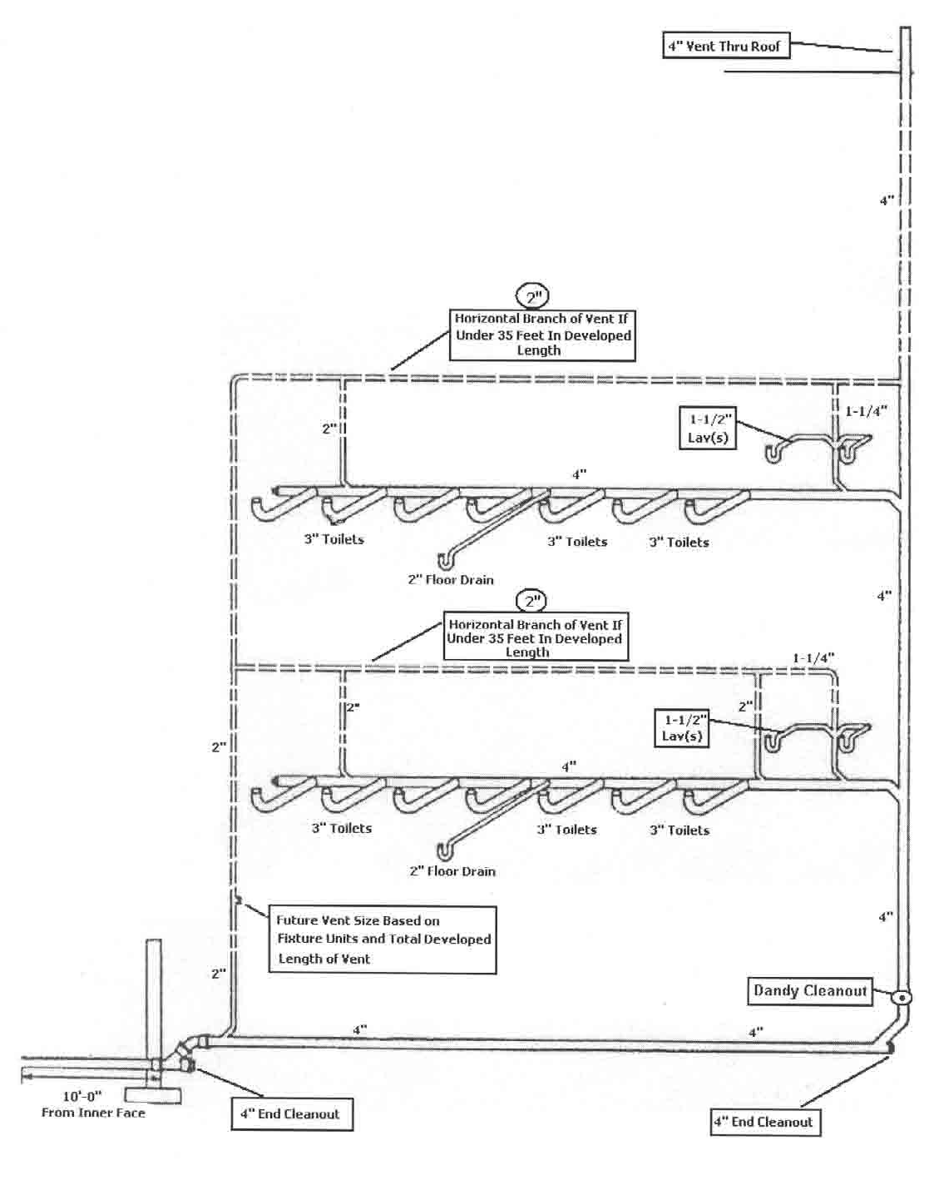

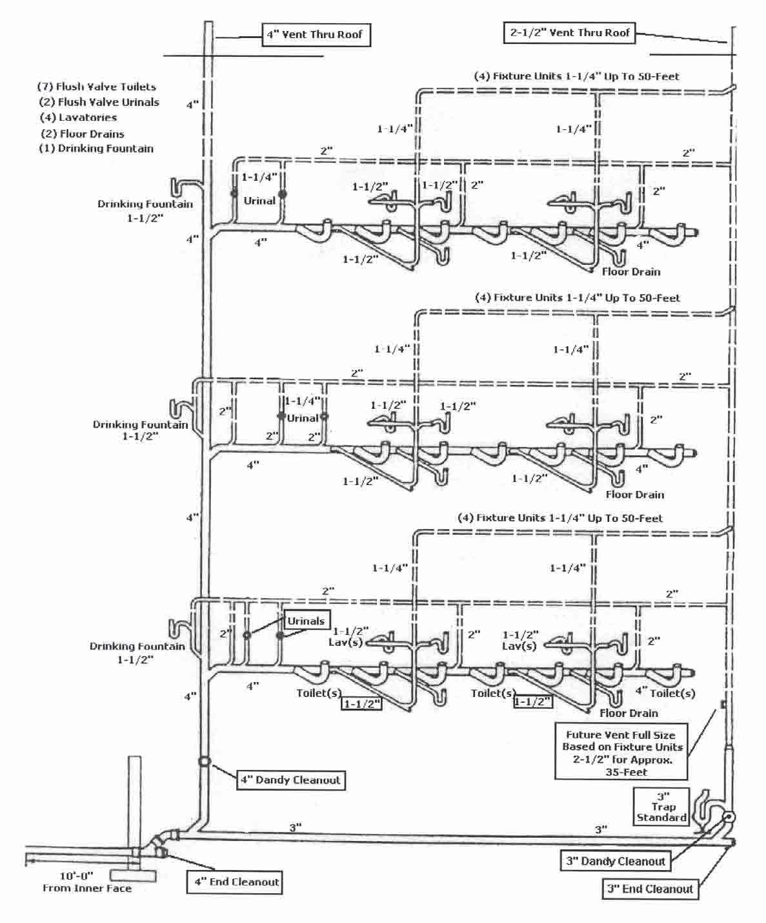
FIGURE 8: Illustration of Battery Circuit, Vent Multiple Floors.

FIGURE 9: Illustration of Battery Loop Vent, Multiple Floors.

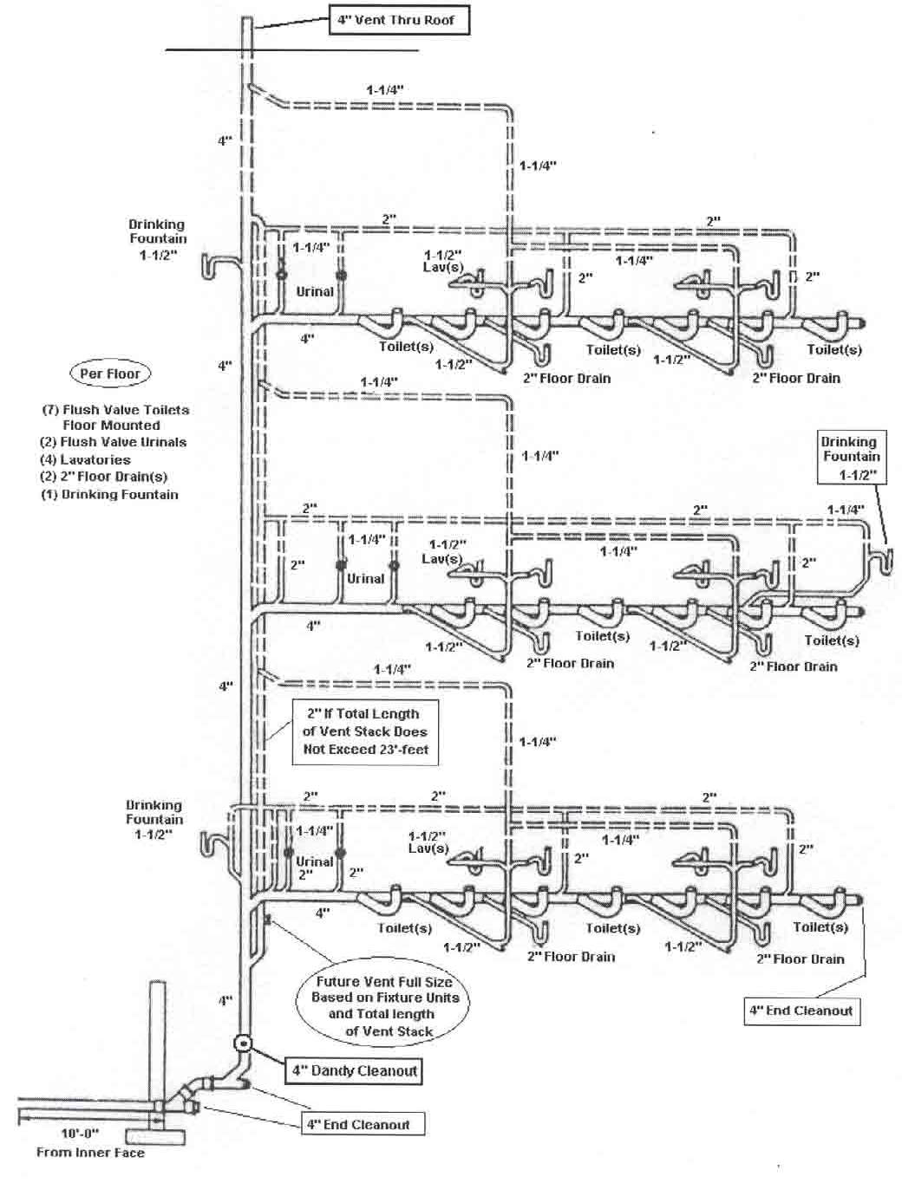

FIGURE 10: Illustration of below the Floor Hazardous Waste Battery Venting.
See 248 CMR 10.13(5)(d).
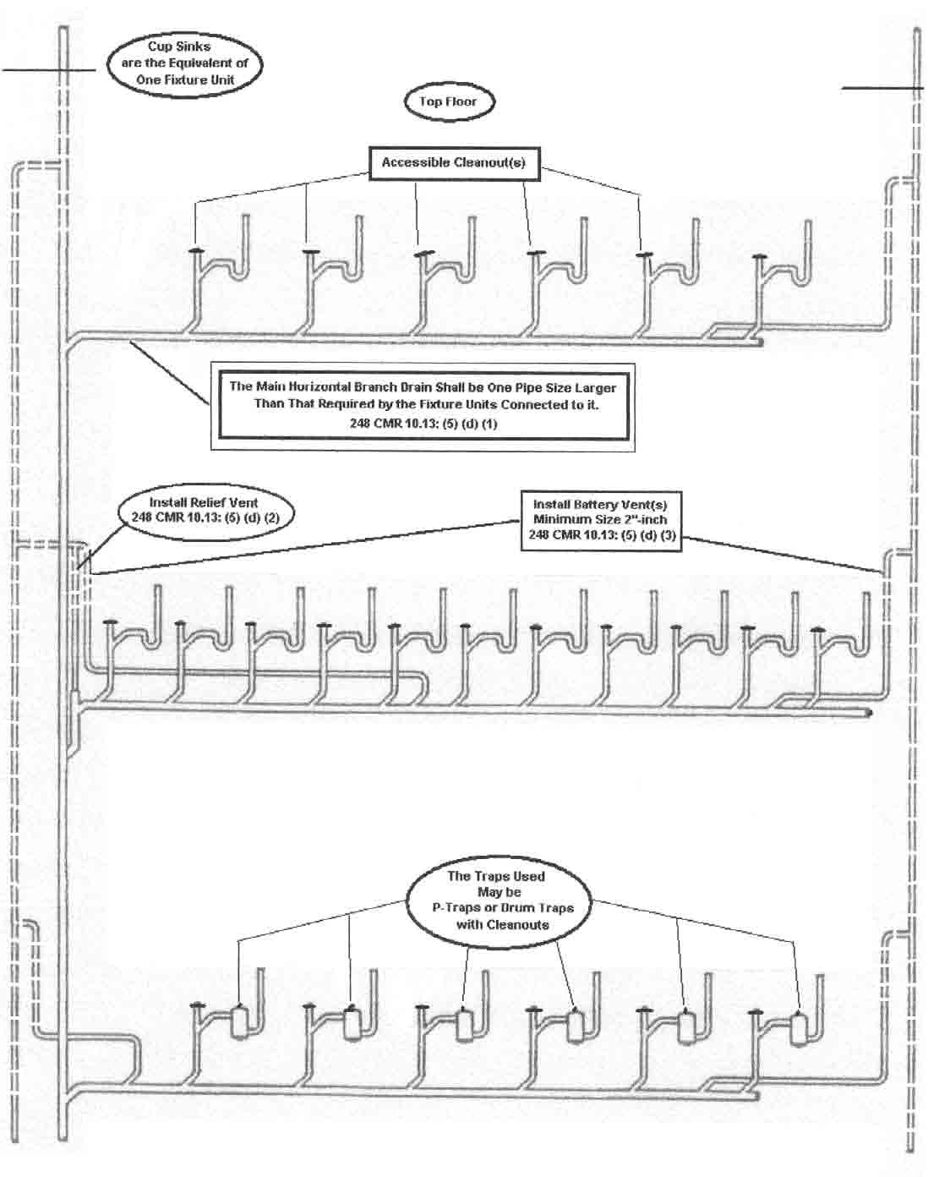

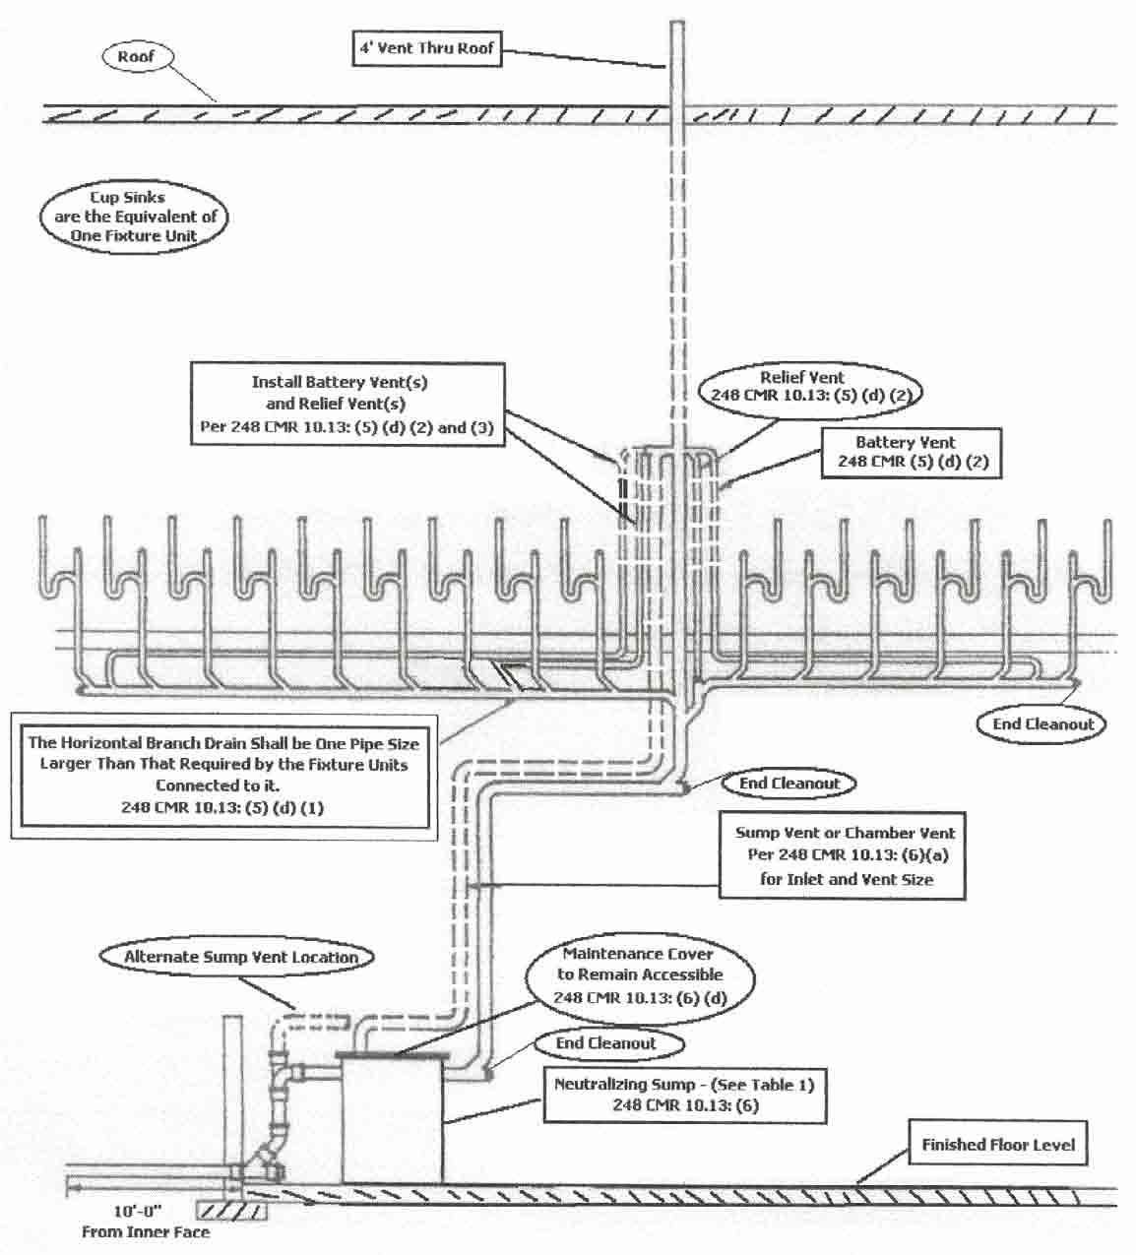
FIGURE 11: Illustration of Hazardous Waste Battery Vented below Floor Level, in Compliance with 248 CMR 10.13.

(FIGURE 12: Reserved)

FIGURE 13A: Illustration of Bow Vent Single Installations.

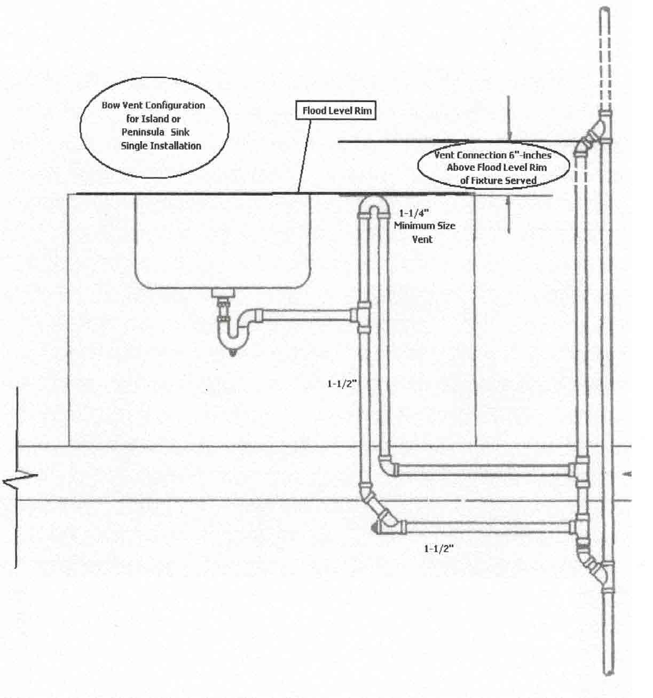

4/30/21 248 CMR - 165

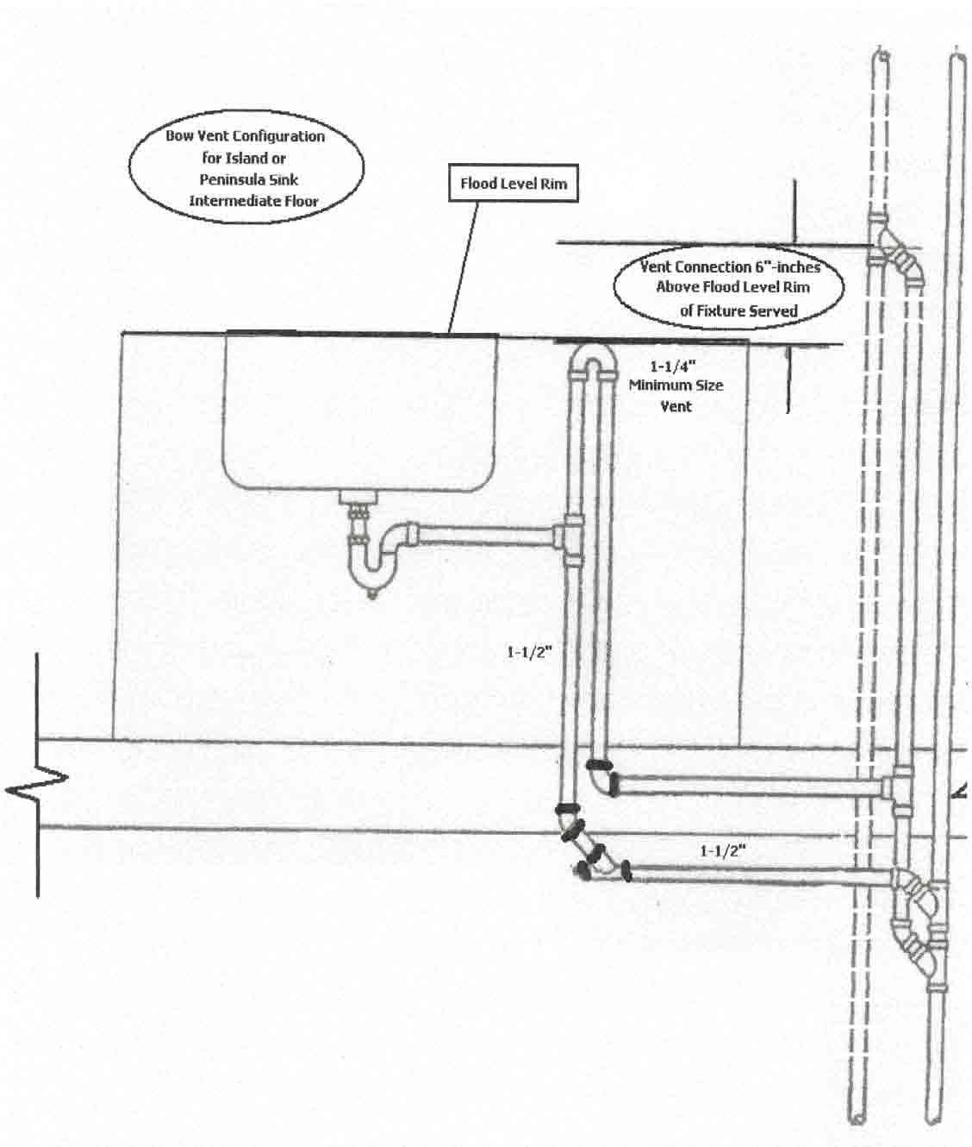
FIGURE 13B: Illustration of Bow Vent Connection at Intermediate Floor.

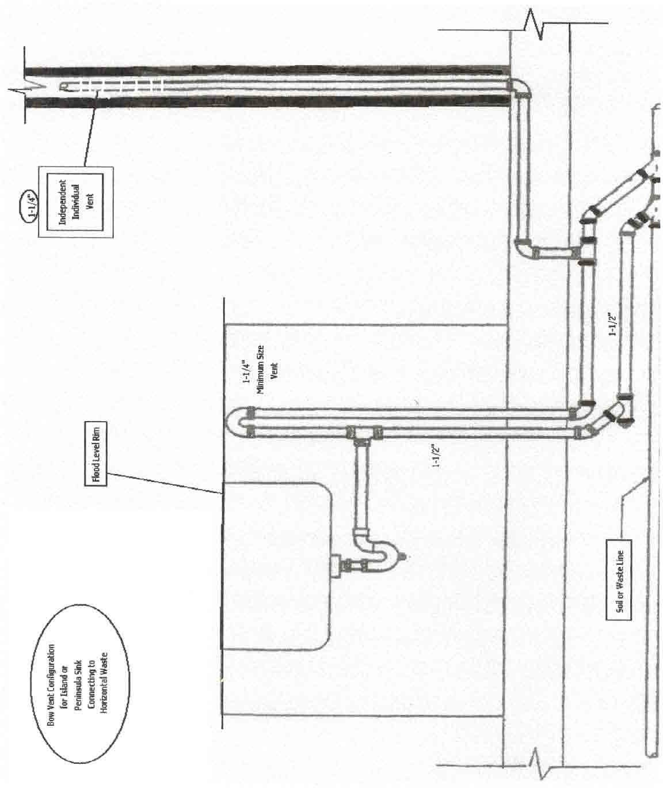
FIGURE 13C: Illustration of Bow Vent Connection to Horizontal.

FIGURE 14: Illustration of Sizing for Safe Waste Pan Drains or Water Heaters. 248 CMR 10.12(1)(h)

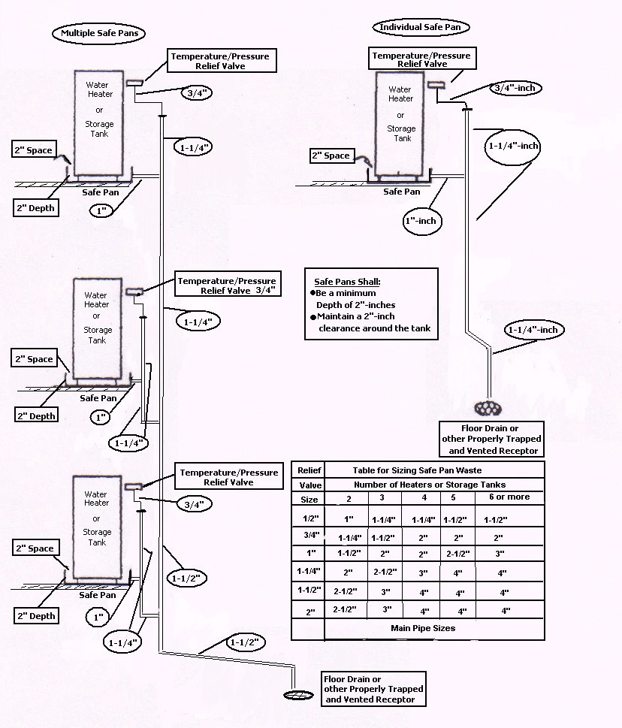

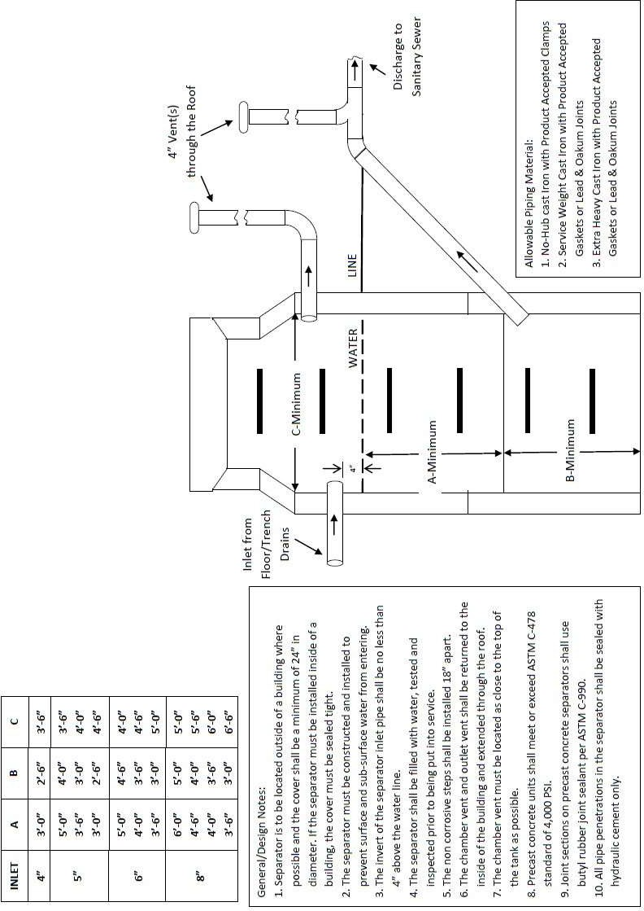
FIGURE 15: Illustration of Gasoline, Oil and Sand Separator

FIGURE 16: Illustration of Horizontal to Horizontal Change of Direction.

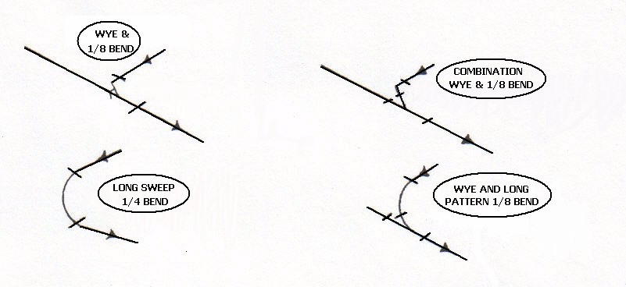

FIGURE 17: Illustration of Vertical to Horizontal Change of Direction.

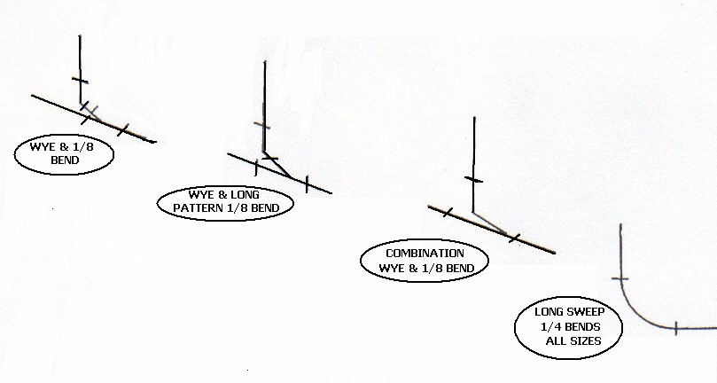

FIGURE 18: Illustrations of Building Drainage Foundation Wall.

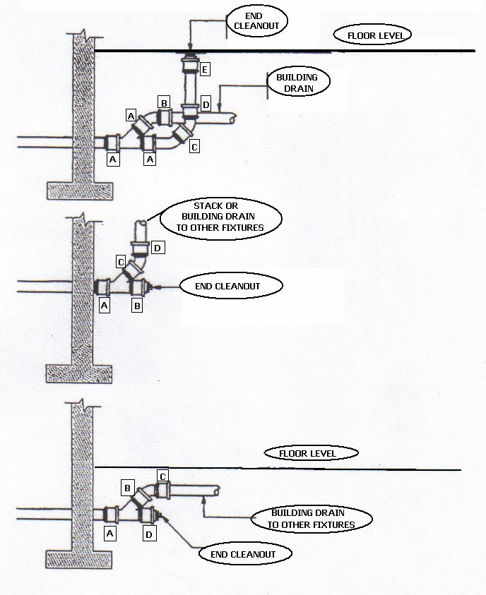

Note: A, B, C, D & E on each figure shall be in compliance with 248 CMR 10.07(1)(c) (Lead & oakum joints).

FIGURE 19: Illustration of Laundries in Multi-story Buildings.
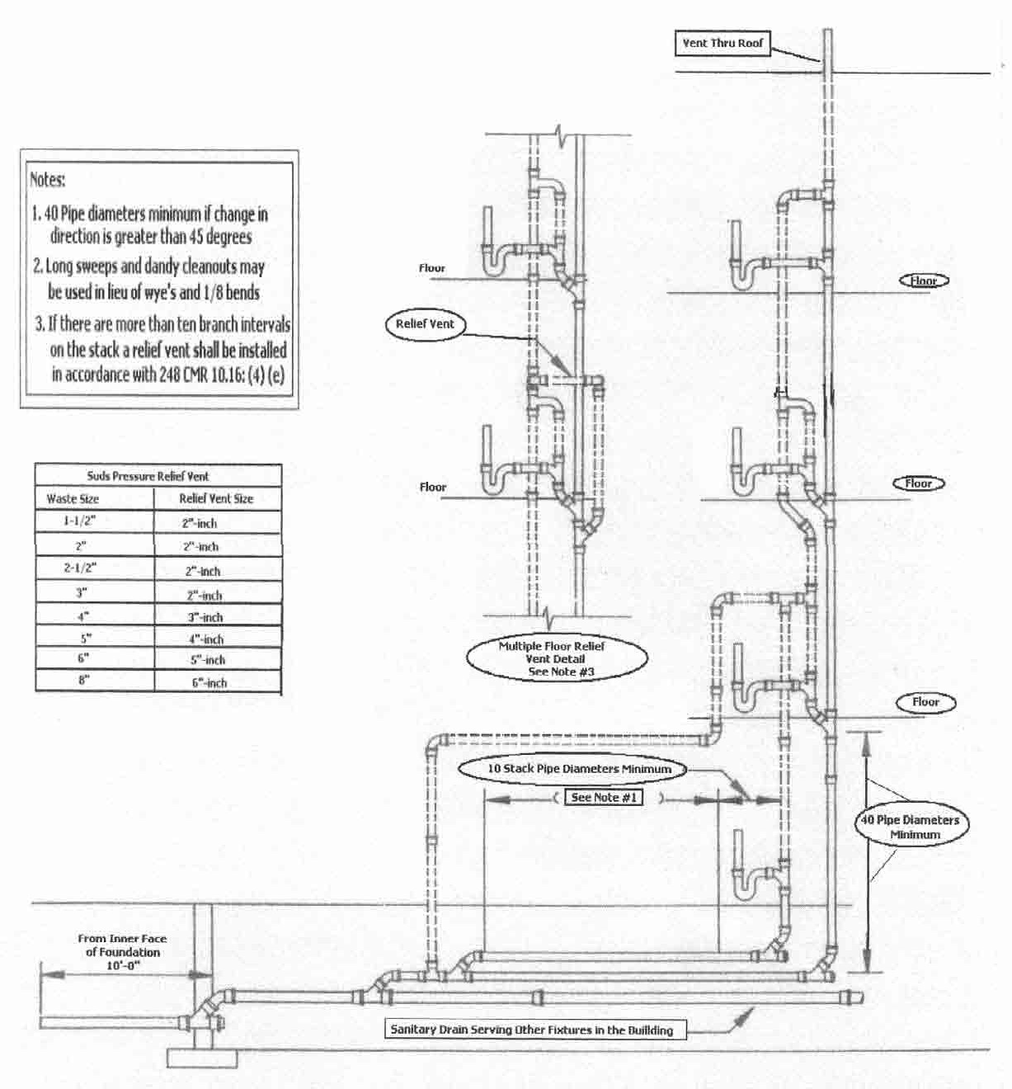

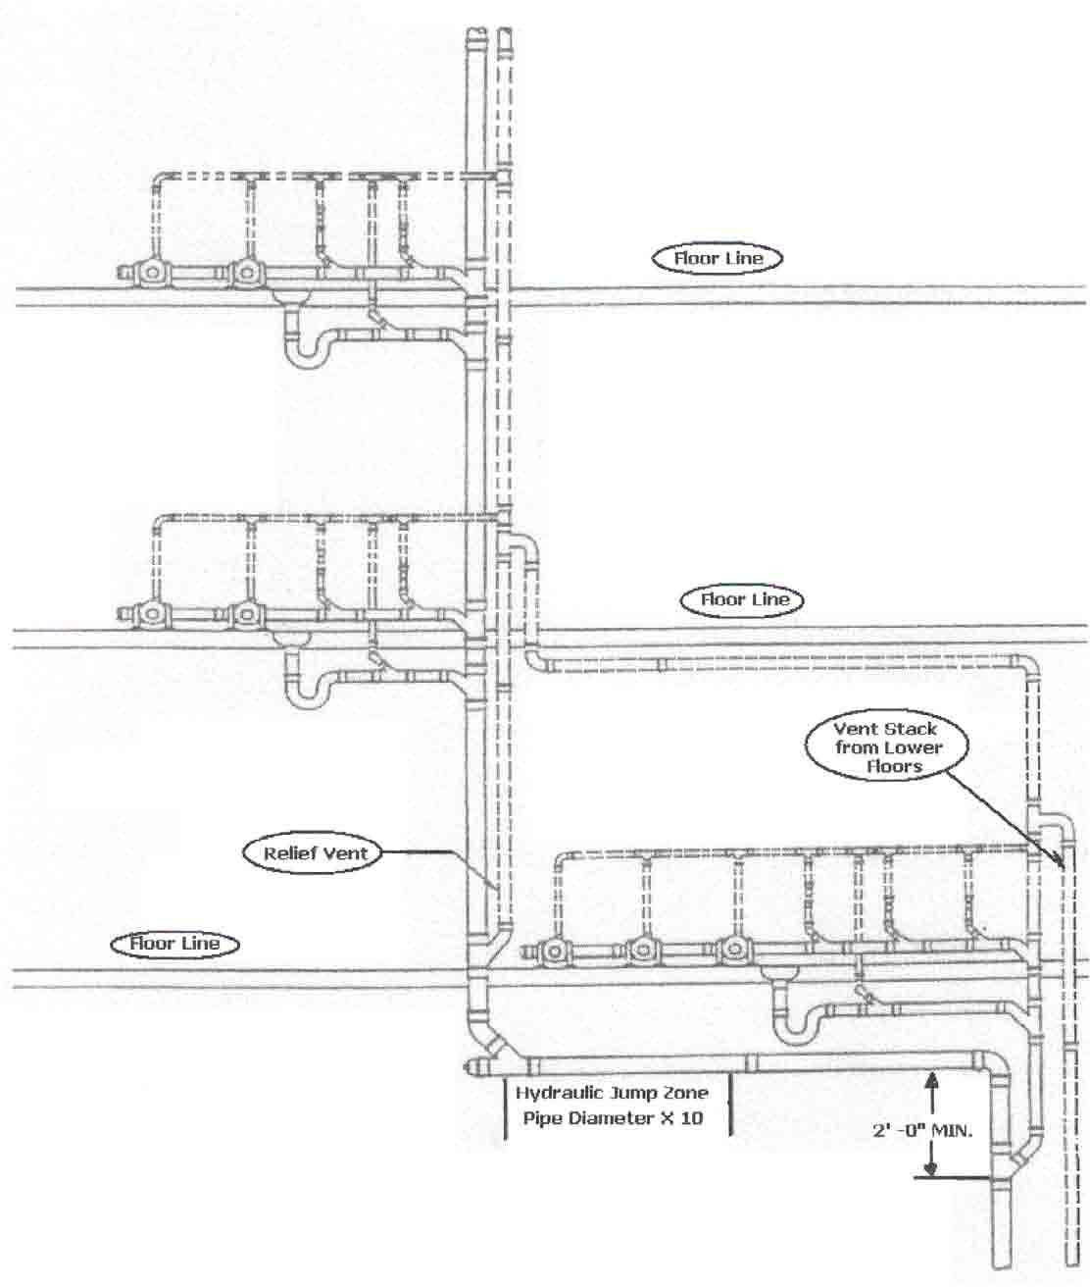
FIGURE 20: Illustration of Offsets of More than 45E in Buildings of Five Stories or More in Compliance with 248 CMR 10.15(8)(b) and 10.16(4)(c).

FIGURE 21: Illustration of Multiple Clear Water Waste Stack.

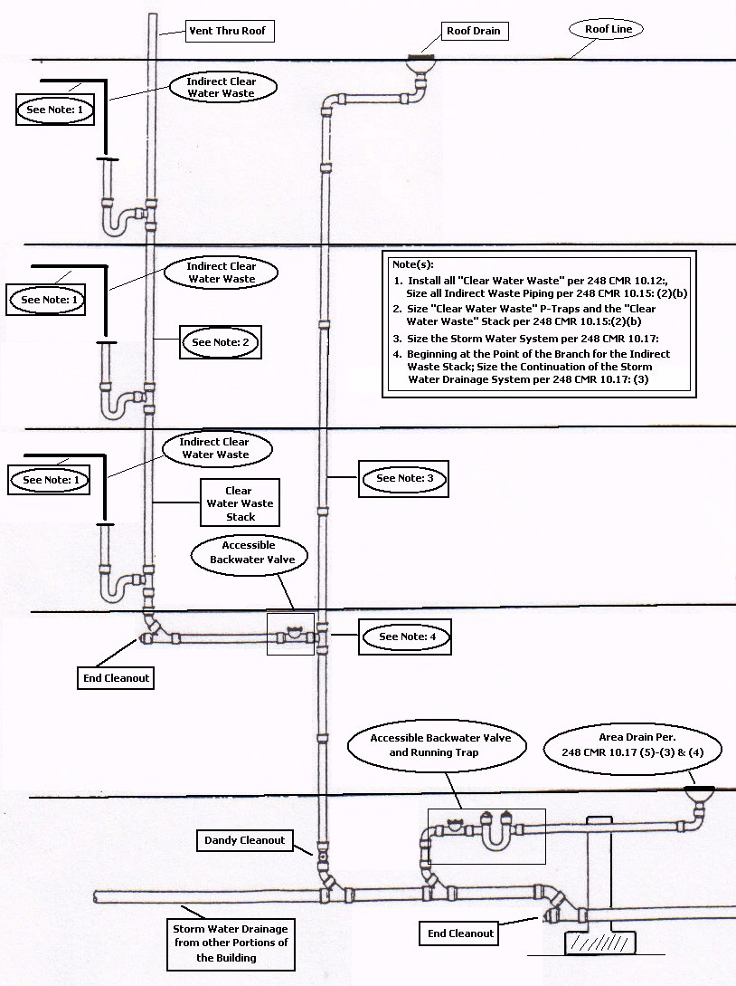

FIGURE 22: Illustrations of Installation of Grease Interceptors.
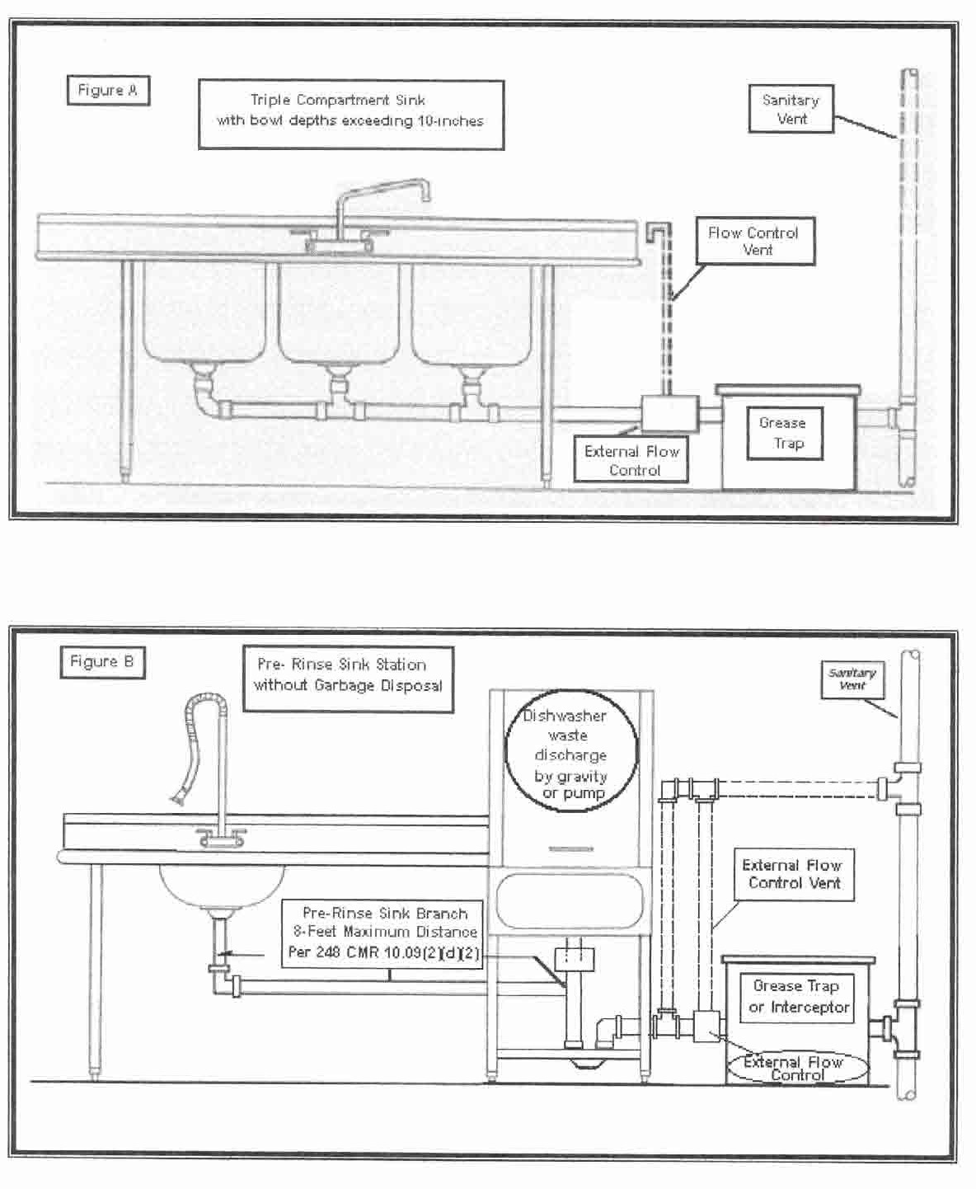

248 CMR - 175

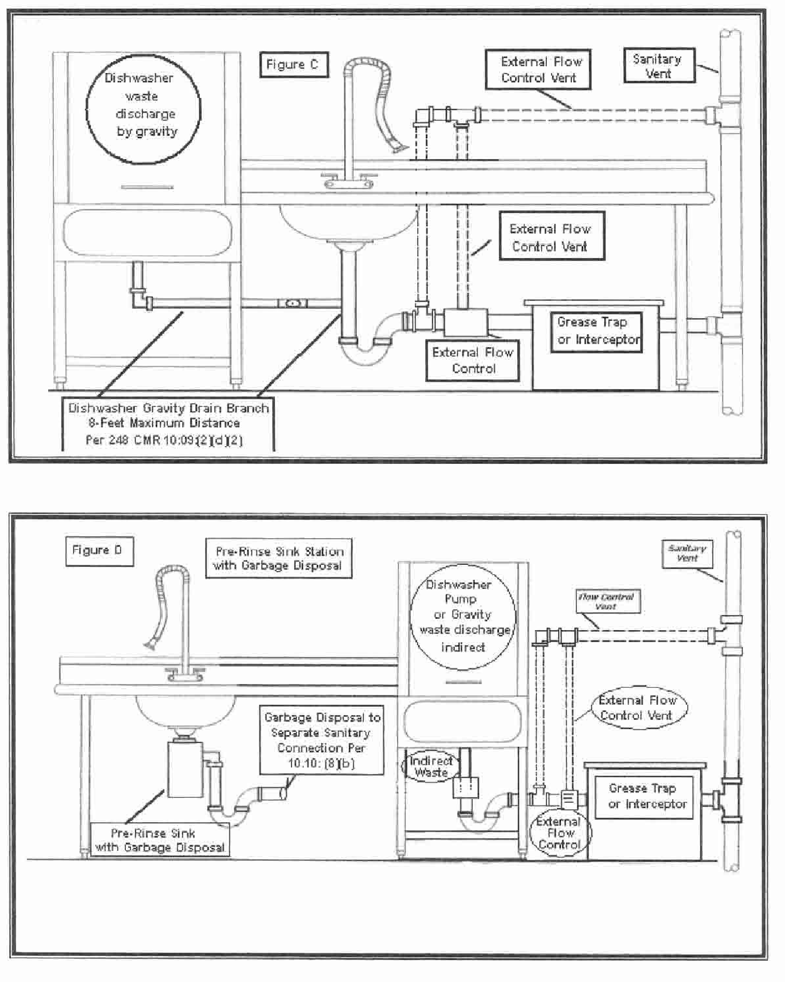
FIGURE 22: Illustrations of Installation of Grease Interceptors (continued)

FIGURE 23: Illustration of Combination Upper and Lower Roof Drain Installations.

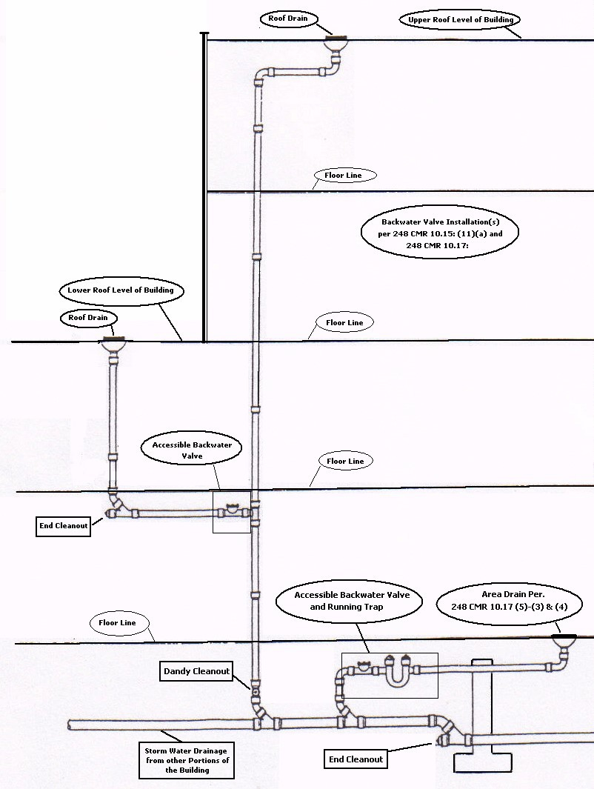

10.21: Vacuum Powered Sanitary Drainage Systems

- ​ (1) General.
  - ​ The purpose of 248 CMR 10.23 is to provide guidance to the Inspector in the evaluation as a proposed alternate and the requirements for the installation of vacuum powered sanitary drainagesystems.
The scope of 248 CMR 10.23 includes the This section shall include all fixtures, piping, connections, vacuum equipment, associated tanks and the method of receiving discharge from or discharging to a conventional drainage system as regulated in 248 CMR 10.15: Sanitary Drainage System.
  - ​ The Inspector may require the plans, specification, calculations and operating instructions to be reviewed and approved prior to the issuance of a permit for installation. The costs for such review shall be borne by the applicant.

- ​ Fixtures.
  - ​ General. All provisions and prohibitions of 248 CMR 10.10 shall be compiled with.
  - ​ Special Fixtures. Special fixtures designed and intended for connection to vacuum drainage systems shall be listed and approved for such use and shall be connected only to such systems.
  - ​ Conventional Fixtures. Conventional Fixtures designed and intended for use and connection to the gravity sanitary drainage systems may be connected to a vacuum drainage systems provided that all of the following conditions are met:
    - ​ The fixtures discharge into a gravity sanitary drainage and vent system complying with 248 CMR 10.15 and 10.16;
    - ​ The fixture shall be served by a trap complying with 248 CMR 10.08; and
    - The gravity drainage system is connected to the vacuum drainage system by an interface device.

- ​ Fixture Units.
Vacuum Toilet Fixture Units.(a) Vacuum drainage systems may be designed by a Massachusetts professional engineer.
  - ​ (b) Vacuum drainage system sizing and design:
    - ​ shall be determined from the manufacturer's data and engineering calculations; and
    - ​ shall be approved by theManufacturer.
  - ​ Conventional Fixture Units. Fixture units for gravity drainage systems discharging into or receiving discharge from vacuum drainage systems shall be determined as in 248 CMR 10.15(7): Table 1.
Water Pipe Sizing. Factor Values for the purposes of water pipe sizing shall be systems shall be installed in accordance with 248 CMR 10.14(4): Table 1 as normal. In addition to 248 CMR 10.14(4): Table 1, "Vacuum Toilets" shall be listed with a fixture unit value of one and shall be based upon ½ gallon consumption per flush.the equipment manufacturer’s

- ​ Traps and Vents.
Conventional Traps. Conventional fixtures shall be provided with traps as in 248 CMR installation instructions.

  - 10.23(2)(c)2.
  - Conventional Venting. Conventional fixtures shall be provided with vents as in 248 CMR 10.23(2)(c)1.
  - ​ Special Venting.
    - ​ A vent shall be installed where a vacuum interface device is installed for interfacing22: Boiler Discharge to a gravity drainage system to prevent clearing of the gravity traps.
    - ​ The vent shall be no less than two inches in diameter and shall be sized in accordancewith manufacturer's recommendations.

VacuumBuilding Drainage Piping.System
  - ​ General. Detailed and fully dimensioned plans at a scale of not less than c-inch equal one foot shall be submitted with all necessary data and engineering calculations for review

and approval.

10.23: continued

  - ​ Material.
    - ​ Vacuum drainage piping materials shall be composed of materials suitable for waste handling and shall have a smooth and uniformbore.
    - ​ Joints and fittings shall provide a smooth interiortransition.
  - ​ Fixture Connection. Vacuum drainage piping shall be connected to fixtures or gravity drainage systems by Product-accepted devices as required by 248 CMR 10.23(2)(c).
  - ​ Vertical Lifts.

The sum total of vertical piping used to lift discharges in a single system shall not exceed 20 feet unless documented by detailed engineering calculations.
    - ​ There shall be no offsets in the vertical piping and the diameter of the lift piping shall not change throughout its height.
  - ​ Changes in Direction.
    - ​ Changes of Direction in vacuum drainage systems shall be made by the appropriate use of fittings having no internal obstructions toflow.
    - ​ The radius of such changes in direction whether by a single fitting or combination of fittings shall not be less than that formed by a long sweep ¼ bend of long radius 90E elbow.
  - ​ Horizontal Runs.
    - ​ Horizontal piping shall be installed with a pitch of not less than 0.2% in the direction of flow.
A reforming pocket shall be installed in horizontal runs at intervals of no more than 150 feet or as indicated on the approvedplans
  - ​ Reforming Pockets.
    - ​ When required to re-establish the waste slug, reforming pockets shall be installed. Reforming pockets shall consist of a wye and three c bends or 45s arranged such that the discharge enters the branch of the wye, is pocketed in a trap formed by the three bends and exits at an elevation equal to theentrance.
    - ​ The depth of the trap formed shall be at least 1½ times the diameter of the piping. (See 248 CMR 10.23: Figure F-1.) A cleanout plug shall be installed on the wye.
  - ​ Trapped Sections. Offsets to pass under obstructions in horizontal runs maybe installed provided that such offsets are constructed as reforming pockets and do not exceed three feet in length, except that Offsets may exceed three feet in length if a second reforming pocket is installed at the terminus of the offset. (See 248 CMR 10.23: Figure F-2.)
  - ​ Piping Connections. Vacuum Drainage system piping connections shall be as follows:
    - ​ Horizontal piping connecting to horizontal piping shall enter from the top of the line by way of a wye fitting. (See 248 CMR 10.23: Figure F-3.)
    - ​ Vertical lift piping connecting to horizontal piping shall enter from the top of the line by way of a wye fitting. Where design drawings show a check valve to be installed in the horizontal piping between the lift piping and the branch inlet of the wye, such check valve shall be approved for use in vacuum waste drainage systems by the manufacturer of the system. The volume of the horizontal piping in direction of flow shall be at least ten times the volume of the vertical lift piping. (See 248 CMR 10.23: Figure F-4.)
    - ​ Horizontal piping connecting to vertical lift piping shall be by way of a reforming pocket. (See 248 CMR 10.23: Figure F-5.)
    - ​ Horizontal piping connection to vertical drop piping shall be by way of single wye branches. Multiple connections shall be at staggered levels. Double wyes or divided flow fittings are prohibited. (See 248 CMR 10.23: FigureF-6.)
    - ​ Vertical Droppipingconnectiontohorizontalrunsshallbebywayofacombination wye and c bend. (See 248 CMR 10.23: Figure F-7.)
  - Pipe Sizing.
    - ​ Vacuum drainage piping shall be sized in accordance with engineering principles.
    - ​ The installation of piping shall be in conformance with the sizes and layouts shown on the approved plans.
    - The plans shall contain a statement attesting to review and acceptance of the proposed installation by the Product-accepted manufacturer of the system.
    - EXCEPTION: When approved by the Inspector, minor installations, additions or relocations maybe permitted without the submission of additional plans when

provisions for such were clearly made in the original approved plans.

10.23: continued

  - ​ Cleanouts. Cleanouts shall be provided in the following locations:
    - ​ Start of horizontal runs;
    - ​ Top of stacks;
    - ​ Reforming pockets;
    - ​ Horizontal changes in direction equal to or greater than 90E;
    - ​ Intervals of 50 feet in horizontal runs.
  - ​ Tank Connections. Vacuum drainage piping shall enter the vacuum tank at its top. A full-port valve shall be installed at theconnection.
  - Supports and Bracing.
    - ​ Vacuum Drainage piping shall be supported every six feet on its vertical portions and every four feet on its horizontalportions.
    - ​ The vacuum piping shall be braced to prevent any movement in the vertical and horizontal planes.
    - ​ Piping shall not rely on fixtures, collection tank or pumps for any portion of its support. Seismic restraint shall be installed as required by 780 CMR: State Board of Building Regulations and Standards.
  - ​ Access. Service access shall be provided to cleanouts check valves and interface valves.

- ​ Vacuum Collection Tank Assembly.
  - ​ General. A vacuum collection tank assembly shall be provided of sufficient capacity to maintain the required vacuum pressure when the collection tank is 75% filled with system discharge fluids. Size shall be calculated based on engineering principles and drawings shall contain a statement attesting to review and acceptance of the proposed installation by the approved manufacturer of thesystems.
  - ​ Location. A vacuum collection tank assembly located within a building shall be in a well ventilated room and to which access is restricted to authorized personnel. Vacuum collection tanks shall be protected fromfreezing.
  - ​ Materials.
    - ​ Vacuum collection tanks shall be constructed of vacuum tight, welded steel construction or other Product-accepted materials and capable of withstanding a sustained vacuum pressure of 29 inches ofmercury.
    - ​ The interior of the tanks shall be treated to retard corrosion, the method of treatment shall be submitted with documentation for review and approval.
  - ​ Access Hatch.
    - ​ A gas tight, bolted access hatch not less than 14 inches in diameter shall be provided. The cover of the hatch shall bear a permanently affixed warning label indicating the presence within of toxic and flammablegases.
    - ​ The warning label shall contain directions regarding safety procedures to be observed when opening or entering thetank.
    - ​ A clear pathway not less than three feet in width shall be maintained from the exit of the room to the access hatch.
  - ​ Vacuum Pumps.
    - ​ The assemblyshall be equipped with automaticallyoperated, duplex vacuum pumps capable of drawing down to 19 inches of mercury, vacuum.
    - ​ Pumps shall have the capacity to maintain an operating vacuum in the system of 16 inches of mercury.
  - ​ Sewage Discharge Pumps.
    - ​ The assembly shall be equipped with automatically operated, duplex sewage discharge pumps each sized to accommodate the calculated flow.
    - ​ Discharge to the gravity drainage system or sewer shall be as required for sewage ejector's.
  - ​ Vacuum Pump Discharge Piping.
    - ​ Vacuum pump discharge piping shall be extended full size without creating traps to the exterior of the building.
    - ​ The termination of the piping shall be direction downward to avoid entry of rain or debris.

10.23: continued

    - The termination shall be located at least two feet above a roof surface or 15 feet above a pedestrian surface and no closer than ten feet to any opening into a building.
    - Discharge terminations may be horizontal through a wall. (See 248 CMR 10.23:
Figure F-8.)
  - ​ Indication and Alarm.
    - ​ Vacuum tank assemblies shall provide separate indication and alarm of low vacuum conditions and high sewage level.
    - ​ Alarm conditions may be in two or morestages.
    - Early stage alarm may be transmitted for alerting service personnel to potential problems.
    - Failure stage alarm shall automatically shut down the system and annunciate the problem.
    - ​ Alarm indicator shall be at a location that has the approval of the Inspector.

- ​ Tests and Demonstrations.
  - ​ General. Recorded proof of all required tests and demonstrations shall be submitted to the plumbing inspector.
  - ​ Vacuum Drainage Piping.
    - ​ Prior to installation of any special fixtures or gravityto vacuum interface devices, the entire vacuum drainage piping system shall be pressurized to not less than 15 psig and shall show no loss in gauge pressure for at least tenminutes.
    - ​ EXCEPTION: When approved by the inspector minor additions, alterations or repairstoanexistingcomplyingsystem maybedonewithout the 15 psigairpressuretest.
  - ​ Gravity Drainage Piping. Conventional waste and vent piping shall be tested as required by 248 CMR 10.15 and 10.16.
  - ​ Functional Test.
    - ​ After completion of the entire system installation, the system shall be subjected to a vacuum pressure of 19 inches of mercury and shall be demonstrated to function as required by operating eachdevice.
    - ​ Such demonstration shall be conducted in the presence of the manufacturers authorized representative.

- ​ Instructions.
  - ​ Operation and Maintenance. Prior to final approval, the Inspector shall satisfy himself that written instructions on the operation and maintenance of the entire system has been delivered to the owner and that the owner has received on site instruction from the installer and manufacturer.

FIGURE F-1 REFORMING POCKETS
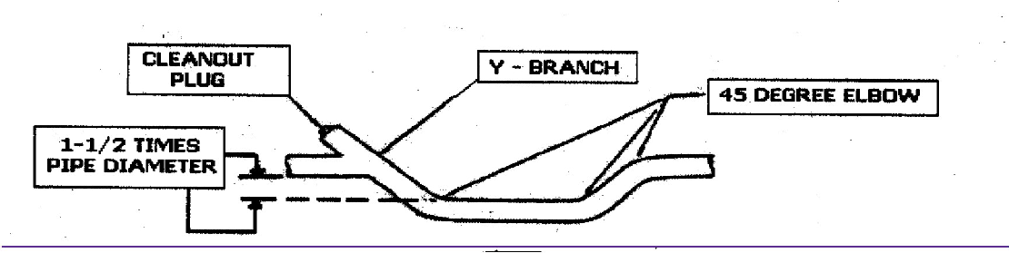

FIGURE F-2 TRAPPED SECTIONS

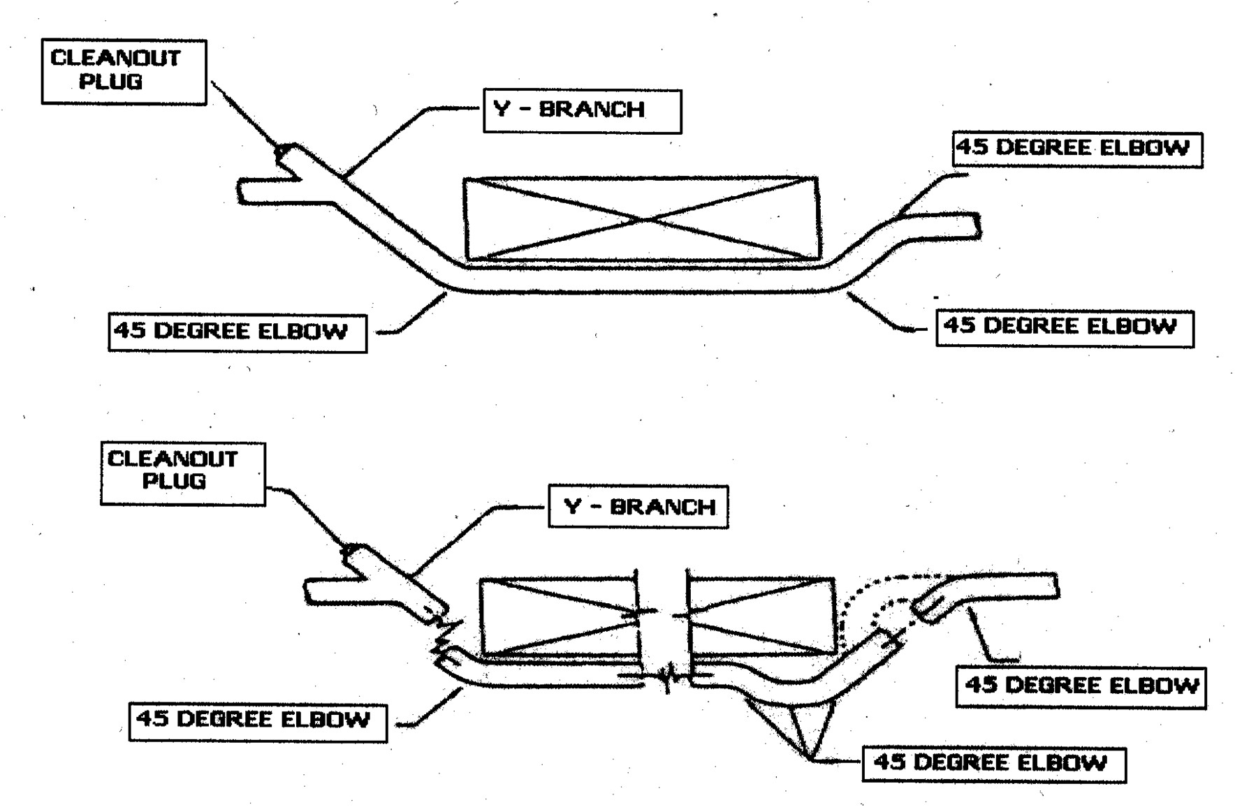

FIGURE-3
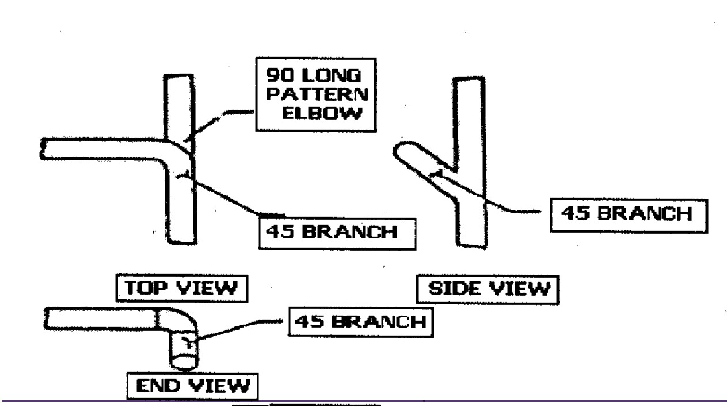
HORIZONTAL TO HORIZONTAL CONNECTION

FIGURE F-4
VERTICAL LIFT TO HORIZONTAL CONNECTION
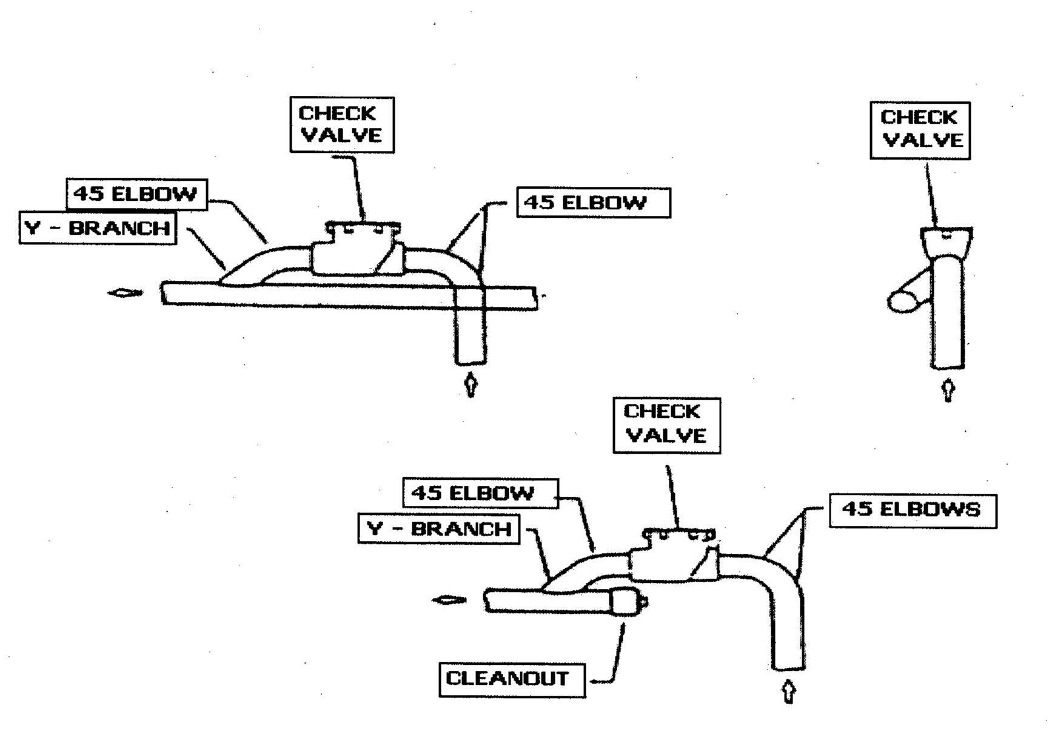

FIGURE F-5
HORIZONTAL TO VERTICAL LIFT CONNECTION

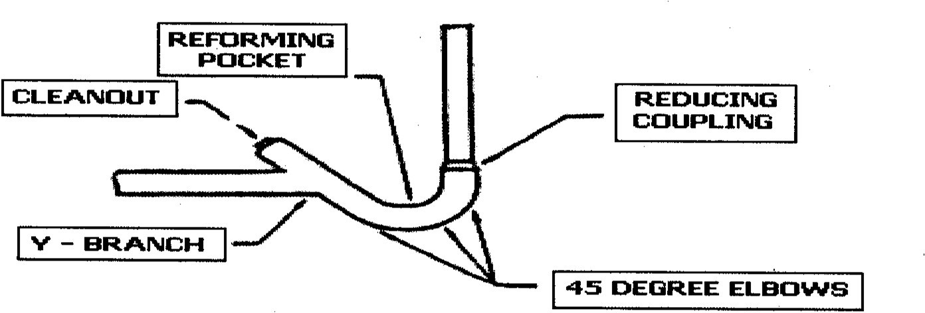

FIGURE F-6
HORIZONTAL TO VERTICAL DROP CONNECTION
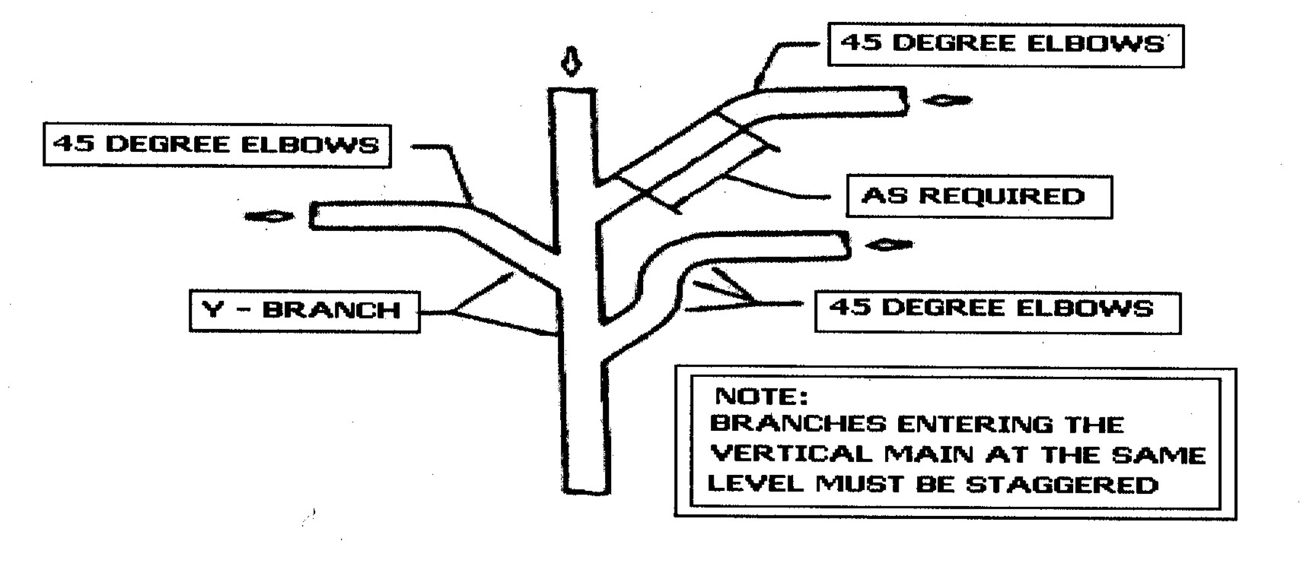

FIGURE F-7
VERTICAL DROP TO HORIZONTAL CONNECTION
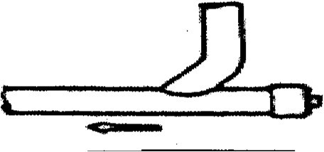

FIGURE F-8
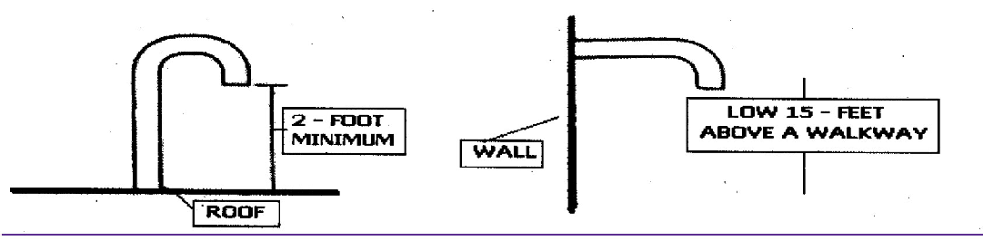
VACUUM PUMP DISCHARGE PIPE TERMINATION

FIGURE F-9
TYPICAL VACUUM FIXTURE INSTALLATION
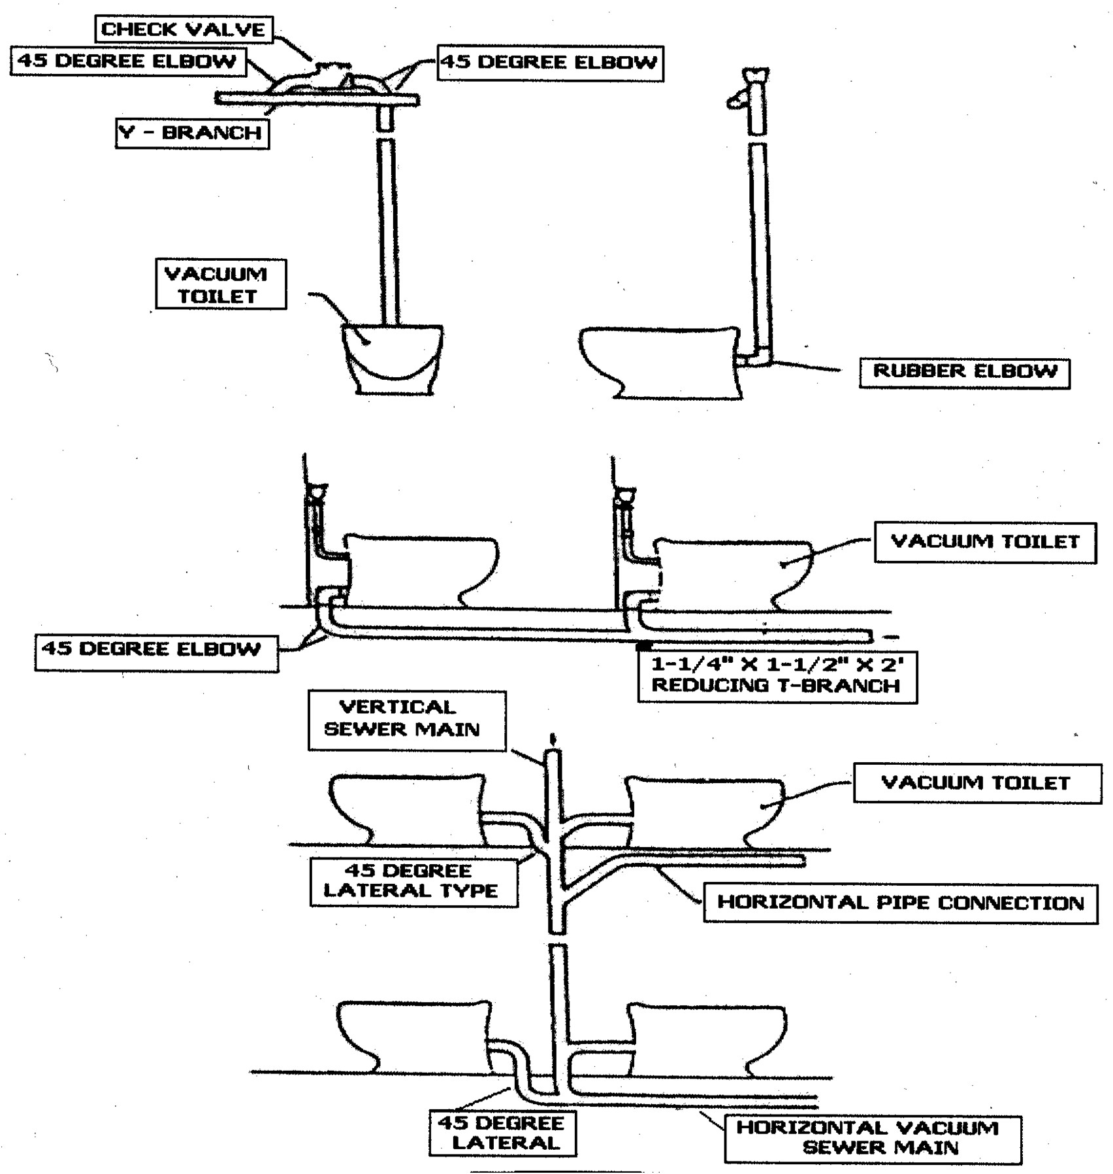

4/30/21 248 CMR - 187

FIGURE F-9
TYPICAL VACUUM FIXTURE INSTALLATION (CONTINUED)
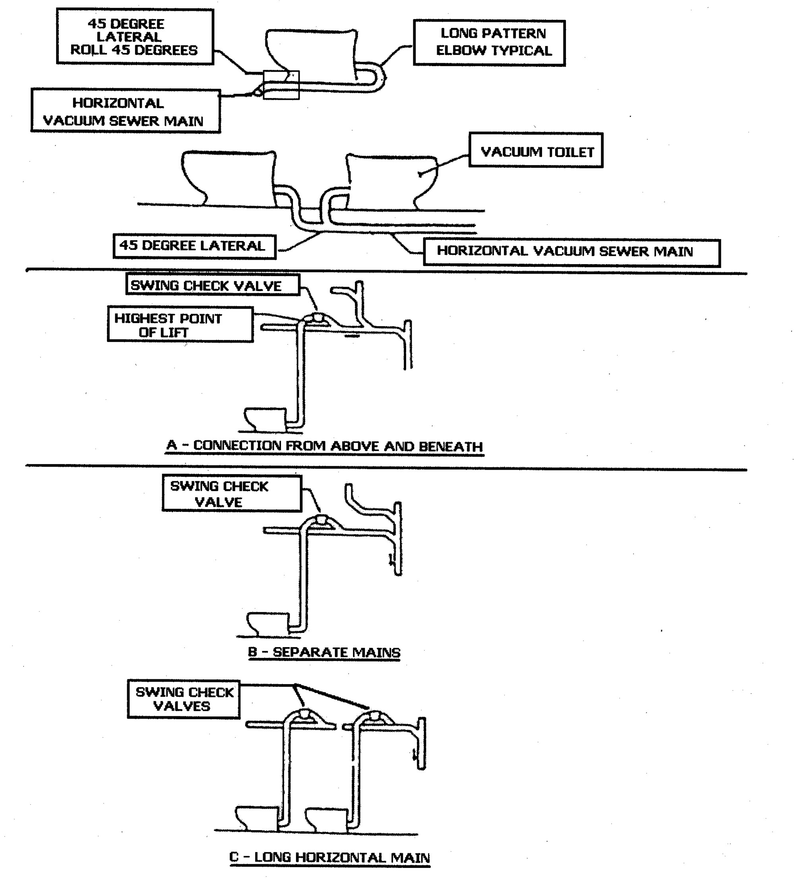

FIGURE F-10
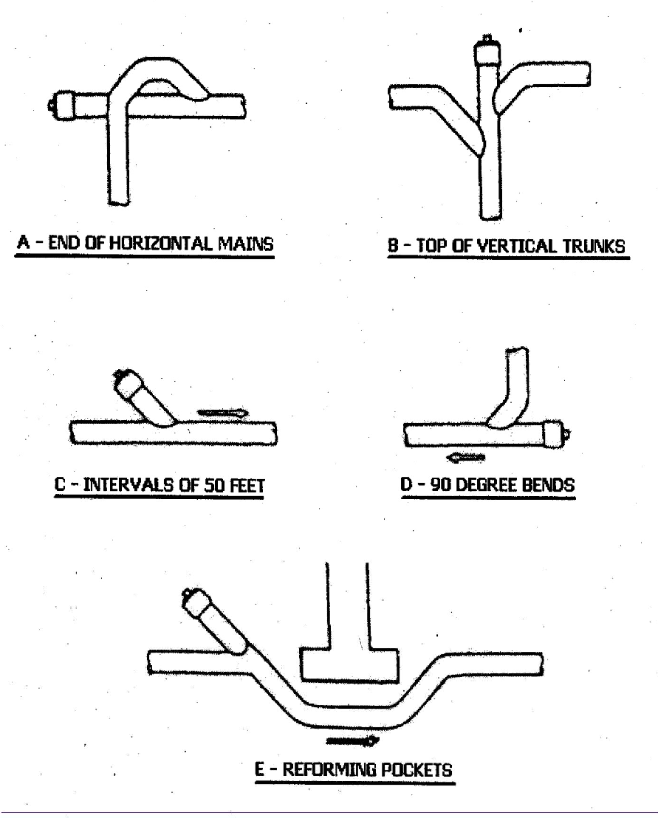
TYPICAL CLEANOUT LOCATIONS

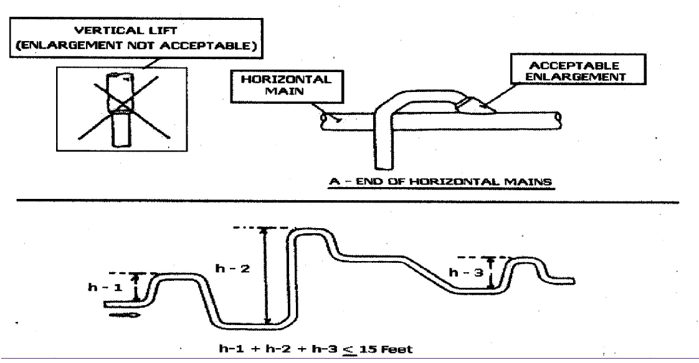

FIGURE F- 11 VERTICAL LIFT RESTRICTIONS

FIGURE F-12
PIPING SUPPORT REQUIREMENTS

